Using ODK for Durability Monitoring

Installing ODK and getting started with the sample form

- Obtain an Android tablet (e.g. Samsung Tab 4, Lenovo), and connect it to the internet or your computer.
- In the Google Play store, search and download “ODK Collect” to your tablet. This will create a directory on your tablet called odk with three sub-directories
  - Forms,
  - Instances (i.e. where the actual data goes), and
  - Metadata (where additional files like pics and preloaded data are stored).
- Open the zip file “DM_baseline_generic_en_fr_pt” and copy both the xml file and the media directory to the Forms folder of ODK Connect
- Open ODK Collect and click on “fill blank form”; you will see a list of all forms stored on the tablet; open the “DM_baseline_generic_en_fr_pt” file
- You can change the language of the questionnaire from the menu in the upper right corner.
- When the questionnaire has been completed click the “save form and exit” to complete and start the next interview by clicking “fill blank form” again.

Notes:
When a popup window comes up saying “Add new Group?”, this takes you to a listing section – e.g. the household listing, or the listing of the nets. Click on “add group” to add a new household member or new net. After the last member or net has been entered, click on “do not add” to return to the main questionnaire.

Editing the form and creating an updated xml file

You will likely need to make changes to the template form to edit the brand of net, sources of nets, etc. This can be done by working with the xls file “DM_baseline_generic_en_fr_pt”. This Excel file has three sheets: the “survey” sheet which has the main questions and contains skips, calculations and in the “label” columns the text that is shown on the screen in the different languages; the “choices” sheet which contains the options (values and labels) for the multiple choice variables like brand or color of net etc.; the “settings” sheet which contains among others the name of the form which for DM is set up to contain the name of the form version, the date and household number for easy identification.

If more structural changes are needed like deletion or addition of questions it is recommended that this is done by somebody with experience in creating ODK forms.

Once the changes are done, save the Excel file under a new name (don’t forget to enter that new name under “settings”). Now the xls file needs to be converted into the xml form. This is done using the XLSForm tool of ODK which can be found online at http://opendatakit.org/xiframe/ (there is also an offline version for Windows available). Click the “browse” button and select the location of your Excel file, then press “submit”. Once the conversion is complete (you will receive a detailed error message if there is a problem) download the new xml file and copy it to the “Forms” directory of the tablet or phone making sure that the “Media” sub-directory has the same name as the form.

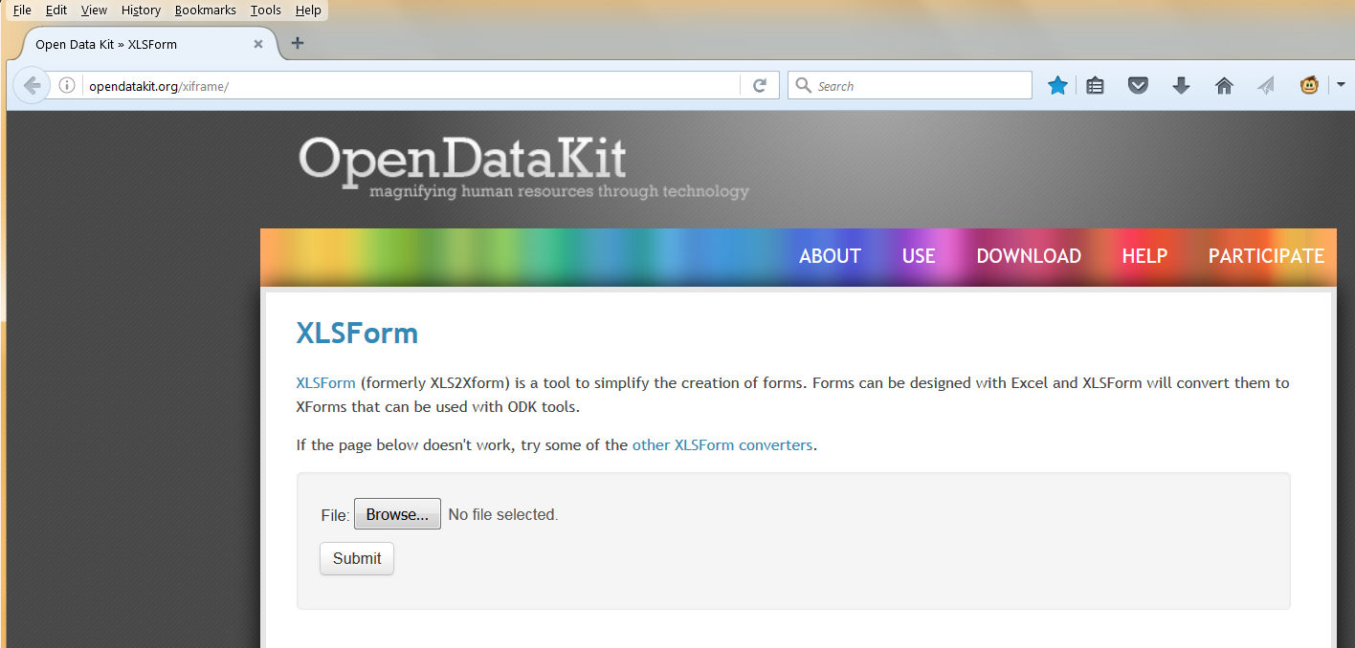

Securing data from tablet and upload/transfer

Once all household interviews for a day are completed, the site coordinator will copy all records to his laptop. It is suggested to use a system where a directory for each day of field work is created naming it “yyyy_mm_dd” and within that a sub-directory for each team named “team1” etc. From the tablet or phone the “Instances” directory with the data from that day is copied and then uploaded to a dropbox with the same structure to which only the coordinator and the co-investigator handling the primary data have access. The coordinator then sends an email to inform about the data upload and waits for email confirmation that data have been received correctly and secured. This includes verifying that each record folder actually includes an xml file with the data as sometimes an empty folder may appear if the upload was not completed due to poor internet connection. Only then are the records on the tablet deleted to clear room for the next day’s work.

Conversion of records to cvs format data files

In order to verify each days data and detect any potential problems the co-investigator in charge of primary data handling converts each day’s and team’s data to cvs format files (comma delimited) and screens for completeness and possible errors. This is done using the ODK briefcase application which can be downloaded from the ODK website at https://opendatakit.org/downloads/download-info/odk-briefcase/ . To run this application you need to have installed Java 7 or higher on you Windows or MAC computer.

When you run the “ODK Briefcase v.n.n.n. Production.jar” file for the first time you will be prompted to create a new folder called “ODK Briefcase Storage” (if it does not start by double-clicking on the file use right mouse > “open”). It is recommended to put this folder near to where you will store the data (e.g. into a ODK folder in your “documents” storage place.

Note:
To “pull” the raw data from the records the ODK briefcase needs to find all three directories “Instances”, “Forms” and “Media”. However, as long as the form and media files have not been changed, they can be added on the recipient’s side which will make the amount of data that needs to be uploaded much smaller and more suitable for areas with slow internet connection.

Pulling and exporting data with the ODK briefcase

It is recommended that on the receiving end the same directory structure is used as by the field coordinator, i.e. survey day and then team1, team 2 etc. within the ODK folder.

- Open the ODP briefcase application

- Use will see three tabs (Pull, Push and Export), “pull” is the default. If it is not highlighted, go to the tab “pull”
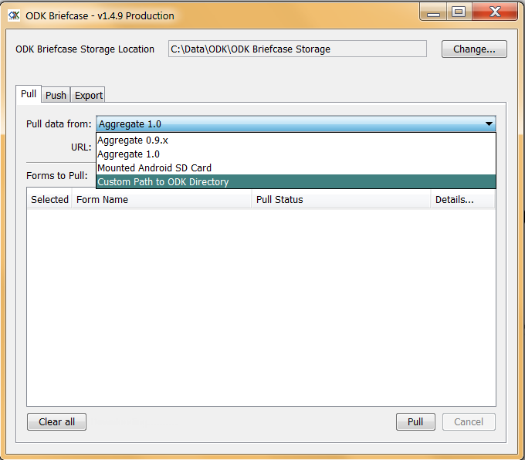

- Under “pull data from” select from the drop-down menu the last item “Custom path to ODK directory”

- In the ODK directory, click “choose” to select the path to the data you want to pull (the teams daily data directory), you should see the three subdirectories listed (forms, instances and media) as shown below.

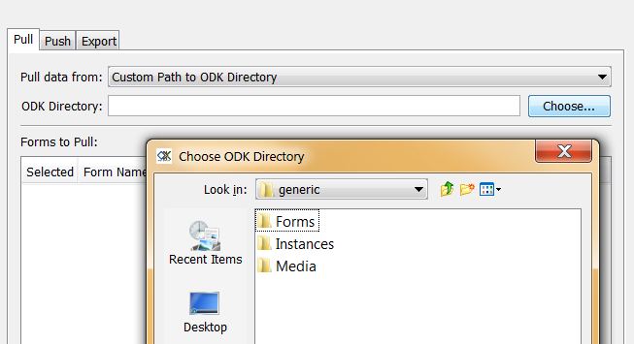

- In the “Forms to Pull” window the forms available will appear. Select the form you want to pull by ticking the box (in our example “DM_baseline_generic_en_fr_pt”) and click on the “pull” button at the bottom.

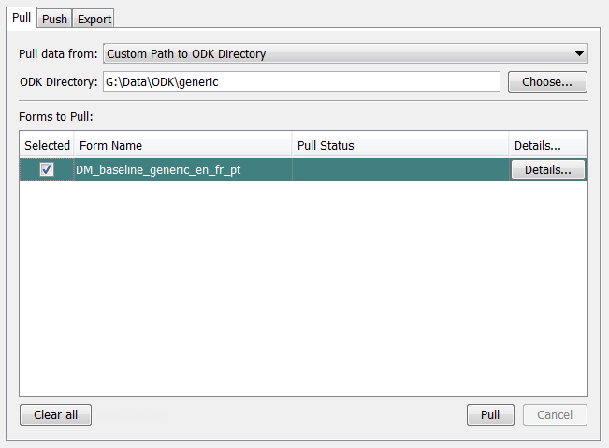

- You will then see the records being converted followed by a “SUCCESS” message.

- Now go to the “export” tab and select from the drop-down menu under “Form” the file you want to export, in our example. “DM_baseline_generic_en_fr_pt”.
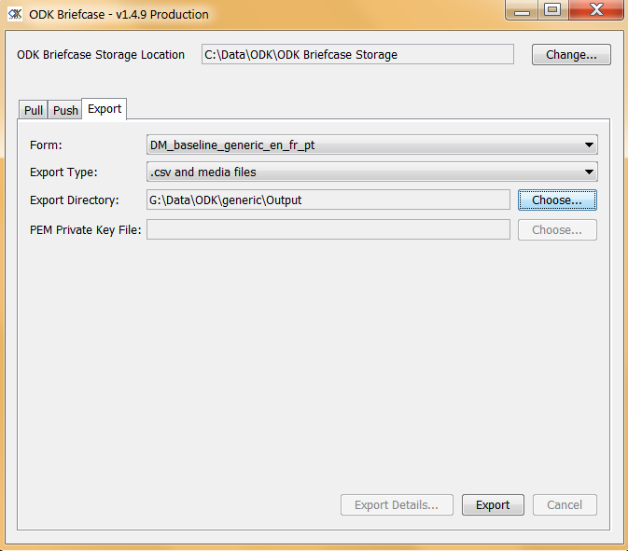

- Next select the export directory (recommended to use the same naming system as the raw data, i.e. day and team) and click the “export” button.

- In the folder into which you have exported the data, you will now see four .csv format files. It is recommended to rename these as follows:
  - DM_baseline_generic_en_fr_pt.csv = site_day_team_hh.csv (the household file)
  - DM_baseline_generic_en_fr_pt_repeat_residents.cvs = site_day_team_ind.cvs (the household member file)
  - DM_baseline_generic_en_fr_pt_group_repeat_programme_nets.csv = site_day_team_cnet.csv (the campaign cohort nets)
  - DM_baseline_generic_en_fr_pt_group_repeat_no_programme_nets.csv = site_day_team_ncnet.csv (the non-campaign nets)

- These can now be individually opened in Excel and screened for completeness and major errors or inconsistencies. Any errors found are reported back to the team on a daily basis.

Hint: Check in the household file whether each household has a unique ID number, a GPS location and that questions on nets in the household are properly filled; in the member file check the age of people; in the campaign net file look for the brand and specifics of the campaign net and the reading of the four digit bar-code label.

- Important: before the next batch of data is pulled (next team or next day) it is critical that the previous records are removed from the ODK storage. Go to the directory “ODK briefcase storage” then select “Forms” > “DM_baseline_generic_en_fr_pt” > “Instances” and delete all folders with the records previously pulled. If this is not done these records will be added to the next batch of data pulled for the same form!

- Data conversion is now complete and the data sets from each day and team (hh, ind, cnet and ncnet) will be later merged into single files for each site as part of the data management and analysis procedures.

