Durability Monitoring
Instructions for household listing and sampling

For the Durability Monitoring the following definitions apply:

Household: group of people who usually live together and “eat from the same pot”. By this definition polygamous families are considered as one household.

The principle activities on the survey day are:
- Listing of all inhabited households in the community (or selected section)
- Selection of 10 households for interview from the listings using the random numbers, plus 6 potential replacements for households that did not participate in the campaign.
- Visit of the selected households for interview

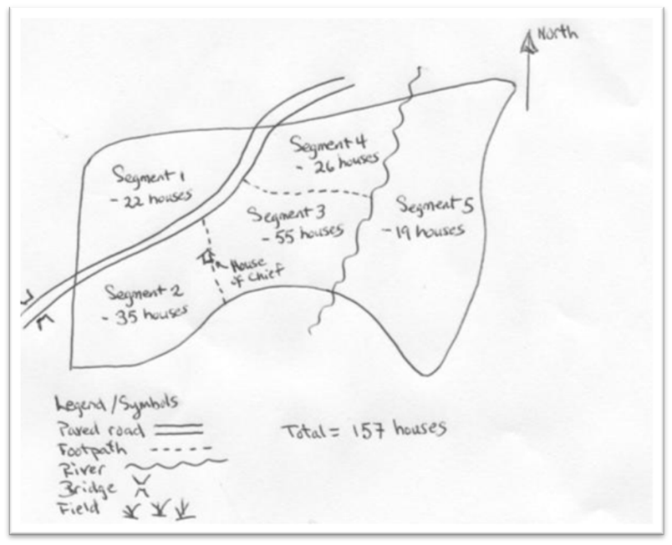
- During the mobilization phase the supervisor inquires from the local authorities the approximate size of the community (settlement). If the size is more than 100 households the community should be divided into 2 or more approximately equal sections of 100 households or less with the help of the chief (a rough sketch a map of the area will be helpful, use natural boundaries if available) and one section will be selected randomly. This selection can be done before the field visit or as the first thing when the team arrives in the cluster.
- The supervisor now allocates a defined area within the community (or selected section) to each interviewer (plus local guide) and ensures that they have the household listing forms.
- Each interviewer visits all the inhabited households (i.e. where people live and some slept in the previous night) in the area he is allocated and lists name of head of household. Exclusions will follow the rules used in the net distribution campaign, i.e. office buildings, schools, markets, health facilities, prisons, orphanages, and any uninhabited other building. The numbering will be as follows:
  - First a one digit number will be allocated to the interviewer within the team (1,2,etc)
  - This is followed by a two digit number (01,02, etc) for the household listed by this interviewer
  - The complete household ID number used on the questionnaire will then be the combination of interviewer and household number (101, 102, etc.)
- Once all interviewers have completed their listing the supervisor will “merge” them by completing a running number 1….n) across all forms using the “#” column in the supervisor section of the form.
- The last number entered will be the total number of households listed in the community (or selected section). This number is looked up in the first column of the random number table provided to the supervisor. Going across that row the running numbers of the 10 selected households are given in the table. These are marked with an X in the “selected” column of the household listings.
- The supervisor now allocates the households to the interviewers to go back and undertake the interview. It is important that on each questionnaire also the interviewer code is entered in order to distinguish potential duplicate HH-ID numbers within a cluster.
- The household ID entered on the questionnaire is the ID number given by the interviewer in the listing form.
- Any selected household that is not eligible for interview (did not participate in the campaign) is noted and after the first round of interviews are finished the supervisor allocates the corresponding number of replacement households. If a replacement household is found not eligible, it will not be replaced and not more than 6 households maximum will be replaced.
- After the interviews are complete the supervisor fills the Supervisor Cluster Monitoring Sheet with the details of that cluster.

