Random Number List for Selecting Sections within Clusters

Step 1. Draw a map of the settlement and divide it into sections of 60-100 households
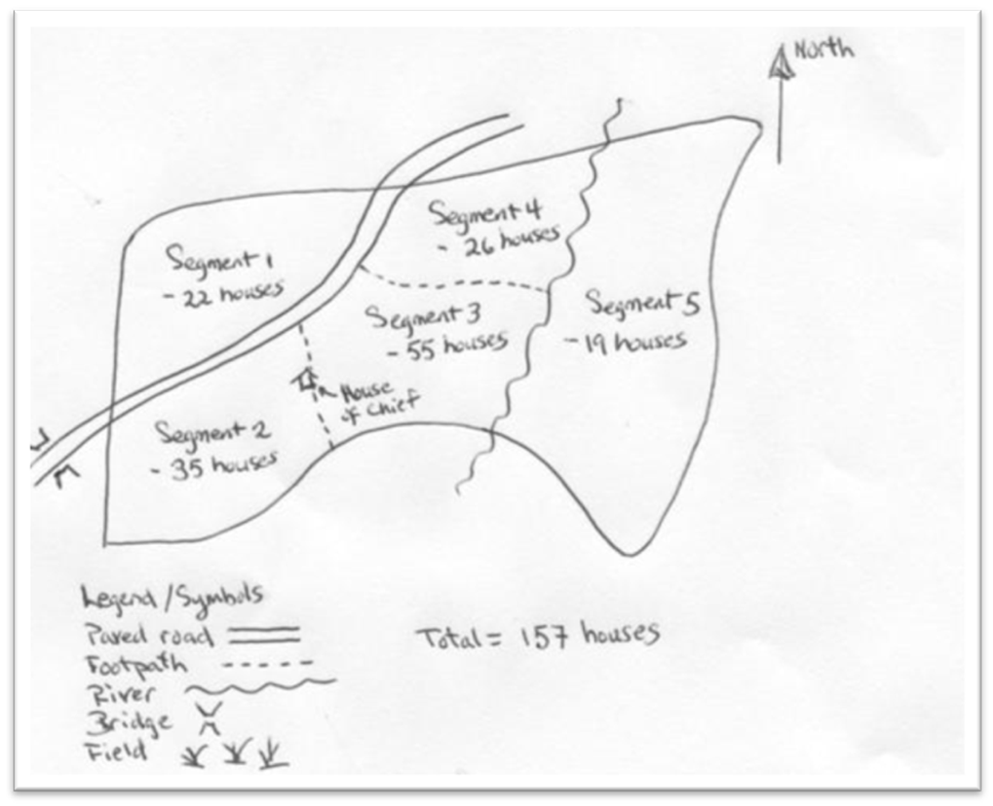
Step 2. Number the sections on the map.

Step 3. How many sections do you have? | Step 4. This is the settlement you will list:
2 | 2
3 | 1
4 | 3
5 | 4
6 | 2
7 | 5
8 | 7
9 | 3
10 | 2
11 | 1
12 | 1
13 | 12
14 | 1
15 | 5
16 | 14
17 | 16
18 | 10
19 | 4
20 | 5
21 | 18
22 | 4
23 | 20
23 | 15

