

**Long Lasting Insecticidal Net Hole Assessment**

**Facilitator’s Guide**

**NetWorks / Malaria Consortium**

**2012, revised October 1, 2015**



Final Version

Table of Contents

LLIN Hole Assessment Training Overview 1

Purpose 1

Training Objectives 1

Training Agenda 2

How to Use this Guide 4

Training Adults 7

Facilitator Responsibilities 10

Overview of Assessment of Physical Integrity of Nets 12

Background 12

LLIN Durability Studies—Review 13

Hole Assessment 13

Hole Assessment Procedure 20

Facilitator Instructions 24

Day 1 26

Session 1—Introduction to Training (40 min) 26

Session 2—Introduction to LLIN Durability Studies (60 min) 30

Session 3—Hole Assessment Template (60 min) 34

Session 4—Hole Tally Sheet (60 min) 37

Session 5—Assessing LLINs—Skills Practice (3 hours) 39

Day 2 43

Session 1—Review of Day One (45 min) 43

Session 2—Field Practice - Hole Assessment (5.5 hours) 45

Session 3—Review of Field Practice (1 hour) 49

Annex 52

Training Documents 53

Acknowledgements

This training manual is made possible by the generous support of the American people through the United States Agency for International Development (USAID) under the terms of USAID/JHU Cooperative Agreement No. GHS-A‐00‐09-00014-00. The contents do not necessarily reflect the views of USAID or the United States Government.

A special thank you to the following individuals and organizations who contributed to the development of this manual.

**Collaborating Partners**

* Albert Kilian, MD, MPH, Director M&E Malaria Consortium
* Ato Selby, MD, MPH, Networks Coordinator, Malaria Consortium Africa Regional Office
* Megan Fotheringham, MPP, MPH, Public Health Advisor, President’s Malaria Initiative, USAID
* George Greer, PhD, Senior Infectious Disease Advisor, President’s Malaria Initiative, USAID
* Matthew Lynch, PhD, Director, Global Program on Malaria, Center for Communication Programs. Johns Hopkins Bloomberg School of Public Health
* Mitra Feldman, MSc, Consultant

**Instructional Design**

* Maddy Marasciulo-Rice, BSN, MA, ACRN, Case Management Specialist, Malaria Consortium Africa Regional Office

****Training Materials****

This Facilitator’s Guide is accompanied by a set of PowerPoint slides,*LLIN Hole Assessment Training for Surveyors,* and a Surveyor Job Aid.

Acronyms

**BCC** Behaviour Change Communication

**CCP** Center for Communication Programs

**JHU** Johns Hopkins University

**LLIN** Long Lasting Insecticidal Nets

**PE** Polyethylene

**PET** Polyester

**PP** Polypropylene

**USAID** United States Agency for International Development

**WHO** World Health Organization

**WHOPES** World Health Organization Pesticide Evaluation Scheme

**Introduction**

LLIN Hole Assessment Training Overview

Purpose

This guide contains facilitator instructions for interactive training activities to train field surveyors to be able to accurately and thoroughly count the number of net holes using the *Hole Assessment Template* and *Hole Tally Sheet* following the standards foundin the World Health Organization Pesticide Evaluation Scheme (WHOPES). This Facilitator’s Guide is designed to be a stand-alone manual to train anyone conducting household surveys how to assess of the physical integrity of Long Lasting Insecticidal Nets (LLINs). This guide should be used with the *Surveyor Job Aid,* and when possible, the training PowerPoint slides.

This guide is intended to be used to supplement existing training on how to conduct a net durability study or general household surveys with a hole assessment component using the *WHO Guidelines for Monitoring the Durability of LLIN Mosquito Nets under Operational Conditions.* Therefore, it is expected that individuals attending this training have already received training on: types of surveys and aspects of durability studies; selection of survey sites; sampling; community sensitization; obtaining consent, ask household members questions using net durability or household questionnaire.

Training Objectives

During the first day of the LLIN Hole Assessment training, surveyors will learn how to:

* Accurately and thoroughly count the number of holes in LLINs.
* Measure the size of each hole using the *Hole Assessment Template.*
* Systematically record the number and size of holes on the *Hole Tally Sheet*.
* Understand the survey team roles and responsibilities during the process of assessing LLIN fabric integrity.

During the second day of training, surveyors will conduct a field visit practicum to apply the skills learned during the first day by conducting surveys in local households. One of the key objectives during the field visit practice is to ensure that surveyor teams take turns assessing the same nets and compare hole counts in order to determine whether the counting variance is within acceptable limits for QA purposes.

Training Agenda

|  |  |  |
| --- | --- | --- |
| **Day ONE** | | |
|  | **Session** | **Duration** |
|  | Introduction to the Training | 40 min |
|  | Introduction to Net Hole Assessment | 40 min |
|  | *Break* | *15 min* |
|  | The *Hole Assessment Template* | 1 hour |
|  | *Lunch* | *1 hour* |
|  | The *Hole Tally Sheet* | 1 hour |
|  | Assessing LLINs—Skills Practice | 3 hours |
| **Day TWO** | | |
|  | Review of Day 1 | 45 min |
|  | *Break* | *15 min* |
|  | Field Practice – Net Hole Assessment | 2 hours |
|  | *Lunch* | *1 hour* |
|  | Field Practice – Net Hole Assessment (cont.) | 3 hours |
|  | Review of Field Practice | 1 hour |

Training in the Classroom and the Field

The training methods and activities used throughout this guide will be practical and participatory, building on participants’ knowledge, skills and experience. In addition to the practical exercises in the classroom, such as learning to use the assessment tools and examining nets; participants will also practice using the tools in community. The fieldwork gives participants an opportunity to apply the practical skills to assess fabric integrity of nets.

Facilitators for this Training

The facilitators for this training should be:

* Able to teach others how use the *Hole Assessment Template and* *Hole Tally Sheet.*
* Able to confidently demonstrate how to use the hole assessment tools and give clear instructions.
* Able to model a high standard of quality and accuracy measuring net integrity.
* Familiar with conducting household surveys such as HMIS, DHS or MIS.
* Evaluate the participants’ hole assessment abilities and give constructive feedback.
* Plan the field practice.

Participants Attending this Training

This training is designed for anyone responsible for conducting household surveys which include the physical integrity assessment of Long Lasting Insecticidal Nets (LLINs).

In order to have enough training space, and to plan and supervise the field work, it is recommended that number of participants for each training be limited to 20 surveyors.

How to Use this Guide

This guide is designed to:

* Give the facilitator a step-by-step guide to lead participatory training activities for surveyors learning how to conduct hole assessment.
* Provide the correct answers to technical questions the facilitators will ask the participants during training.
* Involve the training participants in interactive activities to help them learn and apply new skills.
* Provide consistent content and training format for all facilitators to deliver.
* Provide guidelines for facilitator responsibilities to plan and deliver each training session.

The *Training Manual* and materials are in English. You will need to prepare for each activity and be prepared to translate sections into the local language as needed.

Sessions

There are 8 sessions in this guide. At the beginning of each session there is a table which includes an overview of expected outcomes, the session learning objectives, suggested activities, duration and training methods used, a list of materials required to facilitate the session, advance preparation that the facilitator will need to do, and the facilitator steps the facilitator should follow to train the session.

**Title (approximate length of the session)**

|  |  |  |  |
| --- | --- | --- | --- |
| **Expected Outcomes** | | | |
| The expected outcomes or purpose of the session. | | | |
| **Learning Objectives** | | | |
| What the participants should be able to learn, know, say or do by the end of the session. | | | |
| **Session Activities** | | | |
| **Session** | **Title of Activity** | **Duration** | **Instructional Method** |
| 1.1 | Introduction | 10 min | Presentation |
| 1.2 | Hole Assessment Template | 45 min | Demonstration and Practice |
| **Materials** | | | |
| The resources, equipment and materials the facilitator will need to train the session activities. | | | |
| **Preparation** | | | |
| What the facilitator must do or prepare ahead of time for the session to be successful. | | | |

Facilitator Steps

Following the session table are the steps the facilitator will follow to conduct the training activities. Each step is numbered and begins with a verb to indicate what the facilitator should do:

* ASK—Questions the facilitator will ask the plenary group. Each question is written in ***bold italics.*** After each question there is a highlighted list of possible correct answers. After asking a question, encourage the training participants to freely answer. The facilitator may need to repeat the correct answers to reinforce the content.
* EXPLAIN—this means that the facilitator will need to explain a concept or give more information on the topic. The facilitator will need to know the content; therefore it is important to be well prepared by reading the information in the *Introduction* of this manual
* SAY—Information the facilitator will state aloud. The facilitator will need to say the words that are written in ***bold italics****.*
* INSTRUCT—this means that the facilitator will be giving the training participants instructions to follow.
* SHOW—this means that the facilitator will demonstrate how to do an activity or role play with the co-facilitator so that the participants can see how it is done. For example, the facilitator will show how to assess different net hole types.
* GIVE—this means that the facilitator will be giving the participants a handout document or an item they will use to during an activity such as the hole tally sheet.
* INVITE—this means that the facilitator will request participants to volunteer to participate in an activity.
* DIVIDE—this means that the facilitator will be breaking up the training participants into small groups or pairs for a group discussion or activity.

Instructional Symbols

The facilitator steps are accompanied by symbols to help the facilitator quickly find the facilitator place in the manual. The symbols represent the type of instructional method used during each session. The following is a key to the symbols:

|  |  |
| --- | --- |
|  | **Plenary**  Presentation of information given to the entire group or a question and answer discussion where questions are posed to the large group about the topic. |
|  | **Small Group Discussion**  An activity that involves breaking up the participants into small groups 2 to 8 people to discuss a topic, question or a problem. |
|  | **Skill Building Activity**  Instructions for a training activity such as a role play, skill practice, or review game. |
|  | **Demonstration**  The facilitator demonstrates how to do a skill either by role-playing a scenario or by showing how to do a skill correctly with the co-facilitator and then asking the participants to do the same. |
|  | **PowerPoint Presentation**  The facilitator will use the key talking points to present the content in the PowerPoint slides. If PowerPoint is not possible, the content on the slides can be transferred to flipchart paper. |
|  | **Facilitator Tip**  Additional useful information or hints for the facilitator to train the activity. |

Annex

At the end of this manual is an Annex containing documents and information to facilitate the activities in each session.

Methods for Instruction

This course is designed to build upon the participants’ knowledge and experience and to be relevant to their needs and the needs of their communities. It uses a variety of training methods including written exercises, practical exercises in small groups, discussions, role-plays, practice, case studies and field application.

These methods give participants a thorough overview of concepts and protocols. The course structure is designed to challenge participants to come up with their own solutions to problems. The practical field component will reinforce theory learned in the classroom and give participants an opportunity to develop the practical skills required to implement services. Descriptions of methods and guidance for conducting trainings with adult learners appear at the end of this module. Participants also serve as resources for one another. Respect for individual trainees is central to the training, and sharing of experiences is encouraged throughout.

Optional PowerPoint Slides

Accompanying this manual is an optional set of PowerPoint slides*, LLIN Hole Assessment for Surveyors*, which can be used to visually support the training if power, a projector and a lap top computer are available. The slides contain talking points, in the notes section. If power is not available, the information on the slides can be written on a flipchart as needed.

Surveyor Job Aid

Surveyors will be given a laminated color *Surveyor Job Aid*. The Job Aid is intended to be used during the training to reinforce key content, and also after training to help the surveyors remember the steps of measuring and tallying the holes. The Job Aid contains instructions for using the *Hole Assessment Template* and the *Hole Tally Sheet*. The Job Aid also contains visual reinforcement of the information presented in the training (and the PowerPoint slides) such as pictures of LLIN hole types.

Training Adults

Adults prefer a learning environment where they **feel valued** and respected for their experiences. As a facilitator you should give positive reinforcement when they contribute.

Adults prefer **learning to be active** rather than passively sitting and listening to you. It is important that you give participants opportunities to participate in a variety of activities such as discussions, review games, role play, and case studies.

Adults will be **actively engaged in learning** if they can see how the training will meet their needs. As a facilitator it is important to identify the participants’ expectations for he training and to explain how the training content will be of benefit to them when they are conducting their duties as a surveyor.

Adults have **varied learning styles.** Some adults learn best visually, others learn best by listening and still others by doing. Use a variety of training methods in order to accommodate all learning styles.

Adults learn new content when it relates to something they already know. **Link new content to existing content** by analogies or stories.

Adults appreciate having an opportunity to **apply what they have learned** as soon as possible. Make sure to give all participants a chance to practice new skills.

Adults will learn and remember content when it is **reinforced with repetition**. Try to repeat key concepts **at least 6 times**, but vary the context if possible to show different applications.

Adults are motivated by **positive encouragement.** Be sure to reward the participants with positive feedback and express appreciation when they participate.

The **adult attention span is between 8 and 12 minutes**. To keep participants attentive, change the activity every 10 to 20 minutes and take a break approximately every 90 minutes.

Participatory Training Methods Used in this Training

|  |  |
| --- | --- |
| **Case Studies** | A case study is a written description of a hypothetical or imaginary situation that is used for analysis and discussion. It is a detailed account of a real or hypothetical occurrence (or series of related events involving a problem) that surveyors might encounter in real life. It is analyzed and discussed. Surveyors are often asked to arrive at a plan of action to solve the problem. |
| **Demonstration** | A demonstration shows the skills needed to successfully perform a particular task or technique. The trainer or a participant demonstrates the task, describing each step and explaining the skills needed and the reasons for performing it in a particular way. It is often followed by a practice session where the surveyors perform the activity under the supervision of the trainer.  Before you conduct a demonstration, arrange the necessary equipment, and practice the skill. Allow sufficient time for surveyors to practice in pairs or in small groups.  Simulated scenarios help surveyors practice how they would respond in real life. Surveyors respond to a simulated scenario without prior notice of what the situation will be. |
| **Dividing Participants into Small Groups** | In order to get surveyors involved in activities and discussions, break them into small groups. This allows for physical activity, gets surveyors engaged, and allows them to socialize with different groups of surveyors. You can divide the groups by counting, or by distributing different colored objects, types of leaves or strips of paper with group names.  It is usually a good idea to assign a group leader to lead the group through the activity, take notes, and report the group’s responses to the larger group. |
| **Energizers** | Energizers are designed to boost energy in a group of surveyors who have been sitting and listening for a long period of time. Energizers are short, about 2 to 4 minutes in length, and should include physical activity, laughter, and diversion. Surveyors should stand up and move around during an energizer. As a general rule, energizers should be chosen with sensitivity to the cultural, gender and religious norms of the group. |
| **Icebreakers** | Icebreakers are intended to “break the ice.” They should be designed so that surveyors get to know each other better. Icebreakers will help surveyors relax and get them talking to each other. Icebreakers are all about the audience. As the trainer your role is to facilitate the process, not to talk about yourself. |
| **Plenary** | A plenary is when the entire group comes together to share ideas. As a trainer it will be important to gain participation from as many surveyors as possible. One of the easiest ways to get people involved is by asking for a show of hands if they agree or disagree. You can ask them to stand, stamp their feet or walk to either side of the room. Another way to get surveyors involved is to **ask questions,** and to encourage them to ask their own questions or to make comments in return. The group will look to you for guidance and instructions. Be prepared to give clear instructions, and to ask for feedback about how well you are doing. |
| **Presentations** | A presentation or lecture can provide information, theories or principles quickly and easily. Presentations can range from a lecture to some participant involvement through questions and discussion. Whenever possible, ask the surveyors questions to encourage participation and focus their attention. |
| **Review** | Reviewing content reinforces important information and helps surveyors remember information and skills. Reviewing also helps the trainer to evaluate how well surveyors understand the material. To have fun and excitement with the learning process, consider using games to review content that you want the surveyors to remember. |
| **Role-Play** | Role-playing allows surveyors to act out situations that they might encounter in real life. It helps surveyors to practice skills, solve problems, and gain insights into attitudes, values, and perception held by others. Role-plays are often improvised with Instructions, guidelines, and roles provided by the trainer. If possible, a few props are recommended such as a clipboard, uniform, or name tag in order to help establish the scene. It is a good idea to debrief after a role-play and reflect on the experience. |
| **Visual Aids** | Visual aids are important for communicating concepts and diagrams. Pictures or drawings are helpful for audiences with limited literacy. Visual aids provide color and help with memory retention. There are many kinds of visual aids that can be used in a training setting. Some examples of easy to use visual aids are flipchart paper with color markers. Avoid using red markers to write text on flipcharts because it is difficult to read. |

Facilitator Responsibilities

As a Facilitator for this training you will need to:

* Be skilled in demonstrating all the tasks expected to perform.
* Explain the training content in words and ways surveyors will understand.
* Allow enough time for participants to practice newly acquired skills during training and give them feedback so they can continually improve.
* Be well-organized and give clear explanations and instructions.
* Repeat instructions and key messages often.
* Use active listening skills.
* Guide and motivate participants during and after training.
* Mentor participants by reinforcing the training content during targeted supervision visits.
* Commit to doing quality work.

Preparation and Planning Before Training

Successful training begins with thorough preparation. It is important that as a Facilitator you take the time to plan the training in order to secure a location for conducting the training, invite the participants to the training, and obtain the needed equipment and materials to train.

The following checklist will help to prepare you for the training:

* READ and understand the content of this *LLIN Hole Assessment Facilitator Guide.*
* Prepare the list of participants with names and contact information.
* Secure a location to deliver the training for the selected training dates:
  + Select a training space with room for a total of 20 participants to stretch out nets.
  + Ensure you have electric power or arrange for a generator and fuel.
  + Select space with good lighting and ventilation.
  + Request the training room is set-up so that it allows participants to interact with one another.
  + Secure enough chairs and tables.
  + Confirm lunch and tea breaks.
* Invite the participants to the training.
* Prepare all the needed resources and materials needed for each session including ten (10) LLINs with a variety of hole sizes and hole types.
* Arrange with local households to conduct the field practice on Day 2.
* Request per diem for all training participants.
* Rehearse all of the training session activities.

Training Materials

Part of being a prepared facilitator is to make sure you have all the training materials and resources needed for each day of training and in sufficient quantities. Throughout the training the following training resources and materials will be used:

* Facilitator Guide (1 for facilitators only)
* Laminated *Surveyor Job Aid* (1 for each participant)
  + Laminated *Hole Assessment Template* (included in the Surveyor Job Aid)
  + Laminated *Hole Tally Sheet (*included in the Surveyor Job Aid)
* Erasable markers for laminated Tally Sheet
* Paper (non-laminated) Tally Sheets for practice (25 per participant)
* Sample questionnaire to enter data from Tally Sheet (25 per participant)
* Sample LLINs with holes of various sizes and types (minimum 10, best 25 nets)
* Blue Pens (1 for each participant)
* Clipboard (1 for each participant)
* Flipchart paper (1 ream)
* Flipchart markers (1 box)

Optional:

* PowerPoint slides
* LCD Projector
* Laptop

Overview of Assessment of Physical Integrity of Nets

Background

Long Lasting Insecticidal Nets (LLINs) play a significant role in the prevention and control of vector-borne diseases, especially malaria. LLINs have been proven to reduce malaria cases and deaths, and all-cause childhood mortality,[1] LLINs are now distributed through large-scale campaigns to meet World Health Organization (WHO) recommendations of Universal Coverage, with the aim that all men, women and children at risk of malaria have access to an effective malaria prevention tool.[2]

In many current LLIN distribution programs, it is assumed that LLINs have a relatively uniform lifespan of about 3 years. Thus, it is often assumed that mass distribution campaigns at 3-year intervals are enough to maintain adequate levels of net coverage throughout the 3-year interval. However, of concern is their useful life, and the recognition that LLINs vary in degree of material durability (physical strength) in differing contexts: between regions, between households, and within a household[3]

The WHO has now produced guidelines for monitoring the durability of LLINs under operational conditions that will produce data on how different brands perform while under field use. The results from this monitoring will enable countries and agencies that procure LLINs, and donors who fund them, to make appropriate decisions on what are the most suitable LLINs for their context.[4]

Currently World Health Organization Pesticide Evaluation Scheme (WHOPES) approved nets are made of Polyethylene (PE), Polyester (PET) coated with approved insecticides, or Polypropylene (PP) treated with a pyrethroid insecticides [5]

LLIN Durability Studies—Review

Country programs planning for long-term coverage with insecticide-treated nets need information on the durability of different net products in order to select and procure the best nets for their specific settings and needs. Knowledge about the durability of LLINs after distribution is needed in order to estimate the necessary rate of replacement in continuous distribution systems and/or the appropriate interval between campaigns.

Monitoring of the durability of nets may lead to better understanding of the factors that determine LLIN durability. It can also provide an opportunity to improve Behavior Change Communication (BCC) messages so that users take better care of their nets.

Hole Assessment

Durability Assessment Surveys

Durability studies involve the implementation of a standard household questionnaire (survey). In addition to asking questions related to the usage, fate and maintenance of LLIN, the survey also requires a physical inspection of all nets in the household. The purpose of the inspection is to assess the net fabric in order to estimate its durability. The two main components that need to be considered when estimating the durability of LLIN fabric are:

1. Attrition—the proportion of LLINs which are no longer in use as intended after a defined period after distribution to the household. This may be due to loss, damage, given away or other reasons.
2. Physical integrity—the number, location, size and type of hole(s) in each net. This requires counting the number of holes in each net by their location on the net and by their size.

This guide only addresses the assessment of the physical integrity while the attrition is captured in the household interview part of the survey.

Parts and Shapes of Nets

LLINs are either rectangular or conical in shape. The hole assessment questionnaire will have a question about the shape of the LLIN.

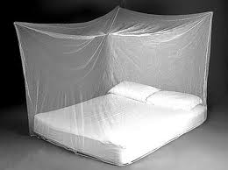 

Rectangular shape Conical shape

A rectangular mosquito net has five sections: four sides and a roof. There are two long sides and two short sides:

* The long side of the net refers to the side of the net with a loop or tie half way down its length.
* The short side of the net usually goes at the head and foot of the sleeping space and does not have a tie or loop half way down.



The brand label or tag can usually be found along one of the seams.

A conical net also has a roof which is much smaller than for a rectangular net and the side is a single piece of netting without sub-divisions.

Hole Types

There are many ways that an LLIN can acquire holes. Some can be cause by tears, burns, seam failure or animal bites. The cause may differ depending on the local context, such as:

* Local context and climate
* Construction of the house (shape and building materials) and sleeping place (bed, mat etc.)
* Rodents (rats or mice)
* Proximity of the LLIN to fire
* LLIN washing and maintenance practices
* Number of and age of persons using the LLINs

The appearance and location of the holes will differ based on what caused the destruction and what material that the LLINs are made of. The following are examples of some of the typical different hole types, locations and repairs that may be encountered while assessing nets for damage.[6]

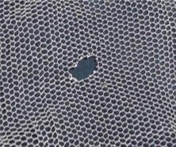 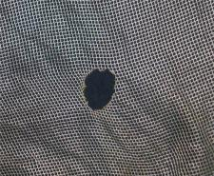

1. **Burn Hole PET 2. Burn Hole PE**

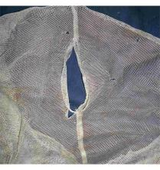 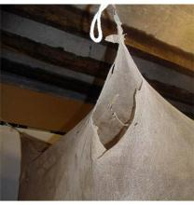

1. **Open Seam Hole 4. Torn Corner Hole**

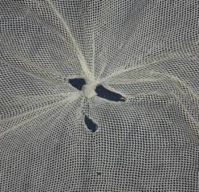 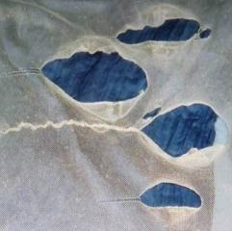

1. **Repair Knotting 6. Repair Stitching**

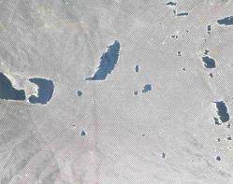 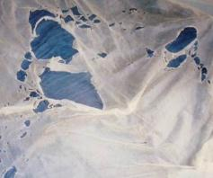

**Multiple holes: A challenge to count with so many different sizes**

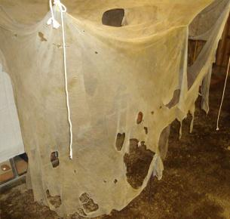

**Huge part of the LLIN missing.**

Hole Categories

Net holes are measured in 4 categories, as recommended by the WHO Guidelines of LLIN durability monitoring. The categories of hole sizes are described in Table 1.

**Table 1**

|  |  |  |
| --- | --- | --- |
| **Category of Hole** | **Hole Size Description\*** | **Hole Size** |
| **Size 1** | Smaller than a thumb (finger) | 0.5 — 2 cm diameter |
| **Size 2** | Larger than a thumb but smaller than fist (hand) | 2 — 10 cm diameter |
| **Size 3** | Larger than a fist but smaller than a head (head) | 10 — 25 cm diameter |
| **Size 4** | Larger than a head | > 25 cm diameter |

* *the description only serves as a general orientation, not as the actual measurement.*

Source: World Health Organization. Guidelines for monitoring the durability of long-lasting insecticidal mosquito nets under operational conditions. (2011)

Hole Assessment Template

The *Hole Assessment Template* is designed tohelp surveyors measure the size of different net holes and determine the size of each hole in a LLIN. The *Hole Assessment Template* contains diagrams of 3 circles that measure the exact diameter of the hole sizes. The template contains the diameter for hole size categories 1, 2, and 3. Size 4 holes are measured by using the length of the 25 cm line at the top of the template.

The *Hole Assessment Template* is printed and laminated on A4 paper. A copy of the template can found on **page 54** of this guide. A smaller example of the Template can be found below in Figure 1.

**Figure 1**

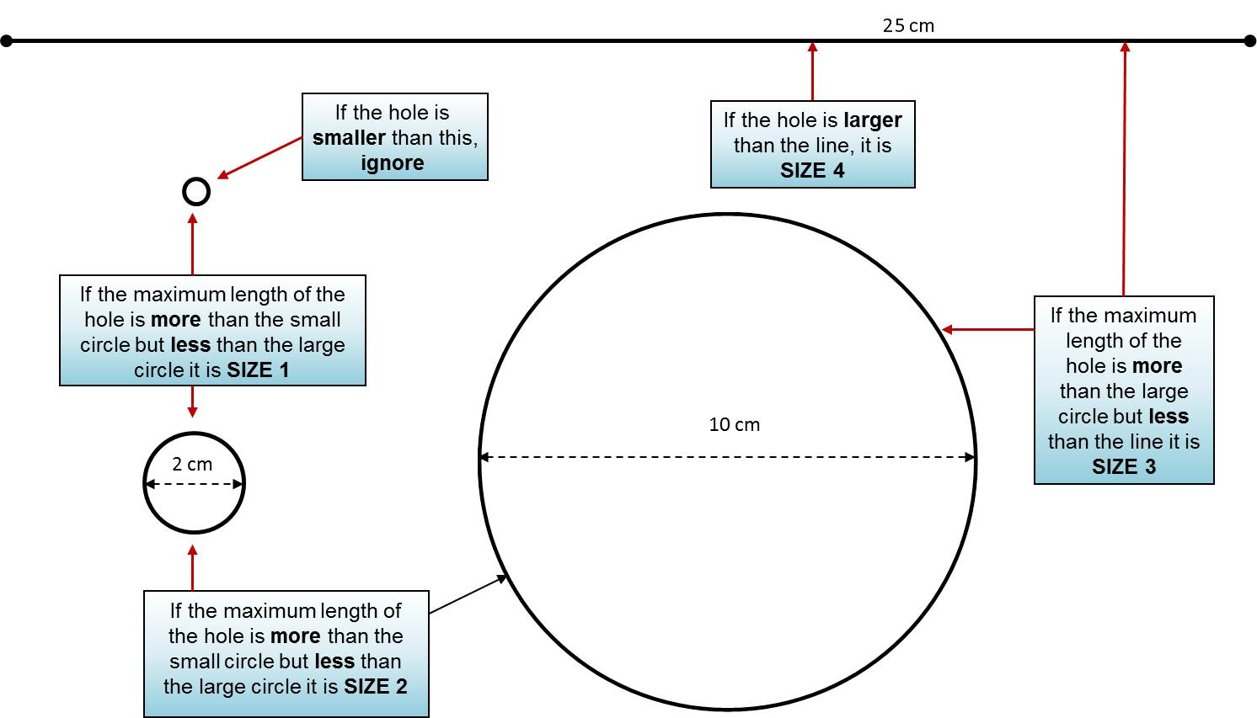

Hole Tally Sheet

The *Hole Tally Sheet* is used to keep track of the total number of holes found on each side of the net. It is especially useful when counting holes for LLINs with many holes. When there are very few holes the counting is easy. Practice is necessary to develop expertise in accurately counting holes.

The *Hole Tally Sheet* is divided by thefive sections of the rectangular net: 2 short sides, 2 long sides, and the roof (for conical nets only the roof and one side is used). Each section has tally marks for all 4 hole size categories. Each hole size category has 20 circles that are filled in with each hole identified. The *Hole Tally Sheet* can found on **page 55** of this guide. A smaller example of the Template can be found below in Figure 2.

**Figure 2**

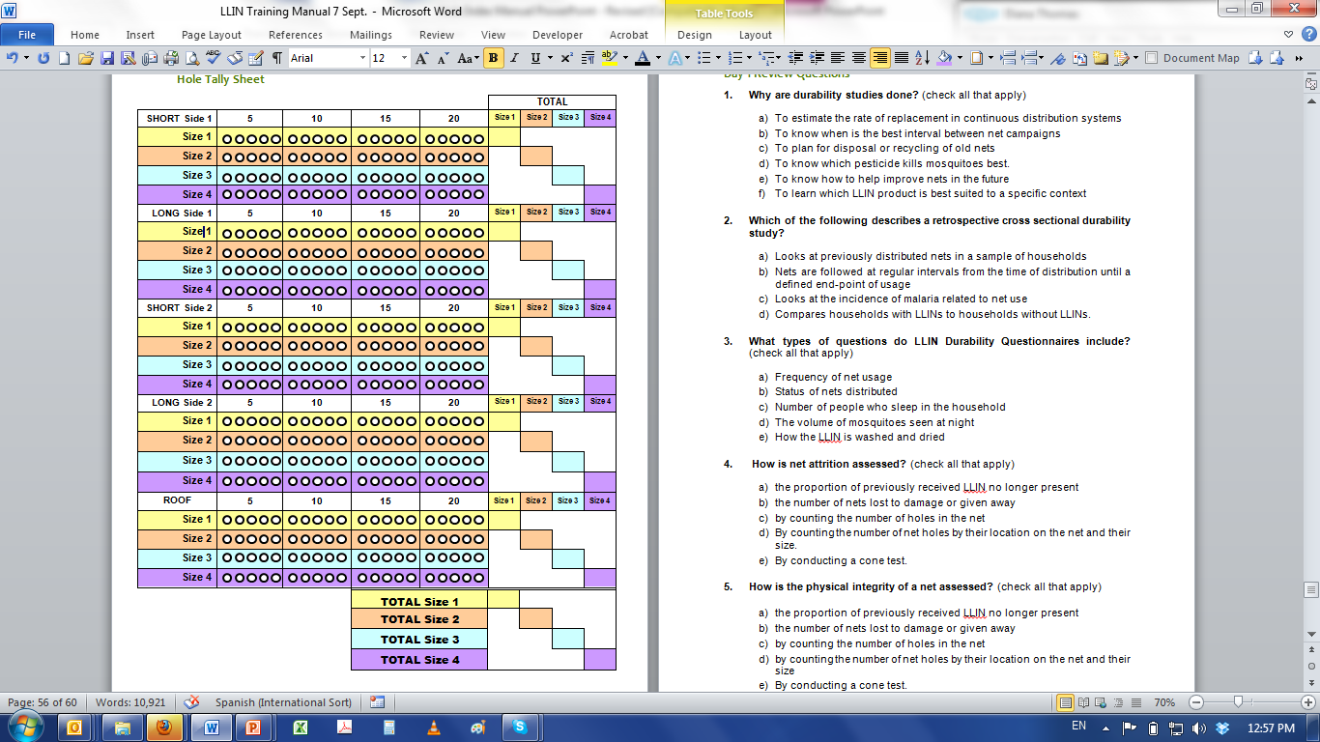

Hole Assessment Procedure

Surveyors work in teams of two surveyors. One surveyor is responsible for recording the number and size of the holes. One surveyor is responsible for counting the holes. Household members should be encouraged to assist by holding the nets by their corners.

Using the Hole Assessment Template and Tally Sheet

1. Identify if the LLIN is hanging over the bed or sleeping place. Unfold or untie the LLIN so that all sides are easily visible, and holes can be easily counted and measured. If the net is not hanging, take it to a place with sufficient room and light (but also some privacy). The net should be held up by two people by the “hanging loops”. Conical nets are held at center of the roof.

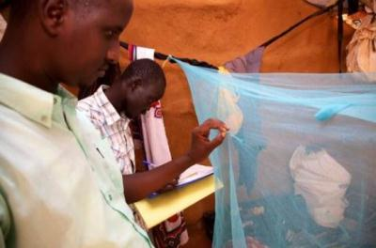

LLIN Durability Survey at Dadaab Refugee Camp — Assessing for holes. Image S. Hoibak / UNHCR

1. Identify the LLIN brand name on the tag.

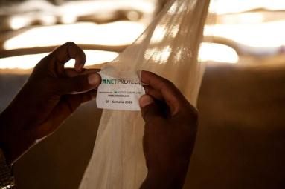

1. Start the net inspection on the **Short Side** next to the net label. (For Conical nets start at the net tag and work your way around the net. Fill in only the first part of the tally sheet).
2. Begin by counting the number of **Size 1 holes** on the short side of the net using the *Hole Assessment Template* by holding the template behind the hole.

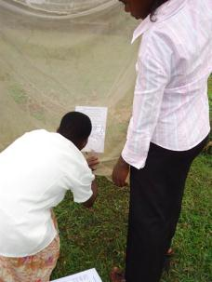

1. Mark the number of **Size 1 holes** on the tally sheet by filling in the corresponding circle on the sheet.
2. Count the number of **Size 2 holes** on the same side. Count the number of **Size 3** **holes** and then **Size 4 holes**. Mark the number of Size 2, 3 and 4 holes on the tally sheet by filling in the corresponding circle on the sheet.
3. Move to the **Long Side** of the LLIN (next to the net label) making sure not to double count holes just at the border between the two sides.
4. Repeat the procedure for the **Long Side** and fill in the corresponding circles for the number of Size 1, 2, 3 and 4 holes on the tally sheet.
5. Repeat the procedure for the **other short and long side**, and the **roof**.
6. When all sides are finished, count the total number of filled circles in each row (size category) for all five sections and enter the number in the “Total” box.

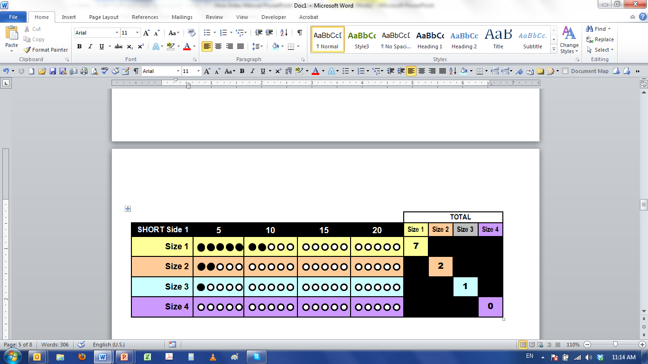

1. Add up all Size 1, Size 2, Size 3 and Size 4 holes at the bottom right of the tally sheet.
2. Record the total numbers on the LLIN durability questionnaire. Once the data is recorded the laminated tally sheet is wiped clean and ready for use for the next net.

The following circumstances require different recording:

* Open seams are treated as holes and measured by the length of the open area.
* A hole that is fully repaired (completely closed) is NOT counted as a hole.
* If large parts of the net are missing so that counting of size 4 holes is not possible the result is coded as 98 for size 4.

Duration of Hole Assessment

The duration of the hole assessment process will depend on the number of LLINs found, the condition they are found in, and how many holes there are in the LLINs. On average it should take approximately 5-7 minutes to complete an assessment of one LLIN.

Sureveyor Responsibilities

LLIN durability surveys are conducted by surveyors trained in conducting household questionnaires, assessment of net integrity and record keeping. Surveyors work in pairs (teams of 2) to assess LLIN durability.

Surveyors are responsible for the following activities when conducting a durability survey:

* Introducing themselves to the household and explaining the purpose of the survey.
* Informing household that all information collected will remain confidential and that participation is completely voluntary, with no negative effects for non-participation.
* Obtaining consent to enter the home and see the nets.
* Asking the questions on the survey questionnaire and recording the answers.
* Identifying the LLIN, and putting it in a position that makes it easy to see and count the holes.
* Counting the number of holes and determining their type.
* Measuring the size of the holes.
* Recording the number and size of holes on the assessment hole tally sheet.
* The household member answering the questionnaire will be encouraged to assist with holding the nets to facilitate and ease the counting of holes.
* The hole assessment portion of the questionnaire should ideally be answered by the person who uses the net in question. If they are not available, the questions can be answered by any adult in the household.

Throughout the survey it is important the surveyors should remember they are representing their organization. Their conduct must always be professional. It is important they are friendly and cooperative with respondents, and recognize that they are entering the respondent’s home and handling their personal objects.

* Surveyors must act in a respectful way towards the respondent and their property
* The team must work together to support each other to identify, measure, count and record holes accurately.
* The data gathered during the survey must be accurate and valid. Spot checks by supervisors will be performed to validate this.

Hole Assessment Materials Checklist

When leaving for the field each survey team should have the following items:

* Blue Pens
* Clipboard
* *Surveyor Job Aid*
  + *Hole Assessment Template*
  + *Hole Tally Sheet*
* Erasable markers
* Questionnaires
* Bag to carry questionnaires

**Facilitator Instructions**

Day 1

Session 1—Introduction to Training (40 min)

|  |  |  |
| --- | --- | --- |
| **Expected Outcomes** | | |
| During this session participants will get to know each other, learn the objectives for the training and share their expectations for the 2 days of training. Participants will understand what content will be delivered during the 2 days agenda and that the second day of training will consist of a field practice in the community to apply the knowledge and skills learned during the first day in the classroom. Participants will be given the *Surveyor Job Aid* and introduced to its purpose. | | |
| **Learning Objectives** | | |
| *At the end of this session, participants will be able to:*   * Know each other’s names and interests. * Know what to expect during the training. | | |
| **Session Activities** | | |
| **Activity** | **Minutes** | **Method** |
| Arrival and Registration | | |
| * 1. Getting to Know Each Other | 15 | Icebreaker |
| * 1. Expectations for Training | 15 | Brainstorm |
| * 1. Training Agenda | 10 | Presentation |
| **Materials** | | |
| * Daily Training Attendance Register; see **page 53** * Flipchart paper * Marking pens * *Surveyor Job Aid* (1 laminated A4 copy per participant) * PowerPoint slides, Overhead Projector, Laptop (optional) | | |
| **Preparation** | | |
| * Arrive to the training one hour before the start to set up the room. * Thoroughly read and be prepared to explain **pages 1 to 12** of this guide. * If it is not possible to display the PowerPoint slides; prepare a flipchart with the Training Agenda, see **page 2** of this guide. | | |

Arrival and Registration

|  |  |
| --- | --- |
|  | 1. Greet the participants as they arrive to the training room. 2. Instruct the participants to complete the *Daily Training Attendance Register* and take a seat. |

1.1—Getting to Know Each Other (15 min)

|  |  |
| --- | --- |
|  | 1. Welcome the participants to the 2-day training. 2. Introduce yourself and any other facilitators. |
|  | 1. EXPLAIN that you will begin the training with an icebreaker activity so the participants can get to know each other. 2. INSTRUCT the participants to form 2 circles, one inside the other. 3. INSTRUCT the participants to face each other. 4. EXPLAIN that the participants will be introducing themselves to the person standing in front of them by sharing the following information:  * Their name. * Where they live. * Their experience as a surveyor. * How many of their family members sleep under an LLIN.  1. INSTRUCT each participant to introduce themselves to the person standing in front of them. 2. After 1 minute, clap, and ask the outer circle to move to 2 steps to the right. INSTRUCT the inner circle to remain where they are. 3. INSTRUCT the participants to introduce themselves to the new person they are facing. 4. Repeat until the outer circle has completed one full round. 5. INVITE the participants to sit and thank the participants for their participation. 6. Encourage participants to meet and introduce themselves to 2 more participants during the tea break. |
|  | **Facilitator Tip:** If there are more than 20 participants in the training room, you will need to form 2 sets of inner and outer circles in order to complete the icebreaker activity in time. |

1.2—Expectations of the Training (15 min)

|  |  |
| --- | --- |
|  | 1. EXPLAIN the objectives of the LLIN Hole Assessment Training is to ensure surveyors are able to:  * Accurately and thoroughly count the number of holes in LLINs. * Measure the size of each hole using the *Hole Assessment Template.* * Systematically record the number and size of holes on the *Hole Tally Sheet*. * Understand the survey team roles and responsibilities during the process of assessing LLIN fabric integrity. |
|  | 1. DIVIDE the participants into groups of 4 people each. 2. ASK each group to nominate a group leader. 3. INSTRUCT the participant groups to discuss with each other what they expect to learn from the training. 4. Allow 5 minutes for the small group discussion. 5. INVITE each group leader to share what was discussed in their group for the plenary. 6. Write their responses on the flipchart. 7. Clarify any expectations that are not in line with what the training will cover. |
|  | **Facilitator Tip:** Save the flipchart of participant expectations for review at the close of training on Day 1. |

1.3—Training Agenda (10 min)

|  |  |
| --- | --- |
|  | 1. EXPLAIN the 2–day Agenda. 2. Refer to the flipchart of participant expectations and describe how their expectations will be met during the course of the training. 3. EXPLAIN that each participant will be getting *Surveyor Job Aid*. 4. SAY: ***The Job Aid will be used during the training to reinforce key content. It contains instructions for using the Hole Assessment Template and the Hole Tally Sheet.*** 5. SAY: ***The Job Aid also contains the laminated copies of the Hole Assessment Template and the Hole Tally Sheet you will use during the net assessment survey.*** 6. GIVE each participant a *Surveyor Job Aid*. 7. EXPLAIN that on Day 2 the participants will be spending time in the field practicing what they learn today. 8. EXPLAIN that participants will work in pairs or teams of two and will be visiting local households to practice counting LLIN holes and recording. 9. EXPLAIN that a minimum of 15 LLINs must be assessed by each team during the field practice activity. 10. EXPLAIN that a supervisor will accompany them to provide feedback and assistance. 11. EXPLAIN administrative and logistic information including, payment of per diems, meals and transportation. 12. Answer questions as needed. |

Session 2—Introduction to LLIN Durability Studies (60 min)

|  |  |  |
| --- | --- | --- |
| **Expected Outcomes** | | |
| It is expected that during the session participants will review the purpose and types of LLIN durability studies and surveys. Participants will be introduced to the types of and parts of the nets and the various types of net holes and how they can be acquired. Participants will be able to view and touch examples of nets with various types of holes. | | |
| **Learning Objectives** | | |
| *At the end of this session, participants will be able to :*   * Refresh their knowledge of LLIN durability studies. * Identify the parts of a rectangular net. * Recognize various types of net holes and their probable cause. | | |
| **Session Activities** | | |
| **Activity** | **Minutes** | **Method** |
| 2.1 Overview and Background | 20 | Presentation |
| 2.2 Parts and Shapes of Nets | 10 | Demonstration |
| 2.3 Net Hole Types | 30 | Presentation and Demonstration |
| **Materials** | | |
| * *Surveyor Job Aid* * Damaged nets with a variety of hole types (PE and PET nets) * Flipchart paper and markers * PowerPoint slides, Overhead Projector, Laptop (optional) | | |
| **Preparation** | | |
| * Thoroughly read and be prepared to explain **pages 12 to 23** of this guide. * Ensure you enough damaged LLINs each with a variety hole types so that the participants can distinguish between the types of holes (burns, tears, repairs, multiple holes) | | |

2.1—Review Background of Durability Studies (20 min)

|  |  |
| --- | --- |
|  | 1. ASK: ***Why are LLIN Durability studies are needed?***   To learn about the durability of LLINs after distribution is needed in order to estimate:   * Rate of replacement in continuous distribution systems * Appropriate interval between campaigns * Plan for disposal or recycling of old nets * How to help improve products in the future * Which LLIN product is best suited to the specific context  1. ASK: ***What are the 2 types of durability studies?***  * Prospective longitudinal * Retrospective cross sectional  1. EXPLAIN the difference between each type of study. 2. EXPLAIN the purpose of LLIN Durability Surveys.  * Assess economic status of households. * Include questions related to the usage, fate, and maintenance of LLIN. * Inspection of the nets.  1. EXPLAIN the 2 components of LLIN Durability.  * **Attrition—**the proportion of previously received LLIN no longer present lost to damage or other reasons, given away which is captured in the household interview. * **Physical Integrity—**which requires the counting of holes in the net.  1. Review the WHOPES recommended LLINs:  * Polyethylene (PE) * Polyester (PET) * Polypropylene (PP) |

2.2—Parts and Shapes of Mosquito Nets (10 min)

|  |  |
| --- | --- |
|  | 1. Review the shapes of mosquito nets.    * Rectangular    * Conical 2. EXPLAIN where the type of net is recorded on the questionnaire. 3. EXPLAIN the five sections of a rectangular net:  * 2 long sides * 2 short sides * Roof |
|  | 1. INVITE 2 participants to come to the front of the classroom to help hold up an LLIN. 2. SHOW participants the 5 sections of the rectangular net using the LLIN.    * **Long sides**—the side of the net with a loop or tie half way down its length    * **Short sides**—usually goes at the head and foot of the sleeping space and does not have a tie or loop half way down    * **Roof** 3. Review the *parts of net* found on **page 1** of the *Surveyor Job Aid.* |

2.3—Net Hole Types (30 min)

|  |  |
| --- | --- |
|  | 1. ASK: ***What are some factors that can contribute to LLINs getting holes?***    * Local context and climate    * Construction of the house (shape and building materials) and sleeping place (bed, mat etc.)    * Rodents (rats or mice)    * Proximity of the LLIN to fire    * LLIN washing and maintenance practices    * Number of and age of persons using the LLINs 2. EXPLAIN where holes can appear on different parts on the LLIN including corners or seams. 3. SHOW the different types of net hole that can be found:    * Burns    * Tears—seam and corner    * Partially repaired holes    * Multiple holes    * Huge parts of the net missing 4. Review the *different types of net hole*s found on **page 2** of the *Surveyor Job Aid.* |
|  | 1. GIVE participants examples of LLINs with various types of holes. 2. EXPLAIN the difference between PE and PET nets. 3. SHOW examples of seam holes and corner holes; tears and burns; knotted and stitched repairs; too many holes to count. 4. Allow all participants time to examine each LLIN and familiarize themselves with the different types of net holes. |

**Take a 15 minute break**

Session 3—Hole Assessment Template (60 min)

|  |  |  |
| --- | --- | --- |
| **Expected Outcomes** | | |
| Participants will learn how net holes are categorized into 4 sizes by the WHO Guidelines of LLIN durability monitoring. They will be introduced to the purpose of the *Hole Assessment Template* and how it is used during the LLIN hole assessment. Participants will practice measuring a variety of hole sizes using the *Hole Assessment Template* on damaged nets. | | |
| **Learning Objectives** | | |
| *At the end of this session, participants will be able to:*   * Describe the 4 hole categories as recommended by the WHO Guidelines of LLIN durability monitoring. * Understand the purpose of the *Hole Assessment Template.* * Accurately use the *Hole Assessment Template* to measure the size of holes on LLINs. | | |
| **Session Activities** | | |
| **Activity** | **Minutes** | **Method** |
| 3.1 Net Hole Categories | 15 | Presentation |
| 3.2 Introduction to the *Hole Assessment Template* | 15 | Presentation |
| 3.3 Using the *Hole Assessment Template* | 30 | Demonstration and Practice |
| **Materials** | | |
| * *Hole Assessment Template* (found in the *Surveyor Job Aid*) * Damaged nets with a variety of hole sizes * PowerPoint slides, Overhead Projector, Laptop (optional) | | |
| **Preparation** | | |
| * Ensure you have enough damaged LLINs each with a variety hole sizes so that the participants can practice using the *Hole Assessment Template* to measure hole sizes 1, 2, 3 and 4. | | |

3.1—Net Hole Categories (15min)

|  |  |
| --- | --- |
|  | 1. EXPLAIN that net holes are measured in 4 categories, as recommended by the WHO Guidelines of LLIN Durability Monitoring. 2. EXPLAIN the description and the diameter size for each hole category. 3. SHOW the participants where they can find the *hole categories* in their *Surveyor Job Aid*. |

3.2—Introduction to the *Hole Assessment Template* (15 min)

|  |  |
| --- | --- |
|  | 1. INSTRUCT the participants to find *Hole Assessment Template* in their *Surveyor Job Aid.* 2. EXPLAIN that the *Hole Assessment Template* is designed tohelp surveyors measure the size of different net holes and determine the size of each hole in a LLIN. 3. EXPLAIN that the *Hole Assessment Template* contains diagrams of 3 circles that measure the exact diameter of the hole sizes. 4. SHOW where the diameters for the 3 hole size categories can be found. 5. EXPLAIN that holes smaller than Size 1 should be ignored. 6. EXPLAIN that Size 4 holes are measured by using the length of the 25 cm line at the top of the template. 7. EXPLAIN that open seams are treated as holes and measured by the length of the open area. 8. EXPLAIN that a hole that is fully repaired (completely closed) is NOT counted as a hole. 9. EXPLAIN that if large parts of the net are missing so that counting of size 4 holes is not possible the result is coded as “98” for size 4. |

3.3—Using the Hole Assessment Template (30 min)

|  |  |
| --- | --- |
|  | 1. INVITE 2 participants to volunteer to hold up a net while you demonstrate how use the *Hole Assessment Template.* 2. SHOW the participants how to use the *Hole Assessment Template* by holding it behind several net holes. 3. EXPLAIN that it can be challenging to count the smaller sized SIZE 1 holes. There is usually more discrepancy in numbers recorded for these hole sizes, but they will improve with practice. |
|  | 1. DIVIDE the participants into pairs. 2. GIVE each pair a damaged LLIN. 3. INSTRUCT the pairs to practice measuring the size of the holes found on the net. 4. INSTRUCT the participants that when they have fully examined one net to exchange their net with another pair of participants and examine a second net. 5. INSTRUCT participants to examine a total of 3 nets. |

**Take a 1 hour lunch break**

Session 4—Hole Tally Sheet (60 min)

|  |  |  |
| --- | --- | --- |
| **Expected Outcomes** | | |
| Participants will understand the purpose of the *Hole Assessment Tally Sheet* and how it is used during the LLIN hole assessment. Participants will practice counting the number of hole sizes on all five sections of damages rectangular LLIN and recording the number of each size hole on *Hole Assessment Template*. Participants will also tally the total number of each hole size in order to record it on the durability assessment questionnaire. | | |
| **Learning Objectives** | | |
| *At the end of this session, participants will be able to:*   * Understand the purpose of the *Hole Tally Sheet.* * Accurately use the *Hole Tally Sheet* to count the total number hole sizes on all five sections of a rectangular net. | | |
| **Session Activities** | | |
| **Activity** | **Minutes** | **Method** |
| 4.1 Introduction to the *Hole Tally Sheet* | 20 | Presentation |
| 4.2 Using the *Hole Tally Sheet* | 40 | Demonstration and Practice |
| **Materials** | | |
| * *Hole Tally Sheets* with circles filled in only (1 per participant—varied) * *Surveyor Job Aid* * Damaged nets with a variety of hole sizes (10) * PowerPoint slides, Overhead Projector, Laptop (optional) | | |
| **Preparation** | | |
| * Be prepared to give instructions and demonstrate how to fill in the circles on the *Hole Tally Sheet,* how to tally the number of holes for each size and section of the net and how to total the number of hole sizes per net. * Fill in various circles of 1 *Hole Tally Sheets* (but do not fill in the totals) and **make 20 copies.** | | |

4.1—Introduction to the *Hole Tally Sheet* (20 min)

|  |  |
| --- | --- |
|  | 1. Welcome the participants back from lunch. 2. SAY: ***You have learned about the different types of holes and how to measure the 4 sizes of holes. Now you are going to learn how to count the number of each size of hole on a net.*** 3. EXPLAIN that a *Hole Tally Sheet* is used to keep track of the total number of holes found on each side of the net. 4. SAY: ***The Hole Tally Sheet is especially useful when counting holes for LLINs with many holes.*** 5. EXPLAIN that the *Hole Tally Sheet* is color coded and divided by thefive sections of the net:  * Short side 1 & 2 * Long side 1 & 2 * Roof  1. EXPLAIN that each net section has tally marks for all 4 hole size categories. 2. EXPLAIN that each hole size category has 20 circles that are filled in when each hole identified. 3. SHOW the participants where the *Hole Tally Sheet* can be found in their *Surveyor Job Aid*. 4. SHOW where to write the head of household name at the top of each *Tally Sheet* so that they can be easily tracked with the survey. |

4.2—Using the Hole Tally Sheet (40 min)

|  |  |
| --- | --- |
|  | 1. SHOW how to mark the number of **Size 1, 2, 3 and 4 holes** on the tally sheet by filling in the corresponding circle on the sheet for each section of the net. 2. SHOW how to add up the number of filled in circles in **each row** (size category) and how to enter the number in the “Total” box under each size. 3. SHOW how to add up all Size 1, Size 2, Size 3 and Size 4 holes at the bottom right of the tally sheet. 4. EXPLAIN that total number of holes for each size is recorded on the LLIN durability questionnaire. |
|  | 1. GIVE each participant a tally sheet with circles filled in, but without the summary figures. 2. INSTRUCT the participants to practice filling in the totals for each row and then for each size. 3. Review their answers and correct any errors as needed. |

Session 5—Assessing LLINs—Skills Practice (3 hours)

|  |  |  |
| --- | --- | --- |
| **Expected Outcomes** | | |
| Participants will work in pairs and take turns to assess ten (10) damaged LLINs using the *Hole Assessment Template* and *Hole Tally Sheet.* Each surveyor will measure the holes of 5 LLINs. The facilitator will coach and mentor the surveyors during the activity. After surveyors have completed their assessment of all ten nets, they will compare their results to the baseline and verify their accuracy in counting holes. Participants with <75% accuracy will require additional practice before field practice. | | |
| **Learning Objectives** | | |
| *At the end of this session, participants will be able to:*   * Accurately measure and count net holes. * Work in pairs and take turns assessing nets. * Confidently use the *Hole Assessment Template* and *Hole Tally Sheet.* | | |
| **Session Activities** | | |
| **Activity** | **Hours** | **Method** |
| 5.1 LLIN Hole Assessment Procedure | 2 hours  45 min | Role Play and Practice |
| 5.2 Plan for Day 2 | 10 min | Presentation |
| **Materials** | | |
| * *Hole Assessment Template* * *Hole Tally Sheet* (5 paper copies for each participant) * *Surveyor Job Aid* * Damaged nets with a variety of hole sizes (15) | | |
| **Preparation** | | |
| * Label each damaged net 1 through 15. * Assess and document the number and size of holes on each if the damaged nets in order to have a quality control of the correct answers when reviewing the participants’ assessment. * Make paper copies of the Hole Tally Sheet so that each participant gets 5 copies. See **page 55** to make copies. | | |

5.1—LLIN Hole Assessment Procedure (2hours and 45 min)

|  |  |
| --- | --- |
|  | 1. INSTRUCT the participants to find the *LLIN Hole Assessment Procedure* on page 4 of their *Surveyor Job Aid* and refer to them as you review each step. 2. EXPLAIN each step of the hole assessment procedure. |
|  | 1. INVITE 2 participants to volunteer to hold up a net while you demonstrate each step of the hole assessment procedure. 2. SHOW how to select **Short Side 1** of the net. 3. SHOW how to measure and count all the **Size 1 holes** on Short Side using the *Hole Assessment Template* and the *Hole Tally Sheet.* 4. SHOW how to measure and count all the **Size 2, Size 3, and Size 4 holes** on **Short Side 1** of the net. 5. EXPLAIN that the same procedure is done for the other 3 sides and the roof. 6. SHOW how easily holes can be counted twice when they are right on the edge between two sides, and how this can be avoided by holding one hole between your fingers when moving to the next side. 7. SHOW how to correctly move to **Long Side 1**, then **Short Side 2** and **Long Side 2** before assessing the roof. 8. EXPLAIN that when all 5 sections of the net have been measured and counted, participants should tally the total number of holes for each section of the net on the *Hole* *Tally Sheet.* |
|  | 1. DIVIDE the participants into pairs. 2. EXPLAIN that for the rest of the day they will practice measuring and counting different size net holes. 3. EXPLAIN that the pairs must work together and take turns counting holes on a minimum of 10 nets. Each participant will measure a total of 5 LLINs. 4. EXPLAIN that at the end of the practice session their hole tally sheets will be compared to the control in order to determine their accuracy. 5. EXPLAIN that If the accuracy is poor (<75% accuracy) additional training on practice LLINs will be required before they can participate in the field practice. 6. Remind participants that there is usually more discrepancy in the numbers of **Size 1** holes so examine the nets carefully. 7. GIVE each participant 5 *Hole Tally Sheets* and instruct them to write their name on each. 8. EXPLAIN that there are a total of 15 nets at the front of the room. Each net is labeled with a number 1 through 15. 9. EXPLAIN that each pair will select one net to work on at a time and **take turns** measuring and recording:    * One surveyor will measure and count the number holes    * One surveyor will record the number and size of the holes. 10. EXPLAIN that when it’s their turn to measure and count they should write the number of the net examined to avoid repetition. 11. EXPLAIN that each time they have completed assessing one net they should hand in their *Tally Sheet* to the facilitator and return the net to the front of the room to exchange it with another. 12. Answer any questions and provide assistance as needed. |
|  | **Facilitator Note:** Check the *Tally Sheets* as they are handed in for accuracy and provide feedback and mentoring as needed**.** |

5.2—Plan for Day 2 (15 min)

|  |  |
| --- | --- |
|  | 1. Review agenda and purpose of Day 2 of training and what time training will begin. 2. EXPLAIN briefly the logistics for the field practice including:  * The communities that will be surveyed * Materials needed * Number of nets each participant is required to assess * Duration * Transportation  1. EXPLAIN the surveyors responsibilities and expectations:  * Work in teams * Act in a respectful way towards respondent and their household property (LLINs) * Work together to support each other * Collect data that is VALID and ACCURATE  1. Answer any questions. 2. End Day 1 of training. |
|  | **Facilitator Note:** You will be giving a more detailed explanation of the logistics for the field practice the next day. |

Day 2

Session 1—Review of Day One (45 min)

|  |  |  |
| --- | --- | --- |
| **Expected Outcomes** | | |
| It is expected that participants will review what they learned from Day 1 of training. The purpose of this session is to provide an opportunity for participants to clarify any questions they may have about LLIN hole assessment procedure before going to the field and applying their learned skills. | | |
| **Learning Objectives** | | |
| *At the end of this session, participants will be able to:*   * Understand the expectations for the field practice. * Feel prepared and have all the materials for their field practice. | | |
| **Session Activities** | | |
| **Activity** | **Minutes** | **Method** |
| Arrival and Registration | | |
| 1.1 Day 1 Review Game | 45 | Interactive Game |
| **Materials** | | |
| * Daily Attendance Register (same one) * 5 copies of the Review Questions see **page 56.** | | |
| **Preparation** | | |
| * Make 5 copies of the review questions. * Review the answer key to the review questions on **page 58.** | | |

Arrival and Registration

|  |  |
| --- | --- |
|  | 1. Greet the participants as they arrive to the training room. 2. Instruct the participants to sign their name in the “Day 2 column” on the Daily *Training Attendance Register* and take a seat. |

1.1—Day 1 Review Game (45 min)

|  |  |
| --- | --- |
|  | 1. EXPLAIN that they will be reviewing what they learned during Day 1. 2. DIVIDE the participants into 5 teams of 4 people each. 3. GIVE each group one copy of the review questions. 4. INSTRUCT each team to work together to answer all the review questions. 5. Allow 20 to 30 minutes to complete. 6. Review the correct answers and clarify any misunderstandings. |

Session 2—Field Practice - Hole Assessment (5.5 hours)

|  |  |  |
| --- | --- | --- |
| **Expected Outcomes** | | |
| Surveyors will be assigned in pairs to visit various households in the community to conduct hole assessment surveys. Each person in the team of surveyors is expected to assess a minimum of 10 LLINs (20 LLINs per pair). | | |
| **Learning Objectives** | | |
| *At the end of this session, participants will be able to:*   * Apply hole assessment skills learned in the classroom in the community. * Practice interacting with community household members. * Gain added practice with hole assessment skills. | | |
| **Session Activities** | | |
| **Activity** | **Duration** | **Method** |
| 1.2 Field Practice Logistics | 20 min | Presentation |
| 2.2 Field Practice | 5 hours | Field application |
| **Materials** | | |
| * Blue Pens * Clipboard * *Surveyor Job Aid* * Laminated *Hole Tally Sheet* (in Job Aid) * Laminated *Hole Assessment Template* (in Job Aid) * Erasable markers (1 per participant) * Questionnaires to enter hole assessment (25 per participant) * Bag to carry questionnaires | | |
| **Preparation** | | |
| * Gain approval from community leaders for the household LLIN survey as a part of training. * Identify 15 households in the area with LLINs and assess their nets for holes to establish a baseline. * Label each LLIN with a unique number and develop a schedule so that each group rotates through each selected household and grades the same LLINs. This provides a more useful comparison and allows teams with greater discrepancy to review their mistakes and if necessary, go back and repeat the observations on a specific net. Gain agreement from household members to allow several surveyors to enter their home to assess their nets for holes. Agree to day and time. * Arrange for transport if households are not within walking distance | | |

2.1—Field Practice Logistics (20 min)

|  |  |
| --- | --- |
|  | 1. DIVIDE the surveyors into pairs for the field visit. 2. Assign each pair of surveyors to one of three groups:  * Group A: 3 pairs of surveyors (6 people) * Group B: 3 pairs of surveyors (6 people) * Group C: 4 pairs of surveyors (8 people)  1. EXPLAIN the directions for the field practice:  * Each group (A, B, and C) will be assigned to a different group of approximately 5 households each. * Each pair will take turns surveying the same households in their assigned group. * Households will be identified and compared by the name of the head of household. * After all the pairs in the group have surveyed all the households in their group, they will meet to compare the results from their questionnaires with the facilitator(s). * If there are discrepancies in the number of holes for size 2-4 holes, the group of pairs will need to repeat the survey assessment for that household. * Counts should be within +/- 1 to maximum of 2. Discrepancies for size 1 can be up to 5. * If there are no discrepancies they will survey the next group of households and repeat the same process. * All three groups (A, B, and C) will survey all three groups of households. e.g. each pair will survey a total of approximately 15 households. * Each pair of surveyors is expected to assess a minimum of 15 LLINs.  1. ASK if there are any questions and clarify any misunderstandings with the directions. 2. EXPLAIN that at the completion of the field visit, they will return to the training venue to review and debrief the field practice experience. 3. Review the logistics for the field practice including:  * The groups of households that will be surveyed and their location * Materials needed * Number of nets each participant is required to assess * Duration * Lunch * Transportation * Where groups should meet to compare results by size and category and how they will rotate to the next group of households. * Where they will gather to return to the training venue to debrief the activity.  1. Review the surveyors’ responsibilities and expectations:  * Work in pairs. * Act in a respectful way towards respondent and their household property (LLINs). * Work together to support each other. * Collect data that is VALID and ACCURATE.  1. Assign each group to the group of households they will be visiting first. 2. Ensure each participant has their *Surveyor Job Aid*, erasable markers and enough questionnaires to inspect 15 LLINs. |

**Take a 15 minute break**

2.1—Field Practice ( 5 hours)

|  |  |
| --- | --- |
|  | 1. Accompany each group to show them the assigned group of households. 2. Provide logistical support to the surveyor pairs and groups during their LLIN assessment. 3. Ensure all three groups of pairs visit all the selected households. 4. Ensure each pair meets with the other pairs to compare results after observing a few households (5-7LLINs). 5. Before leaving observation site, meet with the group of trainees to compare the results between their questionnaires*,* your baseline, and with the other pairs for each LLIN. 6. If there is a discrepancy in the number of holes between the pairs in the same group for the same LLIN for size 2-4 holes, ask them to repeat the LLIN assessment and return to compare results again.  * Counts should be within +/- 1 to maximum of 2 for sizes 2-4 * Discrepancies for size 1 can be up to 5.  1. Ensure time is taken for lunch. 2. Return to the training venue after all the household nets have been assessed and met the guidelines for agreement. |

Session 3—Review of Field Practice (1 hour)

|  |  |  |
| --- | --- | --- |
| **Expected Outcomes** | | |
| Participants will return to the training venue to review the results from their field visit. Participants will share lessons learned during the field practice with other participants. The review questions will be administered as a quiz with students grading each other’s quizzes. The Facilitator will wrap up and close the 2-day training by reviewing whether the participants’ expectations and the training objectives were met. | | |
| **Learning Objectives** | | |
| *At the end of this session, participants will be able:*   * Share best practices form surveys. | | |
| **Session Activities** | | |
| **Activity** | **Minutes** | **Method** |
| 3.1 Field Practice Review and Close | 60 | Plenary discussion |
| **Materials** | | |
| * Training Objectives * 3 sheets of flipchart paper. * Flipchart of participant expectations from Day 1 | | |

3.1—Field Practice Review and Close of Training (1 hour)

|  |  |
| --- | --- |
|  | 1. Divide participants by Group A, B and C. 2. GIVE each group a sheet of flipchart paper. 3. INSTRUCT each group to write their group name (A, B, C) at the top of the flipchart paper. 4. INSTRUCT each group to divide their flipchart paper vertically into five columns and label the first column “Household Name” and the next 4 columns by hole size category, 1 to 4.      1. Randomly select 10 head of household names and instruct the groups to write the names in the first column. 2. INSTRUCT each group to write the hole tally results from their questionnaires for the 10 households by entering the total number of hole sizes in the corresponding columns. 3. After each group has finished, compare the results on the flipcharts for each group. |
|  | 1. ASK each pair of surveyors to share the lessons learned during their field practice. 2. DISCUSS where most of the discrepancies were found between surveyors’ assessment of the same nets and what the possible reasons were. 3. DISCUSS ways in which errors can be minimized and the quality of LLIN net hole assessment can be improved. |
|  | 1. INSTRUCT the participants to stand in a large circle. 2. INSTRUCT each participant to say:  * 1 thing they learned from the training which they plan to apply when surveying LLINs.  1. Review the flipchart with the list of *Participants’ Expectations for Training* from Day 1 and ask if they were met. 2. Review the training objectives and ask participants to share how confident they are regarding:  * Accurately and thoroughly count the number of holes in LLINs. * Measure the size of each net hole using the *Hole Assessment Template.* * Record the number and size of holes on the *Hole Tally Sheet*.  1. Thank the surveyors for their participation. 2. Close the training |

**Annex**

Training Documents

Daily Training Attendance Register (copy)



Hole Assessment Template

Important: when printing make sure to print as “actual size” using the correct paper size.

Hole Tally Sheet

|  |  |  |  |  |  |  |  |  |  |  |
| --- | --- | --- | --- | --- | --- | --- | --- | --- | --- | --- |
|  | | | | | | **TOTAL** | | | | |
| **SHORT Side 1** | **5** | **10** | **15** | **20** | | **Size 1** | | **Size 2** | **Size 3** | **Size 4** |
| **Size 1** |  |  |  |  | |  | |  | | |
| **Size 2** |  |  |  |  | |  | |  |  | |
| **Size 3** |  |  |  |  | |  | | |  |  |
| **Size 4** |  |  |  |  | |  | | | |  |
| **LONG Side 1** | **5** | **10** | **15** | **20** | | **Size 1** | | **Size 2** | **Size 3** | **Size 4** |
| **Size 1** |  |  |  |  | |  | |  | | |
| **Size 2** |  |  |  |  | |  | |  |  | |
| **Size 3** |  |  |  |  | |  | | |  |  |
| **Size 4** |  |  |  |  | |  | | | |  |
| **SHORT Side 2** | **5** | **10** | **15** | **20** | | **Size 1** | | **Size 2** | **Size 3** | **Size 4** |
| **Size 1** |  |  |  |  | |  | |  | | |
| **Size 2** |  |  |  |  | |  | |  |  | |
| **Size 3** |  |  |  |  | |  | | |  |  |
| **Size 4** |  |  |  |  | |  | | | |  |
| **LONG Side 2** | **5** | **10** | **15** | **20** | | **Size 1** | | **Size 2** | **Size 3** | **Size 4** |
| **Size 1** |  |  |  |  | |  | |  | | |
| **Size 2** |  |  |  |  | |  | |  |  | |
| **Size 3** |  |  |  |  | |  | | |  |  |
| **Size 4** |  |  |  |  | |  | | | |  |
| **ROOF** | **5** | **10** | **15** | **20** | | **Size 1** | | **Size 2** | **Size 3** | **Size 4** |
| **Size 1** |  |  |  |  | |  | |  | | |
| **Size 2** |  |  |  |  | |  | |  |  | |
| **Size 3** |  |  |  |  | |  | | |  |  |
| **Size 4** |  |  |  |  | |  | | | |  |
|  | | | **TOTAL Size 1** | |  | |  | | | |
|  | | | **TOTAL Size 2** | |  | |  | |  | |
|  | | | **TOTAL Size 3** | |  | | | |  |  |
|  | | | **TOTAL Size 4** | |  | | | | |  |

Day 1 Review Questions

1. **Why are durability studies done?** (check all that apply)
2. To estimate the rate of replacement in continuous distribution systems
3. To know when is the best interval between net campaigns
4. To know which pesticide kills mosquitoes best.
5. To know how to help improve nets in the future
6. To learn which LLIN product is best suited to a specific context
7. **Which of the following describes a durability study?**
8. Looks at previously distributed nets in a sample of households.
9. Nets are followed at regular intervals from the time of distribution until a defined end-point of usage.
10. Looks at the incidence of malaria related to net use.
11. Compares households with LLINs to households without LLINs.
12. **What types of questions do LLIN Durability Questionnaires include?** (check all that apply)
13. Frequency of net usage
14. Status of nets distributed
15. Number of people who sleep in the household
16. The volume of mosquitoes seen at night
17. How the LLIN is washed and dried
18. **How is net attrition assessed?** (check all that apply)
19. The proportion of previously received LLIN no longer present.
20. The number of nets lost to damage or given away.
21. By counting the number of holes in the net.
22. By counting the number of net holes by their location on the net and their size.
23. By conducting a cone test.
24. **How is the physical integrity of a net assessed?** (check all that apply)
25. The proportion of previously received LLIN no longer present.
26. The number of nets lost to damage or given away.
27. By counting the number of holes in the net.
28. By counting the number of net holes by their location on the net and their size.
29. By conducting a cone test.
30. **What are the three types of WHOPES recommended LLINs?**
31. Polyethylene (PE)
32. Polyester (PET)
33. Polyvinyl (PV)
34. Polypropylene (PP)
35. **Describe how to identify each section of a rectangular net?**
36. **List four factors that can contribute to getting holes in nets?**
37. **List four types of net holes?**
38. **What is the diameter for each of the four hole size categories?**

* Size 1
* Size 2
* Size 3
* Size 4

1. **What should you record on the questionnaire if large parts of the net are missing and counting of size 4 holes is not possible?**
2. **How should open seams be measured?**
3. **What is the purpose of the Hole Tally Sheet?**
4. **List five responsibilities of a surveyor when conducting a Hole Assessment Survey?**
5. **When surveyors work in teams what duties should they take turns doing?**

Answer Key to Day 1 Questions

|  |  |
| --- | --- |
|  | A, B, D, E |
|  | A. |
|  | A, B, C, E |
|  | A. |
|  | C. and D. |
|  | A. B. and D. |
|  | * 5 sections * 2 long sides—the side of the net with a loop or tie half way down its length * 2 short sides—usually goes at the head and foot of the sleeping space and does not have a tie or loop half way down * Roof |
|  | * Local context and climate * Construction of the house (shape and building materials) and sleeping place (bed, mat etc.) * Rodents * Proximity of the LLIN to fire * LLIN washing and maintenance practices * Number of and age of persons using the LLINs |
|  | * Burn Holes * Tears * Open Seam * Torn Corner * Partially Repaired Holes * Repair Knotting * Repair Stitching * Multiple Holes * Huge Parts of The Net Missing |
|  | * Size 1: 0.5 to 2 cm * Size 2: 2 to 10 cm * Size 3: 10 to 25 cm * Size 4: >25 cm |
|  | The result is coded as 98 for size 4. |
|  | By the length of the open area. |
|  | To keep track of the total number of holes found on each side of the net. |
|  | * Introduce themselves to the household and explaining the purpose of the survey * Inform household members that all information collected will remain confidential and that participation is completely voluntary, with no negative effects for non-participation * Obtain consent to enter the home and assess the nets * Ask the questions on the survey questionnaire and record the answers * Identify each LLIN in the household * Count the number of holes and determine their type. * Measure the size of each holes on each section of the LLIN * Record the number and size of holes on the assessment hole tally sheet * Respect the household members and their household property (LLINs) * Work together to support each other * Collect data that is VALID and ACCURATE |
|  | * One surveyor is responsible for recording the number and size of the holes. * The other surveyor is responsible for measuring and counting the holes. |

1. Lengeler C. *Insecticide-Treated Bed Nets and Curtains For Preventing Malaria.* Cochrane Review (2004)
2. World Health Organization, *Insecticide-Treated Mosquito Nets: A WHO Position Statement*. (2007) pp. 1-12
3. Kilian A. "*LLIN durability: Construction and application of a proportionate hole index*". Presentation 6th Vector Control Working Group. February 6-9, 2011, Geneva.
4. World Health Organization, *Guidelines for Monitoring the Durability Of Long-Lasting Insecticidal Mosquito Nets Under Operational Conditions*. (2011)
5. World Health Organization Pesticide Evaluation Scheme (WHOPES). [www.who.int/WHOPES/ITN](http://www.who.int/WHOPES/ITN)
6. Net Hole Types (Images A. Kilian / Malaria Consortium)