Title: Bioassays to determine residual efficacy of piperonyl butoxide (PBO) and pyrethroids on PBO synergist ITNs

 | Full name | Signature | Date (dd/mm/yyyy)
Author | PMI VectorLink
QA Reviewer
Approved by

Document history:

Supersede version / issue date | Revisions & reason for change | Current  version & version date | Reviewer’s name

- Purpose
This SOP outlines the procedures for conducting bioassays to evaluate the insecticidal bioefficacy of piperonyl butoxide (PBO) and pyrethroids on PBO synergist insecticide treated nets (ITNs). PBO is added to nets due to its ability to inhibit the activity of oxidase enzymes which break down pyrethroids. However, there are concerns that the PBO may not remain effective on the net as long as the pyrethroid. To assess the residual bio-efficacy of both PBO and the pyrethroid, it is necessary to have procedures that separate the actions of these two compounds through testing with pyrethroid susceptible and resistant malaria vectors.

Equipment and Materials
  - WHO cones
  - Plastic frame with holes the diameter of WHO cones
30cm x 30cm, with holes to allow mosquitoes in cones access to nets (see SOP 0× https://pmivectorlink.org/resources/tools-and-innovations/).
  - Aspirators with HEPA filter (separate aspirators for each insecticide, as well as separate aspirators for each technician)
  - Plastic/paper cups
  - Rubber bands
  - Untreated netting (for covering cups)
  - Cotton wool
  - Timers
  - Plastic frame, 30cm x 30cm
  - Plastic frame, 30cm x 30cm, with 4 holes the same size as the base of a WHO cone.
  - Binder/bulldog clips
  - Holding board (for holding plastic frames at 45° angle)
  - Sugar or honey
  - Distilled water
  - Stapler
  - Paper labels
  - Permanent marker pens
  - Laboratory coat
  - Laboratory gloves
  - Temperature/humidity, max/min reader with digital display
  - Data forms
  - Pens
  - WHO tubes
  - PBO papers (4%) (from USM)
  - 30x30x30 mosquito cage
  - Untreated mosquito netting
  - New PBO nets (positive control)
  - New pyrethroid nets (positive control)
  - Field sampled PBO nets

MOSQUITOES NEEDED
Strain | Characteristics
Susceptible | Higher than 98% mortality when tested in standard WHO tube tests with papers treated with the pyrethroid of interest at the diagnostic dose.
Resistant | Either a well characterized (please see SOP16 on how to characterize) pyrethroid-resistant insectary strain or wild mosquitoes collected from the field. Wild mosquitoes should only be used if a resistant insectary strain is not available. For the purposes of these assays, resistant mosquitoes must have less than 70% mortality when tested in a WHO tube test with the pyrethroid of interest at the diagnostic dose. Additionally, the pre-exposure to PBO should result in an absolute increase in mortality of at least 20% (e.g.. 30% to 50%). Ideally a malaria vector species should be used, but a well characterized Aedes or Culex species may also be used.

Control nets NEEDED
Net type | Purpose
Untreated netting | Negative control that must be tested each day, just before and just after testing treated netting material. If mortality in the untreated control is >10% all bioassays conducted on field nets on that day must be repeated.
New PBO net | Positive control that will be used to compare with field used nets. Therefore, the new PBO net must be the same brand as the field sampled PBO nets.
New pyrethroid only net | Positive control that should be used if the PBO net has PBO on all surfaces. This is not necessary for synergist nets with PBO only on the roof as the pyrethroid sides will be used for comparison. Standard pyrethroid nets should have the same insecticide as the PBO net, for example, if Olyset Plus from the field was being tested, this would be compared to new Olyset Plus and new Olyset nets.

- Safety
HAZARDS
- Hazard – Dermal exposure to insecticide treated netting and insecticide papers.

RISK CONTROL
- Risk control – Wear a lab coat and gloves at all times when handing ITNs and insecticide treated papers.

  - Glossary
Table 1. Classification of adult mosquitoes as alive, knocked down or dead in WHO Cone bioassays
Alive | Knockdown (recorded 60 minutes after exposure) | Dead (recorded 24 hours after exposure)
-Can both stand and fly in a coordinated manner | -Any mosquito that cannot stand (e.g. has 1 or 2 legs due to exposure to insecticide)  -Any mosquito that cannot fly in a coordinated manner  -A mosquito that lies on its back, moving legs and wings but unable to take off  -A mosquito that can stand and take of briefly but falls down immediately | -No sign of life: immobile; cannot stand  -A mosquito that lies on its back, moving legs and wings but unable to take off

  - Background information
As of September 2020, there were six PBO synergist ITNs that have WHO PQ listing for malaria prevention (Table 2). All six have a pyrethroid insecticide on the sides and roof of the net. Four have PBO on the sides and the roof of the net, while two have PBO only on the roof. The procedures are different for PBO synergist nets with PBO only on the roof compared to those with PBO on the sides and roof of the net. Note that PBO net panels may contain different levels of pyrethroid (e.g., PermaNet 3.0 sides have 2.8g/kg of deltamethrin on the walls (75 denier) compared with 4g/kg on the roof; Tsara Plus has 2.5g/kg of deltamethrin on the walls, compared with 3g/kg on the roof). These differences should be considered when interpreting the data.

Table 2. WHO Pre-qualified PBO Synergist ITNs

Net name | Type of pyrethroid | PBO location | Pyrethroid & PBO content
DuraNet Plus | Alpha-cypermethrin | Sides & roof | - 6.0 g/kg (270 mg/m²) alpha‐cypermethrin  - 2.2 g/kg (99 mg/m²) PBO
VEERALIN | Alpha-cypermethrin | Sides & roof | - 6.0 g/kg (216 mg/m²) alpha‐cypermethrin  - 2.2 g/kg (79 mg/m²) PBO
PermaNet 3.0 | Deltamethrin | Roof | Roof:  - 4 g/kg deltamethrin  - 25 g/kg PBO  Sides (deltamethrin only):  2.8 g/kg for 75 denier  2.1 g/kg for 100 denier
Tsara Boost | Deltamethrin | Sides & roof | - 12% (120mg/m²) deltamethrin  - 44% (440mg/m²) PBO
Tsara Plus | Deltamethrin | Roof | Roof:  - 3g/kg (120mg/m²) deltamethrin  - 11g/kg (440mg/m²) PBO  Sides:  - 2.5g/kg (100mg/m²) deltamethrin
Olyset Plus | Permethrin | Sides & roof | - 2% permethrin; 1% PBO

- Procedures

Figure 1 shows an overview flow chart of activities when conducting bioassay testing of PBO synergist nets.

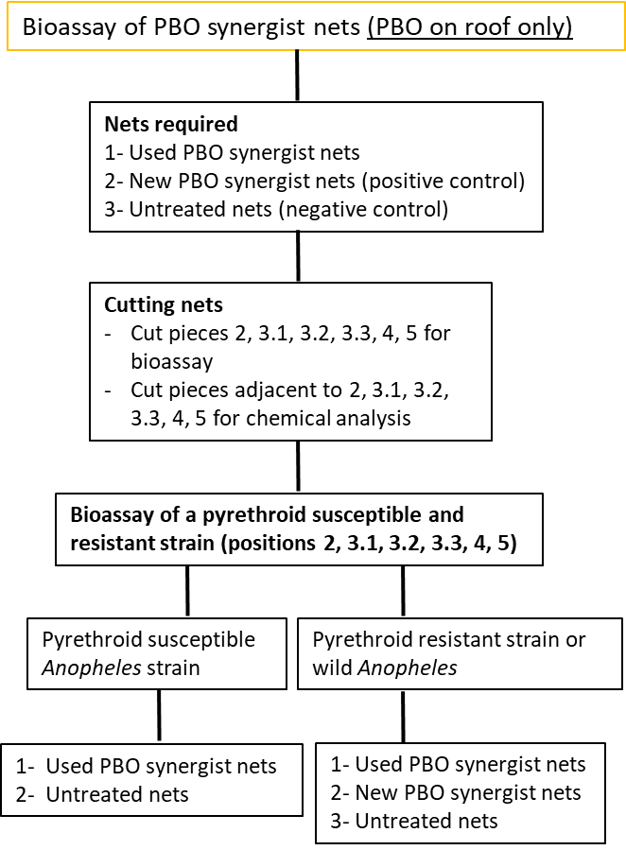
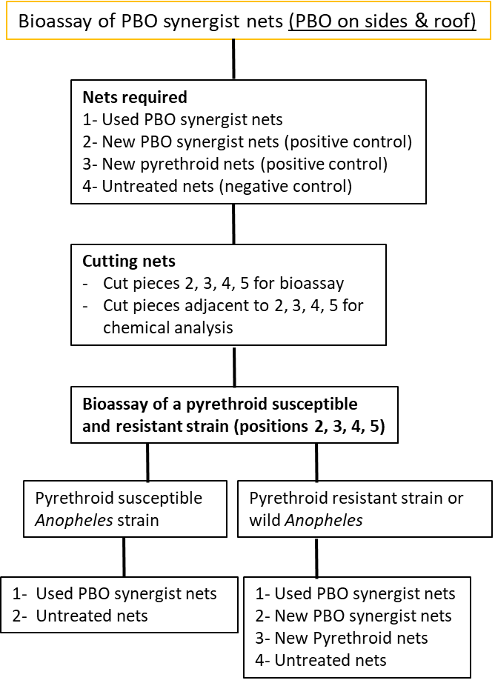
Figure 1. Flow chart showing nets required, pieces to be cut, mosquito strains to be tested and nets to be tested by mosquito strain.

2.1 Cutting Net Pieces

2.1.1 Always wear gloves while handling and cutting the nets. Change gloves when handling different insecticides to avoid contamination.

2.1.2 If the net has PBO on all surfaces, cut a total of four netting pieces: 3 from the sides and 1 from the roof as shown in Figure 1.

2.1.3 If the net has PBO only on the roof (ie. PermaNet 3.0 or Tsara Plus), cut a total of 6 netting pieces: 3 from the sides and 3 from the roof as shown in Figure 2.

2.1.4 Label the individual netting pieces using paper labels stapled onto the corner of a net. Store each individual netting piece separately in aluminium foil in a refrigerator (4±3°C) when not in use. The net label and outside of the aluminium foil should also be labelled with the net brand, net code, netting piece number and age of net (e.g. PermaNet 3.0/B102/P3/12mo).

2.1.5 The same cutting and labelling procedure should also be followed for the positive controls (new PBO nets and new pyrethroid nets) and the negative control (untreated netting).

2.1.6 Additional pieces of netting should be cut for chemical analysis. For every position cut for bioassay an additional piece should be cut in an adjacent position for chemical analysis.

Figure 1: Recommended positions from which netting pieces should be taken if PBO is on all surfaces of the net.
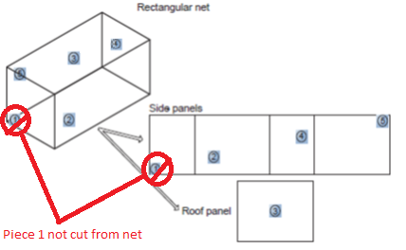

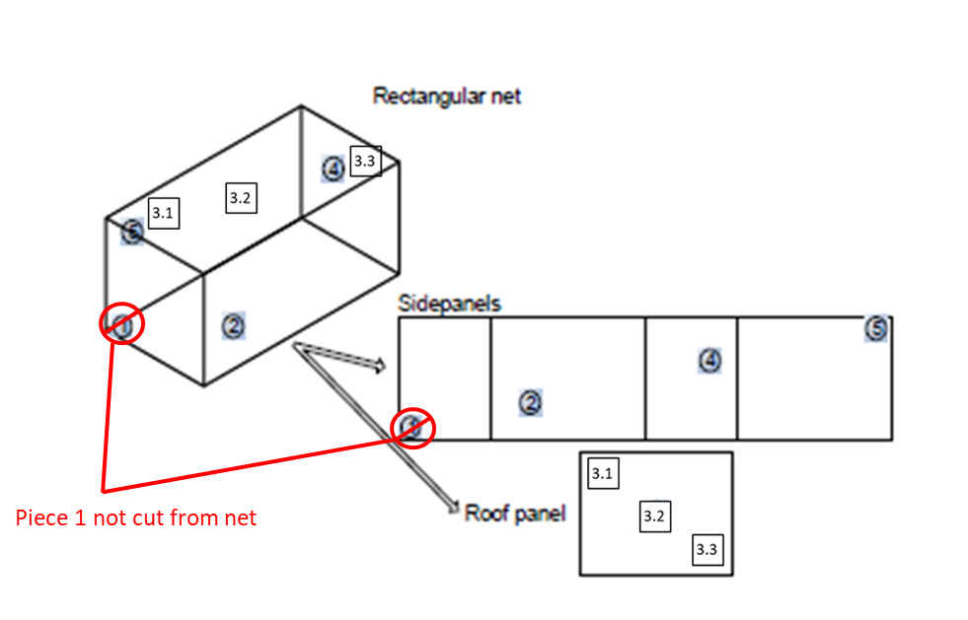
Figure 2: Recommended positions from which netting pieces should be taken if PBO is only on the roof of the net (i.e. PermaNet 3.0, Tsara Plus).

2.2 Mosquitoes to be used in bioassays

    - Bioassays will be done with both an insectary-reared pyrethroid susceptible strain (e.g. An. gambiae Kisumu) and a pyrethroid resistant strain or wild collected Anopheles.

    - It is essential that for the pyrethroid resistant strain at least part of the resistance should be due to elevated p450 oxidases.

    - Characterization of both susceptible and resistant mosquitoes must be done before net bioassays begin according to VectorLink SOP16 (Characterization of pyrethroid susceptible and resistant Anopheles for use in PBO synergist and dual active ingredient ITN bioefficacy monitoring).

2.3 Bioassay Procedures

2.3.1 Clean all testing surfaces with bleach solution or soapy water and dry using paper towel.

2.3.2 Prepare the paper cups by covering them with pieces of untreated netting and secure the netting with a rubber band. Cut a small slit in the netting in the center of the cup to allow the end of the aspirator to pass through the netting, and plug this hole with a small wad of cotton wool.

    - Wash hands and then prepare a 10% sugar/honey solution e.g. by adding 50g of sugar to 500ml of distilled water or 50ml of honey to 450ml of distilled water. Mix well with a spoon.

    - Take the printed data forms ‘ITN Cone Bioassay Test Record Form’ (Appendix 2) and complete ‘Section 1: WHO ITN Cone Bioassay Location Details’, before starting tests.

    - Gloves should be worn at all times during bioassays and should be changed when handling nets with different insecticides.

2.2.7 Place the solid plastic frame on the bench top and then place the netting on top of the frame. Place the cones on top of the netting and secure them by placing the plastic plate with 4 holes over the cones. Note that we will only use 2 cones per netting piece. Use binder clips to secure the frames to each other. The frames should then be placed at a 45° angle on the holding board so that mosquitoes rest on the netting, and clamp the plates into place (Figure 3).

Figure 3: Cone bioassay of mosquito net pieces. Courtesy of Dr Vincent Corbel, Institut de Recherche pour le Développement, Montpellier, France. Taken from ‘WHO Guidelines for Laboratory and field testing of long-lasting insecticidal nets’.
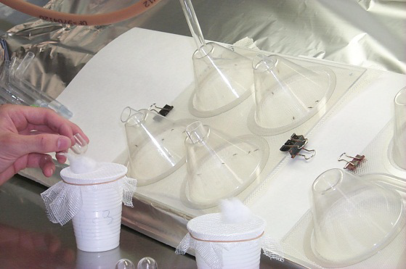

2.2.8 Temperature and humidity should be monitored with a data logger or manually by recording the max/min during the testing and holding periods and recorded on the data forms.

    - For each of the net pieces testing should be done with 5 mosquitoes per cone using 2 cones, resulting in 10 mosquitoes per net piece. Therefore, for nets with PBO on all surfaces the total number of mosquitoes tested (four net pieces) is 40 and for nets with PBO only on the roof it is 60 (six net pieces).

    - Mosquitoes exposed to untreated net pieces are used as controls; they should be tested at the start and end of each day. If the mortality in controls on any day is < 10%, the results for that day should be adjusted by Abbott’s formula. If the mortality in controls is > 10% on a given day, the results for that day are considered invalid and should be discarded.

    - Before adding mosquitoes to the cones, set the timer for 3 minutes. For each cone, 5 mosquitoes should be introduced by aspirator into the cone and the cone blocked with a piece of cotton. The timer should be started as soon as all mosquitoes are in the cone. Ideally a separate timer should be used for each cone.

    - Once the timer reaches 3 minutes, the mosquitoes should be aspirated gently from the cone and into the paper cup through the slit cut in the netting. Cover the slit with cotton wool after the mosquitoes are in the cup.

    - Provide mosquitoes with honey/sugar solution by moistening a piece of cotton wool, squeezing it to remove excess solution, and placing it on top of the cup. Before handling sugar solution hands should be washed with soapy water to prevent contamination through handling treated netting.

    - Knock-down of mosquitoes should be recorded 60 minutes after the end of the cone bioassay and mortality 24 hours after bioassay, according to the definitions in the glossary (Table 1).

  - Data management and interpretation

    - All cone bioassay data will be recorded using the ‘ITN Cone Bioassay Test Record Form’. Note that there are two form versions, one for PBO on the roof only and another for PBO on the sides and roof (See Appendix 2)

    - Data will subsequently be entered into an excel database titled ‘PBO Synergist Cone Bioassay Database’ (file template to accompany this SOP).

    - Efficacy criteria will be quantified using two definitions:

1) Exceeds WHO thresholds of 95% KD60 or 80% 24-hour mortality.
2) Is within 10% of the new PBO ITN KD60 or 24-hour mortality.

  - Optional method for testing the residual efficacy of piperonyl butoxide

The previous methods evaluate the bioefficacy of pyrethroids alone, and pyrethroids in combination with PBO. If PBO net efficacy has declined, it may be useful to determine whether the loss of efficacy is due to loss or unavailability of PBO. A method for assessing the residual efficacy of PBO is listed here. This method can be conducted at time points when mean mortality of PBO synergist nets has dropped below 80% using pyrethroid resistant mosquitoes.

2.4.1 PBO pre-exposure will be done using WHO tube tests and PBO papers (4%) or alternatively CDC bottle bioassays could be used with 100µg PBO/bottle). Appropriate untreated controls will also be tested.

2.4.2 Prior to the cone tests, at least 50 pyrethroid resistant mosquitoes should be exposed to PBO treated papers (4%) in a WHO tube test or a CDC bottle (treated at 100μg/bottle) for 60 minutes. After 60 minutes, the mosquitoes should be released into a cage with sugar solution before being used in cone bioassays.

2.4.3 Cone bioassays of netting pieces should be conducted as described earlier (2.3). If the net has PBO on all sides, 2 cones using 5 mosquitoes can be conducted on each of the four pieces using the PBO-pre-exposed mosquitoes, and 2 cones using 5 mosquitoes can be conducted on each of the four pieces using unexposed mosquitoes.

2.4.4 If the net has PBO on the roof only, 3 cones using 5 mosquitoes can be conducted on each of the three roof pieces using the PBO-pre-exposed mosquitoes, and 3 cones using 5 mosquitoes can be conducted on each of the three pieces using unexposed mosquitoes. The control will be done with 5 pieces and two cones conducted on each piece.

2.4.5 The results of the bioassays will be recorded using the ‘ITN Cone Bioassay Test Record Form’ which has tick boxes in Section 3 to record whether pre-exposure with PBO was conducted.

2.4.6 The data can be interpreted by dividing the percentage mortality in the resistant mosquitoes tested without pre-exposure by the percentage mortality in the resistant mosquitoes that were pre-exposed to PBO.

- QUALITY CONTROL

  - As described above, the susceptible and pyrethroid resistant strains should be characterized within two weeks before netting bioassays are conducted.

  - Negative control bioassays using untreated netting will be conducted at the start and end of each day.

- SOP Copy Control Log

Purpose: The log records the number of certified copies of this SOP printed and where they were distributed.
When: Whenever the SOP is reviewed: annually or more often when necessary.
By whom: By QA staff / designee

Distribution Date: 18th September 2020 |  | Total number of certified copies  (including Master Copy): NA
SOP Distribution (location and number of certified copies)

- Appendices
Appendix 1: SOP Training Log for Personnel Training Files

Date: | SOP Number and Title | Employee Signature | Supervisor Initials

Appendix 2. ITN Cone Bioassay Test Record Form

Name of Person Completing Form: _________________(Surname, First Name) |  | Date of WHO ITN Cone Bioassay Test: __ __ -__ __ - __ __ __ __ (DD-MM-YYYY)
Section 1: WHO ITN Cone Bioassay Location Details
Country: ___________________ Province: ______________________ District: ____________________ Village: ____________________
Household GPS Coordinates (of net collection) (in decimal degrees):
Latitude ___|___|.___|___|___|___|___º (i.e. 17.92412º) Longitude ___|___|.___|___|___|___|___º (i.e. 25.85723 º) Altitude (in meters): _______
GPS accuracy (in meters): ______  (values >10 meters should be retaken) | GPS data source:  ☐GPS Device ☐Phone ☐Tablet ☐Other |  | Specify GPS data source (e.g. name/make of device; application; software; etc.): __________________________________
ITN Code:___________________________
Type of ITN (Please choose one option that best fits):
☐Untreated Net (Control) ☐TSARANet ☐TSARABoost ☐TSARAPlus ☐TSARASoft ☐DawaPlus 2.0 ☐DawaPlus 3.0 ☐DawaPlus 4.0 ☐Duranet ☐Interceptor ☐Interceptor G2 ☐MiraNet ☐MAGNet ☐OLYSET Net ☐OLYSET Plus ☐Panda Net 2.0 ☐ PermaNet 2.0 ☐PermaNet 3.0 ☐Royal sentry ☐ SafeNet ☐VEERALIN ☐ Yahe LN ☐Yorkool LN ☐Unknown ☐Other If other, specify____________
Age of ITN (Please choose one):
☐Baseline (0-6 Months) ☐ 12 Months ☐18 Months ☐ 24 Months ☐36 Months ☐Unknown ☐Other If other, specify___________
☐New If new, specify date of production and batch number: __________________
Section 2: Mosquito Details
Mosquito Origin (Please choose one):  ☐Susceptible colony  ☐F0: Reared from wild larvae  ☐F1: Reared from eggs of wild adults  ☐F2: Reared from F1 adults  ☐Collected adults  ☐Pyrethroid Resistant Colony |  | If mosquito origin was F0, F1, F2, or Collected Adults, please specify details on where mosquitos were originally sourced:  Country: ___________________ Region: _______________________________ District: ____________________ Village: ____________________
Mosquito Species Tested (Please choose one):
☐An. gambiae (Kisumu) ☐An. arabiensis (susceptible colony) ☐An. funestus s.l. ☐An. gambiae s.l. ☐An. coluzzii VKPER (resistant colony)
☐An. coluzzii (susceptible colony) ☐Other If other, specify__________________
Mosquito Age (days) (Please choose one): ☐2-5 days ☐Other age (days) ☐Unknown If other, specify__________
Section 3: WHO Cone Bioassay Test Details and Results
Temperature (○ Celsius):  Exposure period: Max_______(Celsius) Min______(Celsius)  Holding period: Max_______(Celsius) Min______(Celsius) |  | Relative humidity (%):  Exposure period: Max ______ % Min ______%  Holding period: Max______% Min______%
Optional test: was 60 minutes PBO pre-exposure conducted before net bioassay (Please choose one): ☐ Yes (4% PBO paper) ☐ Yes (100µg PBO/bottle) ☐ No

Net Position | Replicates/Cones | Number of mosquitoes tested | Number of mosquitoes knocked down: 60 min | Number of mosquitoes dead: 24 hours
1 (side) | 1
 | 2
2 (side) | 1
 | 2
3.1 (roof) | 1
 | 2
3.2 (roof) | 1
 | 2
3.3 (roof) | 1
 | 2
4 (side) | 1
 | 2
5 (side) | 1
 | 2

VectorLink Technical Review:

Name of Person Completing Form: _________________(Surname, First Name) |  | Date of WHO ITN Cone Bioassay Test: __ __ -__ __ - __ __ __ __ (DD-MM-YYYY)
Section 1: WHO ITN Cone Bioassay Location Details
Country: ___________________ Province: ______________________ District: ____________________ Village: ____________________
Household GPS Coordinates (of net collection) (in decimal degrees):
Latitude ___|___|.___|___|___|___|___º (i.e. 17.92412º) Longitude ___|___|.___|___|___|___|___º (i.e. 25.85723 º) Altitude (in meters): _______
GPS accuracy (in meters): ______  (values >10 meters should be retaken) | GPS data source:  ☐GPS Device ☐Phone ☐Tablet ☐Other |  | Specify GPS data source (e.g. name/make of device; application; software; etc.): __________________________________
ITN Code:___________________________
Type of ITN (Please choose one option that best fits):
☐Untreated Net (Control) ☐TSARANet ☐TSARABoost ☐TSARAPlus ☐TSARASoft ☐DawaPlus 2.0 ☐DawaPlus 3.0 ☐DawaPlus 4.0 ☐Duranet ☐Interceptor ☐Interceptor G2 ☐MiraNet ☐MAGNet ☐OLYSET Net ☐OLYSET Plus ☐Panda Net 2.0 ☐ PermaNet 2.0 ☐PermaNet 3.0 ☐Royal sentry ☐ SafeNet ☐VEERALIN ☐ Yahe LN ☐Yorkool LN ☐Unknown ☐Other If other, specify____________
Age of ITN (Please choose one):
☐Baseline (0-6 Months) ☐ 12 Months ☐18 Months ☐ 24 Months ☐36 Months ☐Unknown ☐Other If other, specify___________
☐New If new, specify date of production and batch number: __________________
Section 2: Mosquito Details
Mosquito Origin (Please choose one):  ☐Susceptible colony  ☐F0: Reared from wild larvae  ☐F1: Reared from eggs of wild adults  ☐F2: Reared from F1 adults  ☐Collected adults  ☐Pyrethroid Resistant Colony |  | If mosquito origin was F0, F1, F2, or Collected Adults, please specify details on where mosquitos were originally sourced:  Country: ___________________ Region: _______________________________ District: ____________________ Village: ____________________
Mosquito Species Tested (Please choose one):
☐An. gambiae (Kisumu) ☐An. arabiensis (susceptible colony) ☐An. funestus s.l. ☐An. gambiae s.l. ☐An. coluzzii VKPER (resistant colony)
☐An. coluzzii (susceptible colony) ☐Other If other, specify__________________
Mosquito Age (days) (Please choose one): ☐2-5 days ☐Other age (days) ☐Unknown If other, specify__________
Section 3: WHO Cone Bioassay Test Details and Results
Temperature (○ Celsius):  Exposure period: Max_______(Celsius) Min______(Celsius)  Holding period: Max_______(Celsius) Min______(Celsius) |  | Relative humidity (%):  Exposure period: Max ______ % Min ______%  Holding period: Max______% Min______%
Optional test: was 60 minutes PBO pre-exposure conducted before net bioassay (Please choose one): ☐ Yes (4% PBO paper) ☐ Yes (100µg PBO/bottle) ☐ No

Net Position | Replicates/Cones | Number of mosquitoes tested | Number of mosquitoes knocked down: 60 min | Number of mosquitoes dead: 24 hours
1 (side) | 1
 | 2
2 (side) | 1
 | 2
3 (roof) | 1
 | 2
4 (side) | 1
 | 2
5 (side) | 1
 | 2

VectorLink Technical Review:

https://www.who.int/pq-vector-control/prequalified-lists/en/ (Accessed 16th September, 2020)

