STANDARD AND STREAMLINED DURABILITY MONITORING
PMI supports two approaches to durability monitoring (DM):
- Standard DM approach can be implemented where there is no or limited country data available on ITN durability, or if an issue has been noted.
- Streamlined DM approach should be considered in countries that have previously collected DM data and are primarily interested in evaluating bioefficacy, particularly for new types of nets.
Both approaches include pre-distribution testing of ITNs, and a typical study includes two sites (either two products at similar sites or one product at two sites).
The streamlined approach requires less time for fieldwork and will cost less than the standard approach for the same set of ITN brands being monitored.
Standard Durability Monitoring involves pre-distribution tests and four rounds of fieldwork over three years
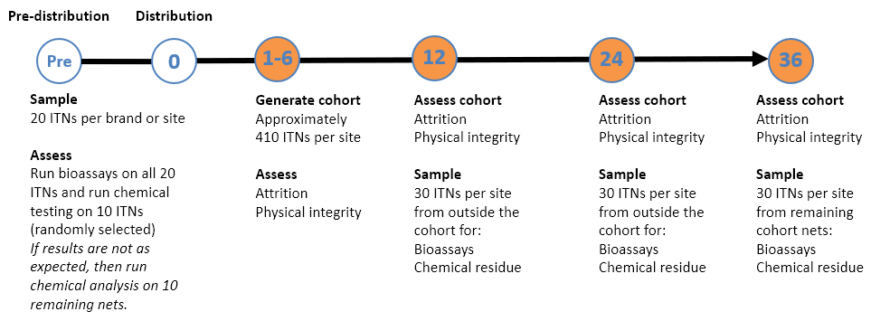 | Primary objectives  - Assess ITN survivorship (attrition and physical integrity), identify major determinants of field performance and assess insecticidal efficacy.  Implementation  - A cohort of approximately 410 ITNs per site is generated at a first timepoint, 1-6 months after the campaign, typically from 15 clusters of 10 households.  - Fieldwork = 25 days at first timepoint, then 15-20 days at follow-up timepoints; 1 site = 1 team x 4 people  - All ITNs remaining in the cohort are assessed for holes at each timepoint, and household data is additionally captured on residents, net use, net care and repair, and other nets owned by the household.  - Costs are higher than the streamlined approach due to following-up all cohort ITNs and a longer questionnaire.
Streamlined Durability Monitoring involves pre-distribution tests and three rounds of fieldwork over three years
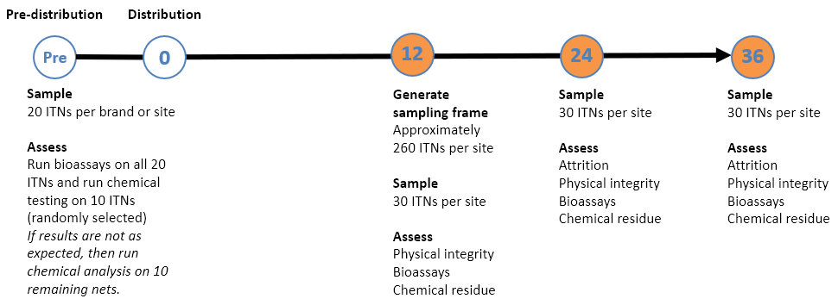 | Primary objectives  - Assess insecticidal efficacy and monitor attrition and physical integrity.  Implementation  - A sampling frame of approximately 260 ITNs per site is generated 12 months after the campaign, typically from 15 clusters of 10 households.  - Fieldwork = 18 days at 12-month timepoint, then 8 days at follow-up timepoints; 1 site = 1 team x 1 or 2 people  - At each fieldwork timepoint, 30 ITNs per site are randomly sampled for withdrawal from households (90 ITNs per site over three years). Withdrawn ITNs undergo a hole assessment in the laboratory prior to bioassays and chemical testing.  - Costs are lower than the standard approach as fewer ITNs are targeted and the questionnaire is shorter.

