The PMI Evolve Project
Burkina Faso Durability Monitoring Snapshot: 36 months
July 4 – August 19, 2022

Study Overview
Net products:
- Interceptor® G2 (alpha-cypermethrin + chlorfenapyr)
- Interceptor® (alpha-cypermethrin)
- PermaNet® 3.0 (deltamethrin + PBO)
Design: Three brands in similar zones
Campaign date: June-November 2018
Last data collection round: 36 months (July 4 – August 19, 2022)

Study Site Locations Within Burkina Faso
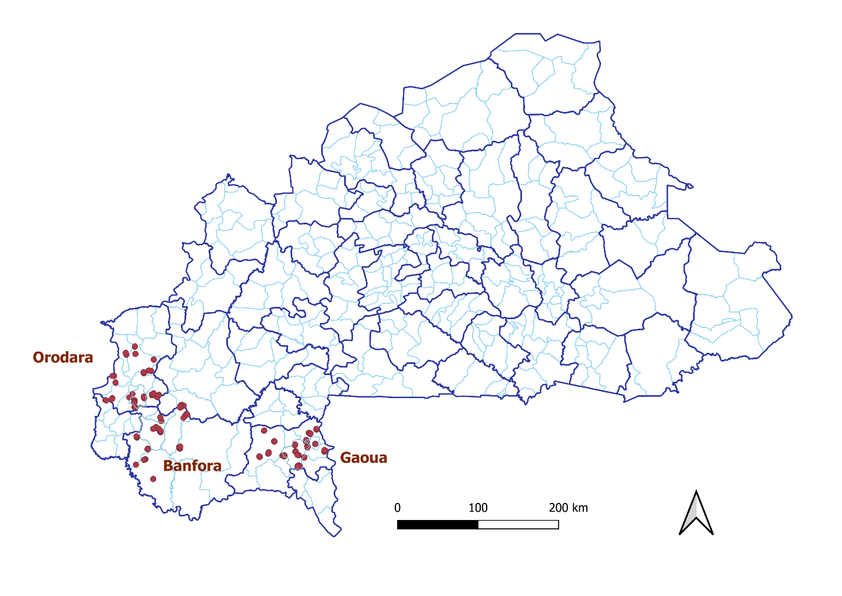

Key Results
At survey endline, the proportion of cohort nets remaining and in serviceable condition was similar in the three study sites (80% in Banfora and Gaoua, and 90% in Orodara). Interceptor® ITNs maintained the highest mortality despite losing the most chemical content (70% 24-hour mortality despite a mean76% reduction in alpha-cypermethrin content after 36 months). Conversely, PermaNet 3.0 ITNs had the lowest mortality despite maintaining the most chemical content (26% 24-hour mortality despite only a mean 49% reduction in PBO chemical content after 36 months).
Site | Survey round and time since distribution (months) | Attrition wear and tear (%) | Remaining nets in serviceable condition %  (N) | Remaining nets hanging over sleeping space (%) |  | 24/72 – hour mortality against susceuptible or resistant mosquito strain (%) | Chemical content  N (95% CI)
 |  |  |  | Campaign | Other
Banfora  (Interceptor® G2) | Baseline (1.4) | 0.0% | 100% (N=294) | 28.9% | 81.9% | 84.5ª (79.6-89.3) | 5.00 ^{d} (4.70-5.31)
 | 12m (10.1) | 1.4% | 96.5% (N=231) | 63.2% | 81.6% | 66.2 ª (58.6-73.7) | 3.54 ^{d} (3.15-3.92)
 | 24m (24.1) | 13.9% | 84.2% (N=101) | 68.4% | 88.1% | 71.8 ª (57.2-86.3) | 2.21 ^{d} (1.55-2.87)
 | 36m (33.1) | 20.3% | 80.0% (N=60) | 86.6% | 89.3% | 50.5ª (39.1-61.8) | 1.6 ^{d} (1.0-2.2)
Gaoua (Interceptor®) | Baseline (4.3) | 0.0% | 98.9% (N=282) | 52.8% | 84.9% | 99.9^{b} (99.7-100.0) | 3.33e (2.66-4.00)
 | 12m (13.1) | 9.7% | 97.1% (N=206) | 75.2% | 80.9% | 99.2^{b} (98.2-100.0) | 2.73 ^{e} (1.89-3.58)
 | 24m (24.1) | 26.0% | 88.4% (N=138) | 75.3% | 82.1% | 99.5 ^{b} (98.8-100.0) | 1.70 ^{e} (1.16-2.24)
 | 36m (36.1) | 41.4% | 79.8% (N=94) | 87.2% | 81.1% | 70.8^{b} (58.0-83.7) | 0.8 ^{e} (0.3-1.3)
Orodara (PermaNet® 3.0) | Baseline (5.5) | 0.0% | 94.7% (N=346) | 72.9% | 63.1% | 71.7^{c} (63.9-79.6) | 15.20 ^{f} (1.21-1.73)
 | 12m (14.4) | 5.1% | 95.7% (N=280) | 81.4% | 72.6% | 75.1 ^{c} (69.2-81.1) | 9.03 ^{f} (7.39-10.67
 | 24m (24.2) | 15.9% | 90.4% (N=209) | 84.7% | 83.0% | 51.8 ^{c} (38.5-64.7) | 7.82 ^{f} (5.86-9.79)
 | 36m (36.1) | 31.0% | 90.1% (N=141) | 90.1% | 90.5% | 25.7^{c} (15.7-35.6) | 7.82 ^{f} (5.86-9.79)
a Result for 72-hour mortality when tested against resistant strain using tunnel tests
b Result for 24-hour mortality when tested against susceptible strain using cone bioassays
c Result for 24-hour mortality when tested against the resistant strain on the PBO roof panel using cone bioassays
d Chlorfenapyr
e Alpha-cypermethrin
f PBO

Key Risk Factors for Cohort ITN Physical Durability
- Exposure to net messaging in the six months before the survey was lowest in Gaoua, where no respondents reported exposure (0%), and higher in Banfora (39%) and Orodara (47%). Accordingly, a low proportion of respondents had favorable attitudes towards nets and net care and repair in all study sites, especially in Gaoua where respondents weren’t exposed to messaging:
  - Favorable net attitudes: 7% in Gaoua, 36% in Banfora, and 26% in Orodara, (p<0.001).
  - Favorable net care and repair attitudes: 6% in Gaoua, 18% in Banfora, and 3% in Orodara (p=0.014).
- At 36-months, cohort nets in Gaoua are subject to higher overall risk of damage.
  - The proportion of households storing food in a room used for sleeping was highest in Gaoua (100% in Gaoua, 64% in Banfora, and 50% in Orodara(p<0.001).
  - The proportion of households ever cooking in a room used for sleeping was highest in Gaoua (45% in Gaoua, 26% in Banfora, and 4% in Orodara (p<0.001).
  - Nets were most commonly hung over a mat or the ground in Gaoua (83% in Gaoua, 28% in Banfora, and 28% in Orodara; (p<0.001).
- Significantly more hanging nets in Orodara (93%) were not folder or tied compared to Banfora (44%) and Gaoua (44%) (p<0.001).

Cohort Survival in Serviceable Condition
The chart plots the proportion of nets surviving in serviceable condition against hypothetical survival curves for nets lasting one to four years using the survival data from baseline 12-, 24-, and 36-month study rounds. After the 36 months, using the estimate as the relative position of the data point on a horizontal line between the two adjacent median survival curves, the estimated median useful life for Interceptor® G2 nets in Banfora was 2.6 years, Interceptor® nets in Gaoua was 2.4 years, and PermaNet® 3.0 nets in Orodara was 3.2 years.

Survival plots at both time points against hypothetical survival curves for nets lasting one to four years. Estimated median useful life based on the survival data from months 24 and 36.

Bioassay and Chemical Results: Interceptor® Brand ITNs
The Interceptor® brand is a pyrethroid-only ITN with alpha-cypermethrin as its only active ingredient. Cone bioassays were conducted using a colony of An. gambiae Kisumu mosquitos, which were characterized as being susceptible to deltamethrin and alpha-cypermethrin prior to each survey round. Polymerase chain reaction confirmed the species as An. gambiae with no kdr mutations present.
Despite an 84% loss in chemical content from the manufacturer’s target dose of 5 g/kg, 60% of field samples maintained optimal effectiveness against the susceptible An. gambiae Kisumu strain at survey endline.
Alpha-cypermethrin content of Interceptor® brand ITNs from Gaoua District, Burkina Faso: 2019-2022
Percent KD60 and 24-hour mortality for Interceptor® brand ITNs taken from Gaoua District, Burkina Faso against susceptible An. gambiae Kisumu mosquitos: 2019-2022

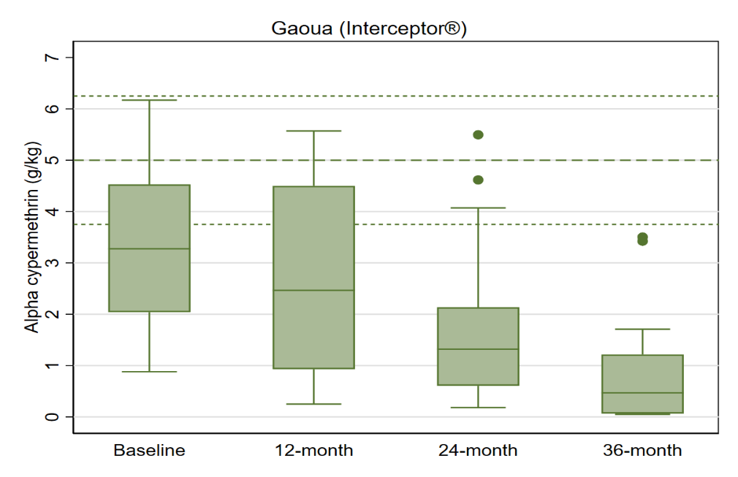
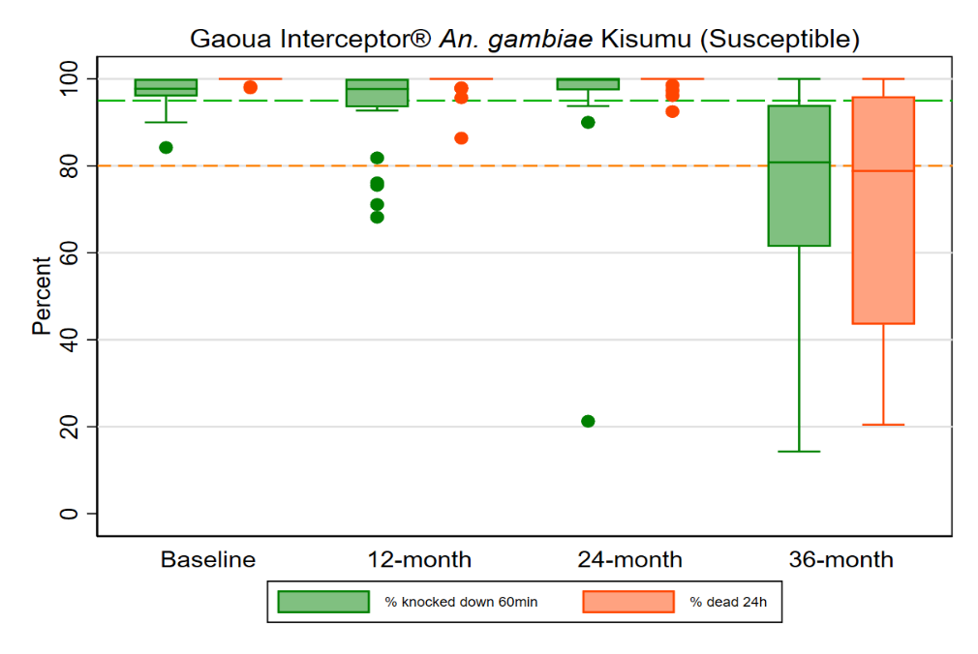

Box plot shows the median (horizontal line), interquartile range (box), adjacent values (whiskers), outliers (circles), and for each legend, bold line dashes specify manufacturer threshold (with fine line dashes indicating acceptable range).
Box plot shows the median (horizontal line), interquartile range (box), adjacent values (whiskers), outliers (circles), and for each legend, dashed lines represent WHO thresholds for knock-down (green line, KD60 95%) and mortality (orange line, mortality, 80%).

Bioassay and Chemical Results: PermaNet® 3.0 Brand ITNs
The PermaNet® 3.0 brand is a pyrethroid + PBO synergist ITN with deltamethrin-only on the net sides and deltamethrin + PBO on the roof. Testing confirmed the presence of deltamethrin and alpha-cypermethrin resistance in the VKPER strain. PBO synergist tests with deltamethrin showed a greater than 60% increase in mortality compared to deltamethrin alone.
PermaNet® 3.0 field samples achieved three times lower 24-hour mortality at 36 months than at baseline (26% vs. 72%) against the pyrethroid-resistant An. gambiae VKPER colony. The decrease in mortality corresponds with an 86% loss in mean PBO content on roof samples (3.9 g/kg) compared to the manufacturer’s target dose (25 g/kg).
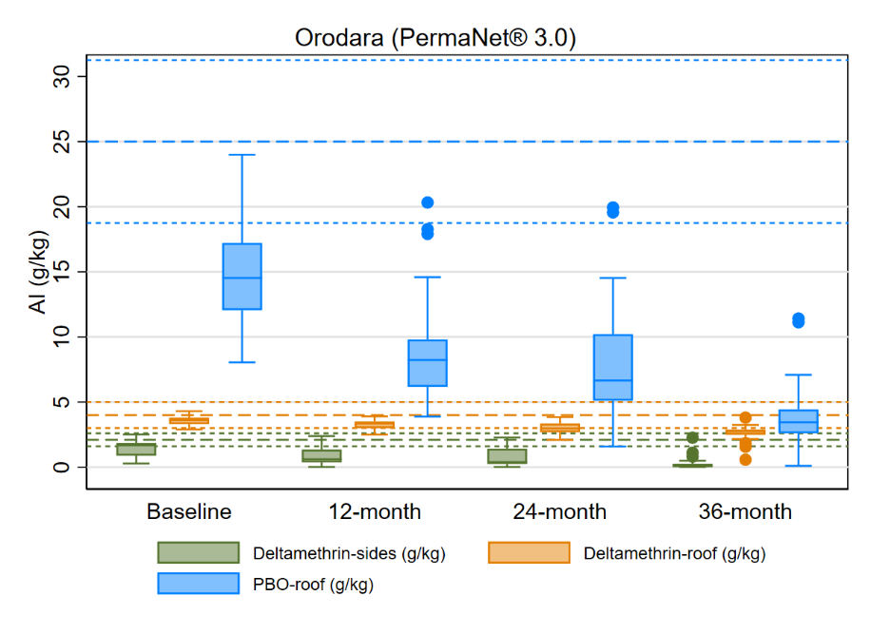
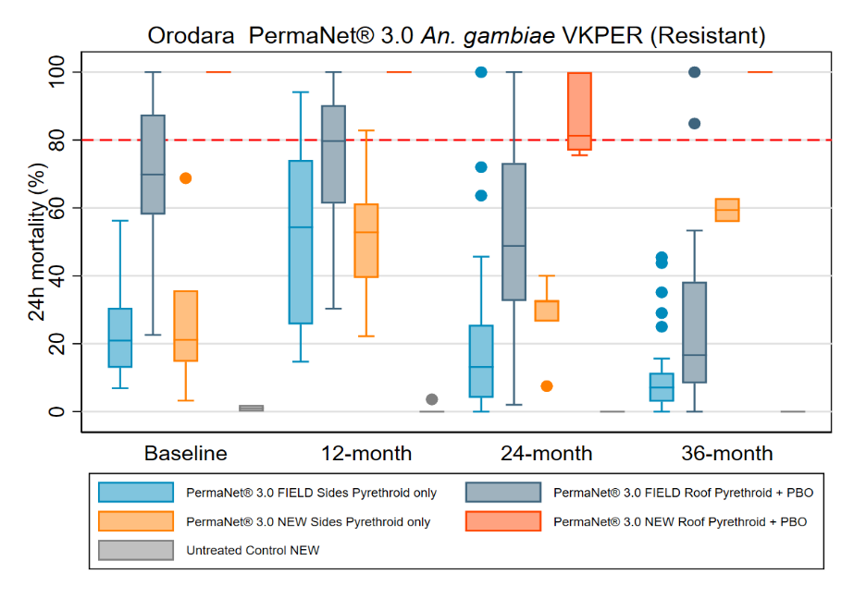
Side/roof deltamethrin content and roof PBO content of PermaNet® 3.0 brand ITNs from Orodara District, Burkina Faso: 2019-2022
Box plot shows the median (horizontal line), interquartile range (box), adjacent values (whiskers), outliers (circles), and for each legend, bold line dashes specify manufacturer threshold (with fine line dashes indicating acceptable range).
Box plot shows the median (horizontal line), interquartile range (box), adjacent values (whiskers), outliers (circles), and for each legend, red dashed line represents WHO optimal effectiveness thresholds for mortality 80%.
24-hour mortality for field/new PermaNet® 3.0 brand side and roof ITNs taken from Orodara District, Burkina Faso against resistant An. gambiae VKPER mosquitos: 2019-2022

Bioassay and Chemical Results: Interceptor® G2 Brand ITNs
Chlorfenapyr testing was added to the characterization from the second round. The results from the 12-, 24-, and 36-month rounds showed that 72-hour mortality remained above 95% with an interim diagnostic dose of 100µg/bottle and 100% with 200 µg/bottle.
After 36 months, Interceptor® G2 field samples achieved 51% 72-hour mortality against the resistant An. gambiae VKPER colony. This decrease corresponds roughly to the 67% reduction in chlorfenapyr content (1.6 g/kg) and 29% loss of alpha-cypermethrin content (1.7 g/kg) compared to their original manufacturer’s target doses of 4.8 g/kg of chlorfenapyr and 2.4 g/kg of alpha-cypermethrin.
Alpha-cypermethrin and chlorfenapyr content of Interceptor® G2 brand ITNs from Banfora District, Burkina Faso: 2019-2022
72-hour mortality for field/new Interceptor® G2 and new Interceptor® ITN brand samples taken from Banfora District, Burkina Faso against resistant An. gambiae VKPER mosquitos: 2019-2022

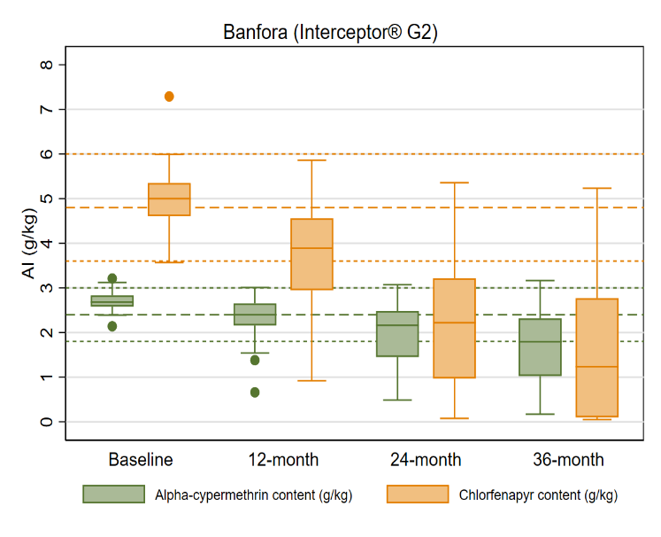
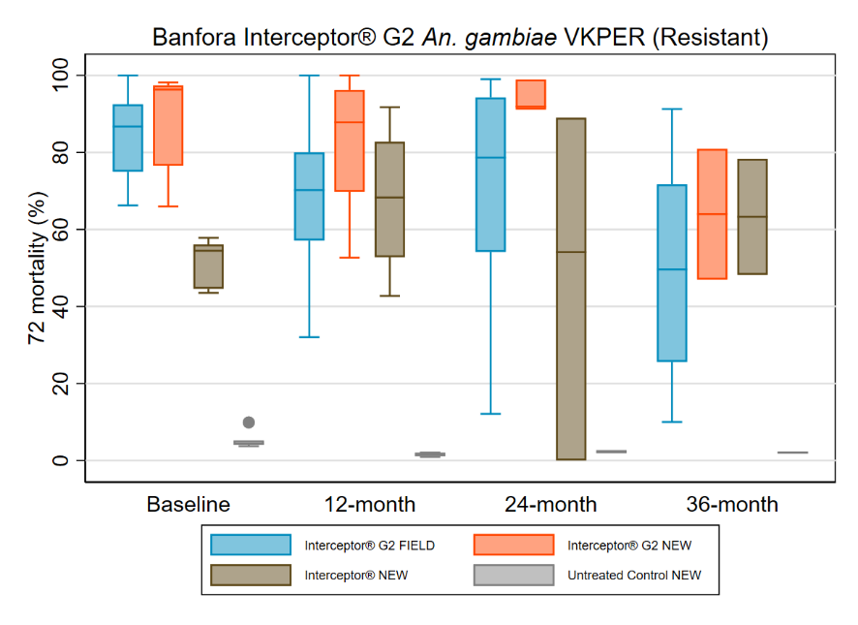
Box plot shows the median (horizontal line), interquartile range (box), adjacent values (whiskers) and outlier (circle).
Box plot shows the median (horizontal line), interquartile range (box), adjacent values (whiskers), outliers (circles), and for each legend, bold line dashes specify manufacturer threshold (with fine line dashes indicating acceptable range).

Durability Monitoring Indicator Definitions
Attrition due to wear and tear: The percentage of cohort nets lost due to being destroyed, discarded or used for other purposes out of all cohort nets received by sampled households. This does not include nets that were given away, sold, or stolen.
Provides an estimate of the attrition relevant to estimation of the physical durability in contrast to “all cause attrition” which includes also nets given away etc. Attrition due to wear and tear is correlated with the median survival of the cohort nets.
Remaining nets in serviceable condition: The percentage of cohort nets surviving to date that are still in serviceable physical condition (good or damaged), specifically, with a proportionate hole index of 642 or less.
Provides an estimate of the physical quality of remaining campaign nets.
Remaining nets hanging over sleeping space: The percentage of cohort nets and, separately, non-cohort nets present in the household that are hanging up, whether tied up or not.
Provides an estimate of the use of different nets in the household. Households adopt nets newly received from campaigns at different rates. A present net hanging up in the home is an indicator of net use generally, beyond the formal indicator of net use the night before the survey.
Optimal insecticidal effectiveness: The percentage of sampled campaign nets that have at least 95% 60-minute knock-down or 80% mortality in the WHO cone bioassay. Alternatively, 90% feeding inhibition or 80% mortality in the tunnel test.
Provides an estimate of the effectiveness of the insecticide found on mass campaign LLIN at each period of follow-up.
Cohort survival in serviceable condition: The proportion of all cohort nets sampled at baseline that are in serviceable physical condition at each period of follow-up out of all cohort nets with a known outcome (excluding nets given away to others, stolen or sold).
Provides an estimate of the proportion of all campaign nets that are still able to effectively protect the population from malaria when slept under.

