THE PMI VECTORLINK BURUNDI
2019 ITN DURABILITY MONITORING
24-MONTH STUDY REPORT

Recommended Citation: The VectorLink Project. June 2022. The PMI VectorLink Burundi 2019 ITN Durability Monitoring 24-Month Study Report. Washington, DC. The PMI VectorLink Project, Population Services International (PSI).
Contract: AID-OAA-I-17-00008
Task Order: AID-OAA-TO-17-00027
Submitted to: United States Agency for International Development/PMI
Submitted on: June 10, 2022
Approved on: August 19, 2022

The views expressed in this document do not necessarily reflect the views of the United States Agency for International Development or the United States Government.
Contents
1. Background 1
2. Methods 4
2.1 Study Sites 4
2.2 ITN Brands Monitored 6
2.3 Study Design Summary 6
2.4 Training and Fieldwork 7
2.5 Data Management 8
2.6 Analysis 8
2.7 COVID-19 Adaptations 10
2.8 Ethical Clearance 10
3. Results 11
3.1 Sample 11
3.2 Determinants of Durability 13
3.3 Net Ownership and Net Use 19
3.4 Durability of Cohort ITNs 23
3.5 Insecticidal Effectiveness of Campaign Nets 29
3.5.1 Gasoho/Yorkool (Deltamethrin) 29
3.5.2 Vumbi/ Permanet 3.0 (Deltamethrin and Pbo Synergist) 30
3.5.3 Reported Net Handling and Use of ITNs Selected for Bioassays 36
4. Conclusions 39
4.1 Summary of Findings 39
4.2 Key Challenges and Lessons Learned 40
Annex 1: Field Team Visual Prompt Cards 42

LIST OF TABLES
Table 1: Summary Results 4
Table 2: Durability Monitoring Study Sites 2
Table 3: Study Site Characteristics 5
Table 4: Malaria Characteristics in Study Areas 5
Table 5: ITN Brands Distributed in Study Areas 6
Table 6: Household Characteristics and Assets 14
Table 7: Prevalence of Household Risk Factors for Damage 15
Table 8: Prevalence of Handling Risk Factors for Cohort ITNs 16
Table 9: Respondent Exposure to Messages About Nets in Last 6 Months 17
Table 10: Respondent Attitudes Toward Nets and Net Care & Repair 18
Table 11: Household Net Care and Repair Experience 20
Table 12: Status and Reported Use of Cohort Nets in the Household 20
Table 13: Ownership and Source of Non-Cohort Nets 21
Table 14: Status and Reported Use of Non-Cohort Nets in the Household 22
Table 15: Use of Cohort Nets by Household Members Among Nets Used the Previous Night 23
Table 16: Use of Non-Cohort Nets by Household Members Among Nets Used the Previous Night 23
Table 17: Household and Population ITN Access and ITN Use 24
Table 18: Cohort ITN Attrition 25
Table 19: Physical Integrity of Observed Cohort ITNs 27
Table 20: Cohort ITNs Surviving in Serviceable Condition 28
Table 21: Estimated Median Survival of ITNs in Years Using Different Methods 29
Table 22: Yorkool® Cone Bioassay Results for Residual Efficacy of Pyrethroid 31
Table 23: Permanet 3.0® Cone Bioassay Results for Residual Efficacy of Pyrethroid and PBO 32
Table 24: Handling of Bioassay Test ITNs 37
Table 25: Reported Use of Bioassay Test ITNs 38
Table 26: Reported Washing of Bioassay Test ITNs 39

LIST OF FIGURES
Figure 1: Study Site Map 4
Figure 2: 24-Month Follow-Up Status of Households Recruited at Baseline 11
Figure 3: 24-Month Follow-Up Status of Cohort Nets Recruited at Baseline 13
Figure 4: Type of Sleeping Place for Cohort ITNs When Used 16
Figure 5: Trends in All-Cause Attrition and Attrition due to Wear and Tear (discarded nets) 26
Figure 6: Types of Damage Mechanisms Reported for Damaged Cohort ITNs 28
Figure 7: Estimated ITN Survival 29
Figure 8: Kaplan-Meier Curves of Physical Survival with 95% Confidence Intervals 30
Figure 9: Box Plot of Cone Bioassay Results for Residual Efficacy of Pyrethoid 31
Figure 10.1: Box Plot of Cone Bioassay Results for Residual Efficacy Against Susceptible Strain 33
Figure 10.1.1: Box Plot of Cone Bioassay for Positive Control (Pyrethroid+PBO) 34
Figure 10.1.2 : Box Plot of Cone Bioassay for Positive Control (New Pyrethroid-Only) 34
Figure 10.2 : Box Plot of Cone Bioassay Results for Residual Efficacy Against Kisumu RSP Strain 35
Figure 10.2.1: Box Plot of Cone Bioassay for Positive Control (Pyrethroid+PBO) 35
Figure 10.2.2 : Box Plot of Cone Bioassay For Positive Control (New Pyrethroid-Only) 36
Figure 10.3: Box Plot of Cone Bioassay Results for Residual Efficacy Against Wild An. gambiae s.l. Strain 36

Acronyms
CRA-W Centre Wallon de Recherches Agronomiques (Walloon Agronomic Research Center)
DHS Demographic and Health Survey
IQR Interquartile Range
ITN Insecticide-Treated Net
NMCP National Malaria Control Program
pHI Proportionate Hole Index
PMI President’s Malaria Initiative
PSI Population Services International
REB Research Ethics Board
WHO World Health Organization

Executive Summary
The importance of insecticide-treated net (ITN) field durability and estimating the average useful life of a mosquito net is one of the critical factors National Malaria Control Programs (NMCP) need to know to determine the frequency with which nets are replaced. The World Health Organization (WHO) recommends that countries routinely monitor ITN durability following mass distribution campaigns, and standard guidance for monitoring has been developed.
In Burundi, USAID is supporting durability monitoring of two types of ITNs in different study sites distributed during the 2019 mass campaign: PermaNet® 3.0, a deltamethrin-based ITN with the synergist piperonyl butoxide (PBO), in Vumbi commune (Kirundo Province), and Yorkool®, a deltamethrin-based ITN, in Gashoho commune (Muyinga Province). The 2019 mass distribution campaign was conducted from December 16 – 20, 2019. Baseline data collection was conducted from August 3-23, 2020, seven to eight months after the mass distribution campaign in each commune. The first follow-up survey was conducted between January 25 and February 4, 2021, 13 months after the distribution (hereafter referred to as the 12-month round). The second follow-up survey was conducted between February 28 and March 11, 2022, 27 months after the mass distribution (referred to as the 24-month round).
During each of these rounds, all nets labeled at baseline were followed-up; the physical integrity of nets still present in the household was measured through a hole assessment and details were recorded for any nets no longer present in the household (attrition). Potential factors affecting net durability were explored through a household interview. These included environmental factors (house structure, cooking fuel, type of sleeping place), net handling (folding nets up when hanging, drying on bushes etc.) as well as attitudes toward nets and net care and repair.
The survey also collected information on all mosquito nets obtained by households outside of the 2019 campaign. Separate to the study cohort, 60 ITNs (30 of each brand) identified as coming from the 2019 mass campaign were sampled for bio-efficacy tests in each of the study rounds. Cone bioassays were performed by the PMI VectorLink Project (VectorLink) in Burundi at the insectary located in Gihanga. Household data collection was conducted by staff from the Burundi NMCP with the technical assistance of VectorLink Burundi. Results of the study will provide the NMCP, PMI, and partners with valuable information regarding the performance and average useful life of each of these ITN types distributed during the 2019 campaign.
Durability monitoring studies typically follow cohorts of ITNs for 36 months after the distribution campaign. Following the 12-month round, a collective decision was made by study implementers that the 24-month round would be the final follow-up in Burundi, in contrast to other PMI-supported durability monitoring studies, which conclude after 36 months. The main rationale for this decision was the low levels of cohort ITN survival recorded after the 12-month round (62% in Kirundo and 49% in Muyinga, corresponding at that point to a median useful life of 1.4 and 1.1 years for PermaNet ® 3.0 and Yorkool, respectively). In addition, at that time Burundi’s next ITN mass distribution campaign was scheduled for June 2022, six months before the planned 36-month round. There were concerns that the inflow of new nets from the planned mass campaign may influence household retention of older, study cohort nets.

Household and ITN follow-up
The durability monitoring study recruited 300 households at baseline (150 for each province). Of the 300 enrolled households, 270 (143 in Kirundo; 127 in Muyinga) and 252 (131 in Kirundo; 121 in Muyinga) remained active at the 12-month and 24-month rounds respectively, with one or more cohort nets in their possession. Of the 131 active households in Kirundo at the 24-month round, 120 (92%) still had one or more cohort nets and 9 (7%) had lost all their cohort nets. Two (1%) households have moved out of the study areas and were not interviewed. Of the 121 active households in Muyinga at the 24-month round, 93 (77%) still had one or more cohort nets and 22 (18%) had lost all their cohort nets. Six households (5%) had moved out of the study area and were not interviewed.
Two years after the 2019 mass campaign, 46% of cohort nets in both sites were still present in the houses (320 nets out of 700 tagged at baseline). Over the two-year study period, 54% of cohort nets (380 out of 700 nets) were no longer present in households. Of the 380 cohort nets not present in households, 40% (152/380) were discarded, 35% (134/380) were given away or stolen, 12% (45/380) were with unknown status, 8% (29/380) were lost for another/unknown reason, 3% (10/380) were with family elsewhere, and another 3% (10/380) of cohort nets were not followed up with because the household moved or refused to participate.
Durability risk factors
Between baseline and the 24-month round, the proportion of households ever storing food in a room used for sleeping increased in Kirundo and stayed steady in Muyinga. At the 24-month round, the practice was more common in Kirundo than in Muyinga (81% vs 64%, p=0.015). Cooking food in the same room used for sleeping was not a common practice as reported by households at each study round, with a significant decrease noted in Muyinga from 19% at the 12-month round to 3% at the 24-month round.
Cohort nets were most commonly used over a bed frame in Kirundo at all time points, though the level decreased from 94% at the 12-month round to 53% at the 24-month round. In Muyinga, cohort nets were most commonly hung over a bed frame for the last two time points (>93%), although this practice was less common at baseline (44%). The difference i n net use over the bed between provinces was statistically significant at the 24-month round (53% in Kirundo versus 93% in Muyinga, p=0.003). The proportion of cohort nets ever washed increased over time for both sites from 66% at 12-month round to 88% at 24-month round in Kirundo and from 61% at 12-month round to 84% at 24-month round in Muyinga. Use of detergent or bleach at the last wash remained very low at each round and for both provinces (<2%). At baseline, a higher similar proportion of cohort nets were hanged untied in both provinces (61%). However, at the 24-month round, the proportion of cohort nets hanged and untied decreased to 26% in Muyinga.
Messages received by interpersonal communication only were more common in both sites and during the three rounds (more than 80%), which were aimed to encourage proper ITN use and net care. At the 24-month round, a higher proportion of respondents in Muyinga expressed positive attitudes toward nets than in Kirundo (46% versus 5%, p<0.001). Positive attitudes toward net care and repair were also more common among respondents in Muyinga (30%) compared to Kirundo (1%; p<0.001). Among active households at each round, the proportion of respondents with positive attitudes toward net care and repair fell in Kirundo from 34% at baseline to 1% at the 24-month round, and increased slightly in Muyinga, from 21% to 30%.
ITN ownership and use
At the 24-month round, more than 90% of cohort nets had ever been used in both provinces.
Household ownership of any non-cohort net was higher in Muyinga than in Kirundo at the 24-month round (27% vs. 4%, p<0.001). The proportion of households with any non-cohort nets had decreased over time in Kirundo (10% at baseline to 4% at the 24-month round) but had increased in Muyinga (20% to 27% over the same period). At the 24-month round, the most common non-cohort net source in Muyinga was antenatal care (ANC) visit and other public source (with similar proportion for each, 47%). ANC visits continued to be the most common source of non-cohort net in Muyinga over the three rounds of data collection (range: 46-48%).
At the 24-month round, the proportion of cohort nets used by children sharing with adults was higher in Muyinga than in Kirundo (54% versus 32%, p=0.005). Cohort nets were more likely to be used by adults only in Kirundo than in Muyinga (63% versus 43%, p=0.005). In Kirundo, the proportion of cohort nets used by children sharing with adults decreased from 40% at the 12-month round to 32% at the 24-month round. Proportion of cohort nets used by children only were less than 6% for both sites and across the three rounds. Household access to cohort nets was significantly higher in Kirundo than in Muyinga (46% versus 31%, p=0.026). Similarly, population access to cohort nets was higher in Kirundo (67% versus 52%, p=0.014). Overall, household access, population access to cohort nets, and population use of cohort nets decreased from baseline to the 24-month round for both sites.
ITN survivorship and integrity
Total cohort ITN attrition increased from 14% at baseline to 42% at the 24-month round in Kirundo; and from 33% at baseline to 57% at the 24-month round in Muyinga. At each round, attrition due to wear and tear was higher in Muyinga than Kirundo and reached 30% in Muyinga at 24 months compared to 16% in Kirundo (p=0.021). The proportion of cohort nets classified at baseline as “serviceable” based on their proportionate Hole Index (pHI) value was 79% and 84% in Muyinga and Kirundo, respectively. At the 24-month round only 56% and 51% remained “serviceable”, respectively, a difference that was not significant at the 5% level. Considering attrition and physical integrity data together, the similar proportion of present nets classified as “serviceable” at each round means that survival estimates are driven largely by attrition due to wear and tear. Estimated median survival times were 1.7 years for PermaNet® 3.0 in Kirundo and 1.3 years for Yorkool® nets in Muyinga.
Insecticidal effectiveness
Thirty campaign nets were collected in each study province from the cohort nets recruited at baseline to undergo bioassays at VectorLink Burundi. At 24-month round, 100% of Yorkool® samples had optimal effectiveness, with mean mortality above 96%. The KD60 decreased from 81% at 12-month round to 58% at 24-month round, which was below the WHO threshold. All the PermaNet® 3.0 field samples achieved optimal effectiveness against pyrethroid-susceptible mosquitoes at 24 months with 100% mortality for both side samples and roof samples. The PermaNet® 3.0 samples also demonstrated optimal effectiveness against pyrethroid-resistant mosquitoes An. gambiae Kisumu RSP, and An. gambiae s.l. Nyanza-Lac (99%). Roof samples, incorporating PBO, performed similarly to side samples for the two resistant strains.
A summary of key study results is presented below (Table 1).
Table 1: Summary Results
Site | Survey and time since distribution (months) | Attrition wear and tear (%) | Remaining nets in serviceable condition, %  (N) | Remaining nets hanging over sleeping space (%) |  | Optimal insecticidal effectiveness in bioassay (%)
 |  |  |  | Campaign | Other
Kirundo  (PermaNet® 3.0) | Baseline: 7.8 | 3.4 | 84.0 (N=300) | 60.7 | 81.8 | 100.0
 | 12 months: 13.4 | 9.5 | 72.8 (N=246) | 70.0 | 55.6 | 100.0
 | 24 months: 26.5 | 16.4 | 51.4 (N=175) | 64.0 | 60.0 | --
Muyinga  (Yorkool®) | Baseline: 7.8 | 16.5 | 79.1 (N=235) | 60.9 | 41.9 | 100.0
 | 12 months: 13.4 | 19.0 | 66.4 (N=217) | 46.1 | 42.9 | 100.0
 | 24 months: 26.5 | 30.4 | 55.9 (N=145) | 26.2 | 40.6 | --

Conclusion
Twenty-seven months after the ITN distribution campaign in 2019, cohort ITN survival was 38% in Kirundo and 31% in Muyinga, corresponding to a median useful life of 1.7 years for PermaNet® 3.0 in Kirundo and 1.1 years for Yorkool® nets in Muyinga. Both results strongly suggest a median net life below the assumed three years used for campaign planning.

Background
To support the National Malaria Control Program (NMCP) in achieving their goal of at least 80% of children under the age of five and pregnant women at risk of malaria sleeping under an insecticide-treated mosquito net (ITN), approximately 14.9 million ITNs have been distributed in Burundi since 2004. Burundi implemented ITN mass distribution campaigns in 2011, 2014, 2017, and 2019.
The proportion of households owning at least one ITN has decreased in Burundi, from 66% (2012 Malaria Indicator Survey [MIS]) to 46% (2016-17 Demographic and Health Surveys [DHS]). Population access to an ITN measures the proportion of the population that would be able to use an ITN if each ITN in a household was used by two people. In 2016-17, population access was 50% in urban areas and 30% in rural areas. The proportion of the population that slept under an ITN the previous night also declined from 2012 to 2016-17 levels, from 63% to 53% in urban areas, and 47% to 32% in rural areas. As ITN use requires access to an ITN, these two indicators can be combined in an ITN use/access ratio, which measures population-level use in relation to population-level access to an ITN. The use/access ratio has remained above 1.0 since 2012, reflecting a culture of strong ITN use. The use/access ratio declined slightly between 2012 and 2016-17 in urban areas (from 1.08 to 1.06) and increased slightly in rural areas (from 1.05 to 1.07). The use/access ratio in all regions of Burundi is above 0.8, which is classified as “good.”. It is 1.13 in Kirundo and 1.11 in Muyinga, our two study sites.
The importance of ITN field durability and estimating the average useful life of an ITN is increasingly recognized as one of the critical factors for NMCPs to determine the frequency with which ITNs are replaced in the field. The WHO recommends that countries routinely monitor ITN durability following ITN mass distribution campaigns, and standard guidance for monitoring has been developed with funding from PMI. Durability monitoring generates data on the survivorship, physical integrity, and insecticidal effectiveness of ITNs over the three years following a mass distribution campaign and permits comparisons across brands or geographic areas. Insecticide chemical content testing was only performed at baseline. This study also explores supporting factors, such as net care and repair behaviors, and their association with survivorship and physical integrity.
While vector control has contributed substantially to the global reduction in malaria burden since 2000, global progress toward malaria control and elimination has stalled in recent years and the long-term effectiveness of malaria vector control is threatened by the emergence and intensification of insecticide resistance in key mosquito populations. New ITN tools that use more than one active ingredient and are effective against insecticide resistant mosquitoes have been developed, but large-scale uptake has been slow for various reasons—among which are higher costs associated with new ITN products and previously a lack of sufficient evidence to support broad policy recommendations. As the deployment of ITNs with the insecticide synergist piperonyl butoxide (PBO) has significantly increased only recently and given the limited deployment of PBO-synergist and dual-AI ITNs to date, durability monitoring data for these types of ITNs are sparse and predominantly from field trials.
The Burundi NMCP, in discussion with partners, chose to incorporate PermaNet® 3.0 ITNs that contain a pyrethroid active ingredient (deltamethrin) plus PBO synergist into the 2019 mass distribution campaign. The 2019 ITN mass distribution campaign supplied both PermaNet® 3.0 ITNs with PBO-synergist and standard pyrethroid ITNs to the population of Burundi. PermaNet® 3.0 ITNs were targeted to seven communes in Kirundo Province in the north of the country where pyrethroid resistance has been recorded in local vector populations (Vumbi: 32% mortality with Permethrin) and a partial restoration of vector susceptibility (up to three times of mortality) in the presence of PBO, according to the PMI Africa Indoor Residual Spraying Project (AIRS) 2017 Burundi annual report. High malaria prevalence rates for children under the age of five, were also recorded in Kirundo during the 2016-17 DHS (51%).
Beginning in 2020, PMI has supported ITN durability monitoring of different types of ITNs distributed during the 2019 mass campaign in two communes: PermaNet® 3.0 in Vumbi (Kirundo province) and Yorkool® in Gashoho (Muyinga province).
Durability monitoring studies typically follow cohorts of ITNs for 36 months after the distribution campaign. Following the 12-month round, a collective decision was made by study implementors that the 24-month round would be the final follow-up in Burundi. The main rationale for this decision was the low levels of cohort ITN survival recorded after 12-month round (62% in Kirundo and 49% in Muyinga, corresponding at that point to a median useful life of 1.4 and 1.1 years for PermaNet ® 3.0 and Yorkool, respectively). In addition, at that time Burundi’s next ITN mass distribution campaign was scheduled for June 2022, six months before the planned 36-month round. There were concerns that the inflow of new nets from the planned mass campaign may influence household retention of older, study cohort nets.
Table 2: Durability Monitoring Study Sites
Study site | ITN brand | Campaign distribution date | Baseline round  (sampling and establish cohort) | 12-month round | 24-month round | 36-month round
Vumbi commune | PermaNet® 3.0 | 16-20 December 2019 | 3-23 August 2020 | 25 January - 4 February 2021 | 28 February – 11 March 2022 | Cancelled
Gashoho commune | Yorkool® | 16-20 December 2019 | 2-23 August 2020 | 25 January - 4 February 2021 | 28 February – 11 March 2022 | Cancelled

The study will provide the NMCP, PMI, and global ITN partners with data on survivorship (attrition and physical integrity), insecticidal effectiveness, and the insecticide chemical content of ITNs under real life conditions to inform programmatic decisions on timing and ITN brands for future mass distribution campaigns and continuous distribution.
Specifically, the primary objectives of this study are to:
- Assess the survivorship and physical integrity of PermaNet® 3.0 and Yorkool® ITNs over 24 months and estimate median ITN survival.
- Compare the durability across two locations with similar climate patterns, malaria transmission dynamics, and planned additional malaria control inventions, and identify major determinants of field performance.

The secondary objectives of this study are to:
- Describe major behavioral aspects of net care and repair and their impact on physical durability.
- Assess the insecticidal effectiveness through bioassay of the two ITN types over 24 months and the chemical content analysis performed at baseline.

Baseline data collection was conducted from August 3 - 23, 2020, eight months after the ITN mass distribution campaign. Data collection for the first follow-up round, targeted to take place approximately 12 months after distribution, was conducted January 25 to February 4, 2021, 14 months after the campaign. The 24-month round, which was also the endline survey in Burundi, was conducted February 28 to March 11, 2022, 27 months after the campaign.

Methods

Study Sites
In coordination with the NMCP and PMI, study sites were selected to represent two similar ecological locations in which two different ITN brands were distributed. Vumbi commune in Kirundo Province and Gashoho commune in Muyinga Province were identified as study sites (Figure 1).
Figure 1: Study Site Map

The two sites are in northern Burundi and have similar environmental, epidemiological, and population profiles, though malaria and anemia prevalence are higher in Kirundo. Both study sites have tropical savannah climates with a rainfall precipitation of more than 1,000 millimeters (mm) per year. Agriculture is the main economic activity of the populations in both provinces (Table 3).

Table 3: Study Site Characteristics
Province | Kirundo | Muyinga | Source
Commune selected for study | Vumbi | Gashoho
ITN brand | PermaNet® 3.0 | Yorkool®
ITN type | PBO | Standard
Environment
Annual rainfall Precipitation (mm) | 1,072 | 1,082 | Climate-Data.org
Annual Temperature (°C) | 19.5 | 19.2
Climate | Tropical Savannah | Tropical Savannah
Population main activity | Agriculture | Agriculture
Health
Population (Province) | 628,256 | 632,409 | 2012 Census
Total fertility rate | 6.1 | 6.9 | DHS 2017
Percentage of children under the age of 5 with fever in the past two weeks | 61.5% | 54.8% | DHS 2017
DHS: Demographic and Health Survey

Table 4: Malaria Characteristics in Study Areas
Commune selected for study | Vumbi | Gashoho | Source
ITN brand | PermaNet® 3.0 | Yorkool®
ITN type | PBO | Standard
Malaria
Prevalence of anemia in children under the age of 5 | 79.2% | 65.2% | DHS 2017
Percentage of households with at least one ITN (%) | 36.4% | 36.6% | DHS 2017
Percentage of households with at least one ITN for every 2 people (%) | 10.9% | 9.9% | DHS 2017
Population access to ITN (%) | 23.8% | 23.2% | DHS 2017
Population use of ITN last night (%) | 29.7% | 30.6% | DHS 2017
Use:Access ratio | 1.13 | 1.11 | BA 2020
Malaria prevalence among children under the age of 5, by RDT (%) | 79.3% | 59.3% | DHS 2017
Malaria prevalence among children under the age of 5, by microscopy (%) | 50.6% | 44.6% | DHS 2017
DHS: Demographic and Health Survey; BA: Breakthrough Action
Population access: proportion of the population that would be able to use an ITN if each ITN in a household was used by two people.
Use:Access ratio: ratio of population use to population access.

ITN Brands Monitored
Table 5 summarizes the two ITN brands monitored for the study. Both PermaNet® 3.0 and Yorkool® ITNs were distributed December 16-20, 2019. The PermaNet® 3.0 brand PBO ITNs were distributed in four communes of Kirundo province while Yorkool® brand ITNs were distributed in 42 communes of 16 different provinces. A total requirement of 6,978,428 ITNs was forecasted for the campaign. Of the total number of ITNs procured for the campaign, 553,265 were PermaNet® 3.0. The 12-month round was conducted between 13 and 14 months after the ITN mass distribution campaign, delayed slightly space the round from baseline and to accommodate holidays that would have interrupted field activities. The 24-month round was implemented 27 months after the ITN mass distribution.
Table 5: ITN Brands Distributed in Study Areas
 | PermaNet® 3.0 | Yorkool®
ITN type | PBO-synergist | Standard
Chemical content | Deltamethrin (2.8 g/kg sides, 4.0 g/kg roof; equivalent to approx. 118 mg/m² and 180 mg/m²)  PBO (25 g/kg roof only; equivalent to approx. 1100 mg/m²) | Deltamethrin (55 mg/m² (1.8 g/kg for 75D; 1.4 g/kg for 100D)
Fabric | Sides: polyester  Roof: polyethylene | Polyester
Denier | Sides: 75  Roof: 100 | Sides: 75  Roof: 100
Shape | Rectangular | Rectangular
Manufacturer | Vestergaard | Tianjin Yorkool® International Trading Co.
Study site | Kirundo | Muyinga
2019 Mass campaign distribution date | December 16-20 2019 | December 16-20 2019
Average time between distribution and baseline data collection (months) | 7.8 | 7.8
Average time between distribution and 12-month round of data collection (months) | 13.4 | 13.4
Average time between distribution and 24-month round of data collection (months) | 26.5 | 26.5

Study Design Summary
The principal study design is that of a prospective study of a cohort of nets distributed through an ITN mass distribution campaign. The baseline round was conducted seven to eight months following the 2019 campaign, during which a representative sample of campaign nets from the study locations was identified through a cluster household survey with all campaign nets from consenting households forming the study cohort. These nets were labeled with a unique identifier and their presence and physical condition was assessed. At each annual assessment (12- and 24-months following the distribution) the presence and physical condition of each net in the study cohort were reassessed and recorded, together with household characteristics and use, care, and repair behavior for the net. These characteristics will be used to identify household- and respondent-level risk factors for net survivorship once the study is complete. In the first two data collection rounds, samples of campaign nets are selected from outside the cohort for insecticide bio-effectiveness testing by bioassay and for chemical testing. At the final (24-month) round, nets were collected from households within the cohort. Details on the main analytic approaches are described later in this section.
Per PMI guidance, the sample size was 150 households per study site (15 clusters with 10 households each), or 300 households in total. Given the ITN mass distribution campaign strategy of one net for every 1.8 people in a household and assuming an average household size of 4.8 persons in the study sites, this generates an expected 389 campaign ITNs registered in each site, or 778 ITNs in total. This number of ITNs is estimated to be sufficient to detect an 8.7 percentage-point difference in median survival time across study sites, assuming the median survival is three years. These figures correspond to a median survival difference across sites of less than 0.5 years, the minimum difference which has historically been considered important to detect for the purposes of campaign planning.
A cluster design of ten households in 15 clusters per commune was set to achieve the required 150 households. Communes in Burundi are subdivided into villages. At the first stage, 15 villages were selected in each commune with probability proportionate to population size from a list of all villages in the commune. At the second stage, within each selected village, the field team mapped the whole area (i.e., listed all inhabited houses) and 10 households were selected using simple random sampling using random number lists.
During the household interview, ITNs from the campaign were identified by matching the net brand label, color, shape, and respondent recall of receiving the net from the campaign. Eligible cohort ITNs were tagged with a unique number written with permanent marker. It was explained to the eligible households that the unique number tag would not inhibit the regular use of the net and they must be careful not to remove it. Households were geo-located to facilitate subsequent visits. In addition to ITNs from the 2019 campaign, all other mosquito nets present in the selected households were recorded to capture full and comparable data on all nets in each household.
For each study site, thirty campaign ITNs were randomly sampled from households outside of the cohort at the 12-month round and within the cohort at the 24-month round to undergo biological tests and evaluate insecticidal effectiveness. Participating households received a new like-for-like replacement ITN in exchange for the one withdrawn for the study. Bioassays for this study were conducted by the PMI VectorLink Project (VectorLink) in Burundi and the NMCP in Bujumbura, in accordance with standard WHO guidelines for cone and tunnel tests for pyrethroid ITNs, and standard operating procedures for testing ITN products with PBO synergist.,

Training and Fieldwork
Online training-of-trainers for eight participants including VectorLink Burundi, the PSI research team, and NMCP staff took place February 14-16, 2022, with three days of virtual instruction led by VectorLink research staff experienced in ITN durability monitoring. In-person interview training for 20 fieldworkers took place in Bujumbura from February 21-24, 2022, with three days of classroom-based training and one field practice day in a local community. Training covered the following topics: the study design and sampling procedures; ethical considerations (such as consent); detailed review of the questionnaire with role plays; use of smartphones and the SurveyCTO questionnaire software; physical assessment of holes and net repairs with practical exercises; and COVID-19 adaptations. In-person training was co-led by senior staff from VectorLink Burundi, the PSI research team, and the NMCP.
Fieldwork was overseen by a dedicated study coordinator and conducted by four teams of four people each, with two teams per commune. Fieldwork staff were selected from the NMCP, possessed knowledge of the local language, and experience conducting household surveys. Staff from VectorLink Burundi performed quality assurance during data collection. Fieldwork was conducted from February 28 to March 11, 2022.
In each selected village, the field team sought approval to conduct the study from the village chief, sharing information on the study objectives and processes. Communities were then sensitized and mobilized to obtain maximum cooperation. Community members selected by the village chief assisted the teams to understand the village boundaries and locate households in spatially distributed villages at baseline. During the 24-month round, three nets from the cohort households were randomly selected and withdrawn for bioassay testing in each of the fifteen villages. Because of the higher attrition rate in Burundi, the number of nets collected for the bioassay was increased from two to three nets per cluster to provide a sufficient sample size for laboratory work. In charge of the bioassay analysis, VectorLink in Burundi randomly selected 30 nets (among the nets collected from the field) per site for the testing. The list of the three nets with the household identification (ID) and net ID was prepared in advance by the VectorLink team and shared with the interviewers prior to the fieldwork. The nets withdrawn for bioassay were replaced with new ITNs.
Data for the main household survey was collected using ODK-based SurveyCTO software (version 2.70.5) on Android tablets. The questionnaire comprised the following sections: household listing of usual members; household characteristics and assets, including the number of mosquito nets owned by the household; net care and repair behavior for mosquito nets owned by the household; details of campaign ITNs no longer in the household; details of campaign ITNs owned by the household, including an assessment of physical integrity and information on net use; details of non-campaign nets owned by the household, including information on net use but excluding the assessment of physical integrity.
During fieldwork, each evening, team leaders reviewed all data collected that day and gave feedback to the team on their performance, strengths, and weaknesses. Daily progress reports were shared with the study coordinator and any problems that arose were reported to the VectorLink Regional Research Manager and shared with the study team via WhatsApp for resolution. The Regional Research Manager remotely downloaded and examined data each day and provided feedback to the field teams via WhatsApp.

Data Management
The questionnaire was thoroughly tested prior to deployment. Skip patterns and filters, internal consistency checks, range checks and logical checks were programmed to support high quality data collection. Depending on the local conditions in each cluster, interviewer data was uploaded to a web-based database daily or stored on tablets until they could be transferred. At baseline and the12-month round, a one-page paper questionnaire was completed for each ITN taken for bioassay analysis. Responses were entered in an Excel file created with all questions and used as a data entry form. The questionnaire was stored with the ITN for transfer to the laboratory. At the 24-month round, no separate questionnaire was required as descriptive data for selected bioassay nets was available from the main study questionnaire. At the end of the survey, the web-based database was downloaded and converted into a Stata data file for analysis. Data values were checked for internal consistency and logic, and coding was applied for non-response or missing values. All operations were documented in Stata do-files.

Analysis
The household sample is considered self-weighting and no weights were applied during analysis. Estimates of sampling errors accounted for the clustered survey design.
Attitudes toward nets and net care/repair were captured using Likert score questions, where respondents stated the extent to which they agreed or disagreed with a standard set of statements. Data from the Likert score questions were summarized into two summary scores (nets and net care/repair) by first recoding the four-level Likert scale to have a value of -2 for “strongly disagree”, -1 for “disagree”, +1 for “agree” and +2 for “strongly agree”. These values for each response were then summed and divided by the number of statements to calculate an overall attitude score. An average score greater than +1 is interpreted as a household respondent with favorable attitudes to a given topic.
The physical integrity of cohort ITNs was assessed in accordance with WHO Guidelines, with the number of holes of size 0.5 < 2 centimeters (cm) diameter (size 1), 2 < 10 cm diameter (size 2), 10 < 25 cm diameter (size 3) and > 25 cm diameter (size 4) recorded for each net following examination by the team in a well-lit location. Data from the ITN hole assessment was transformed into the proportionate Hole Index (pHI) for each ITN using standard weights defined by WHO:
pHI = Number (No.) of size 1holes + (No. of size 2 holes x 23) + (No. of size 3 holes x 196) + (No. of size 4 holes x 576)

Based on the pHI value, ITNs were categorized as “good,” “serviceable,” or “torn,” as defined below. Note that “good” is a subset of all “serviceable” ITNs.
Good: pHI ≤ 64 (corresponding to a total hole surface area < 0.01m²)
Serviceable: pHI ≤ 642 (total hole surface area ≤ 0.1 m²)
Torn: pHI > 642 (total hole surface area > 0.1m²)

The outcomes of insecticidal effectiveness were based on the bioassay results performed by VectorLink Burundi and the NMCP. For pyrethroid-only ITNs, standard WHO cone tests used a pyrethroid-susceptible Kisumu strain of Anopheles gambiae with five mosquitoes per cone, four sites tested on each net (standard positions 2, 3, 4 and roof) and two replicates per location (eight cone tests with 40 mosquitoes per net in total). Cone bioassays for pyrethroid + PBO ITNs followed a similar approach. Cone assays were run separately on netting samples taken from the ITN sides (containing deltamethrin only) and roof (deltamethrin and PBO) and repeated with pyrethroid-susceptible and pyrethroid-resistant mosquitoes. Each set of bioassays on field sampled nets were accompanied by tests on netting from a positive control (samples from the sides and roof of a new PermaNet® 3.0 ITN) and untreated netting as a negative control. Resistant mosquito strains were characterized prior to conducting the assays. Tests followed the SOP for PBO-synergist ITNs.
For all tests, the 60-minute knock-down (KD60) and the 24-hour mortality rate (mortality) were measured. For pyrethroid-only ITNs, the two variables from these tests were combined into the following outcome measures:
Optimal effectiveness: KD60 ≥ 95% or mortality ≥ 80%
Minimal effectiveness: KD60 ≥ 75% or mortality ≥ 50%

As no agreed bio-efficacy thresholds exist for pyrethroid + PBO nets, outcomes were described in terms of the residual efficacy of active ingredients by comparing mortality (and knockdown) among susceptible and resistant mosquito strains to netting samples from the field. Results were also compared to positive and negative controls. Bioassays results on samples from the 24-month endline round are ongoing and will be added in the next version of this report.

COVID-19 Adaptations
To reinforce the safety of study participants, trainers, and fieldwork staff, COVID-19 mitigations measures were implemented throughout the survey round. A training of trainers was organized to eliminate the need for in-country technical assistance for training. This training was held online for study staff from the NMCP, PSI research, and VectorLink teams and was run over three days. Training materials were modified from those used during in-person training, and participants were trained on the study design and methods as well as how to administer the questionnaire, conduct net assessments, and implement COVID-19 adaptations. During in-person fieldworker training, staff were instructed not to enter households, and trained on how to examine nets with minimal contact and obtain oral consent (rather than written consent). In the field and during training, staff were required to always wear a mask, maintain hand washing, and to use a new pair of gloves when examining nets at each new study household. A set of COVID-19 pre-screening questions was added to the questionnaire for application in the field. These questions sought to determine whether respondents were at risk from contact with the study team (e.g., if anyone in the household had a pre-existing medical condition that would require shielding from COVID-19) and whether the study team was at risk from household members (e.g., if the household included member(s) with COVID-19 symptoms). Additional Institutional Review Board approval was sought before fieldwork began, as described below.

Ethical Clearance
This study has been determined to be research with human subjects and received written approval from the Comité National d’Ethique pour la protection des être humains sujets de la recherche biomédicale et comportementale on April 19, 2020, under reference number CNE/11/2020. The PSI Research Ethics Board (REB) granted authorization on February 19, 2020, under reference number 07.2020. A third application was submitted to the PSI REB to obtain approval to resume activities under COVID-19 and authorization was granted on January 15, 2021. Staff implementing this study complied with all policies and procedures of both PSI REB and the ethics board in Burundi. Informed oral consent was sought for all participants in this study to prior conducting the interview.

Results

Sample
A total of 300 households (150 households in each province) were recruited for durability monitoring at baseline. During the 12-month round in Kirundo, of the 143 eligible households from baseline, 130 households still had at least one cohort net; 10 had lost all their nets; two had moved outside the study location or refused to participate to the study, and one household had no eligible respondent available for interview (Figure 2). In Muyinga, of the 127 eligible households from baseline, 121 still had at least one cohort net and six lost all of them.
During the 24-month round (Figure 2), 131 and 121 out of the households which had been visited for the 12-month round were eligible for interviews, in Kirundo and Muyinga respectively. Of the 131 households visited in Kirundo, 120 still had one or more cohort nets; nine had lost all their cohort nets; and two households moved out of the study area or refused to participate to the study. In Muyinga, 93 out of 121 eligible households still had one or more cohort nets; 22 lost all of them; and six refused to be interviewed or moved away in other locations outside the study area. No households were excluded due to COVID-19 screening protocols.
Figure 2: 24-Month Follow-Up Status of Households Recruited at Baseline
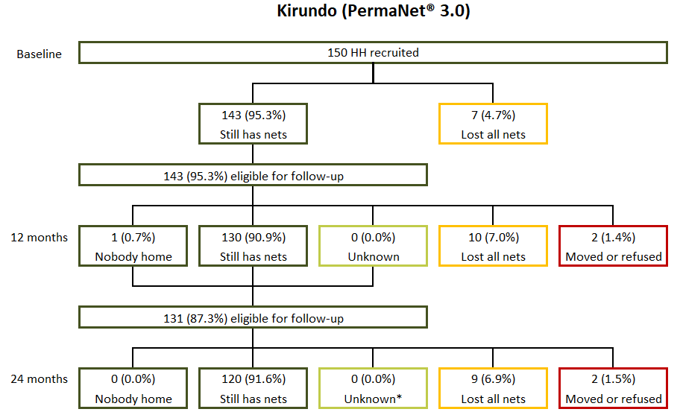

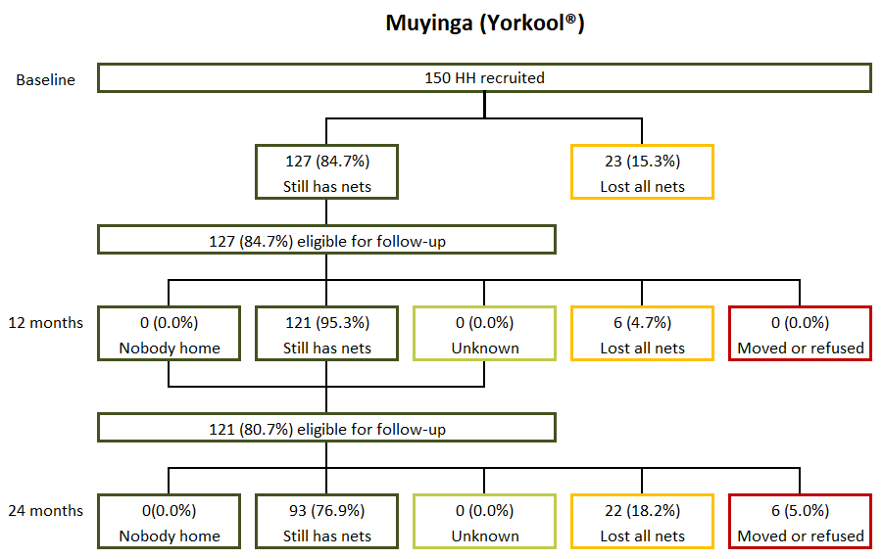

The 300 households visited at baseline reported receiving a total of 700 cohort nets (348 in Kirundo and 352 in Muyinga; Figure 3). Of these 700 nets, 535 (300 in Kirundo and 235 in Muyinga) were present in the household at baseline and were thus tagged as cohort nets for the study.
In Kirundo, during the 12-month follow-up, 247 of the 300 cohort nets eligible from baseline were still in the households and audited; 20 nets had been discarded (also known as attrition due to wear and tear); 23 were given away; six were lost; two had unknown status; and two were not audited because the household moved outside the study area (Figure 3). Of the remaining cohort nets, 249 nets were eligible at the 24-month round, of which 175 were still in the households; 17 had been discarded; 16 had been stolen or given to others, 39 had an unknown status (either due to nobody being home or lack of more precise respondent recall); and two belonged to households that had moved out of the study area.
During the 12-month round in Muyinga, 217 of the 235 cohort nets eligible for follow-up were still in the household, and one net was with a family member elsewhere (Figure 3). A total of 17 nets were no longer present: eight had been discarded; seven had been given away; and two were lost for other or unknown reasons. At 24-months round, 145 of the 218 cohort nets eligible for follow-up were still in the household, 37 nets had been discarded; 20 had been given away to others; six had unknown status; four were lost; and six could not be assessed because the household moved out of the study site or refused to be interviewed.

Figure 3: 24-Month Follow-Up Status of Cohort Nets Recruited at Baseline
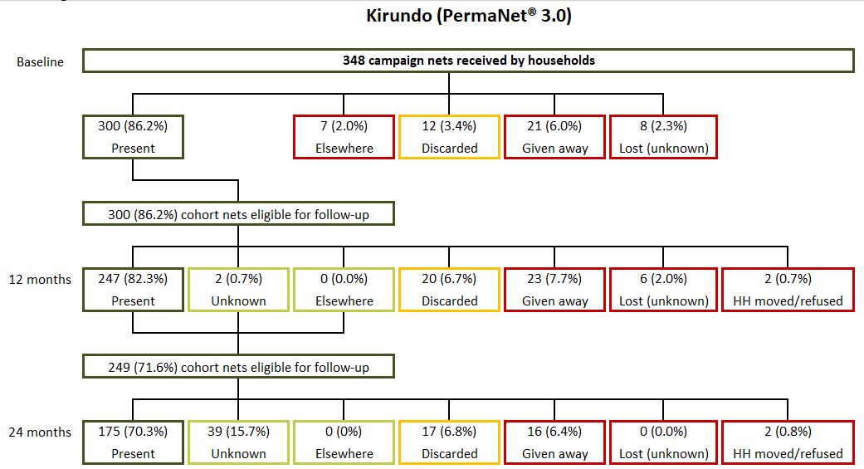

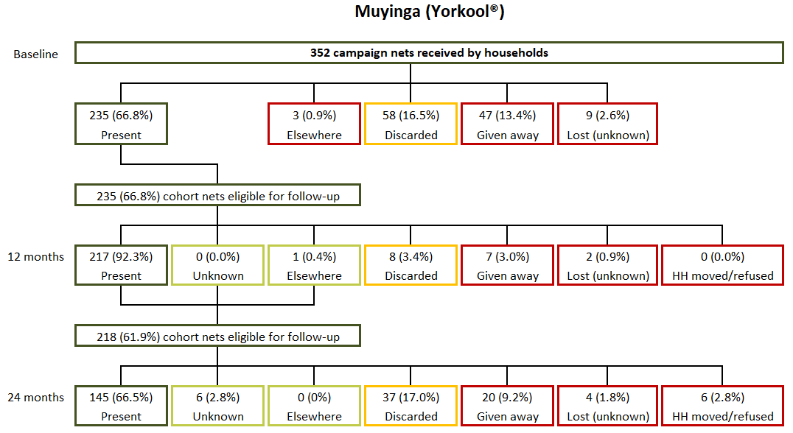

Determinants of Durability
The study assessed household risk factors for physical integrity as well as attitudes and behaviors related to net care and repair. Factors previously shown to be associated with physical integrity can be categorized as household factors, handling factors, and net care and repair attitudes and behaviors.
Household assets are household factors which can contribute indirectly to the durability of nets (Table 6). At baseline and 24 months, household characteristics were similar in both sites, with minor differences. In both sites, at 24 months, more than 80% of houses had roof sheets or tiles; firewood was the most common source of energy used for cooking (greater than 99%); nearly all households had access to safe water (greater than 99%) and access to a latrine (more than 98%); households reporting animal husbandry (greater than 84%) or owning farming land (greater than 89%); and households having land for farming (greater than 89%). Household ownership of a simple mobile phone at endline was higher in Muyinga compared to Kirundo (34% versus 14%, p=0.012).
Table 6: Household Characteristics and Assets
 | Baseline | 24 months
Kirundo | N=150 | N=129
Roof (sheets/ tile) | 77.3% | 80.6%
Cooking fuel (firewood) | 100.0% | 100.0%
Access to safe water | 98.7% | 100.0%
Access to latrine | 98.0% | 98.4%
Radio | 18.0% | 18.6%
Mobile phone | 26.7% | 14.0%
Any transport | 14.0% | 19.4%
Animal husbandry | 80.0% | 86.0%
Owning land for farming | 83.3% | 96.1%
Muyinga | N=150 | N=115
Roof (sheets/ tile) | 78.0% | 84.3%
Cooking fuel (firewood) | 96.0% | 99.1%
Access to safe water | 99.3% | 100.0%
Access to latrine | 99.3% | 99.1%
Radio | 25.3% | 22.6%
Mobile phone | 30.0% | 33.9%
Any transport | 26.0% | 27.0%
Animal husbandry | 75.3% | 83.5%
Owning land for farming | 93.3% | 88.7%

The presence of rodents in the household and cooking practices are both risk factors for physical integrity. Table 7 presents the prevalence of these risk factors in the two study sites. At 24 months, contrary to the 12-month round, food storage in a room used for sleeping was more common among households in Kirundo than in Muyinga (81% compared to 64%; p=0.015). In addition, households in Kirundo also reported cooking in the same room used for sleeping more often than those in Muyinga (18% compared to 3%, p<0.001). Doing so may result in nets potentially being damaged through burning. Storing food or cooking near nets may also attract rodents, which in turn can also increase the likelihood of damage to ITNs. However, both provinces, Kirundo and Muyinga, at 24 months reported very higher presence of rodents in the past six months (100% versus 94%, p=0.002).

Table 7: Prevalence of Household Risk Factors for Damage
 | Baseline | 12 months | 24 months
Kirundo | N=150 | N=140 | N=129
Ever store food in room used for sleeping | 66.0% | 56.4% | 81.4%
Cook in sleeping room
Never | 76.7% | 85.7% | 79.8%
Sometimes | 5.3% | 0.0% | 2.3%
Always | 18.0% | 14.3% | 17.8%
Don't know | 0.0% | 0.0% | 0.0%
Observed rodents in last six months | 99.3% | 96.4% | 100.0%
Muyinga | N=150 | N=127 | N=115
Ever store food in room used for sleeping | 68.7% | 70.9% | 64.3%
Cook in sleeping room
Never | 70.0% | 72.4% | 89.6%
Sometimes | 9.3% | 8.7% | 7.8%
Always | 20.7% | 18.9% | 2.6%
Don't know | 0.0% | 0.0% | 0.0%
Observed rodents in last six months | 96.0% | 96.1% | 93.9%

The type of sleeping place may also affect net durability. Generally, nets used when sleeping on mats or on the ground are more prone to wear and tear than those used over mattresses and bed frames. Figure 4 shows the types used with cohort ITNs by province and study period. At 24 months, 53% of available cohort nets in Kirundo were used over a bed frame, compared to 93% in Muyinga (p=0.003). The result in Kirundo represents a large decrease from baseline to 24 months, from 94% to 53%, contrary to Muyinga where the trend increased from 44% to 93% between baseline and the 24-month round. Further inquiry with the field team and supervisors indicated there may have been data quality issues at baseline. Due to the newly implemented COVID-19 measures, teams had to rely on heads of household to report the location of the net as opposed to observing the net location themselves. This is discussed further in Section 4.2.

Figure 4: Type of Sleeping Place for Cohort ITNs When Used
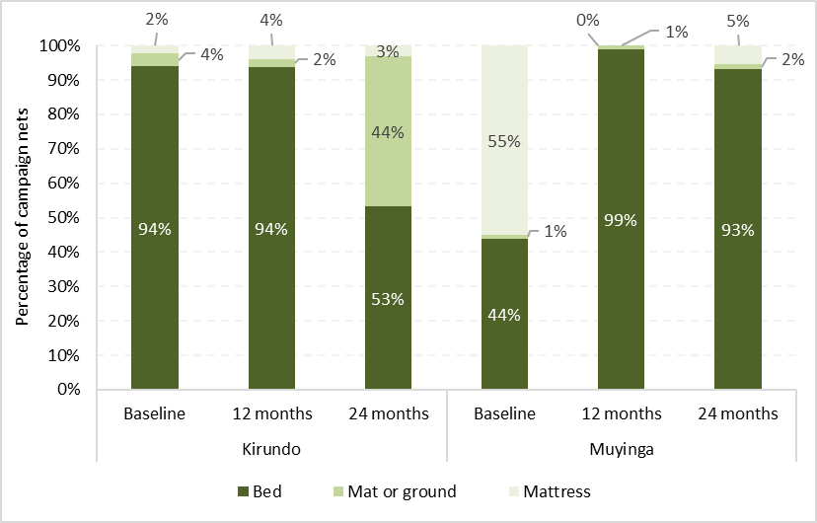
Note: Further inquiry with the field team and supervisors indicated there may have been data quality issues at baseline, which likely explain the variation in type of sleeping place noted from baseline to 24-month round.

In addition to food storage and cooking practices, excessive net handling is a risk factor for durability (Table 8). For example, excessive washing can diminish insecticide effectiveness. By the 24-month round, similar higher proportions of cohort nets in Kirundo and Muyinga (respectively 88% and 84%, difference not statistically significant) were ever washed. The use of detergent and bleach for washing cohort nets was no longer being practiced either in Kirundo or Muyinga (0%). The methods of drying cohort nets on bushes or a fence at the last wash was very similar, with no statistically significant difference, for both provinces, 31% in Kirundo and 34% in Muyinga. Additionally, among hanging cohort nets, 100% in Kirundo and 40% in Muyinga were reported as hanging loose (not folded or tied up) when not in use (p<0.001).
Table 8: Prevalence of Handling Risk Factors for Cohort ITNs
 | Baseline | 12 months | 24 months
Kirundo | N=300 | N=247 | N=175
ITNs ever washed | 36.3% | 66.4% | 88.0%
Among ITNs ever washed: | N=109 | N=164 | N=154
Median number of washes in last six months [IQR] | 2.0 [1.0-2.0] | 1.0 [1.0-2.0] | 2.0 [2.0-3.0]
Used detergent or bleach for last wash | 0.9% | 0.0% | 0.0%
ITNs dried on bush or fence for last wash | 65.1% | 56.1% | 30.5%
Among hanging ITNs: | N=182 | N=173 | N=112
Hanging ITNs are not folded or tied up | 100.0% | 100.0% | 100.0%
Muyinga | N=235 | N=217 | N=145
ITNs ever washed | 28.1% | 60.8% | 84.1%
Among ITNs ever washed: | N=66 | N=132 | N=122
Median number of washes in last six months [IQR] | 2.0 [1.0-2.0] | 2.0 [1.0-2.0] | 2.0 [1.0-2.0]
Used detergent or bleach for last wash | 0.0% | 1.5% | 0.0%
ITNs dried on bush or fence for last wash | 56.1% | 45.5% | 33.6%
Among hanging ITNs: | N=143 | N=132 | N=94
Hanging ITNs are not folded or tied up | 100.0% | 75.8% | 40.4%
IQR: Interquartile Range

Exposure to information on use, care, and/or repair of nets is shown in Table 9. At 24 months, a similar proportion of respondents reported receiving any information in the past six months for both provinces, Kirundo and Muyinga (4% compared to 11%, p=0.113). Among exposed households, a higher proportion in both provinces and across the three survey rounds reported receiving messages through interpersonal communication (as opposed to media only). At 24 months, household in both provinces, Kirundo and Muyinga respectively, reported to recall exposure messages on the following aspects (differences between sites for each indicator are not statistically significant at the 5% level): to use a net every night (100%), to hang nets (80% and 92%) to care for nets (100% and 92%), to repair nets (20% and 46%) and those nets prevent malaria (100% and 85%).
Table 9: Respondent Exposure to Messages About Nets in Last 6 Months
 | Baseline | 12 months | 24 months
Kirundo | N=150 | N=140 | N=129
Any exposure in last six months | 22.0% | 12.1% | 3.9%
Among those exposed: | N=33 | N=17 | N=5
Mean number of sources among exposed* | 1.5 | 1.1 | 2.0
Type of media source among exposed
Media only | 6.1% | 0.0% | 0.0%
Interpersonal communication only | 81.8% | 100.0% | 80.0%
Both | 12.1% | 0.0% | 20.0%
Messages recalled among exposed
“Use net (every) night” | 100.0% | 100.0% | 100.0%
“Hang net” | 100.0% | 94.1% | 80.0%
“Care for net” | 97.0% | 100.0% | 100.0%
“Repair net” | 36.4% | 58.8% | 20.0%
“Nets prevent malaria” | 93.9% | 100.0% | 100.0%
Muyinga | N=150 | N=127 | N=115
Any exposure in last six months | 41.3% | 32.3% | 11.3%
Among those exposed: | N=62 | N=41 | N=13
Mean number of sources among exposed* | 1.1 | 1.1 | 1.2
Type of media source among exposed
Media only | 1.6% | 4.9% | 7.7%
Interpersonal communication only | 98.4% | 95.1% | 92.3%
Both | 0.0% | 0.0% | 0.0%
Messages recalled among exposed
“Use net (every) night” | 85.5% | 53.7% | 100.0%
“Hang net” | 75.8% | 73.2% | 92.3%
“Care for net” | 61.3% | 48.8% | 92.3%
“Repair net” | 6.5% | 7.3% | 46.2%
“Nets prevent malaria” | 33.9% | 41.5% | 84.6%

Data on household attitudes toward nets and net care and repair were captured in the form of Likert score questions (i.e., respondents were asked the extent to which they agreed with certain statements). Net use questions sought to understand the extent to which respondents believed they could obtain enough nets for their household, hang nets, use nets consistently, and get children in the household to use nets consistently. Questions on attitudes to net care and repair sought to understand respondent beliefs about the value of nets, their capacity to keep nets in good condition and to repair net damage. These questions were converted into two summary scores by first recoding the four-level Likert scale to have a value of -2 for “strongly disagree”, -1 for “disagree”, +1 for “agree” and +2 for “strongly agree”. The values for each response were then summed and divided by the number of statements to calculate an overall attitude score. An average score greater than +1 is interpreted as a household respondent with favorable attitudes to a given topic.
Table 10 summarizes the mean attitude scores and percentage of respondents with favorable attitudes for both nets and net care/repair. At 24 months, only 5% of respondents in Kirundo had a favorable attitude toward nets compared to 46% in Muyinga, p<0.001. In Kirundo province, the percentage with positive attitudes toward net care and repair decreased over time from baseline to 24 months (34% at baseline, 14% at the 12-month, and 1% at the 24-month round) whereas it increased from baseline (21%) to 24 months (30%) in Muyinga. At 24 months, the positive attitude toward net care and repair was significantly different between Kirundo and Muyinga (1% versus 30%, p<0.001).
Table 10: Respondent Attitudes Toward Nets and Net Care & Repair
 | Baseline | 12 months | 24 months
Kirundo | N=150 | N=140 | N=129
Attitude score: Nets
Mean (95% CI) | 0.48 (0.30-0.67) | 0.51 (0.36-0.66) | 0.13 (0.01-0.24)
Percentage of respondents with score > 1.0 | 18.7% | 10.7% | 5.4%
Attitude score: Net care and repair
Mean (95% CI) | 0.80 (0.56-1.04) | 0.69 (0.47-0.90) | 0.17 (0.10-0.25)
Percentage of respondents with score > 1.0 | 34.0% | 13.6% | 0.8%
Muyinga | N=150 | N=127 | N=115
Attitude score: Nets
Mean (95% CI) | 0.92 (0.72-1.12) | 0.83 (0.56-1.11) | 0.92 (0.72-1.11)
Percentage of respondents with score > 1.0 | 58.0% | 38.6% | 46.1%
Attitude score: Net care and repair
Mean (95% CI) | 0.60 (0.47-0.74) | 0.46 (0.29-0.64) | 0.82 (0.71-0.94)
Percentage of respondents with score > 1.0 | 20.7% | 11.0% | 30.4%

Household experiences with repairing holes in nets are shown in Table 11. At the 24-month round, 87% of respondents in Kirundo and 80% of respondents in Muyinga reported finding holes in their nets. The proportion of respondents who discussed net care and repair was only 2% in Kirundo compared to 10% in Muyinga at 24 months (p=0.074). It was also noticed that the proportion of respondents who discussed net care and repair decreased between the 12-and 24-month rounds (31% versus 2% in Kirundo and 32% versus 10% in Muyinga). However, discussion was not always predictive of whether households repaired holes. At 24 months, a higher proportion of households in Muyinga repaired nets compared to Kirundo 17% versus 2%, p<0.001).
Table 11: Household Net Care and Repair Experience
 | Baseline | 12 months | 24 months
Kirundo | N=150 | N=140 | N=129
Ever experienced holes in a net | 72.0% | 87.9% | 86.8%
Discussed net care and repair in last six months | 16.7% | 31.4% | 2.3%
Among households experiencing holes: | N=108 | N=123 | N=112
Ever repaired net | 0.0% | 0.8% | 1.8%
Muyinga | N=150 | N=127 | N=115
Ever experienced holes in a net | 61.3% | 83.5% | 80.0%
Discussed net care and repair in last six months | 32.0% | 31.5% | 9.6%
Among households experiencing holes: | N=92 | N=106 | N=92
Ever repaired net | 12.0% | 8.5% | 17.4%

Net Ownership and Net Use
At each study round, all mosquito nets present in selected households are recorded, including nets from sources other than the 2019 mass distribution campaign (referred to as non-cohort nets). The status and reported recent use of cohort (Table 12) and non-cohort nets (Table 13) were recorded to understand net use patterns.
At the 24-month round, 39% of cohort nets were found hanging and tied up in Muyinga, compared 0% in Kirundo (p<0.001). Furthermore, the proportion of cohort nets hanging above the sleeping space but not tied up was significantly higher in Kirundo than in Muyinga (64% versus 26%, p=0.003). When not hanging, cohort nets were most often not stored away (34% in Kirundo and 24% in Muyinga). At the 24-month round, the proportion of cohort nets which had ever been used was high, at more than 90% in both provinces. The proportion of cohort nets used every night in the last week were very similar for both provinces, at 61% and 62%.
Table 12: Status and Reported Use of Cohort Nets in the Household
 | Baseline | 12 months | 24 months
Kirundo | N=300 | N=247 | N=175
Cohort net status
Found hanging and tied up | 0.0% | 0.0% | 0.0%
Found hanging, untied | 60.7% | 70.0% | 64.0%
Not hanging and not stored away | 15.3% | 23.1% | 34.3%
Stored away unpacked | 15.0% | 2.4% | 1.1%
Stored away in a package | 9.0% | 4.0% | 0.6%
Temporarily unavailable during visit | 0.0% | 0.4% | 0.0%
Net ever used | 75.0% | 91.1% | 94.3%
Net used last night | 60.3% | 70.4% | 63.4%
Net used every night last week | 58.0% | 70.4% | 62.3%
Muyinga | N=235 | N=217 | N=145
Cohort net status
Found hanging and tied up | 0.0% | 14.7% | 38.6%
Found hanging, untied | 60.9% | 46.1% | 26.2%
Not hanging and not stored away | 9.8% | 23.5% | 24.1%
Stored away unpacked | 28.5% | 15.2% | 11.0%
Stored away in a package | 0.9% | 0.5% | 0.0%
Temporarily unavailable during visit | 0.0% | 0.0% | 0.0%
Net ever used | 83.8% | 86.2% | 90.3%
Net used last night | 59.6% | 60.8% | 62.8%
Net used every night last week | 57.0% | 60.8% | 60.7%

Household ownership of non-cohort nets and sources of these nets are presented in Table 13. At 24 months, the proportion of households with non-cohort nets was 4% in Kirundo, a six percentage-point decrease from the previous year, while it was 27% in Muyinga, a seven percentage-point increase from the previous year (p<0.001, indicating statistical difference between the two provinces). Across the three assessment rounds, the most common sources for non-cohort nets in Muyinga were antenatal care (ANC) visits and other public sources (both at 47% for each reported source), while 6% did not recall the source for their net. In Kirundo, at 24 months, the main source of non-cohort nets was ANC visits at 80%, followed by other public sources at 20%.
Table 13: Ownership and Source of Non-Cohort Nets
 | Baseline | 12 months | 24 months
Kirundo | N=150 | N=140 | N=129
Households with any non-cohort nets | 6.7% | 10.0% | 3.9%
Non-cohort net sources | Net  N=11 | Net  N=18 | Net  N=5
ANC visit | 36.4% | 22.2% | 80.0%
Previous mass campaign | 18.2% | 22.2% | 0.0%
Other public source* | 27.3% | 22.2% | 20.0%
Private sector | 9.1% | 0.0% | 0.0%
Other/doesn't recall** | 9.1% | 33.3% | 0.0%
Muyinga | N=150 | N=127 | N=115
Households with any non-cohort nets | 18.7% | 19.7% | 27.0%
Non-cohort net sources | Net N=31 | Net  N=28 | Net N=32
ANC visit | 48.4% | 46.4% | 46.9%
Previous mass campaign | 19.4% | 7.1% | 0.0%
Other public source* | 25.8% | 39.3% | 46.9%
Private sector | 3.2% | 0.0% | 0.0%
Other/doesn't recall** | 3.2% | 7.1% | 6.3%
* Other public source: Includes other (non-ANC) public health facility visits, community health initiatives, and immunization campaigns
** Other/doesn't recall: Includes family/friends, non-governmental, and faith-based organizations

During the 24-month round, a total of 37 non-cohort nets (5 in Kirundo and 32 in Muyinga) were audited in study households. Of the nets recorded, 21 were Yahe®, 9 PermaNet® 2.0, 4 PermaNet® 3.0, 1 Yorkool®, 1 Olyset® Plus, and one unbranded net. At 24-month round, many nets were found hanging and untied (60% in Kirundo and 41% in Muyinga) (Table 14). For non-cohort nets which were not hanged and not stored away at 24-month round, none were recorded in Muyinga, while in Kirundo 20% were still recorded (p=0.032). At least approximately 78-80% of non-cohort nets were ever used by the time of the 24-month round in both provinces. More than half (60%) were used the night prior to the survey as well as every night during the prior week in both provinces.
Table 14: Status and Reported Use of Non-Cohort Nets in the Household
 | Baseline | 12 months | 24 months
Kirundo | N=11 | N=18 | N=5
Non-cohort net status
Found hanging and tied up | 0.0% | 0.0% | 0.0%
Found hanging, untied | 81.8% | 55.6% | 60.0%
Not hanging and not stored away | 0.0% | 22.2% | 20.0%
Stored away unpacked | 0.0% | 22.2% | 20.0%
Stored away in a package | 0.0% | 0.0% | 0.0%
Temporarily unavailable during visit | 18.2% | 0.0% | 0.0%
Net ever used | 81.8% | 61.1% | 80.0%
Net used last night | 81.8% | 55.6% | 60.0%
Net used every night last week | 81.8% | 55.6% | 60.0%
Muyinga | N=31 | N=28 | N=32
Non-cohort net status
Found hanging and tied up | 0.0% | 7.1% | 18.8%
Found hanging, untied | 41.9% | 42.9% | 40.6%
Not hanging and not stored away | 3.2% | 10.7% | 0.0%
Stored away unpacked | 45.2% | 25.0% | 21.9%
Stored away in a package | 3.2% | 14.3% | 15.6%
Temporarily unavailable during visit | 6.5% | 0.0% | 3.1%
Net ever used | 83.9% | 71.4% | 78.1%
Net used last night | 38.7% | 50.0% | 59.4%
Net used every night last week | 38.7% | 50.0% | 59.4%

As another potential factor for durability, the studies also captured data on household members using cohort and non-cohort nets the night before the interview (Tables 15 and 16). At the 24-month round, the proportion of cohort nets used by adult only was 63% in Kirundo, significantly higher than the proportion in Muyinga at 43% (p=0.004). The trend was inversed for cohort nets used by children sharing with adults, with a reported proportion of 54% in Muyinga, which was higher than the reported proportion of 32% in Kirundo (p=0.005). However, non-cohort nets were most used by adults sharing with children between the ages of 0 – 9 years in both provinces (100% in Kirundo and 79% in Muyinga). The exclusive use of nets (cohort and non-cohort) by children was rare, accounting for less than 10% in all cases across all rounds (even 0% for non-cohort nets at the 24-month round).

Table 15: Use of Cohort Nets by Household Members Among Nets Used the Previous Night
 | Baseline | 12 months | 24 months
Kirundo | N=181 | N=174 | N=111
Cohort nets
Used by child(ren) only | 5.5% | 3.4% | 5.4%
Used by child(ren) sharing with adult(s) | 40.9% | 40.2% | 31.5%
Used by adult(s) only | 53.6% | 56.3% | 63.1%
Muyinga | N=140 | N=132 | N=91
Cohort nets
Used by child(ren) only | 2.9% | 4.5% | 3.3%
Used by child(ren) sharing with adult(s) | 60.7% | 49.2% | 53.8%
Used by adult(s) only | 36.4% | 46.2% | 42.9%

Table 16: Use of Non-Cohort Nets by Household Members Among Nets Used the Previous Night
 | Baseline | 12 months | 24 months
Kirundo | N=9 | N=10 | N=3
Non-cohort nets
Used by child(ren) only | 0.0% | 10.0% | 0.0%
Used by child(ren) sharing with adult(s) | 66.7% | 60.0% | 100.0%
Used by adult(s) only | 33.3% | 30.0% | 0.0%
Muyinga | N=12 | N=14 | N=19
Non-cohort nets
Used by child(ren) only | 0.0% | 7.1% | 0.0%
Used by child(ren) sharing with adult(s) | 58.3% | 71.4% | 78.9%
Used by adult(s) only | 41.7% | 21.4% | 21.1%

Access to ITNs is an important determinant of ITN use. People need access before they can use an ITN. Access can be measured at the household and population levels. Household access is defined as the proportion of households with one ITN for every two people in the household. Population access is defined as the proportion of people who could sleep under an ITN, assuming each ITN in a household was used by two people. The NMCP has a target of reaching 80% household access to cohort ITNs. Table 17 shows the results of household and population ITN access and use.
In Kirundo, household access to any ITN decreased from 67% at baseline to 48% at the 24-month round, and population access decreased from 81% to 68% over the same period. In Muyinga, household access to any ITN decreased from 48% at baseline to 36% at the 24-month round, while population access was relatively unchanged (66% at baseline and 61% at the 24-month round). However, at 24 months, household access considering only cohort ITN was significantly higher in Kirundo compared to Muyinga (46% in Kirundo and 31% in Muyinga, p=0.025). Population access of cohort nets at 24 months followed the same trend, 67% in Kirundo and 52% in Muyinga (p=0.013).
Table 17: Household and Population ITN Access and ITN Use
 | Baseline | 24 months
Kirundo
Household access | N=150 | N=129
All ITNs | 66.7% | 48.1%
Cohort ITNs (PermaNet® 3.0) | 64.0% | 45.7%
Other ITNs | 0.7% | 0.0%
Population access | N=624 | N=553
All ITNs | 80.9% | 68.4%
Cohort ITNs (PermaNet® 3.0) | 79.6% | 67.1%
Other ITNs | 3.5% | 1.8%
Population use | N=624 | N=553
All ITNs | 63.3% | 39.8%
Cohort ITNs (PermaNet® 3.0) | 59.6% | 38.2%
Other ITNs | 3.7% | 1.6%
Muyinga
Household access | N=150 | N=115
All ITNs | 48.0% | 35.7%
Cohort ITNs (Yorkool) | 41.3% | 31.3%
Other ITNs | 2.7% | 1.7%
Population access | N=692 | N=542
All ITNs | 65.9% | 61.3%
Cohort ITNs (Yorkool) | 61.6% | 52.2%
Other ITNs | 7.9% | 11.4%
Population use | N=692 | N=542
All ITNs | 55.1% | 48.3%
Cohort ITNs (Yorkool) | 51.3% | 39.3%
Other ITNs | 3.8% | 9.0%

Durability of Cohort ITNs
The durability of ITNs can be conceptualized as two components: attrition, or nets that are no longer present in the household; and the physical integrity of nets that are available for use in the household. Table 18 presents results for the attrition of cohort nets at baseline as well as the 12- and 24-month rounds. Of the 348 cohort nets in Kirundo and 352 in Muyinga, 299 and 339 cohort nets respectively were included in the attrition calculation at the 24-month period. The nets which were not included either belonged to households that were not interviewed (nobody was home, had refused to be interviewed, or had moved outside of the study area) or were said to be with family elsewhere and thus their actual status could not be determined.
In Kirundo, total cohort net attrition increased from 14% at baseline to 27% at the 12-month round and to 42% at the 24-month round (Table 18). In both study periods, the most common reason was that they were given away to others (from 6% at baseline to 13% at 12 months and to 20% at the 24-month round). At the 24-month round, an additional 16% of nets was discarded (also known as attrition due to wear and tear).
In Muyinga, total attrition increased from 33% at baseline to 38% at the 12-month round and to 57% at 24 months. The main reason for attrition was reported as “nets discarded,” which increased from 19% at the 12-month round to 30% at the 24-month round (Table 18).
Total attrition rates increased over time in both provinces. The proportions noted at the 24-month round showed statistically significant differences between the two locations, at 42% in Kirundo compared to 57% in Muyinga, p=0.037. Additionally, the proportion of nets discarded was higher in Muyinga than in Kirundo, at 31% compared to 16%, p=0.021. Figure 5 displays these trends for all provinces.
Table 18: Cohort ITN Attrition
 | Baseline | 12 months | 24 months
Kirundo | N=348 | N=337 | N=299
Total cohort ITN attrition | 13.8% | 26.7% | 41.5%
ITNs given away to others | 6.0% | 13.1% | 20.1%
ITNs discarded | 3.4% | 9.5% | 16.4%
ITNs lost for other/unknown reason | 2.3% | 4.2% | 5.0%
Muyinga | N=352 | N=348 | N=339
Total cohort ITN attrition | 33.2% | 37.6% | 57.2%
ITNs given away to others | 13.4% | 15.5% | 21.8%
ITNs discarded | 16.5% | 19.0% | 30.4%
ITNs lost for other/unknown reason | 2.6% | 3.2% | 5.0%
Given away to others includes nets that were stolen, given to non-household members, and recorded as being with family members elsewhere at baseline, e.g., at school.
Discarded (also known as attrition due to wear and tear): includes nets that were destroyed, thrown away, or used for other purposes

Figure 5: Trends in All-Cause Attrition and Attrition due to Wear and Tear (discarded nets)
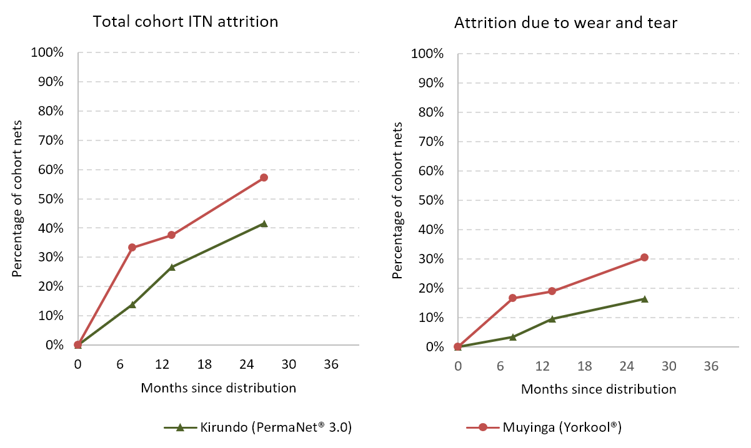
Measuring the second component of ITN durability, physical integrity, is a primary study objective. Data from the ITN hole assessment was transformed into the proportionate Hole Index (pHI) for each ITN using standard weights defined by WHO:
pHI = Number of size 1holes + (No. of size 2 holes x 23) + (No. of size 3 holes x 196) + (No. of size 4 holes x 576)

Based on the pHI value, ITNs were categorized as “good,” “serviceable,” or “torn” as defined below. Note that “good” is a subset of all “serviceable” ITNs.

Good: pHI ≤ 64 (corresponding to a total hole surface area < 0.01m²)
Serviceable: pHI ≤ 642 (total hole surface area ≤ 0.1 m²)
Torn: pHI > 642 (total hole surface area > 0.1m²)
Table 19 reports the physical integrity results of the nets that were in the household during baseline and follow-up visits. Nets that were in the household but were temporarily unavailable due to being washed or locked away were not included in the assessment. The proportion of nets with any holes increased in both provinces after two years of use, from 54 to 90% in Kirundo and from 56 to 89% in Muyinga from baseline to the 24-month round. Both provinces saw a decrease in the proportion of nets in good condition over time, from 67% at baseline to 52% at the 12-month round and to 27% at the 24-month round in Kirundo; and from 62% at baseline to 47% at the 12-month round and to 32% at the 24-month round in Muyinga. After two years of field monitoring, the proportion of nets in good condition decreased, while the proportion of nets classified as torn increased. The proportion of serviceable nets decreased from 84% to 51% from baseline to the 24-month round in Kirundo, and from 79% to 56% during the same timeframe in Muyinga. At the 24-month round, however, none of the differences between the two provinces was statistically significant.
Table 19: Physical Integrity of Observed Cohort ITNs
 | Baseline | 12 months | 24 months
Kirundo | N=300 | N=246 | N=175
Cohort ITN with any holes | 54.3% | 76.8% | 90.3%
ITNs classified as “Good” | 67.0% | 52.4% | 26.9%
ITNs classified as “Too torn” | 16.0% | 27.2% | 48.6%
ITNs classified as “Serviceable” | 84.0% | 72.8% | 51.4%
Among ITNs with any holes: | N=163 | N=189 | N=158
Median pHI for ITNs with any holes | 182.0 | 203.0 | 773.5
Muyinga | N=235 | N=217 | N=145
Cohort ITN with any holes | 56.2% | 73.7% | 89.0%
ITNs classified as “Good” | 61.7% | 46.5% | 32.4%
ITNs classified as “Too torn” | 20.9% | 33.6% | 44.1%
ITNs classified as “Serviceable” | 79.1% | 66.4% | 55.9%
Among ITNs with any holes: | N=132 | N=160 | N=129
Median pHI for ITNs with any holes | 247.5 | 389.0 | 632.0

To understand the ways in which nets were damaged in households, prior to the hole assessment, respondents were asked to state the causes of the holes in their cohort nets. The responses are captured in Figure 6. At the 24-month round (similarly to the 12-month round), the most common cause of holes in Kirundo was from being torn on an object or from pulling (93% in Kirundo and 26% in Muyinga, p<0.001) while the most common cause of holes in Muyinga was from damage by rodents (81% in Muyinga and 39% in Kirundo, p<0.001). The other causes of damage varied across the study sites: for example, a higher proportion of nets were damaged due to a seam opening in Kirundo (42%) compared to Muyinga (2%; p<0.001). Still at the 24-month round, the proportion of nets damaged by burning in Kirundo was 6% compared to 2% in Muyinga (not statistically significant). Other reported damage mechanisms were stated for 1-8% of cohort ITNs in the two provinces and included reports of intentionally cutting nets to shorten them.

Figure 6: Types of Damage Mechanisms Reported for Damaged Cohort ITNs

ITN survivorship combines the two aspects of durability (attrition and physical integrity) and is defined as the proportion of cohort ITNs originally received that are still in the possession of the household and in serviceable condition. As with attrition and physical durability, cohort nets that were said to be used by family elsewhere (e.g., taken to school) were not included in these calculations. Additionally, nets lost for any reason other than attrition due to wear and tear, and nets that were in the home but temporarily unavailable for observation, were not included. Table 20 presents ITN survival estimates. After 26 months of field use, 38% of cohort nets in Kirundo and 31% in Muyinga had survived. Among ever-used nets that were present in the home, survival was 51% in Kirundo and only 49% in Muyinga. However, none of the differences between the two provinces were statistically significant.
Table 20: Cohort ITNs Surviving in Serviceable Condition
 | Baseline | 12 months | 24 months
Kirundo
All cohort nets | N=312 | N=283 | N=224
Survival estimate | 80.8% | 61.8% | 38.4%
95% CI | --- | 50.2%-72.2% | 27.1%-51.1%
Cohort nets ever-used and present | N=225 | N=224 | N=165
Survival estimate | 80.0% | 69.6% | 50.9%
95% CI | --- | 59.2%-78.4% | 39.2%-62.5%
Muyinga
All cohort nets | N=293 | N=289 | N=248
Survival estimate | 63.5% | 48.8% | 30.6%
95% CI | 48.2%-76.4% | 36.1%-61.6% | 22.0%-41.0%
Cohort nets ever-used and present | N=197 | N=187 | N=131
Survival estimate | 77.2% | 59.4% | 48.9%
95% CI | 62.3%-87.4% | 48.6%-69.3% | 37.6%-60.2%

Figure 7 plots ITN survival against hypothetical survival curves for nets lasting one to four years. Results suggest that the median useful life for PermaNet® 3.0 is 1.7 years in Kirundo and 1.3 years for Yorkool® nets in Muyinga, based on the interpolated position of a data point on a horizontal line between the two adjacent median survival curves. Table 21 displays estimated median survival times using the most recent two data points as another method to calculate the survival estimate. Using this method, the median useful life for PermaNet® 3.0 nets in Kirundo was estimated at 1.7 years (95% confidence interval: 1.1-2.3 years) and for Yorkool® nets in Muyinga was 1.3 years (95% confidence interval: 0.8-1.8 years).
Figure 7: Estimated ITN Survival
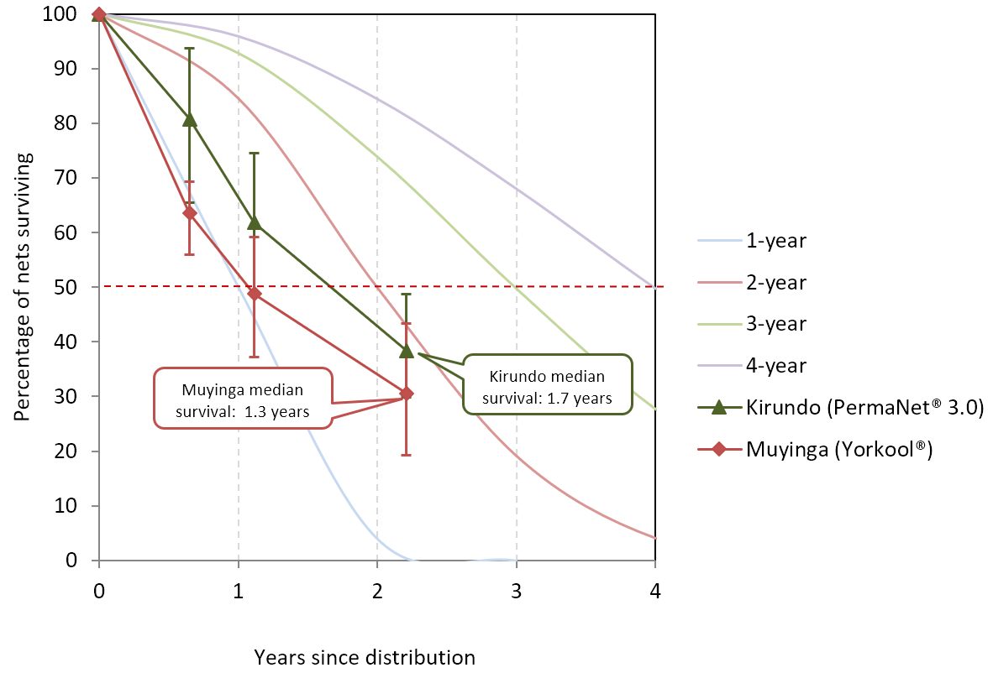
Note: Error bars show 95% confidence intervals.

Table 21: Estimated Median Survival of ITNs in Years Using Different Methods
 | 12 months | 24 months
Kirundo (PermaNet® 3.0) | N=283 | N=224
Estimated from Figure 7 | 1.4 | 1.9
Calculated from last two data points (95% CI) | - | 1.7 (1.1-2.3)
Muyinga (Yorkool®) | N=289 | N=248
Estimated from Figure 7 | 1.1 | 1.7
Calculated from last two data points (95% CI) | - | 1.3 (0.8-1.8)
When data were analyzed as survival analysis in a Kaplan-Meier plot (Figure 8), PermaNet® 3.0 ITNs in Kirundo (blue line), showed a trend of higher survival compared to Yorkool® ITNs in Muyinga (red line), p<0.001.
Figure 8: Kaplan-Meier Curves of Physical Survival with 95% Confidence Intervals
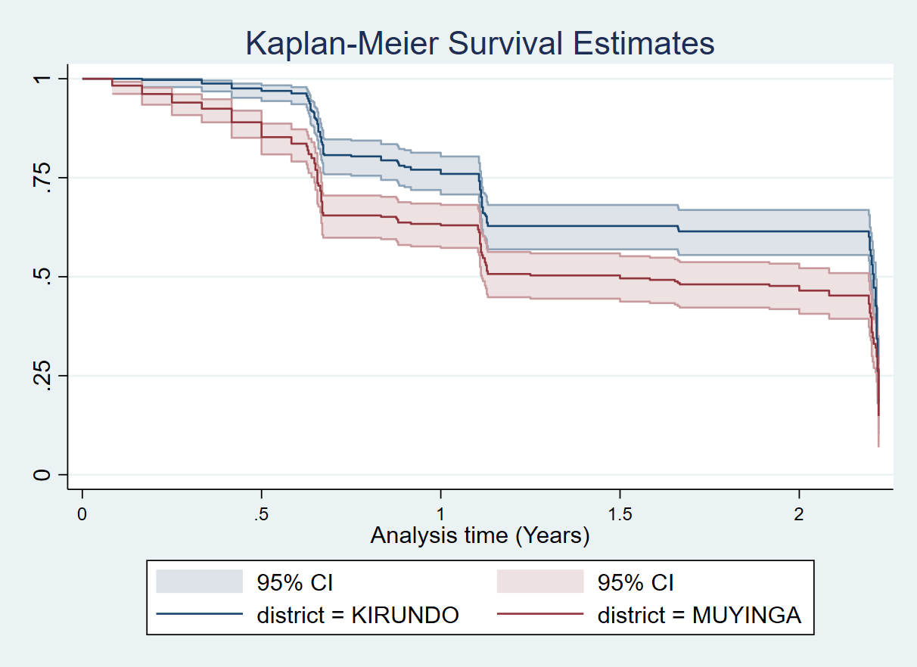

Insecticidal Effectiveness of Campaign Nets
The outcomes of insecticidal effectiveness were based on bioassay results using the standard WHO cone test, where the 60-minute knock-down (KD60) and the 24-hour mortality rate (mortality) were measured. The two variables from these tests were combined into the following outcome measures:
Optimal effectiveness: KD60 ≥ 95% or mortality ≥ 80%
Minimal effectiveness: KD60 ≥ 75% or mortality ≥ 50%

3.5.1 Gasoho/Yorkool (Deltamethrin)

The Yorkool® brand is a pyrethroid-only ITN with an active ingredient of deltamethrin. Cone bioassays were performed with an insectary-reared pyrethroid susceptible strain (An. gambiae Kisumu). Yorkool® samples withdrawn at baseline had been in the field for 8 months. Nets were again extracted during the second round of data collection at 13 months and again at 27 months. Insecticidal effectiveness outcomes for Yorkool were based on the standard WHO cone test results, where 60-minute knock- down (KD60) and 24-hour mortality were measured. The two variables from these tests were combined into the following outcome measures:
Optimal effectiveness: KD60 ≥ 95% or 24-hour mortality ≥ 80%
Minimal effectiveness: KD60 ≥ 75% or 24-hour mortality ≥ 50%

At 24-month round, 100% of Yorkool® samples had optimal effectiveness, with mean mortality 96%. The KD60 decreased from 81% at 12-month round to 58% at 24-month round, which was below the WHO threshold (figure 9).

Table 22: Yorkool® Cone Bioassay Results for Residual Efficacy of Pyrethroid
Gashoho/ Yorkool® | Baseline | 12 Month | 24 Month
Susceptible mosquito strain  (An. gambiae Kisumu) | Mean (95% CI)  N=30 | Mean (95% CI)  N=30 | Mean (95% CI)  N=30
Knock down 60 minutes | 71.6 (64.3-78.8) | 81.4 (78.71-84.12) | 57.67(54.81-60.48)
Mortality 24 hours | 86.13 (84.0-88.2) | 99.5 (98.64-100) | 95.91(94.64-96.96)
Optimal effectiveness | 100.0 (-) | 100.0 (-) | 100.0 (-)
Minimal effectiveness | 100.0 (-) | 100.0 (-) | 100.0 (-)

Figure 9: Box Plot of Cone Bioassay Results for Residual Efficacy of Pyrethoid
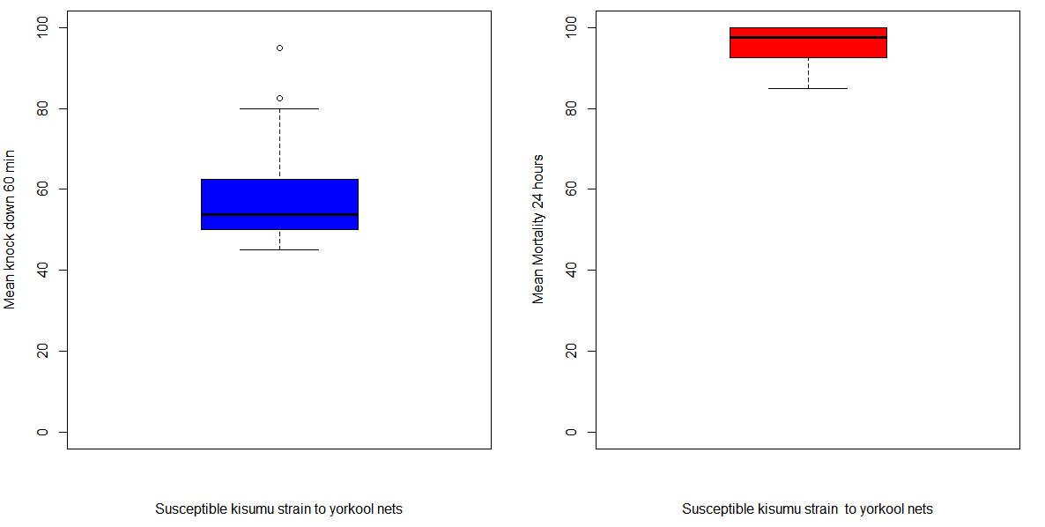
The box plot shows the median (line), interquartile range (box), adjacent values (whiskers) and outliers (circles.)

3.5.2 Vumbi/ Permanet 3.0 (Deltamethrin and Pbo Synergist)
The PermaNet® 3.0 brand is a pyrethroid + PBO synergist ITN with active ingredient deltamethrin only on the net sides and deltamethrin + PBO on the roof. Cone bioassays were performed with an insectary-reared pyrethroid susceptible strain (Anopheles gambiae s.s. Kisumu), a reduced susceptibility to permethrin strain (An. gambiae Kisumu RSP), and Nyanza-Lac wild An. gambiae s.l. strain. Field ITNs were tested against untreated netting as a negative control. Five pyrethroid + PBO nets and four new pyrethroid-only nets were also tested as positive controls. KD60 and mortality results are presented for susceptible and resistant mosquito strains separately, and for PermaNet® 3.0 sides and roof pieces separately in Table 23 and figure 10 below.
All the PermaNet® 3.0 field samples achieved optimal effectiveness against pyrethroid-susceptible mosquitoes at 24 months (Figure 10.1) with 100% mortality for both side samples and roof samples. Mortality for the negative control was under 5%, as expected (Table 23). The PermaNet® 3.0 samples also demonstrated optimal effectiveness against pyrethroid-resistant mosquitoes An. gambiae Kisumu RSP, and An. gambiae s.l. Nyanza-Lac (Figure 10.2 and 10.3). Roof samples, incorporating PBO, performed similarly to side samples for the two resistant strains.
All positive control achieved optimal effectiveness against pyrethroid-susceptible and pyrethroid-resistant Kisumu strains (figure 10.1.1, 10.1.2, 10.2.1, and 10.2.2).

Table 23: Permanet 3.0® Cone Bioassay Results for Residual Efficacy of Pyrethroid and PBO
Vumbi / PermaNet 3.0 | Baseline | 12 Month | 24 Month
Susceptible mosquito strain ( An. gambiae Kisumu) | Mean (95% CI) | Mean (95% CI) | Mean (95% CI)
Sides (pyrethroid-only) | N=30 | N=30 | N=30
Knock down 60 minutes | 80.2 (76.2-84.2) | 79.9 (77.64-82.10) | 79.33(76.54-81.93)
Mortality 24 hours | 97.3 (96.1-98.6) | 99.7 (99.3-100) | 100.0 (99.9-100)
Roof (pyrethroid + PBO) | N=30 | N=30 | N=30
Knock down 60 minutes | 90.2 (86.0-94.4) | 81.0 (79.26-82.87) | 86.22(83.80-88.41)
Mortality 24 hours | 98.0 (97.1-98.9) | 100.0 (99.9-100) | 100.0 (99.9-100)
Untreated control | N=6 | N=6 | N=3
Knock down 60 minutes | 0.0 | 0.0 | 0.0
Mortality 24 hours | 0.76(0.1-1.4) | 0.41(0.0-1.5) | 1.8(0.05-9.72)
Positive Control (pyrethroid + PBO) | - | -
Sides (pyrethroid-only) | - | - | N=5
Knock down 60 minutes | - | - | 96.00(91.50-98.52)
Mortality 24 hours | - | - | 100
Roof (pyrethroid + PBO) | - | - | N=5
Knock down 60 minutes | - | - | 97.33(93.31-99.37)
Mortality 24 hours | - | - | 100
Positive Control (New pyrethroid-only) | - | - | N=4
Knock down 60 minutes | - | - | 94.37(95.57-99.85)
Mortality 24 hours | - | - | 100
Resistant mosquito strain  (An. gambiae Kisumu RSP) | Mean (95% CI) | Mean (95% CI) | Mean (95% CI)
Sides (pyrethroid-only) | N=30 | N=30 | N=30
Knock down 60 minutes | 75.4 (70.0-80.8) | 75.8 (73.54-78.19) | 69.89(66.77-72.87)
Mortality 24 hours | 97.0 (95.7-98.3) | 100 (100) | 98.72(98.09-99.19)
Roof (pyrethroid + PBO) | N=30 | N=30 | N=30
Knock down 60 minutes | 85.2 (81.1-89.3) | 78.8 (76.94-80.65) | 73.55(70.54-76.41)
Mortality 24 hours | 98.0 (96.8-99.3) | 99.7(99.18-100) | 99(98.11-99.54)
Positive Control (pyrethroid + PBO)
Sides (pyrethroid + PBO) | - | N=4 | N=5
Knock down 60 minutes | - | 85.0 (81.94- 88.06) | 86.00(79.40-91.12)
Mortality 24 hours | - | 100 | 100
Roof (pyrethroid + PBO) | - | N=4 | N=5
Knock down 60 minutes | - | 87.5(80.83-94.17) | 92.00(86.44-95.80)
Mortality 24 hours | - | 100 | 100
Positive Control (New pyrethroid-only) |  |  | N=4
Knock down 60 minutes | - | - | 85.63(79.22-90.66)
Mortality 24 hours | - | - | 98.75(95.57-99.85)
Untreated control | N=6 | N=6 | N=3
Knock down 60 minutes | 0.0 | 0.0 | 0.0
Mortality 24 hours | 1.3(0.2-2.3) | 0.0 | 2.2(0.01-11.77)
Resistant mosquito strain  (An. gambiae s.l. Nyanza Lac) | Mean (95% CI) | Mean (95% CI) | Mean (95% CI)
Sides (pyrethroid-only) | - | N=30 | N=30
Knock down 60 minutes | - | 62.3 (55.15-76.94) | 46.56(43.26-49.88)
Mortality 24 hours | - | 85.6 (75.27-95.98) | 89.56(87.73-91.48)
Roof (pyrethroid + PBO) |  | N=30 | N=30
Knock down 60 minutes | - | 66.0 (55.15-76.94) | 54.33(51.01-57.62)
Mortality 24 hours | - | 87.9 (76.43-99.41) | 94.89(93.24-96.23)
Untreated control | - | N=6 | -
Knock down 60 minutes | - | 0.0 | -
Mortality 24 hours | - | 0(0.0) | -
Resistant mosquito strain  (An. gambiae s.l. Cankuzo) | Mean (95% CI) | Mean (95% CI) | Mean (95% CI)
Sides (pyrethroid-only) | - | N=2 | -
Knock down 60 minutes | - | 46.67 | -
Mortality 24 hours | - | 80.00 | -
Roof (pyrethroid + PBO) |  | N=2
Knock down 60 minutes | - | 56.67 | -
Mortality 24 hours | - | 88.33 | -

Figure 10.1: Box Plot of Cone Bioassay Results for Residual Efficacy against An. gambiae Susceptible Kisumu Strain 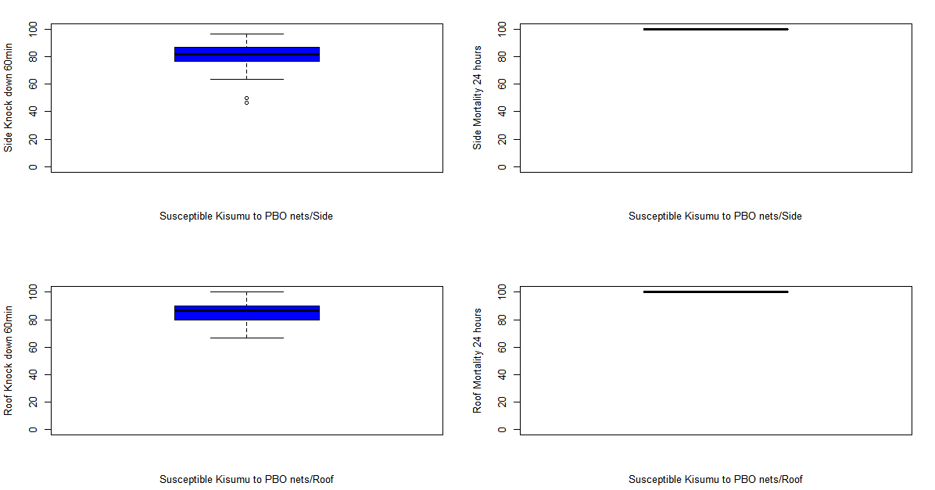

Figure 10.1.1: Box Plot of Cone Bioassay for Positive Control against An. gambiae Susceptible Kisumu Strain (Pyrethroid+PBO)
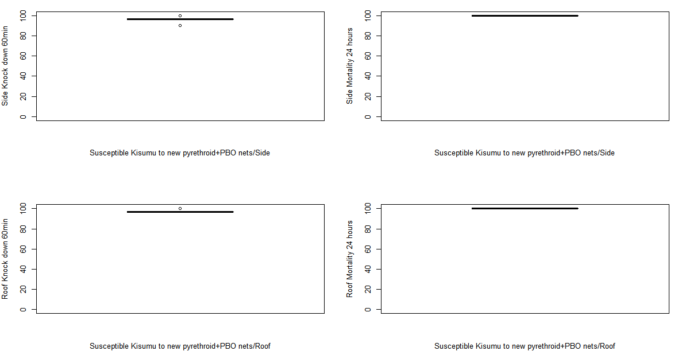

Figure 10.1.2 : Box Plot of Cone Bioassay for Positive Control against An. gambiae Susceptible Kisumu Strain (New Pyrethroid-Only)
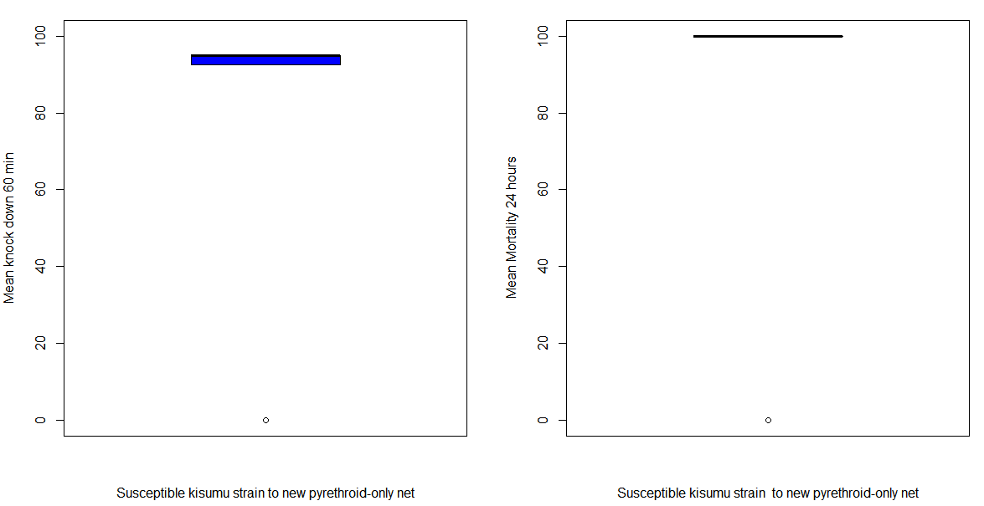

Figure 10.2 : Box Plot of Cone Bioassay Results for Residual Efficacy Against Kisumu RSP Strain
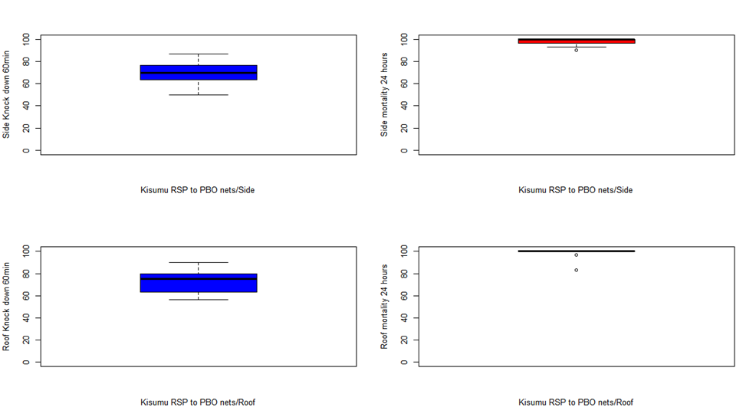
Figure 10.2.1: Box Plot of Cone Bioassay for Positive Control against An. gambiae Kisumu RSP Strain (New Pyrethroid+PBO)
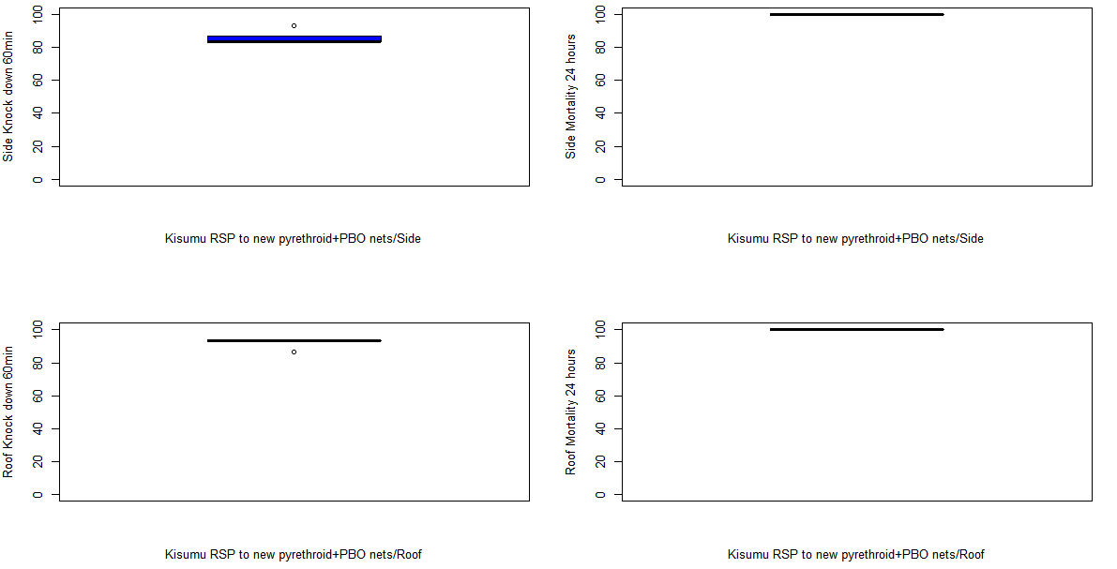

Figure 10.2.2 : Box Plot of Cone Bioassay For Positive Control against An. gambiae Kisumu RSP Strain (New Pyrethroid-Only)
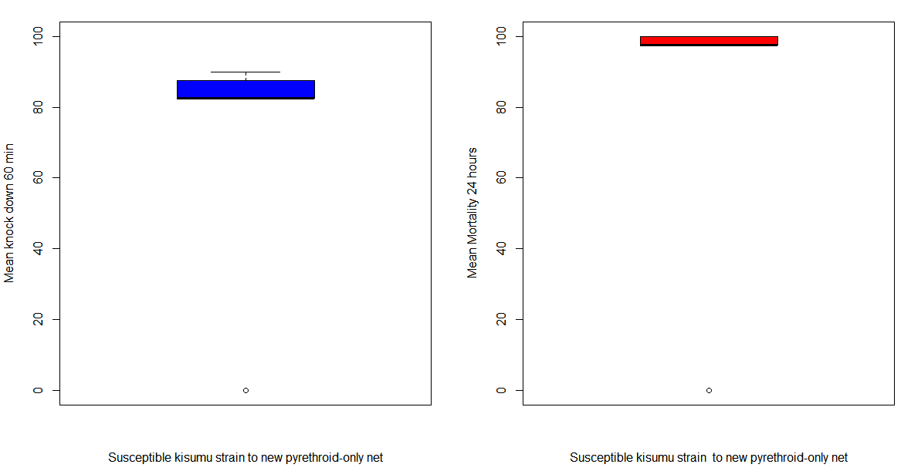

Figure 10.3: Box Plot of Cone Bioassay Results for Residual Efficacy Against Wild An. gambiae s.l. Nyanza Lac Strain
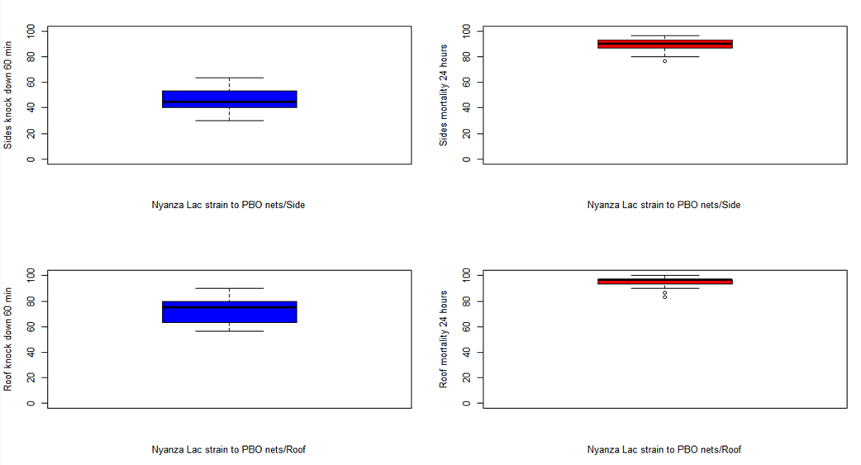
The box plot shows the median (line), interquartile range (box), adjacent values (whiskers) and outliers (circles.

3.5.3 Reported Net Handling and Use of ITNs Selected for Bioassays
Tables 24-26 presents details of reported handling and use for the ITNs undergoing bioassay analysis. Overall, nets collected for bioassay were very similar to cohort nets.
At 24-month round, 67% and 37% (difference not statistically significant) of bioassay nets withdrawn from Kirundo and Muyinga, respectively, were found hanging loose over sleeping spaces. Bioassay nets were more likely to be used over a bed frame in Muyinga compared to in Kirundo (93% versus 53%, p<0.005). In both Kirundo and Muyinga, no children were reported to have slept alone under a bioassay net at 24 months. Adults slept alone under bioassay nets in Kirundo and Muyinga 65% and 50% of times, respectively. At 24 months, 67% and 73% of sampled bioassay nets from Kirundo and Muyinga, respectively, were slept under every night during the previous week. Conversely, 33% and 20% of bioassay nets were not slept under during the previous week in Kirundo and Muyinga, respectively. In both Kirundo and Muyinga, 90% of nets were used equally during rainy and dry seasons. All bioassay nets withdrawn for examination during the 24-month round had ever been washed in Kirundo and 97% of nets had been washed in Muyinga. Bioassay nets were washed an average of 3 times in Kirundo and 2 times in Muyinga. Soap bars were used during 100% and 96% of washes in Kirundo and Muyinga, respectively. Shade was used as the primary drying mechanism in both study sites, being used to dry 93% of washed bioassay nets in Kirundo and 90% of washed bioassay nets in Muyinga.
Table 24: Handling of Bioassay Test ITNs
 | Baseline | 12 months | 24 months
Kirundo
Location found | N=30 | N=26* | N=30
Hanging and folded or tied | 6.7% | 15.4% | 0.0%
Hanging loose | 63.3% | 69.2% | 66.7%
Not hanging | 0.0% | 11.5% | 33.3%
Stored unpacked | 13.3% | 0.0% | 0.0%
Stored in package | 0.0% | 0.0% | 0.0%
Type of sleeping space (if used) | N=21 | N=25 | N=30
Bed | 100.0% | 92.0% | 53.3%
Mattress | 0.0% | 0.0% | 0.0%
Mat/Ground | 0.0% | 8.0% | 46.7%
Net users | N=21 | N=25 | N=20
Child(ren) only | 9.5% | 16.0% | 0.0%
Child(ren) and adult(s) | 57.1% | 36.0% | 35.0%
Adult(s) only | 33.3% | 48.0% | 65.0%
Muyinga
Location found | N=30 | N=30 | N=30
Hanging and folded or tied | 0.0% | 16.7% | 36.7%
Hanging loose | 86.7% | 76.7% | 36.7%
Not hanging | 3.3% | 6.7% | 16.7%
Stored unpacked | 10.0% | 0.0% | 10.0%
Stored in package | 0.0% | 0.0% | 0.0%
Type of sleeping space (if used) | N=27 | N=30 | N=29
Bed | 14.8% | 86.7% | 93.1%
Mattress | 63.0% | 0.0% | 6.9%
Mat/Ground | 22.2% | 13.3% | 0.0%
Net users | N=27 | N=30 | N=22
Child(ren) only | 22.2% | 26.7% | 0.0%
Child(ren) and adult(s) | 18.5% | 50.0% | 50.0%
Adult(s) only | 59.3% | 23.3% | 50.0%
*: Four questionnaires were received with no responses at 12-month round in Kirundo

Table 25: Reported Use of Bioassay Test ITNs
 | Baseline | 12 months | 24 months
Kirundo | N=30 | N=26 | N=30
Used last night | 66.7% | 80.8% | 66.7%
Used last week | N=30 | N=26 | N=30
Every night | 63.3% | 84.6% | 66.7%
Most nights (5-6 nights) | 3.3% | 7.7% | 0.0%
Some nights (1-4 nights) | 0.0% | 0.0% | 0.0%
Not used last week | 3.3% | 3.8% | 33.3%
Never used | 30.0% | 3.8% | 0.0%
Seasonal use | N=30 | N=26 | N=30
Equally in rainy and dry seasons | 66.7% | 76.9% | 90.0%
Mainly rainy season | 3.3% | 15.4% | 10.0%
Rainy season only | 0.0% | 0.0% | 0.0%
Not used | 30.0% | 7.7% | 0.0%
Don't know | 0.0% | 0.0% | 0.0%
Muyinga | N=30 | N=30 | N=30
Used last night | 86.7% | 93.3% | 73.3%
Used last week | N=30 | N=30 | N=30
Every night | 83.3% | 90.0% | 73.3%
Most nights (5-6 nights) | 3.3% | 0.0% | 0.0%
Some nights (1-4 nights) | 0.0% | 0.0% | 3.3%
Not used last week | 0.0% | 6.7% | 20.0%
Never used | 10.0% | 3.3% | 3.3%
Seasonal use | N=30 | N=30 | N=30
Equally in rainy and dry seasons | 86.7% | 93.3% | 90.0%
Mainly rainy season | 0.0% | 3.3% | 6.7%
Rainy season only | 0.0% | 0.0% | 0.0%
Not used | 10.0% | 3.3% | 3.3%
Don't know | 3.3% | 0.0% | 0.0%

Table 26: Reported Washing of Bioassay Test ITNs
 | Baseline | 12 months | 24 months
Kirundo | N=21 | N=25 | N=30
Ever washed | 38.1% | 60.0% | 100.0%
Washes in the last 6 months among all nets (if known) | N=30 | N=25 | N=30
Mean | 0.45 | 1.08 | 2.77
Median | 0.0 | 1.0 | 2.0
Washes in the last 6 months among washed nets | N=8 | N=15 | N=30
Mean | 1.29 | 1.80 | 2.77
Median | 1.0 | 2.0 | 2.0
Soap used for last wash | N=8 | N=15 | N=30
Soap bar | 100.0% | 100.0% | 100.0%
Detergent or bleach | 0.0% | 0.0% | 0.0%
Mix | 0.0% | 0.0% | 0.0%
None | 0.0% | 0.0% | 0.0%
Where dried after last wash | N=8 | N=15 | N=30
Shade | 50.0% | 33.3% | 93.3%
Sun | 50.0% | 66.7% | 6.7%
Muyinga | N=26 | N=30 | N=30
Ever washed | 19.2% | 66.7% | 96.7%
Washes in the last 6 months among all nets (if known) | N=30 | N=29 | N=30
Mean | 0.36 | 1.07 | 1.57
Median | 0.0 | 1.0 | 1.5
Washes in the last 6 months among washed nets | N=5 | N=20 | N=29
Mean | 1.80 | 1.55 | 1.62
Median | 2.0 | 1.0 | 2.0
Soap used for last wash* | N=5 | N=20 | N=30
Soap bar | 100.0% | 100.0% | 96.7%
Detergent or bleach | 0.0% | 0.0% | 0.0%
Mix | 0.0% | 0.0% | 0.0%
None | 0.0% | 0.0% | 0.0%
Where dried after last wash | N=5 | N=20 | N=29
Shade | 40.0% | 40.0% | 89.7%
Sun | 60.0% | 60.0% | 10.3%
*: 3.3% of respondents reported "Do not know" at 24-month round, which will give 100% for the total

Conclusions

Summary of Findings
This durability monitoring study in Burundi includes ITNs that were distributed during the 2019 campaign in two provinces, each receiving a different ITN: PermaNet® 3.0 in Kirundo and Yorkool® in Muyinga. Being neighboring provinces, the study sites represented settings with similar climate patterns, malaria transmission dynamics, and planned additional malaria control inventions. At baseline, the study team successfully recruited a total of 1,000 ITNs from 300 households to study cohorts in each province (including campaign nets reported as lost between the campaign distribution and baseline fieldwork). Following previous rounds in which high levels of attrition were recorded, the standard monitoring durability survey was stopped after the 24-month round.
Of the 300 households enrolled at baseline (150 for each province), 270 (143 in Kirundo and 127 in Muyinga) and 252 (131 in Kirundo and 121 in Muyinga) were active at the 12- and 24-month rounds respectively. At the 24-month round, 120 household still had nets in Kirundo compared to 93 in Muyinga. As a result, the total number of households excluded over time from the study was higher in Muyinga than in Kirundo, due mainly to the loss of all cohort ITNs (51 households compared to 26 households in Kirundo). Of the 348 and 352 ITNs for which information was recorded at baseline in Kirundo and Muyinga, respectively, 175 and 145 ITNs remained present in household at 24 months.
Total cohort ITN attrition increased from 14% at baseline to 42% at the 24-month round in Kirundo; and from 33% at baseline to 57% at the 24-month round in Muyinga. At each round, attrition due to wear and tear was higher in Muyinga than Kirundo and reached 30% in Muyinga at 24 months compared to 16% in Kirundo (p=0.021). In both provinces, the absolute increase in attrition due to wear and tear was approximately 13 percentage points over the monitoring period, however, the level of attrition in Muyinga at baseline was already 17%, compared to only 3% in Kirundo. At baseline, a higher proportion of cohort ITNs had also been given away to others in Muyinga (13%) compared to Kirundo (6%), though province values were similar at 12 months (16% and 13%, respectively) and 24 months (22% and 20%, respectively).
The physical integrity of ITNs remaining in the household declined from one round to the next in both sites. The proportion of cohort nets classified at baseline as “serviceable” based on their pHI value was 79% and 84% in Muyinga and Kirundo, respectively. At the 24-month round only 56% and 51% remained “serviceable”, respectively, a difference that was not significant at the 5% level. The median pHI values among cohort nets with one or more holes increased in both sites and at each round, reflecting the increasing levels of damage recorded in present nets. The most common reported cause of holes in Kirundo was by tearing on an object or by pulling, as reported for 93% of damaged cohort nets in Kirundo compared to 26% in Muyinga, p<0.001. Among damaged nets in Muyinga, rodents were commonly cited as the damage mechanisms (81%) and at a level higher than in Kirundo (39%, p<0.001). This study did not verify the causes of net damage.
Considering attrition and physical integrity data together, the similar proportion of present nets classified as “serviceable” at each round means that survival estimates are driven largely by attrition due to wear and tear. The proportion of cohort nets surviving in a serviceable condition was lower in Muyinga than Kirundo at each round – reflecting attrition outcomes – and reached 31% and 38% at the 24-month round in Muyinga and Kirundo, respectively. Considering the timing of survey rounds, these results correspond to estimated median survival times of 1.7 years for PermaNet® 3.0 in Kirundo and just 1.3 years for Yorkool® in Muyinga. The upper confidence interval for PermaNet® 3.0 in Kirundo (2.3 years) suggests that in this setting, median survival is under three years. Similarly, the upper interval for Yorkool® in Muyinga (1.8 years) suggests that in this setting, median survival is less than two years. The study assessed household risk factors for physical integrity as well as attitudes and behaviors related to net care and repair. Factors previously shown to be associated with physical integrity can be categorized as household factors, handling factors, and net care and repair attitudes and behaviors. Results for individual risks tend to show no difference between the sites or relatively worse results for Kirundo, the setting with a higher median survival time. For example, attitudes to nets and to net care and repair have been strongly associated with better survival outcomes in previous durability monitoring studies. At baseline, 58% of respondents in Muyinga had a positive attitude to nets, compared to 19% of respondents in Kirundo, and results were higher in Muyinga for all three rounds (24-months: 46% Muyinga and 5% Kirundo, p<0.001). A higher proportion of respondents also showed positive attitudes to net care and repair in Muyinga in the 24-month round (30%) compared to Kirundo (1%, p<0.001). Similarly, households in Kirundo as likely or more likely to store food in room(s) used for sleeping during the monitoring period, and recent observations of rodents in the house were above 94% in both sites for all three rounds. At baseline, 36% of cohort nets in Kirundo had been washed compared to 28% in Muyinga, results that rose over time to 88% and 84% in Kirundo and Muyinga respectively at 24 months. At each round, washed nets in Kirundo were as likely or more likely than those in Muyinga to have been dried on a bush or fence (which can result in snags and tears). Together, these results support the physical integrity outcomes which show similar levels of net damage among cohort nets still present in households but do not appear to explain the different levels of attrition due to wear and tear recorded in this study.
Thirty campaign nets were collected in each study province from the cohort nets recruited at baseline to undergo bioassays at VectorLink Burundi. At 24-month round, 100% of Yorkool® samples had optimal effectiveness, with mean mortality above 96%. The KD60 decreased from 81% at 12-month round to 58% at 24-month round, which was below the WHO threshold. All the PermaNet® 3.0 field samples achieved optimal effectiveness against pyrethroid-susceptible mosquitoes at 24 months with 100% mortality for both side samples and roof samples. The PermaNet® 3.0 samples also demonstrated optimal effectiveness against pyrethroid-resistant mosquitoes An. gambiae Kisumu RSP, and An. gambiae s.l. Nyanza-Lac (99%). Roof samples, incorporating PBO, performed similarly to side samples for the two resistant strains.

Key Challenges and Lessons Learned
The study encountered fieldwork challenges related to the timing of fieldwork activities. Although data collection was conducted in January and February between the short rainy season (from September to December) and long rainy season (from February to May), the field teams still faced rain and were difficult road conditions. During travel to each study site and between clusters, data collection teams encountered severe road conditions, and, in many instances, roads were impassable. Visiting households while it was raining was also challenging; however, the team were equipped with raincoats and rain boots, to facilitate mobility during bouts of inclement weather. Additionally, because of the rainy season, some of the cohort houses had collapsed and household members were forced to live with neighbors or relatives within the same cluster. These households were still interviewed, and eligible cohort nets assessed for damage when present.
While compliance with COVID-19 mitigation measures is vital to reinforce the health and safety of participants and field teams, the inability of field teams to directly observe net hanging practices within households required the study to rely on respondent recall for some results. Relying on recall increases the risk that results may be influenced by desirability bias. The differences noted in the results of sleeping space type used at baseline and the 12-month follow-up is a possible result of these limitations. It is possible the Muyinga field team mis-recorded nets hanging over mattresses on bed frames as nets hanging over only mattresses at baseline, then (correctly) as beds at the 12-month follow-up. Results from neighboring Kirundo show a high level of beds as sleeping spaces at baseline and the 12-month round. At the 24-month round, the team was advised to insist on clarifying the type of sleeping space used by the household. Following this, the results showed a balance between bed, mat or ground, and mattress in Kirundo. Additionally, in the 12-month study results showed that among cohort ITNs hung up in Kirundo (70%), none of them were reported to be both hanging and tied up. Results in Muyinga were less concerning with 15% of nets tied-up among the 61% of cohort ITNs reported to be hanging. The way an ITN is hanging in a household is a known risk factor for net survival. To strengthen the validity of this data point for the 24-month round, VectorLink developed a visual prompt card for field teams to use during interviews to verify the location (hanging, stored away) and status (unfolded, folded, or tied up) of cohort campaign nets in the household. The prompt card was used during the 24-month round in Burundi, which improved the efficiency and effectiveness in recording results which were more representative of the household context.

Annex 1: Field Team Visual Prompt Cards
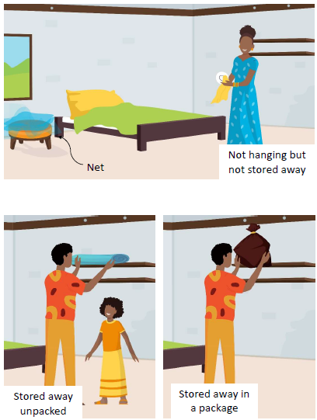

www.durabilitymonitoring.org
In Burundi the National Malaria Control Program is known as the Programme National Intégré de Lutte contre le Paludisme (PNILP)
Milliner, J. The Alliance for Malaria Prevention. Net Mapping Project. [Online] Available at: http://netmappingproject.allianceformalariaprevention.com/
Breakthrough Action. ITN use and access report. [Online] Available at: https://breakthroughactionandresearch.org/resources/itn-use-and-access-report/burundi/.
www.durabilitymonitoring.org
PMI VectorLink Burundi 2018 annual report
World Health Organization: WHO Guidelines for Laboratory and Field Testing of Long‐Lasting Insecticidal Nets. Geneva 2013, WHO/HTM/NTD/WHOPES/2013.3
Bioassays to determine residual efficacy of PBO and pyrethroids on PBO ITNs.
World Health Organization: WHO Guidance Note for Estimating the Longevity of Long-Lasting Insecticidal Nets in Malaria Control. Geneva: 2013
World Health Organization: WHO Guidelines for Laboratory and Field Testing of Long‐Lasting Insecticidal Nets. Geneva 2013, WHO/HTM/NTD/WHOPES/2013.3
Bioassays to determine residual efficacy of piperonyl butoxide (PBO) and pyrethroids on PBO synergist ITNs.
World Health Organization: WHO Guidelines for Laboratory and Field Testing of Long‐Lasting Insecticidal Nets. Geneva 2013, WHO/HTM/NTD/WHOPES/2013.3

