Sierra Leone DM Snapshot: 36 Months (March - April 2023)

Study overview | Study site locations within Sierra Leone
Design: Two PBO synergist brands in similar zones
Net products:
- PermaNet® 3.0 (deltamethrin + PBO)
- Olyset® Plus (permethrin + PBO)
Campaign date: May 22-31, 2020
Last data collection round: 36 Months (March 20th - April 13th, 2023)

Key results
Between baseline and 36 months, the percentage of PermaNet® 3.0 ITNs in Bo remaining in serviceable condition decreased from 99% to 86%. During the same period, the percentage of Olyset® Plus ITNs in Moyamba remaining in serviceable condition decreased from 91% to 41%. Attrition due to wear and tear was a key driver of attrition in Bo (21%) but was less of a challenge in Moyamba (13%), where attrition was driven by nets being given away to others. By the study endline, 73% of remaining cohort ITNs were hanging over a sleeping space in Bo, compared with 56% in Moyamba.

Site | Survey point and actual time since distribution (months) | Attrition due to wear and tear (%) | Remaining nets in serviceable condition (%) | Remaining nets hanging over sleeping space (%) |  | Resistant mosquito 24-hour mortality (%)
 |  |  |  | Cohort | Other
Bo District (PermaNet® 3.0) | Base: 6.3 | 0.0 | 99.1 | 53.2 | 76.4 | 48.1 (roof panel)
 | 12m: 12.0 | 3.1 | 98.4 | 55.3 | 69.4 | 39.0 (roof panel)
 | 24m: 23.0 | 6.1 | 92.6 | 61.5 | 73.3 | 9.1(roof panel)
 | 36m: 34.0 | 21.4 | 85.5 | 73.4 | 91.3 | --
Moyamba District  (Olyset® Plus) | Base: 6.3 | 1.0 | 91.3 | 53.0 | 74.7 | 16.5 (all panels)
 | 12m: 12.0 | 2.8 | 86.4 | 60.1 | 73.4 | 25.0 (all panels)
 | 24m: 23.0 | 5.1 | 67.3 | 57.8 | 90.3 | 4.1(all panels)
 | 36m: 34.0 | 12.6 | 41.1 | 55.9 | 95.0 | --
--: Will be updated when data become available.

Key risk factors for cohort ITN physical durability at baseline,12- , 24- and 36-months
At the study endline, despite a higher prevalence of food storage in sleeping areas among households in Moyamba compared to Bo (98% Moyamba, 88% Bo; p=0.02), most households in both districts reported never cooking in the same room where they sleep (>97%). In Bo, a significantly higher proportion of hanging nets were observed to be folded and tied up compared to Moyamba (91% Bo, 70% Moyamba; p =0.04). Anecdotal evidence suggests that the dramatic decrease in detergent or bleach use in both districts at endline compared with previous rounds was driven by high inflation on basic goods. Compared with 2022, the cost of a single sachet of detergent has increased four-fold, from 500 Leones to 2,000 Leones this year.
Household Risk Factors | Baseline | 12 months | 24 months | 36 months
Bo | N=185 | N=148 | N=135 | N=128
Store food in room used for sleeping (%) | 12.4% | 14.0% | 72.6% | 87.5%
Cook food in room used for sleeping (%) | 0.9% | 0.0% | 0.0% | 0.0%
Moyamba | N=185 | N=166 | N=146 | N=133
Store food in room used for sleeping (%) | 55.1% | 89.5% | 97.9% | 97.7%
Cook food in room used for sleeping (%) | 0.0% | 0.0% | 0.0% | 2.3%
Net Handling Risk Factors | Baseline | 12 months | 24 months | 36 months
Bo | N=358 | N=266 | N=210 | N=210
Nets used over mat or ground (%) | 1.0 (N=210) | 2.0 (N=185) | 4.0 (N=170) | 3.1 (N=131)
Hanging nets folded or tied up (%) | 95.7 (N=190) | 76.8 (N=147) | 95.3 (N=129) | 91.4 (N=105)
Nets washed with detergent or bleach (%) | 24.9 (N=137) | 1.6 (N=154) | 44.7 (N=159) | 0.8 (N=128)
Nets dried on fence or bush (%) | 0.0 (N=137) | 1.1 (N=154) | 0.0 (N=159) | 0.0 (N=128)
Moyamba | N=294 | N=223 | N=180 | N=180
Nets used over mat or ground (%) | 8.0 (N=178) | 2.0 (N=160) | 1.0 (N=166) | 1.8 (N=111)
Hanging nets folded or tied up (%) | 44.7 (N=155) | 80.2 (N=134) | 79.8 (N=104) | 69.7 (N=66)
Nets washed with detergent or bleach (%) | 49.8 (N=94) | 34.8 (N=135) | 42.9 (N=154) | 1.8 (N=110)
Nets dried on fence or bush (%) | 1.3 (N=94) | 2.2 (N=135) | 0.6 (N=154) | 0.0 (N=110)

Cohort survival in serviceable condition
The chart illustrates the proportion of nets remaining in serviceable condition over time, comparing the actual survival data from baseline, 12-month, 24-month, and 36-month rounds with hypothetical survival curves for nets lasting one to four years. After 36-months, by estimating the relative position of the data point between the adjacent median survival curves, the median useful life for PermaNet® 3.0 ITNs in Bo was approximately 3.1 years, and the median useful life for Olyset® Plus nets in Moyamba was 2.2 years.
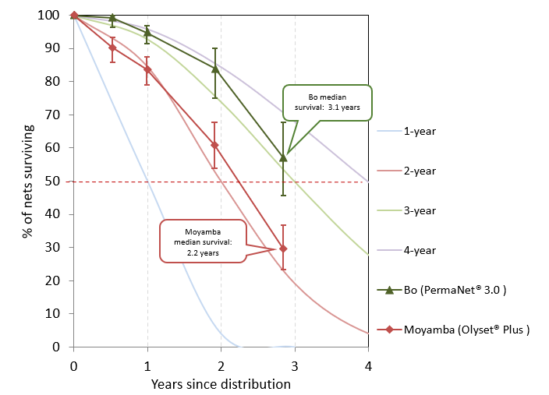

Durability monitoring indicator definitions
Attrition due to wear and tear: The percentage of cohort nets lost due to being destroyed, discarded or used for other purposes out of all cohort nets received by sampled households. This does not include nets that were given away, sold, or stolen.
à Provides an estimate of the attrition relevant to estimation of the physical durability in contrast to “all cause attrition” which includes also nets given away etc. Attrition due to wear and tear is correlated with the median survival of the cohort nets.
Remaining nets in serviceable condition: The percentage of cohort nets surviving to date that are still in serviceable physical condition (good or damaged), specifically, with a proportionate hole index of 642 or less.
à Provides an estimate of the physical quality of remaining campaign nets.
Remaining nets hanging over sleeping space: The percentage of cohort nets and, separately, non-cohort nets present in the household that are hanging up, whether tied up or not.
à Provides an estimate of the use of different nets in the household. Households adopt nets newly received from campaigns at different rates. A present net hanging up in the home is an indicator of net use generally, beyond the formal indicator of net use the night before the survey.
Optimal insecticidal effectiveness: The percentage of sampled campaign nets that have at least 95% 60-minute knock-down or 80% mortality in the WHO cone bioassay. Alternatively, 90% feeding inhibition or 80% mortality in the tunnel test.
à Provides an estimate of the effectiveness of the insecticide found on mass campaign LLIN at each period of follow-up.
Store food in room used for sleeping: The percentage of households that report ever storing food in a room used for sleeping.
Cook food in room used for sleeping: The percentage of households that report always or sometimes cooking food a room used for sleeping.
à Provides an estimate of the level of household-based risk factors for physical integrity. Storing food and cooking in rooms used for sleeping encourages the appearance of rodents and increases the risk of burn damage to ITNs.
Nets used over mat or ground: The percentage of cohort ITNs reportedly used over a mat or ground-based sleeping space, among cohort ITNs reportedly ever used.
à Provides an estimate of the handling risk factor for integrity. Nets used when sleeping on mats or the ground are more prone to wear and tear than those used over mattresses and bed frames.
Hanging nets folded or tied up: The percentage of cohort ITNs found folded or tied up away from the sleeping space, among all hanging cohort ITNs.
à Provides an estimate of the handling risk factor for integrity. Nets that are not folded up and away from sleeping spaces during the day are more prone to accidental tearing and damage from children and animals.
Nets washed with detergent: The percentage of cohort ITNs that were reportedly washed with detergent or bleach in addition to water, among all cohort ITNs washed in the last six months.
à Provides an estimate of the handling risk factor for integrity. Excessive washing, particularly with cleaning products like detergent or bleach in addition to water, can diminish insecticide effectiveness.
Nets dried on fence or bush: The percentage of cohort ITNs that were reportedly dried on a fence or bush, among all cohort ITNs washed in the last six months.
à Provides an estimate of the handling risk factor for integrity. Nets that are dried on rough fences or bushes are more likely to snag and become damaged than those dried on lines.

