Cameroon
Streamlined Durability Monitoring Snapshot: 36 Months
May 30, 2025 – June 5, 2025


Assessment Overview
Net products:
- DuraNet® Plus (alpha-cypermethrin + piperonyl-butoxide [PBO])
- Interceptor® G2 (IG2) (alpha-cypermethrin + chlorfenapyr [CFP])
Design: Streamlined durability monitoring (SDM) - Two brands in similar zones
Campaign date:
- June 5-12, 2022, in Pitoa district
- August 28-September 4, 2022, in Lagdo district
Last data collection round: 36 months (May 30, 2025 – June 5, 2025)

Assessment Site Locations Within Cameroon
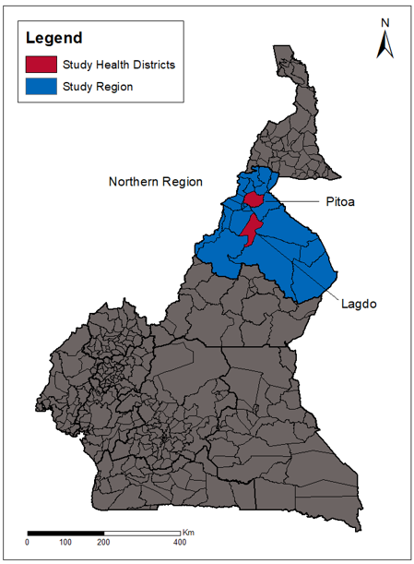

Key Results
The Cameroon SDM assessment was initiated by the U.S. President’s Malaria Initiative (PMI) under the PMI Evolve project in 2022. PMI’s January 2025 reorientation resulted in the haulting of this work prior to its endline survey round. In April 2025, GiveWell stepped in to support endline survey round data collection, endline bioassay/chemical residue analysis, and manuscript production.
In Cameroon, the endline SDM survey round was conducted 33 months post-campaign in Lagdo district and at 35 months post-campaign in Pitoa district. The timing was brought forward by three months in Lagdo and by one month in Pitoa to ensure that data collection was completed prior to the planned mass insecticide-treated net (ITN) distribution campaign in assessment areas.
At endline, ITN attrition reached 46% for IG2 ITNs in Lagdo and 54% for DuraNet® Plus in Pitoa. Attrition due to wear and tear was substantial at both sites, accounting for approximately one-third of the audited ITNs (32% in Lagdo and 35% in Pitoa). A similar SDM assessment of IG2 ITNs in Liberia reported higher total attrition (55%) but lower attrition rate due to wear and tear (12%), suggesting that although more nets were lost overall in Liberia, a greater proportion of ITNs were lost in Cameroon was due to wear and tear. However, due the small ITN sample size generated through the SDM methodology, direct comparisons of approximated attrition values across studies should be interpreted with caution.
The proportion of nets remaining in serviceable condition at endline was similar in both sites (77% in Lagdo vs. 87% in Pitoa). The same trend was observed for the proportion of sampled nets hanging over sleeping spaces (tied or untied), recorded at 70% in Lagdo and 80% in Pitoa.
Both ITN brands remained highly effective against pyrethroid-susceptible mosquitoes after 36 months of field use, achieving over 99% 24-hour mortality with DuraNet® Plus and 81% 72-hour mortality with IG2.
DuraNet® Plus showed poor efficacy against the pyrethroid-resistant Monatele An. gambiae s.l. strain, with 24-hour mortality remaining low across rounds and declining from 27% at pre-distribution to 5% at endline. PBO content loss rose from 9% at pre-distribution to 82% at endline compared to the manufacturer target dose.
IG2 ITN 72-hour mortality against the pyrethroid-resistant Monatele An. gambiae s.l. strain declined from 87% at pre-distribution to 55% at 36 months. Chlorfenapyr content decreased substantially, with losses increasing from 17% at pre-distribution to 79% compared to the manufacturer target dose at endline. IG2 bioassay and chemical residue testing results throughout the assessment are similar with PMI VectorLink’s durability monitoring assessment in Burkina Faso.

Site | Survey round and time since distribution (months) | Attrition due to wear and tear  (%) | Remaining nets in serviceable condition  N (%) | Remaining nets hanging over sleeping space  (%) | 24/72 – hour mortality against resistant mosquito strain  (%) | Mean CFP chemical content (g/kg) | Reduction in CFP compared to manu-facturer target dose (%) | Mean PBO chemical content (g/kg) | Reduction in PBO compared to manu-facturer target dose (%)
Lagdo  (IG2) | Pre-dist | -- | -- | -- | 86.7%ª | 4.0 | 16.7% | -- | --
Lagdo  (IG2) | First (12.6) | 6.3% | 29 (96.7%) | 23 (76.7%) | 70.3%ª | 2.4 | 50.0% | -- | --
Lagdo  (IG2) | Second (22.5) | 12.7% | 23 (76.7%) | 25 (83.3%) | 71.0%ª | 1.5 | 68.8% | -- | --
Lagdo  (IG2) | Third (32.5) | 31.5% | 23 (76.7%) | 21 (70.0%) | 55.3%ª | 1.0 | 79.2% | -- | --
Pitoa  (DuraNet® Plus) | Pre-dist | -- | -- | -- | 26.7%^{b} | -- | -- | 2.0 | 9.1%
Pitoa  (DuraNet® Plus) | First (15.8) | 1.3% | 26 (86.7%) | 29 (96.6%) | 24.2%^{b} | -- | -- | 0.6 | 72.7%
Pitoa  (DuraNet® Plus) | Second (25.3) | 7.5% | 27 (90.0%) | 25 (83.4%) | 16.4%^{b} | -- | -- | 0.9 | 59.1%
Pitoa  (DuraNet® Plus) | Third (35.4) | 35.0% | 26 (86.7%) | 24 (80.0%) | 5.1%^{b} | -- | -- | 0.4 | 81.2%
ª: Result for 72-hour mortality when tested against the resistant strain using tunnel tests
^{b}: Result for 24-hour mortality when tested against the resistant strain on the PBO using cone bioassays
--: Not applicable

Key Risk Factors for Sampled ITN Physical Durability at Endline
- Hanging nets should be folded or tied when not in use to enhance their longevity., A decline in this protective practice reflected by an increase in ITNs left hanging loose over sleeping spaces was observed from 83% (25/30) at 24 months to 60% (18/30) at 36 months in Lagdo, and from 77% (23/30) to 70% (21/30) in Pitoa. Nonetheless, the prevalence of this practice remained relatively high in both sites.
- Generally, nets used when sleeping on mats or the ground are more prone to wear and tear than those used over mattresses and bed frames.^{,1} A higher but statistically insignificant proportion of nets were hung over a mat or the ground in Pitoa (20%, 6/30) compared to Lagdo (7%, 2/30). However, this practice was relatively uncommon in both districts.
- Nets that were slept under by children or by both children and adults have a higher risk of failure³. A slightly higher, though statistically insignificant, proportion of nets were used exclusively by children in Lagdo (23%, 7/30) and in Pitoa (17%, 5/30). Nonetheless, this practice remained relatively uncommon in both districts.
- Drying nets in the sun after washing can reduce the physical and chemical durability of an ITN. This practice was very common across the assessment sites, though it was more popular in Lagdo than Pitoa. Among nets that had been washed, 89% (25/28) in Lagdo and 61% (17/28) in Pitoa had been dried in the sun afterwards (p= 0.0188).
- Using detergent or bleach during washing may also damage the physical and chemical durability of an ITN. This washing behavior was more common in Pitoa with 54% (15/28) of nets washed with detergent or bleach compared to 46% (13/28) in Lagdo, a difference not statistically significant.
- Drying nets on bushes or fences after washing can physically damage ITNs. This practice was not observed in Pitoa, and was only reported for 11% (3/28) of ever-washed nets in Lagdo.
Bioassay and Chemical Results: DuraNet® Plus

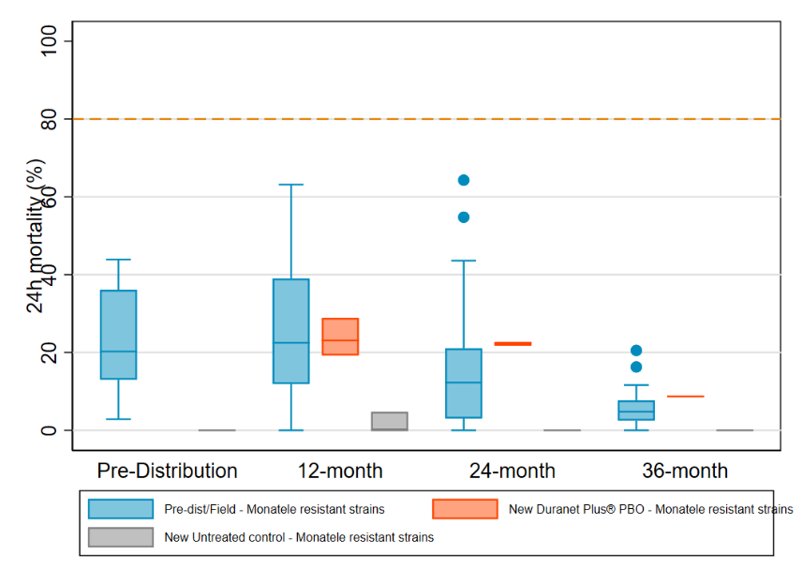
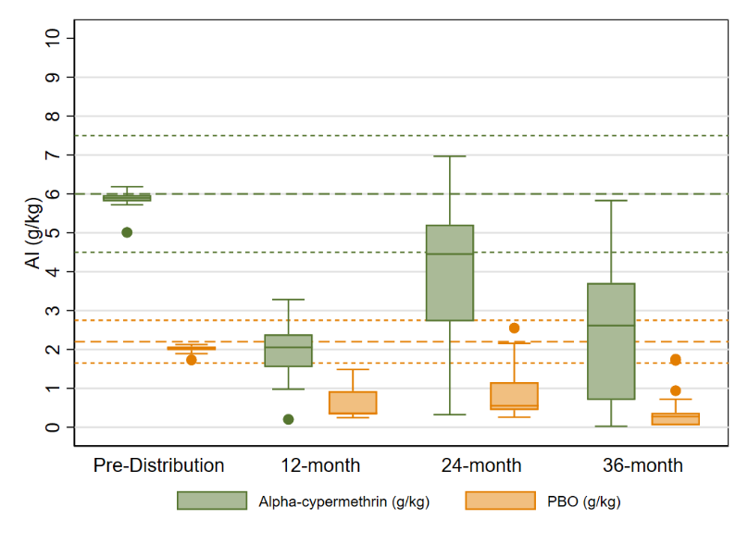
World Health Organization (WHO) tube test results showed mortality of the An. gambiae Kisumu colony to the diagnostic dose of alpha-cypermethrin (0.05%) was 100%. The colony mosquitoes were susceptible to chlorfenapyr, with the Centers for Disease Control and Prevention (CDC) bottle bioassays at 100 µg/bottle showing 100% mortality at 72 hours. The wild strain collected at PMI’s sentinel site, Monatele, was composed of An. gambiae s.s. (96%) and An. coluzzii (4%). Susceptibility testing confirmed resistance of the strain to alpha-cypermethrin alone using WHO tube test (14%). Pre-exposure to PBO-synergist before alpha-cypermethrin showed about a 47% increase in 24-hour mortality compared to alpha-cypermethrin alone. Testing with chlorfenapyr using CDC bottle bioassays at 100ug/bottle showed 72-hour mortality of 99%. The endline 24-hour mortality of DuraNet® Plus ITNs dropped to 5.1%, compared with 16.4% at 24 months, 24.2% at 12 months, and 26.7% at the pre-distribution timepoint when tested against resistant strain. The reduction in 24-hour mortality is consistent with the substantial decline in PBO content over time, with 82% loss (0.4 g/kg) at 36 months compared with the manufacturer’s recommended dose of 2.2 g/kg. All endline ITN samples were below the lower limit of the manufacturer specified range of 2.2 g/kg +/- 20%.
Bioassay and Chemical Results: Interceptor® IG2
Alpha-cypermethrin content and PBO content from Pitoa District, Cameroon
Box plot shows the median (horizontal line), interquartile range (box), adjacent values (whiskers), outliers (circles), and for each legend, bold line dashes specify manufacturer threshold (with fine line dashes indicating acceptable range).
Box plot shows the median (horizontal line), interquartile range (box), adjacent values (whiskers), outliers (circles), and for each legend, red dashed line represents WHO optimal effectiveness thresholds for mortality 80%.
24-hour mortality for field/new DuraNet® Plus brand ITNs taken from Pitoa District, Cameroon against resistant An. gambiae Monatele mosquitos

The same colony was used to test the IG2 ITNs (see characterization data presented above in the DuraNet® Plus results section). At assessment endline the 72-hour mortality was 55% against the resistant strain, down from from 87% at pre-distribution. Endline BFI was surprisingly very low, at only 9% compared to 90% at pre-distribution, 43% at 12 months, and 84% at 24 months. The low BFI may be attributable to the resistance mechanism in the wild mosquito population, which can affect blood feeding under laboratory conditions, even with with untreated netting. At endline, mean alpha-cypermethrin content was 0.9 g/kg, corresponding to a 63% loss compared to the manufacturer’s target dose of 2.4 g/kg. Mean chlorfenapyr content was 1.0 g/kg, representing a 79% reduction from the target dose of 4.8 g/kg. Results indicate that 27 out of 30 field 36-month ITN samples fell below the lower limit of the manufacturer specified chlorfenapyr content range of 3.6 g/kg +/- 20%.
Alpha-cypermethrin and chlorfenapyr content of Interceptor® G2 brand ITNs from Lagdo District, Cameroon
72-hour mortality for field/new Interceptor® G2 ITN brand samples taken from Lagdo District, Cameroon against resistant An. gambiae Monatele mosquitos
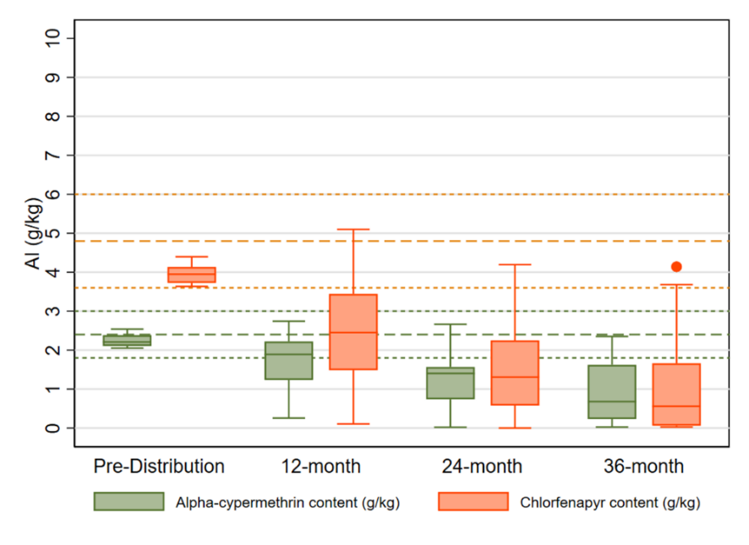
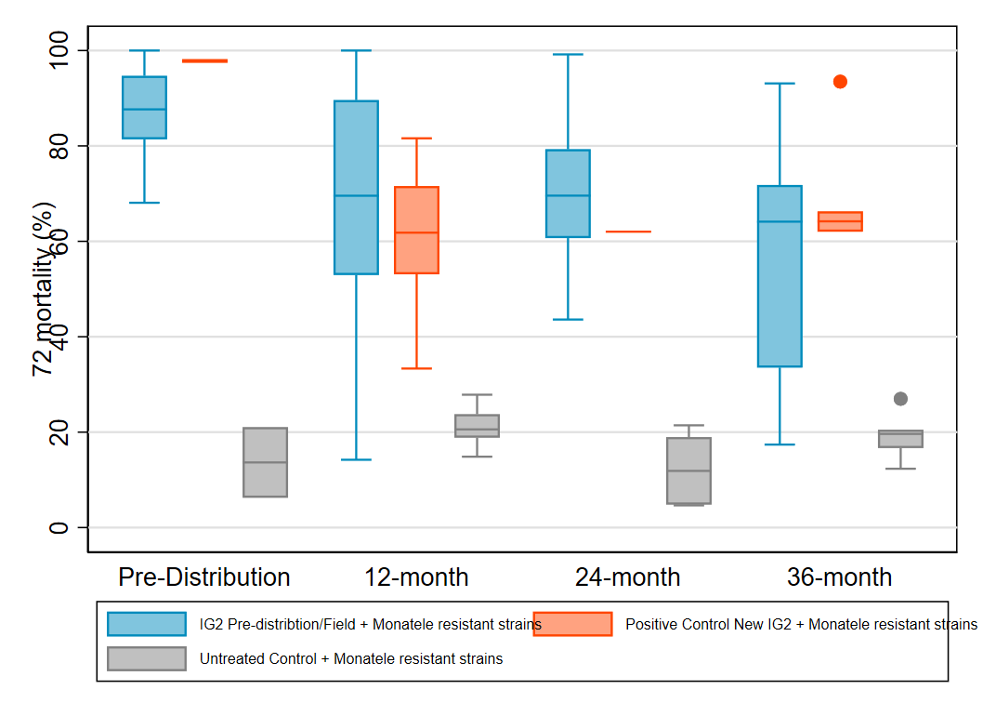

Box plot shows the median (horizontal line), interquartile range (box), adjacent values (whiskers), outliers (circles), and for each legend, bold line dashes specify manufacturer threshold (with fine line dashes indicating acceptable range).
Box plot shows the median (horizontal line), interquartile range (box), adjacent values (whiskers) and outlier (circle).

Durability Monitoring Indicator Definitions
All-cause attrition:
At 12 months, attrition is calculated as the ITNs reportedly received during the mass campaign that are no longer physically present divided by the total number of ITNs reportedly received during the mass campaign.
At 24 and 36 months, total attrition is calculated as the number of nets with known status lost by 12-month plus an estimate* of the number of nets with known status lost between 12 months and the 24- or 36-month survey round divided by the total number of ITNs reportedly received during the mass campaign.
*Assuming all nets in the sampling frame for that round undergo attrition/attrition due to wear and tear at the same level as the point estimate calculated for the survey round.
Attrition due to wear and tear:
At 12 months, attrition due to wear and tear is calculated as the ITNs reportedly received during the mass campaign that were destroyed, discarded or used for other purposes divided by the total number of ITNs reportedly received during the mass campaign.
At 24 and 36 months, total attrition due to wear and tear is calculated as the number of nets with known status that were destroyed /discarded /used for other purposes by 12-month plus an estimate* of the number of nets with known status that were destroyed /discarded /used for other purposes between 12 months and the 24-or 36-month survey round divided by the total number of ITNs reportedly received during the mass campaign.
*Assuming all nets in the sampling frame for that round undergo attrition/attrition due to wear and tear at the same level as the point estimate calculated for the survey round.
Remaining nets in serviceable condition: The percentage of sampled nets surviving to date that are still in serviceable physical condition (good or damaged), specifically, with a proportionate hole index of 642 or less.
à Provides an estimate of the physical quality of remaining campaign nets.
Remaining nets hanging over sleeping space: The percentage of sampled nets and, separately, non-sampled nets present in the household that are hanging up, whether tied up or not.
à Provides an estimate of the use of different nets in the household. Households adopt nets newly received from campaigns at different rates. A present net hanging up in the home is an indicator of net use generally, beyond the formal indicator of net use the night before the survey.

Jacky Raharinjatovo et al., “Physical and Insecticidal Durability of Interceptor®, Interceptor® G2, and PermaNet® 3.0 Insecticide-Treated Nets in Burkina Faso: Results of Durability Monitoring in Three Sites from 2019 to 2022,” Malaria Journal 23, no. 1 (June 4, 2024): 173, https://doi.org/10.1186/s12936-024-04989-w.
Obi E, Okoh F, Blaufuss S, Olapeju B, Akilah J, Okoko OO, Okechukwu A, Maire M, Popoola K, Yahaya MA, Uneke CJ. Monitoring the physical and insecticidal durability of the long-lasting insecticidal net DawaPlus® 2.0 in three States in Nigeria. Malaria journal. 2020 Dec; 19:1-9.
Sudoi, R.K., Esch, K., Yamba, F. et al. Physical and insecticidal durability of PermaNet® 3.0 and Olyset® plus piperonyl butoxide-synergist insecticide-treated nets in Sierra Leone: results of durability monitoring from 2020 to 2023. Malar J 24, 230 (2025). https://doi.org/10.1186/s12936-025-05421-7.
Haji KA, Khatib BO, Obi E, Dimoso K, Koenker H, Babalola S, et al. Monitoring the durability of the long lasting insecticidal nets Olyset® and PermaNet® 2.0 in similar use environments in Zanzibar. Malar J. 2020 May 24;19(1):187.
Atieli, F.K., Munga, S.O., Ofulla, A.V. et al. Wash durability and optimal drying regimen of four brands of long-lasting insecticide-treated nets after repeated washing under tropical conditions. Malar J 9, 248 (2010). https://doi.org/10.1186/1475-2875-9-248
Castellanos ME, Rodas S, Juárez JG, Lol JC, Chanquin S, Morales Z, Vizcaino L, Smith SC, Vanden Eng J, Woldu HG, Lenhart A. Evaluation of the durability of long‐lasting insecticidal nets in Guatemala. Malaria Journal. 2021 May 14;20(1):219.

