
The PMI Evolve Project
Rwanda ITN Durability Monitoring 36-Month Follow-Up Survey Report
2020-2023


Update – August 8, 2026

While recently preparing a manuscript on Rwanda 2020-2023 durability monitoring results, analysts noted that theft of ITNs emerged as the primary driver of ITN attrition (17.3%). Across eight other durability monitoring studies (Burkina Faso, Cote d’Ivoire, Ghana, Liberia, Madagascar, Niger, Sierra Leone and Zambia), the mean proportion of ITNs reported as stolen was 3.3%, with a range between 0.1% and 6.8%).
The Rwanda data was noted as an outlier, which triggered a sensitivity analysis. Results from this analysis can be viewed in Annex 1: Sensitivity analysis. Briefly, the ITNs that were reported as stolen had higher median proportional hole index values and poorer physical integrity than those that were not reported as stolen. Manuscript co-authors, including those from the Rwanda Biomedical Centre – Malaria and Other Parasitic Diseases Control Division, determined that respondents may have felt that reporting ITNs as damaged or disposed of was less socially undesirable than reporting ITNs as stolen. Median expected lifespan calculated through the sensitivity analysis aligned more closely with values reported in a 2014 Rwanda durability monitoring study.

Recommended Citation: The PMI Evolve Project. October 2023. The PMI Evolve Rwanda 2023 ITN Durability Monitoring 36-Month Study Report. Washington, DC. The PMI Evolve Project, Population Services International (PSI).
Contract: 7200AA23C00012
Submitted to: United States Agency for International Development/PMI
Submitted: October 19, 2023
Approved: [Date TBD]
Abt Associates | 6130 Executive Boulevard | Rockville, Maryland 20852 |
T. 301.347.5000 F. 301.913.9061 www.abtassociates.com


The views expressed in this document do not necessarily reflect the views of the United States Agency for International Development or the United States Government.

Contents
Acronyms ii
Executive Summary 1
1. Background 8
2. Methods 10
2.1 Study Sites 10
2.2 ITN Brands Monitored 11
2.3 Study Design Summary 12
2.4 Training and Fieldwork 13
2.5 Data Management 14
2.6 Analysis 14
2.7 Ethical Clearance 16
3. Results 17
3.1 Sample 17
3.2 Determinants of Durability 22
3.3 Net Ownership and Net Use 31
3.4 Durability of Campaign ITNs 42
3.5 Insecticidal Effectiveness and Content of Campaign Nets 50
4. Conclusions 70
4.1 Summary of Findings 70
4.2 Recommendations 71
4.3 Key Challenges and Lessons Learned 72
4.4 Acknowledgements 73

Acronyms
AI Active Ingredient
An Anopheles
ANC Antenatal Care
BFI Blood Feeding Inhibition
CDC Centers for Disease Control and Prevention
CI Confidence Interval
DHS Demographic and Health Surveys
IQR Interquartile Range
ITN Insecticide-treated Net
KD60 60-minute knock-down rate
MIS Malaria Indicator Survey
MOPDD Malaria and Other Parasitic Diseases Division
NMCP National Malaria Control Program
PBO Piperonyl Butoxide
pHI Proportionate Hole Index
PMI U.S. President’s Malaria Initiative
RBC Rwanda Biomedical Centre
REB Research Ethics Board
SBC Social Behavior Change
WHO World Health Organization

Executive Summary
Understanding the durability of insecticide-treated nets (ITNs) and estimating their average useful lifespan is an essential consideration for National Malaria Control Programs (NMCPs) when determining the frequency of ITN replacement. The World Health Organization (WHO) emphasizes the need for countries to routinely monitor ITN durability post mass distribution campaigns and has provided standardized guidance for this purpose.
Data indicates a potential decline in the proportion of households owning at least one ITN in Rwanda, decreasing from 84% according to the 2017 Malaria Indicator Survey (MIS) to 66% based on the 2019 Demographic and Health Survey (DHS). Despite this shift, the ITN use-to-access ratio – a metric measuring population-level ITN use relative to access – remained favorable in 2019 (0.91 in urban areas and 0.88 in rural areas). This ratio, which has slightly varied since 2007 (ranging between 0.88 and 0.97 in urban areas and 0.88 and 1.07 in rural areas), consistently exceeded 0.8, the threshold denoting "good" classification in both settings.
In Rwanda, the U.S. President’s Malaria Initiative (PMI) supported ITN durability monitoring of four types of ITNs distributed during the 2020 mass campaign in different study sites:
- PermaNet® 3.0: A deltamethrin and piperonyl butoxide (PBO) ITN distributed in Kicukiro District, Kigali City;
- Yahe® LN: A deltamethrin ITN distributed in Ruhango District, Southern Province;
- Interceptor® G2: An alpha-cypermethrin and chlorfenapyr ITN distributed in Karongi District, Western Province;
- Olyset®: A permethrin ITN distributed in Burera District, Northern Province.
The mass distribution campaign, which occurred between February and March and later in June 2020 in Karongi district, set the stage for subsequent ITN durability monitoring survey rounds. The baseline round, data for which was gathered between September 1 and October 10, 2020 (three to seven months post-campaign), involved assigning unique ID numbers to all campaign ITNs in sampled households. The delay in baseline data collection beyond the standard six-month window was due to COVID-19. Subsequent data collection rounds included the 12-month survey from May 24 to July 3, 2021 (12 to 16 months post the campaign); the 24-month survey from March 8 to July 13, 2022 (24 to 25 months post campaign); and the 36-month survey from May 2 to July 27, 2023 (35 to 39 months post campaign). These rounds are henceforth referred to as the 12-month, 24-month, and 36-month survey rounds, respectively.
The data collection was conducted by the Rwanda Biomedical Centre (RBC) Malaria & other Parasitic Disease Division (MOPDD) in collaboration with PMI Evolve Rwanda. The study's endline outcomes will furnish RBC-MOPDD, PMI, and other partners with valuable insights into the performance and average useful life of each ITN type distributed during the 2020 campaign.
Household and ITN Follow-Up
In the 36-month survey round, a total of 711 out of 773 eligible households (92%) were successfully interviewed. Among the remaining 62 households (8%) that were not interviewed, 22 (3%) lacked an eligible respondent, 36 (5%) had relocated, and four (1%) declined participation. Of the 1,631 cohort nets that were eligible for follow-up, 1,095 (67%) were found to be present in households, 271 (17%) had been given away, and 54 (3%) had either been discarded or repurposed. Additionally, 73 (4%) nets were associated with households that had either moved or refused participation, while 85 (5%) nets were lost for reasons that are unknown. There were 53 (3%) nets that were linked to the 62 households that were not interviewed, and the status of these nets remained unknown.
Durability Risk Factors
During the 36-month survey round, varying prevalence of household risk factors for damage was observed across study sites. Food storage in rooms used for sleeping varied across Kicukiro (18%), Ruhango (35%), Karongi (30%), and Burera (13%); p<0.001. Cooking in sleeping rooms was uncommon: 13% in Ruhango, 1% in Kicukiro, 2% in Karongi, and 2% in Burera. However, rodent presence was universally high, ranging from 85% in Kicukiro to 96% in Ruhango, 92% in Karongi, and 91% in Burera; p<0.006.
The proportion of cohort nets that had ever been washed varied across districts (91% in Kicukiro, 97% in Ruhango, 77% in Karongi, and 31% in Burera; p<0.001). Bleach usage was universally rare. The practice of drying nets on bushes or fences varied widely (38% in Karongi, 24% in Kicukiro, 21% in Ruhango, 2% in Burera; p<0.001). Among households hanging nets, Burera exhibited the highest prevalence of allowing nets to hang loose while not in use (55% in Burera, 45% in Kicukiro, 23% in Karongi, 17% in Ruhango; p<0.001).
At the 36-month survey round, all districts had mean attitude Likert scores above 1, indicating positive attitudes toward nets and net care/repair. Proportions of respondents with scores greater than one varied significantly (p<0.001 for both scores), with the lowest in Burera (37% for nets, 66% for net care/repair) and highest in Kicukiro (81% for nets, 93% for net care/repair).
Between 72% and 83% of households reported ever experiencing holes in cohort nets across districts by study endline. However, wide variation was reported in household discussion of net care and repair in the last six months: Ruhango (83%), Karongi (47%), Kicukiro (36%), and Burera (11%); p<0.001. Among households with damaged nets, Ruhango households repaired the most nets (57%), followed by Karongi (41%), Kicukiro (43%), and Burera (15%); p<0.001.
ITN Ownership and Use
Cohort nets were most observed hanging and tied up in Ruhango (73%), Karongi (59%), and Kicukiro (45%). Nets hanging and tied up was a less common finding in Burera, where the most common way nets were observed was hanging untied. Cohort net utilization exceeded 90% in three districts, and 86% in Burera. Usage was different across districts, with Kicukiro demonstrating higher use the previous night and consistent weekly use compared to Burera. Cohort nets were predominantly used by adults: 73% in Karongi, 71% in Kicukiro, 69% in Burera, and 65% in Ruhango. Household access to any ITN varied significantly across study sites: Kicukiro (50%), Burera (45%), Ruhango (62%), and Karongi (46%); p=0.037. Conversely, cohort net household access remained relatively consistent, ranging from 41% in Burera to 52% in Ruhango. Population access to cohort nets was also stable, varying from 62% in Burera to 70% in Ruhango. However, both household and population access to non-cohort ITNs remained consistently low across all districts.
ITN Survivorship (Attrition and Physical Integrity)
Cohort ITN attrition increased from baseline to the 36-month survey: Kicukiro; PermaNet® 3.0 (8% to 43%), Ruhango; Yahe® LN (6% to 37%), Karongi; Interceptor® G2 (4% to 50%), and Burera; Olyset® (4% to 43%). Common attrition reasons across districts were households giving nets away (31%), discarding due to wear (6%), and loss (6%). Discarded nets differed by district (between 4% and 7%).
Burera households had the highest percentage of ITNs with any holes (93%), followed by Ruhango (92%), Karongi (88%), and Kicukiro (82%); p=0.005. The highest proportion of nets labeled as "too torn" was found in Burera, where 59% of nets fell into this category, in contrast to 36% in Karongi, 31% in Kicukiro, and 26% in Ruhango; p<0.001. On the other hand, the highest proportion of nets classified as "serviceable" was observed in Ruhango (74%), higher than in Karongi (64%), Kicukiro (69%), and Burera (41%); p<0.001. Causes of net damage across all districts were rodents and tears (72% and 51%, respectively). Rodent damage varied across districts (92% in Burera, 70% in Karongi, 65% in Ruhango, 56% in Kicukiro; p<0.001). Tears also varied (67% in Kicukiro, 66% in Karongi, 54% in Burera, 25% in Ruhango; p<0.001).
Survival of cohort nets varied significantly at 36 months: Burera (33%), Karongi (53%), Kicukiro (61%), Ruhango (66%); p<0.001. Survival of ever used nets followed the same pattern: Burera (42%), Karongi (62%), Kicukiro (67%), Ruhango (72%) (p<0.001). Estimated median useful life of ITNs in Kicukiro (PermaNet® 3.0) was 4.0 (95% confidence interval (CI): 3.6-4.4) years, in Ruhango (Yahe® LN) was 4.3 (95% CI: 4.0-4.7) years, in Karongi (Interceptor® G2) was 3.1 (95% CI: 2.7-3.8) years, and in Burera (Olyset® nets) was 2.3 (95% CI: 2.0-2.7) years.
Insecticidal Effectiveness
Bioassays were conducted by the RBC MOPDD, employing standard WHO cone tests with an insectary-reared pyrethroid-susceptible strain (Anopheles gambiae s.s.). Tests were also performed on PBO nets using wild-collected pyrethroid-resistant mosquitoes (An. gambiae s.l.). Both strains underwent characterization through WHO susceptibility tests, including deltamethrin 0.05% (the pyrethroid in Yahe® and PermaNet® 3.0), permethrin 0.75% (the pyrethroid in Olyset®), and alpha-cypermethrin 0.05% (the pyrethroid in Interceptor® G2). Further tests were conducted with deltamethrin 0.05% after pre-exposure to PBO 4% (deltamethrin + PBO combination in PermaNet® 3.0). The An. gambiae s.l. strain displayed resistance to pyrethroid insecticides, with mortality increasing adequately (>30%) after pre-exposure to the PBO synergist. Mortality of the An. gambiae s.l. strain to 100ug chlorfenapyr in bottle bioassays was 100%.
At study endline, Yahe® net samples showed 54% mean KD60 and 53% 24-hour mortality against pyrethroid-susceptible mosquitoes. Accordingly, both optimal and minimal effectiveness declined to 0% and 1%, respectively. Mean KD60 and 24-hour mortality for Olyset® net samples was 52% against susceptible mosquitoes, with optimal and minimal effectiveness dropping to 0% and 1%, respectively. KD60 was 76% and 24-hour mortality was 48% for PermaNet® 3.0 net samples tested against resistant mosquitoes. Blood feeding inhibition (BFI) and 72-hour mortality for Interceptor® G2 net samples tested against resistant mosquitoes were 45% and 57%, respectively.
Chemical Results
Samples from nets used for bio-effectiveness monitoring were sent to the Centers for Disease Control and Prevention (CDC) in Atlanta for chemical content analysis. By study endline, mean deltamethrin content of Yahe® ITNs in Ruhango district declined by 86% against the manufacturer’s target dose, to 0.2g/kg. Mean permethrin content in Olyset® nets from Burera decreased by only 5% against the manufacturer’s target dose, to 19.0 g/kg. An 81% reduction in side deltamethrin and roof PBO contents was measured in PermaNet® 3.0 ITNs from Kicukiro district and roof deltamethrin decreased by 8%. Alpha-cypermethrin and chlorfenapyr content dropped by 46% and 60%, respectively, in Interceptor® G2 ITNs in Karongi.
A summary of key results from the baseline, 12-month, 24-month and 36-month survey rounds are presented in Table 1.

Table 1: Baseline, 12 Month, 24 Month and 36 Month Survey Round Results
Site | Survey round and time since distribution (months) | Attrition wear and tear (%) | Remaining nets in serviceable condition % (N) | Remaining nets hanging over sleeping space (%) |  | Optimal insecticidal effectiveness in bioassay (%) | 24/72-hour mortality against resistant mosquito strain in bioassay (%)
 |  |  |  | Campaign | Other | Optimal insecticidal effectiveness in bioassay (%)
Kicukiro  (PermaNet® 3.0) | Baseline: 6.9 | 0.2 | 97.7 (488) | 72.1 | 75.0 | -- | 98.9 (24h)
Kicukiro  (PermaNet® 3.0) | Second: 15.5 | 1.4 | 91.3 (424) | 82.2 | 73.4 | -- | 52.2 (24h)
Kicukiro  (PermaNet® 3.0) | Third: 25.0 | 1.7 | 83.6 (383) | 90.8 | 72.5 | -- | 51.2 (24h)
Kicukiro  (PermaNet® 3.0) | Fourth: 39.0 | 4.0 | 68.9 (270) | 81.8 | 82.3 | -- | 48.0 (24h)
Ruhango  (Yahe® LN) | Baseline: 6.9 | 0.4 | 97.4 (504) | 83.3 | 60.0 | 100.0 | --
Ruhango  (Yahe® LN) | Second: 15.6 | 0.8 | 94.0 (451) | 90.9 | 66.6 | 80.0 | --
Ruhango  (Yahe® LN) | Third: 25.0 | 1.0 | 88.0 (407) | 89.4 | 57.4 | 53.3 | --
Ruhango  (Yahe® LN) | Fourth: 39.1 | 4.8 | 73.8 (313) | 88.1 | 67.3 | 0.0
Karongi  (Interceptor® G2) α | Baseline: 3.2 | 0.2 | 99.6 (534) | 87.1 | 70.0 | -- | 81.8 (72h)
Karongi  (Interceptor® G2) α | Second: 11.9 | 3.5 | 90.8 (448) | 84.0 | 54.4 | -- | *
Karongi  (Interceptor® G2) α | Third: 24.4 | 5.1 | 81.1 (355) | 88.7 | 60.0 | -- | 53.0 (72h)
Karongi  (Interceptor® G2) α | Fourth: 35.2 | 7.2 | 63.9 (233) | 76.3 | 77.8 | -- | 56.5 (72h)
Burera  (Olyset®) | Baseline: 6.5 | 0.4 | 91.2 (488) | 72.7 | 66.7 | 43.3 | --
Burera  (Olyset®) | Second: 15.2 | 2.1 | 72.7 (421) | 80.1 | 62.0 | 53.3 | --
Burera  (Olyset®) | Third: 24.6 | 4.2 | 59.2 (368) | 81.0 | 63.8 | 0.0 | --
Burera  (Olyset®) | Fourth: 38.5 | 5.8 | 41.0 (271) | 54.7 | 70.0 | 0.0 | --
* Data not available. Tunnel tests on Interceptor® G2 ITNs were not conducted for the 12-month survey round due to budget constraints.
Α: Bioassays for Interceptor®G2 ITNs used tunnel tests. Bioassays for all other nets used cone tests.

Conclusion
The three-year Rwanda durability monitoring study has yielded valuable insights into ITN durability and usage patterns following the 2020 mass distribution campaign. The findings highlight district-specific trends in net ownership, utilization, and physical integrity, underscoring the need for tailored interventions to sustain effective malaria control efforts. At study endline, the estimated median survival of Yahe® nets from Ruhango was 4.3 years (95% CI: 4.0-4.7). However, both optimal and minimal insecticidal effectiveness were measured at 0% and 1%, respectively, and mean deltamethrin content decreased by 86% compared to the manufacturer’s target dose. Survival of Olyset® nets from Burera was estimated to be less than three years (2.3 years; 95% CI: 2.0-2.7). While optimal and minimal insecticidal effectiveness fell to 0% and 1%, respectively, mean permethrin content decreased by just 5% compared to the manufacturer’s target dose. Estimated median survival of PermaNet® 3.0 ITNs from Kicukiro was 4.0 years (95% CI: 3.6-4.4). Despite robust physical survival outcomes, 24-hour mortality against pyrethroid-resistant mosquitoes was 48% and mean PBO content dropped by 81% compared to the manufacturer’s target dose. Survival of Interceptor® G2 ITNs from Karongi was estimated at 3.1 years (95% CI: 2.7-3.8). BFI and 72-hour mortality were 45% and 57%, respectively, aligning with reductions in mean alpha-cypermethrin and chlorfenapyr content of 46% and 60%, respectively, compared to the manufacturer’s target dose.
Overarching recommendations
- Recently, the WHO recommended the prioritization of PBO and CFP ITNs over pyrethroid-only ITNs in settings with pyrethroid resistant mosquitoes. These recommendations should be adhered to by stakeholders when considering ITN procurement. It is important to note that 24-hour mortality for both pyrethroid-only ITNs was between 52% and 53% at study endline against susceptible mosquitoes. Despite losses in chemical content and corresponding reductions in mortality in CFP and PBO ITNs, both PermaNet® 3.0 and Interceptor® G2 outperformed pyrethroid-only ITNs in mortality of susceptible mosquitoes at endline. Additionally, PermaNet® 3.0 and Interceptor® G2 ITNs offered protection against resistant mosquitoes. Finally, both PermaNet® 3.0 and Interceptor® G2 ITNs demonstrated median survival estimates above three years.
- Ensure implementation of entomological monitoring to measure resistance to pyrethroids, CFP and PBO.
- Address downward trend in household and population access to ITNs through mass campaign and routine distribution of ITNs in Kicukiro, Karongi and Burera, where access ranged from 45% to 50% at study endline.
- Given consistent presence of rodents (>85%) across districts, prioritize engagement with rodent control stakeholders and social behavior change (SBC) messaging around rodent control to safeguard net longevity.
- Enhance SBC efforts to encourage net use, care, and repair, as exposure to SBC messaging is low across districts (10%-25%).
- Use SBC messaging to positively reinforce existing common protective practices like cooking away from sleeping rooms, avoiding bleach and detergents when washing nets, favorable attitudes towards net and net care/repair, and consistent net usage.
District-specific recommendations
Kicukiro
- Implement focused rodent control interventions and SBC messaging to reduce the primary mechanism of net damage.
- Promote the tying of loose nets (45%) while not in use to reduce damage.
Ruhango
- Implement focused rodent control interventions and SBC messaging to reduce the primary mechanism of net damage.
- Discourage food storage in sleeping areas, particularly given its higher prevalence (35%) in the district.
- Discourage practice of using nets over mats or the ground (26%) and encourage use over mattresses and bedframes, if possible.
Karongi
- Implement focused rodent control interventions and SBC messaging to reduce the primary mechanism of net damage.
- Discourage the practice of drying nets on bushes or fences (38%).
Burera
- Implement focused rodent control interventions and SBC messaging to reduce the primary mechanism of net damage.
- Promote the tying of loose nets (24%) while not in use to reduce damage.
- Promote hole repair practices among household with damaged nets (15%) as part of SBC net care and repair messaging.
- Increase SBC communication, tailoring messaging on net care and repair to emphasize the role of a well-maintained net to prevent malaria.

Background
To support the Rwanda Biomedical Centre (RBC) Malaria and Other Parasitic Diseases Division (MOPDD) in achieving its goal outlined in the National Malaria Strategic Plan – aiming to ensure that at least 85% of the population at risk, including children under five and pregnant women, is effectively protected with preventive intervention such as insecticide treated nets (ITN) by 2024, Rwanda has implemented mass distribution campaigns in 2010, 2012, 2016, and 2020. Approximately 7.5 million nets were distributed during the 2020 mass net distribution round.
The proportion of households owning at least one ITN has decreased in Rwanda in recent years, from 84% (2017 Malaria Indicator Survey [MIS]) to 66% (2019 Demographic and Health Survey [DHS]). It is important to note that the 2017 MIS occurred right after a mass campaign and the 2019 DHS occurred before the mass campaign in Rwanda. Population access to an ITN measures the proportion of the population that would be able to use an ITN if each ITN in a household was used by two people; in 2019, this was 68% in urban areas and 47% in rural areas. The proportion of the population that slept under an ITN the previous night was 81% in urban areas, and 68% in rural areas. As ITN use first requires access to an ITN, these two indicators can be combined in an ITN use: access ratio, which measures population-level use in relation to population-level access to an ITN. The use: access ratio is classified as “good” (value of 0.8 and above) in all regions of Rwanda.
The importance of ITN field durability and estimating the average useful life of an ITN is one of the critical factors National Malaria Control Programs (NMCPs) need to know to determine the frequency with which ITNs are replaced in the field. The World Health Organization (WHO) recommends that countries routinely monitor ITN durability following mass distribution campaigns, and standard guidance for monitoring has been developed with funding from the U.S. President’s Malaria Initiative (PMI). Durability monitoring generates data on the survivorship, physical integrity, insecticidal effectiveness, and insecticide chemical content of ITNs over three years following a mass distribution campaign and permits comparisons to be made across brands or/and geographic areas. Durability studies also explore risk factors, such as net care and repair behaviors, and their association with survivorship and physical integrity.
While vector control has contributed substantially to the global reduction in malaria burden since 2000, global progress towards malaria control and elimination has stalled in recent years, and the long-term effectiveness of malaria vector control is threatened by the emergence and intensification of insecticide resistance in key mosquito populations. New ITNs that incorporate more than one active ingredient and are effective against insecticide resistant mosquitoes have been developed, but large-scale uptake has been slow for various reasons—among which are higher costs associated with new ITN products and a lack of sufficient evidence to support broad policy recommendations. Given the limited deployment of piperonyl butoxide (PBO)-synergist and dual active ingredient (dual-AI) ITNs to date, durability monitoring data for these types of nets are sparse and come predominantly from field trials.
In 2020, with support from PMI, the RBC – MOPDD distributed approximately 7.5 million ITNs to the population of Rwanda. Along with pyrethroid-only Yahe® LN and Olyset® ITNs, the RBC – MOPPD distributed PermaNet® 3.0 ITNs, with a pyrethroid active ingredient plus the insecticide synergist PBO and Interceptor® G2 ITNs, which contain dual-AIs, alpha-cypermethrin and chlorfenapyr.
This durability monitoring study will provide the RBC – MOPDD, PMI, and global ITN partners with data on survivorship (attrition and physical integrity), insecticidal effectiveness, and insecticide chemical content of ITNs under daily life use and field conditions to inform programmatic decisions on timing and net brands for future continuous and mass distribution campaigns.
Specifically, the objectives of the study are:
- Assess the physical durability (attrition and physical integrity) of PermaNet® 3.0, Yahe® LN, Interceptor® G2 and Olyset® brand ITNs over a three-year period, estimate median ITN survival, and identify major determinants of field performance.
- Describe major behavioral aspects of net care and repair and their impact on physical integrity.
- Assess the insecticidal effectiveness (through bioassay and chemical content analysis) at prescribed time intervals and after three years of field use.
Baseline data collection occurred between August 31 and October 10, 2020, three months after the mass net distribution campaign in Karongi, and seven months after the campaign in Kicukiro, Ruhango, and Burera. The 12-month survey data was collected from May 24 to July 3, 2021, 12 months after the net campaign in Karongi and 16 months after the campaign in Kicukiro, Ruhango, and Burera. For the 24-month survey, data collection spanned from March 8 to July 13, 2022, corresponding to 24.4 to 25.0 months post-campaign across all study districts. The 36-month survey took place from May 2 to July 27, 2023, 35 to 39 months post-campaign. This endline report presents the results from all four survey rounds.

Methods

Study Sites
Study sites were selected purposefully in coordination with the RBC – MOPDD and PMI based on the timing of the 2020 mass net distribution campaign and the brand of ITNs distributed. Four districts, Kicukiro, Ruhango, Karongi, and Burera were selected, and each received a different brand of ITN during the mass distribution campaign (Figure 1). One rural sector was selected in each district, with sectors exhibiting similar ecological characteristics, household characteristics and malaria endemicity, and selection also considering accessibility, topography, the presence of an entomology sentinel site, and past entomology or vector control studies.
Figure 1: Map of Study Districts and ITN Distribution Within Rwanda
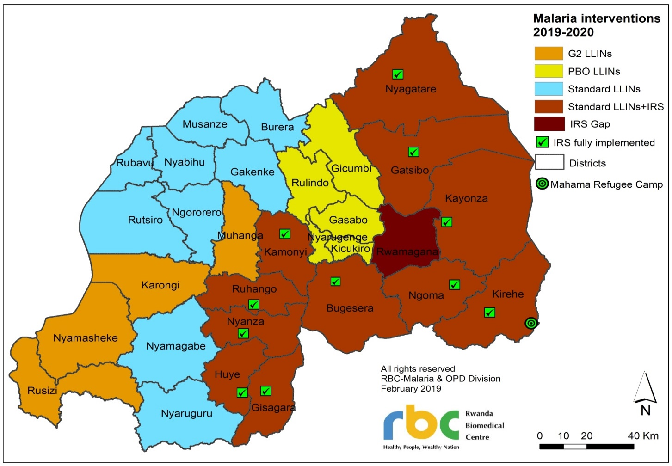
Rwanda is located within a temperate tropical highland climate. Average temperatures are lower than typical in equatorial regions because most of the country is located on a plateau approximately 1,500m above sea level. Average annual rainfall varies between 1,000 to 1,4000 mm. Rainfall is higher in the mountainous Northern and Western provinces, and during the two rainy seasons from February to June and September to December. The study sites are each located within different provinces (Kigali, Southern, Western and Northern) but are geographically clustered, all located 150km or less from one another. Malaria endemicity and ITN coverage in the study districts are reported in Table 2, based on the 2017 Rwanda MIS.
Table 2: Key Malaria Characteristics in Study Sites
District (Province) | Malaria Endemicity  (per district) | Proportion of households or population
District (Province) | Malaria Endemicity  (per district) | Households with at least one ITN | Population with access to an ITN in their household | Population using ITN the night before survey | Use/Access  Ratio
Kicukiro (Kigali City) | Moderate | 84.2% | 77.2% | 70.3% | 0.91
Ruhango (Southern) | Moderate | 81.7% | 65.7% | 59.8% | 0.91
Karongi (Western) | Low | 89.5% | 77.0% | 69.9% | 0.91
Burera (Northern) | Moderate | 91.6% | 82.7% | 73.5% | 0.89
Source: 2017 MIS.
Population access: proportion of population that would be able to use an ITN if each ITN in a household was used by two people. Use/Access ratio: ratio of population access to population using an ITN.

ITN Brands Monitored
The material, insecticide, loading dose, campaign distribution dates and WHO pre-qualification dates for the ITN brands are included in Table 3.

Table 3: ITN Brands Distributed in Study Sites
 | PermaNet® 3.0 | Yahe® LN | Interceptor® G2 | Olyset®
Date of WHO prequalification | January 29, 2018 | February 19, 2018 | January 29, 2018 | December 7, 2017
Province | Kigali | Southern | Western | Northern
Quantity | 816 | 839 | 839 | 859
Distribution date | February 17-21, 2020 | February 17-21, 2020 | March 2-6, 2020 | June 8-14, 2020
ITN type | PBO-synergist | Standard | Dual-AI | Standard
Chemical content | Deltamethrin (2.8 g/kg sides, 4.0 g/kg roof; equivalent to approx. 118 mg/m² and 180 mg/m2)  PBO (25 g/kg roof only; equivalent to approx. 1100 mg/m2) | Deltamethrin (56.0 mg/m²) | Alpha-cypermethrin (100 mg/m²)  Chlorfenapyr (200 mg/m²) | Permethrin (800 mg/m²)
Fabric | Sides: polyester  Roof: polyethylene | Polyester | Polyester | Polyethylene
Denier | Sides: 75  Roof: 100 | 130 | 100 | 150
Shape | Rectangular | Rectangular | Rectangular | Rectangular
Manufacturer | Vestergaard | Fujian Yamei Industry & Trade Co Ltd | BASF | Sumitomo Chemical Co., Ltd
Study site | Kicukiro | Ruhango | Karongi | Burera
Average time between distribution and data collection (months) | 39.0 | 39.1 | 35.2 | 38.5

Study Design Summary
The principal study design was that of a prospective study of a cohort of nets distributed through a mass distribution campaign. The baseline round was conducted three months after the mass net distribution campaign in Karongi, and seven months after the campaign in Kicukiro, Ruhango and Burera, during which a representative sample of campaign nets from the study locations was identified through a cluster household survey with all campaign nets from consenting households forming the study cohort. These nets were labelled during the mass distribution campaign with a unique identifier. During the baseline visit, the net IDs were recorded, and their presence and physical condition assessed. At each subsequent annual assessment (approximately 12-, 24- and 36-months following the distribution) the presence and physical condition of each net in the study cohort was reassessed and recorded, together with household characteristics and use, care, and repair behavior for the net. These characteristics were used to identify household- and respondent-level risk factors for net survivorship. In the first three data collection rounds (including this 24-month survey round), samples of campaign nets were selected from outside the cohort for insecticide bio-effectiveness testing by bioassay. At the final (fourth) round, nets were collected from households within the cohort. Details on the main analytic approaches are described later in this section.
The sampling strategy followed the recommendation from PMI guidance of at least 150 households per study site (15 clusters with 10 households each), or 300 households in total. Given the mass distribution campaign strategy of one net for every 1.8 people in a household and assuming an average household size of 5.9 persons in the study sites, this generates an expected 476 campaign ITNs registered in each district, or 952 ITNs in total. This number of ITNs was estimated to be sufficient to detect a 7.1 percentage-point difference in median survival time across study sites, assuming the median survival is three years. These figures correspond to a median survival difference across sites of at least 0.5 years, the minimum difference which has historically been considered important to detect for the purposes of campaign planning.
A cluster design of 15 clusters with 14 households per district was set to achieve the required 840 households. Districts in Rwanda are subdivided into sectors. At the first stage, six sectors were selected in each district with probability proportionate to population size from a list of all sectors in the district. At the second stage, within each selected sector, the field team mapped the whole area (i.e., listed all inhabited houses where people live) and 14 households were selected using simple random sampling from random number lists.
During the mass distribution campaign, 1,680 ITNs in the selected districts were tagged as cohort nets with an expectation that 1,544 nets would be present at the baseline survey. It was explained to the eligible households that the unique number tag will not inhibit the regular use of the net and they must be careful not to remove it. At the baseline round, households were geo-located to facilitate subsequent visits. In addition to ITNs from the 2020 campaign, all other mosquito nets present in the selected households were recorded to capture full and comparable data on all nets in each household.
For each study site, 30 campaign ITNs were randomly sampled from households within the cohort to undergo tests for bio-efficacy and insecticidal content analysis. Participating households received a new like-for-like replacement ITN in exchange for the one withdrawn for the study. Bioassays for this study were conducted by RBC – MOPDD in accordance with standard WHO guidelines for cone and tunnel tests for pyrethroid ITNs and standard operating procedures produced by the Centers for Disease Control and Prevention (CDC) for testing PBO synergist ITN products. Chemical content analysis was conducted at the CDC laboratory in Atlanta.

Training and Fieldwork
A one-day, in-person training of trainers’ session led by PMI Evolve research staff, was conducted on May 2, 2023, for 11 RBC – MOPDD personnel. Subsequently, a comprehensive in-person fieldworker training was conducted by the RBC – MOPPD with support from PMI Evolve, in Kigali from May 3 to May 5, 2023. This training encompassed two days of classroom-based instruction followed by one day of practical exercises in a local community. The training program covered a range of topics, including study design, sampling procedures, ethical considerations (including obtaining consent), a detailed review of the questionnaire with role-playing exercises, proficiency with tablets and SurveyCTO software, as well as the hands-on assessment of holes and net repairs.
Fieldwork was conducted by a dedicated implementation team, consisting of seven members per district. Each district team included a supervisor and three data field teams, with each field team comprising a notetaker and an interviewer. Data collection coordination was overseen by a designated coordinator, with additional support provided by two field coordinators (one per two districts). The selection of staff for these roles was meticulous, considering their experience and expertise in conducting household surveys.
In each study village, the field team sought approval from local authorities and chiefs to proceed with the follow-up survey. They reiterated the study’s objectives and processes to gain the necessary consent. Communities were then sensitized and engaged to ensure maximum cooperation. A local community guide was enlisted to assist the field teams in locating the designated study households.
Data collection for the primary household survey utilized the ODK-based SurveyCTO software (version 2.70) on Android tablets. As part of the daily routine during fieldwork, team coordinators conducted comprehensive reviews of the data collected that day. Feedback was provided to the teams regarding their performance, highlighting strengths and identifying areas for improvement. Daily progress reports were promptly shared with the study coordinator, and any arising issues were communicated to co-investigators or the principal investigator via WhatsApp for timely resolution. The Regional Research Advisor conducted remote data downloads and examinations on a daily basis, providing valuable insights and feedback to the field teams via WhatsApp.

Data Management
The questionnaire was thoroughly tested prior to deployment. Skip patterns and filters, internal consistency checks, range checks, and logical checks were programmed to support high quality data collection. Depending on the local conditions in each cluster, interviewer data was uploaded to a web-based database daily or stored on tablets until they could be transferred. At the end of the survey, the web-based database was downloaded and converted into a Stata data file for analysis. Data values were checked for internal consistency and logic, and coding was applied for non-response or missing values. All operations were documented in Stata “.do” files.

Analysis
Estimates of sampling errors accounted for the clustered survey design and sampling weights were applied to account for the modified sampling strategy. Chi-squared tests were run to assess differences in results between study sites and statistical significance was determined using the associated p-value. Results with a p-value < 0.05 were considered statistically significant.
The household sample is considered approximately self-weighting and therefore no weights were applied during analysis. Estimates of sampling errors accounted for the clustered survey design.
Attitudes towards nets and net care/repair were captured using Likert score questions, where respondents stated the extent to which they agreed or disagreed with a standard set of statements. Data from the Likert score questions were summarized into two summary scores (nets and net care/repair) by first recoding the four-level Likert scale to have a value of -2 for “strongly disagree”, -1 for “disagree”, +1 for “agree” and +2 for “strongly agree”. These values for each response were then summed and divided by the number of statements to calculate an overall attitude score. An average score greater than 1 is interpreted as a household respondent with favorable attitudes to a given topic.
The physical integrity of campaign ITNs was assessed in accordance with WHO guidelines, with the number of holes of size 0.5 – 2 cm diameter (size 1), 2 – 10 cm diameter (size 2), 10 – 25 cm diameter (size 3) and >25 cm diameter (size 4) recorded for each net, following examination by the team in a well-lit location. Data from the ITN hole assessment was transformed into the proportionate Hole Index (pHI) for each ITN using the following standard equation defined by WHO:
pHI = Number of size 1 holes + (No. of size 2 holes x 23) + (No. of size 3 holes x 196) + (No. of size 4 holes x 576)
Based on the pHI value, ITNs were categorized as “good”, “serviceable” or “torn” as defined below. Note that “good” is a subset of all “serviceable” ITNs.
Good: pHI ≤ 64 (corresponding to a total hole surface area ≤ 0.01m²)
Serviceable: pHI ≤ 642 (total hole surface area ≤ 0.1 m²)
Torn: pHI > 642 (total hole surface area > 0.1m²)
The insecticidal effectiveness was performed by RBC – MOPDD (Entomology Laboratory). The outcomes were based on the bioassay results using the standard WHO cone test guidelines. Cone bioassays were performed for PermaNet® 3.0, Olyset®, and Yahe® LN ITNs using a pyrethroid-susceptible Kisumu strain of Anopheles gambiae s.s. and a pyrethroid resistant strain of Anopheles gambiae s.l. with five mosquitoes per cone. For Olyset® and Yahe® LN ITNs, four sites were tested on each net (standard positions 2, 3, 4 and roof) and two replicates per location (eight cone tests with 40 mosquitoes per net in total). For PermaNet® 3.0 ITNs, cone assays were run separately on netting samples taken from the ITN sides (containing deltamethrin only) and roof (deltamethrin and PBO). Bioassays on Interceptor® G2 nets with wild mosquito colony using tunnel tests followed Evolve developed SOPs. Therefore, Interceptor® G2 nets were tested by RBC – MOPDD with susceptible colony Anopheles gambiae s.s. and wild collected pyrethroid-resistant mosquitoes Anopheles gambiae s.l. For cone bioassays, the 60-minute knock-down (KD60) and the 24-hour mortality rate (mortality) are measured. The two variables from these tests were combined into the following outcome measures:
Optimal effectiveness: KD60 ≥ 95% or mortality ≥ 80%
Minimal effectiveness: KD60 ≥ 75% or mortality ≥ 50%
Blood feeding inhibition (BFI) and 72 hours mortality rates were determined from the tunnel test of the Interceptor® G2 nets.
Separate samples taken from ITNs selected for bioassays were packaged following standard procedures and shipped to CDC Atlanta for chemical content testing. Samples from the roof and sides were tested separately for the PermaNet® 3.0 brand. Outcome measures from these tests present the mean and median level of active ingredient across the net brand samples in g/kg and compare these averages with manufacturer specifications for the insecticides used on the netting.

Ethical Clearance
This study has been determined to be research with human subjects and received written continuing approval from the Republic of Rwanda National Ethics Committee on July 23, 2019, under reference number 517/RNEC/2019. Staff implementing this study complied with all policies and procedures of the local ethics boards. Informed oral consent was sought for all participants in this study prior to conducting the interview.

Results

Sample
At baseline, a total of 891 households were recruited for durability monitoring (214 (24%) in Kicukiro, 218 (25%) in Ruhango, 237 (27%) in Karongi, 222 (25%) in Burera), of which 773 (86%) households (186 (24%) in Kicukiro, 193 (25%) in Ruhango, 195 (25%) in Karongi, 199 (26%) in Burera) were eligible for follow-up at the 36-month round of data collection (Figure 2). Of the households that were eligible for follow-up at 36 months, 172 (93%) in Kicukiro, 183 (95%) in Ruhango, 169 (87%) in Karongi and 187 (94%) in Burera still had the nets.
Figure 2: Follow-Up Status of Households Recruited at Baseline
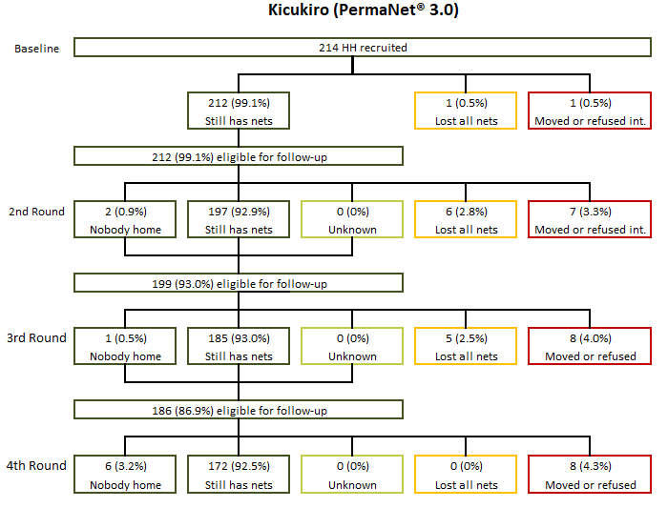
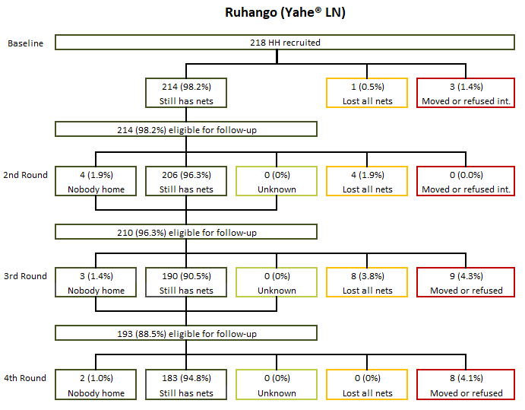
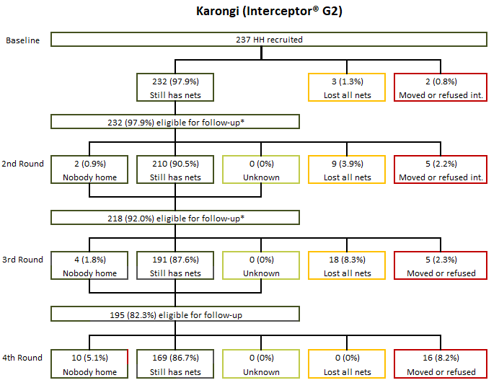
During the second round, six households in Karongi were not interviewed due to positive COVID-19 screenings. These households were included in the sample of eligible households for the subsequent rounds.
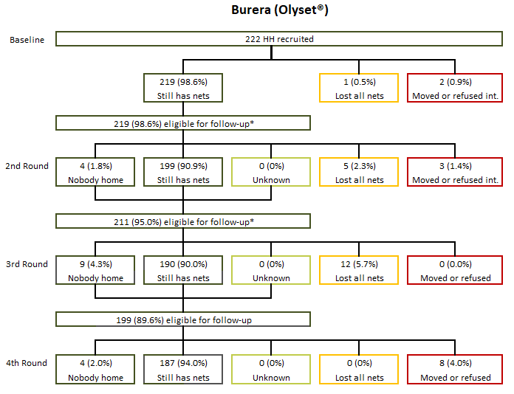
During the second round, eight households in Burera were not interviewed due to positive COVID-19 screenings. These households were included in the sample of eligible households for the subsequent rounds.
The 891 households visited at baseline received a total of 2,130 campaign nets (530 (25%) in Kicukiro, 536 (25%) in Ruhango, 556 (26%) in Karongi, 508 (24%) in Burera; Figure 3). Of these, 2,024 (95%) nets (496 (25%) in Kicukiro, 504 (25%) in Ruhango, 534 (26%) in Karongi, 490 (24%) in Burera) were either present in the household or with family elsewhere and were tagged for study follow-up. A total of 1,631 (77%) cohort nets were eligible for follow-up at the 36-month survey round.
At 36 months, 270 (66%) ITNs in Kicukiro, 313 (73%) ITNs in Ruhango, 241 (60%) ITNs in Karongi, 271 (69%) ITNs in Burera were still in the households, had an unknown status (either due to nobody being home or lack of more precise respondent recall), or were elsewhere with family members (Figure 3).

Figure 3: Follow-Up Status of Cohort ITNs Recruited at Baseline
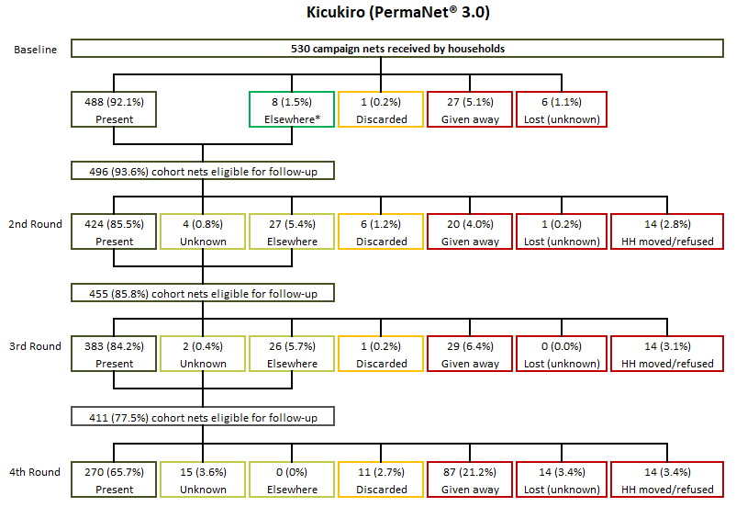
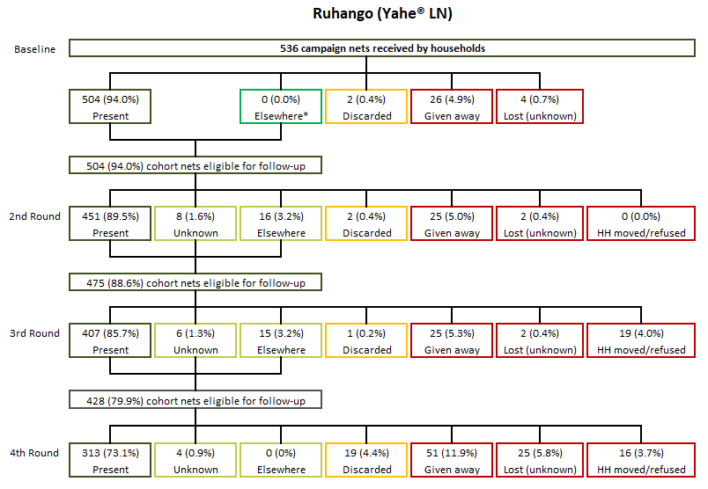
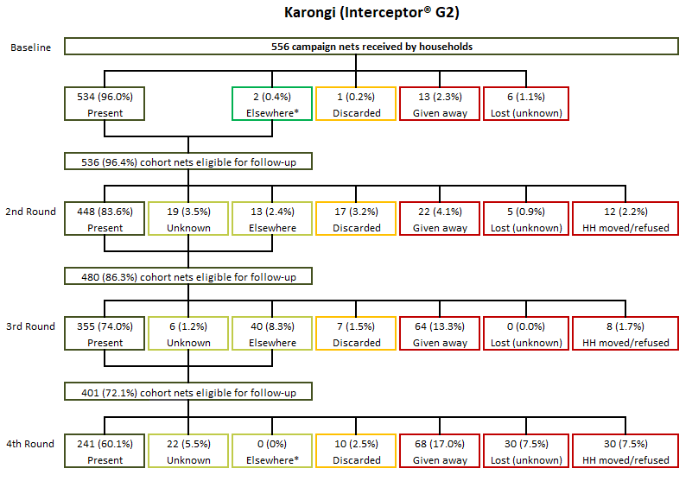
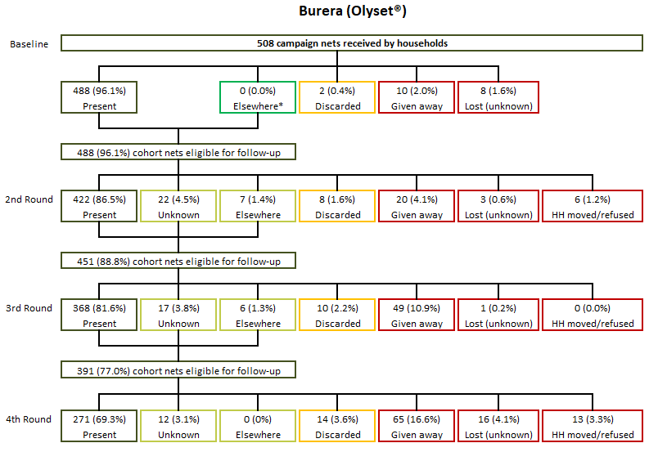

Determinants of Durability
The study assessed household risk factors for net durability and attitudes and behaviors related to net care and repair. Factors that have previously been shown to be associated with net durability can be divided into household factors, handling factors, and net care and repair attitudes and behaviors. The presence of rodents in the house and the presence of food and practice of cooking near sleeping areas are risk factors for net durability. Table 4 presents the prevalence of these risk factors in the four study sites.
At 36-months, food storage practices in sleeping rooms varied across districts: Ruhango (35%), Karongi (30%), Kicukiro (18%), and Burera (13%), p<0.001. Cooking in sleeping rooms was infrequent across all districts (Never cooking in sleeping room; Kicukiro: 99%, Ruhango: 87%, Karongi: 98%, Burera: 98%). Rodent presence was universally high, but showed district-level variations, ranging from 96% in Ruhango to 92% in Karongi, 91% in Burera, and 85% in Kicukiro, p<0.006.
Food storage in sleeping rooms decreased in all districts from baseline to 36 months (Kicukiro: 35% to 18%, Ruhango: 53% to 36%, Karongi: 46% to 30%, Burera: 31% to 14%). Avoidance of cooking in sleeping rooms increased (Kicukiro: 96% to 99%, Ruhango: 81% to 87%, Karongi: 84% to 98%, Burera: 95% to 98%). Rodent presence declined in Kicukiro (97% to 85%) and fluctuated in Ruhango (93% to 96%), Karongi (91% to 92%), and Burera (94% to 91%).

Table 4: Prevalence of Household Risk Factors for Damage
 | Baseline | 12-Month | 24-Month | 36-Month
Kicukiro | N=213 | N=203 | N=190 | N=172
Ever store food in room used for sleeping | 35.2% | 25.6% | 17.9% | 18.0%
Cook in sleeping room
Never | 96.2% | 96.6% | 97.9% | 99.4%
Sometimes | 3.3% | 3.0% | 1.6% | 0.6%
Always | 0.5% | 0.5% | 0.5% | 0.0%
Don’t know | 0.0% | 0.0% | 0.0% | 0.0%
Observed rodents in last six months | 96.7% | 94.1% | 93.2% | 84.9%
Ruhango | N=215 | N=210 | N=198 | N=183
Ever store food in room used for sleeping | 52.6% | 40.5% | 20.7% | 35.5%
Cook in sleeping room
Never | 81.4% | 88.6% | 89.4% | 86.9%
Sometimes | 14.4% | 7.6% | 2.5% | 8.7%
Always | 3.7% | 3.8% | 8.1% | 4.4%
Don’t know | 0.5% | 0.0% | 0.0% | 0.0%
Observed rodents in last six months | 93.0% | 96.7% | 93.4% | 96.2%
Karongi | N=235 | N=219 | N=209 | N=169
Ever store food in room used for sleeping | 45.5% | 38.4% | 34.9% | 30.2%
Cook in sleeping room
Never | 83.8% | 90.4% | 90.0% | 98.2%
Sometimes | 6.0% | 6.8% | 7.2% | 0.6%
Always | 10.2% | 2.7% | 2.9% | 1.2%
Don’t know | 0.0% | 0.0% | 0.0% | 0.0%
Observed rodents in last six months | 90.6% | 95.4% | 96.2% | 91.7%
Burera | N=220 | N=204 | N=202 | N=187
Ever store food in room used for sleeping | 31.4% | 26.0% | 21.3% | 13.9%
Cook in sleeping room
Never | 95.0% | 98.0% | 96.0% | 97.9%
Sometimes | 1.8% | 1.0% | 2.5% | 1.6%
Always | 2.3% | 1.0% | 1.5% | 0.5%
Don’t know | 0.9% | 0.0% | 0.0% | 0.0%
Observed rodents in last six months | 93.6% | 91.2% | 94.6% | 90.9%

The type of sleeping place may also affect net durability. Generally, nets used over mats, or the ground are more prone to wear and tear than those used over mattresses and bed frames. Figure 4 shows the types of sleeping spaces over which cohort ITNs were used by site and study period. The majority of nets were used over a bed frame or mattress. However, the proportion of cohort nets used over a mat or ground varied considerably across study sites. At the 36-month survey round, cohort net usage over mats or the ground was most prominent in Ruhango (26%) but less so in Karongi (11%), Burera (8%) and Kicukiro (4%).
Figure 4: Type of Sleeping Place for Cohort ITNs When Used
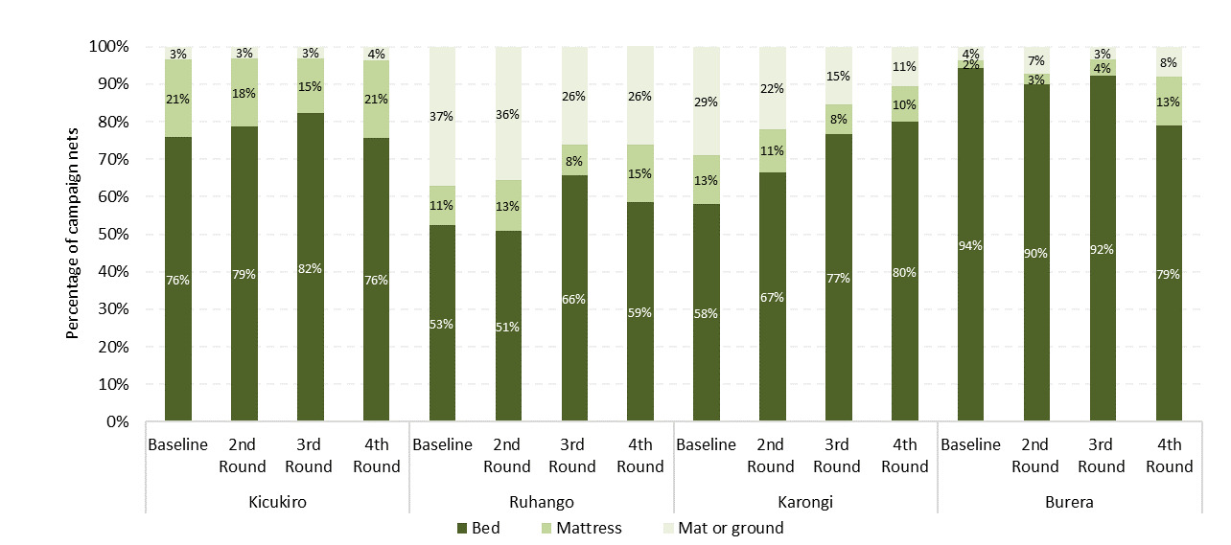
In addition to food storage and cooking practices, excessive net handling is a risk factor for durability (Table 5). Excessive washing, particularly with cleaning products like detergent or bleach, can diminish insecticide effectiveness. At the 36-month survey, differences in cohort net washing emerged across districts: Ruhango at 97%, Kicukiro at 91%, Karongi at 77%, and Burera at 31%, p<0.001. Among washed cohort nets, median wash frequency in the six months preceding the survey remained consistent between districts (2.0 in Kicukiro, Karongi, and Ruhango, 1.0 in Burera). The use of bleach was uncommon in all districts but was most frequent in Kicukiro (9% in Kicukiro, 7% in Ruhango and Burera, 0% in Karongi; p<0.001).
Drying nets on a bush or fence, another physical durability risk factor, varied, being most frequent in Karongi (38% in Karongi, 24% in Kicukiro, 21% in Ruhango, 2% in Burera; p<0.001). Among reported hanging nets, the proportion of loose hanging cohort nets, which can increase the risk of wear and tear, differed between districts (55% in Burera, 45% in Kicukiro, 23% in Karongi, 17% in Ruhango; p<0.001). Notably, behaviors regarding ITN washing, drying, and hanging evolved over survey rounds. ITN washing rates increased across all districts (Kicukiro: 64% to 91%, Ruhango: 70% to 97%, Karongi: 34% to 77%), except in Burera (40.8% to 31.0%).
Table 5: Prevalence of Handling Risk Factors for Cohort ITNs
 | Baseline | 12-Month | 24-Month | 36-Month
Kicukiro | N=488 | N=428 | N=383 | N=270
ITNs ever washed | 64.3% | 88.1% | 92.7% | 91.1%
Among ITNs ever washed: | N=314 | N=377 | N=355 | N=246
Median number of washes in last six months -  [Interquartile range (IQR)] | 2.0 [1.0-2.0] | 2.0 [1.0-2.0] | 2.0 [2.0-2.0] | 2.0 [1.0-2.0]
Used detergent or bleach for last wash | 31.2% | 16.7% | 13.0% | 9.3%
ITNs dried on bush or fence for last wash | 28.7% | 27.1% | 26.2% | 23.6%
Among hanging ITNs: | N=352 | N=352 | N=348 | N=221
Hanging ITNs are not folded or tied up | 47.7% | 31.2% | 25.6% | 45.2%
Ruhango | N=504 | N=452 | N=407 | N=313
ITNs ever washed | 69.6% | 92.5% | 91.6% | 96.8%
Among ITNs ever washed: | N=351 | N=418 | N=373 | N=303
Median number of washes in last six months [IQR] | 1.0 [1.0-2.0] | 2.0 [1.0-2.0] | 1.0 [1.0-2.0] | 2.0 [1.0-2.0]
Used detergent or bleach for last wash | 12.5% | 4.3% | 2.7% | 6.9%
ITNs dried on bush or fence for last wash | 25.1% | 23.0% | 11.8% | 21.8%
Among hanging ITNs: | N=420 | N=411 | N=364 | N=276
Hanging ITNs are not folded or tied up | 46.7% | 33.1% | 45.3% | 17.4%
Karongi | N=534 | N=451 | N=355 | N=241
ITNs ever washed | 34.3% | 76.5% | 93.2% | 76.8%
Among ITNs ever washed: | N=183 | N=345 | N=331 | N=185
Median number of washes in last six months [IQR] | 1.0 [1.0-1.0] | 1.0 [1.0-2.0] | 2.0 [1.0-2.0] | 2.0 [1.0-2.0]
Used detergent or bleach for last wash | 5.5% | 2.0% | 3.9% | 0.0%
ITNs dried on bush or fence for last wash | 54.1% | 51.0% | 54.7% | 38.4%
Among hanging ITNs: | N=465 | N=379 | N=315 | N=184
Hanging ITNs are not folded or tied up | 41.1% | 24.3% | 35.6% | 23.4%
Burera | N=488 | N=426 | N=369 | N=271
ITNs ever washed | 40.8% | 71.8% | 79.1% | 31.0%
Among ITNs ever washed: | N=199 | N=306 | N=292 | N=84
Median number of washes in last six months [IQR] | 1.0 [1.0-2.0] | 2.0 [1.0-2.0] | 2.0 [1.0-2.0] | 1.0 [1.0-2.0]
Used detergent or bleach for last wash | 18.1% | 9.2% | 4.1% | 7.1%
ITNs dried on bush or fence for last wash | 21.6% | 29.1% | 23.3% | 2.4%
Among hanging ITNs: | N=355 | N=341 | N=299 | N=148
Hanging ITNs are not folded or tied up | 76.9% | 31.1% | 35.5% | 55.4%
IQR: interquartile range

Table 6 illustrates respondent exposure to information on net use, care, and repair. At the 36-month survey round, exposure proportions differed between study sites: Ruhango 25%, Karongi 20%, Burera 20%, and Kicukiro 10%, p=0.03. Among those exposed, most respondents (ranging from 65% to 77%) received information through interpersonal communication. Commonly recalled messages included “use net every night” and “care for net” (ranging from 70% to 94% across districts). Caution is advised when interpreting or comparing study districts due to low exposure levels (Kicukiro N=17; Ruhango N=46; Karongi N=33; Burera N=36) in the six months prior to the 36-month survey round. Exposure to malaria prevention messages fluctuated across study rounds. Kicukiro initially increased (6% to 21%) and then declined (10%), while Ruhango decreased (29% to 11%) followed by an increase (25%). Similarly, Karongi decreased (57% to 36%) and decreased again (20%), and Burera decreased (44% to 14%) before increasing (20%).
Table 6: Respondent Exposure to Messages About Nets in Last Six Months
 | Baseline | 12-Month | 24-Month | 36-Month
Kicukiro | N=213 | N=203 | N=190 | N=172
Any exposure in last six months | 5.6% | 7.4% | 21.1% | 9.9%
Among those exposed: | N=12 | N=15 | N=40 | N=17
Mean number of sources among exposed* | 1.2 | 1.1 | 1.2 | 1.3
Type of media source among exposed
Media only | 8.3% | 13.3% | 7.5% | 5.9%
Interpersonal communication only | 83.3% | 86.7% | 87.5% | 76.5%
Both | 8.3% | 0.0% | 5.0% | 17.6%
Messages recalled among exposed
“Use net (every) night” | 91.7% | 80.0% | 95.0% | 94.1%
“Hang net” | 33.3% | 46.7% | 80.0% | 52.9%
“Care for net” | 66.7% | 93.3% | 95.0% | 82.4%
“Repair net” | 0.0% | 46.7% | 67.5% | 47.1%
“Nets prevent malaria” | 25.0% | 33.3% | 95.0% | 58.8%
Ruhango | N=214 | N=210 | N=198 | N=183
Any exposure in last six months | 29.4% | 38.1% | 10.6% | 25.1%
Among those exposed: | N=63 | N=80 | N=21 | N=46
Mean number of sources among exposed* | 1.3 | 1.2 | 1.3 | 1.3
Type of media source among exposed
Media only | 14.3% | 11.2% | 0.0% | 15.2%
Interpersonal communication only | 69.8% | 75.0% | 90.5% | 65.2%
Both | 15.9% | 13.8% | 9.5% | 19.6%
Messages recalled among exposed
“Use net (every) night” | 92.1% | 97.5% | 85.7% | 87.0%
“Hang net” | 77.8% | 91.2% | 57.1% | 37.0%
“Care for net” | 76.2% | 95.0% | 76.2% | 87.0%
“Repair net” | 41.3% | 77.5% | 57.1% | 54.3%
“Nets prevent malaria” | 82.5% | 92.5% | 42.9% | 41.3%
Karongi | N=235 | N=219 | N=209 | N=169
Any exposure in last six months | 57.0% | 13.7% | 35.9% | 19.5%
Among those exposed: | N=134 | N=30 | N=75 | N=33
Mean number of sources among exposed* | 2.4 | 1.3 | 1.1 | 1.1
Type of media source among exposed
Media only | 3.7% | 6.7% | 2.7% | 12.1%
Interpersonal communication only | 77.6% | 76.7% | 93.3% | 84.8%
Both | 18.7% | 16.7% | 4.0% | 3.0%
Messages recalled among exposed
“Use net (every) night” | 89.6% | 76.7% | 77.3% | 69.7%
“Hang net” | 87.3% | 26.7% | 22.7% | 18.2%
“Care for net” | 89.6% | 60.0% | 58.7% | 87.9%
“Repair net” | 28.4% | 46.7% | 68.0% | 48.5%
“Nets prevent malaria” | 76.9% | 23.3% | 30.7% | 15.2%
Burera | N=220 | N=204 | N=202 | N=187
Any exposure in last six months | 43.6% | 26.5% | 13.9% | 19.3%
Among those exposed: | N=96 | N=54 | N=28 | N=36
Mean number of sources among exposed* | 1.9 | 1.3 | 1.1 | 1.4
Type of media source among exposed
Media only | 2.1% | 13.0% | 7.1% | 0.0%
Interpersonal communication only | 58.3% | 74.1% | 82.1% | 72.2%
Both | 39.6% | 13.0% | 10.7% | 27.8%
Messages recalled among exposed
“Use net (every) night” | 75.0% | 75.9% | 75.0% | 88.9%
“Hang net” | 51.0% | 46.3% | 32.1% | 44.4%
“Care for net” | 55.2% | 79.6% | 71.4% | 83.3%
“Repair net” | 10.4% | 44.4% | 28.6% | 25.0%
“Nets prevent malaria” | 62.5% | 37.0% | 17.9% | 27.8%
*During the 36-month round study, the mean number of sources was 1.3 and included community
health agent, health worker, community leader, and town announcer.

Table 7 shows the mean attitude score for nets and for net care and repair (scores above 1 indicate favorable attitudes). At the 36-month survey round, the mean attitude scores for nets and net care and repair were greater than one in all study districts indicating overall favorable attitudes towards nets and net care and repair. These favorable attitudes offer a great opportunity for reinforcing positive attitudes towards nets and their care and repair.

Table 7: Respondent Attitudes Towards Nets and Net Care and Repair
 | Baseline | 12-Month | 24-Month | 36-Month
Kicukiro | N=213 | N=203 | N=190 | N=172
Attitude score: Nets
Mean (95% confidence interval CI) | 1.42 (1.31-1.53) | 1.48 (1.39-1.57) | 1.38 (1.29-1.47) | 1.55 (1.48-1.62)
Percentage of respondents with score > 1.0 | 75.6% | 80.8% | 70.5% | 81.4%
Attitude score: Net care and repair
Mean (95% CI) | 1.11 (0.96-1.25) | 1.43 (1.30-1.56) | 1.50 (1.37-1.62) | 1.72 (1.66-1.78)
Percentage of respondents with score > 1.0 | 62.0% | 79.8% | 80.5% | 93.0%
Ruhango | N=215 | N=210 | N=198 | N=183
Attitude score: Nets
Mean (95% CI) | 1.43 (1.32-1.55) | 1.16 (1.01-1.31) | 1.29 (1.20-1.38) | 1.20 (1.11-1.28)
Percentage of respondents with score > 1.0 | 70.7% | 47.6% | 59.6% | 57.4%
Attitude score: Net care and repair
Mean (95% CI) | 1.63 (1.53-1.72) | 1.72 (1.62-1.82) | 1.63 (1.54-1.73) | 1.53 (1.43-1.62)
Percentage of respondents with score > 1.0 | 83.3% | 88.1% | 86.4% | 86.9%
Karongi | N=235 | N=219 | N=209 | N=169
Attitude score: Nets
Mean (95% CI) | 1.73 (1.32-1.55) | 1.12 (1.01-1.31) | 1.67 (1.20-1.38) | 1.36 (1.11-1.28)
Percentage of respondents with score > 1.0 | 88.1% | 53.4% | 90.9% | 70.4%
Attitude score: Net care and repair
Mean (95% CI) | 1.50 (1.53-1.72) | 1.39 (1.62-1.82) | 1.64 (1.54-1.73) | 1.54 (1.43-1.62)
Percentage of respondents with score > 1.0 | 83.8% | 75.3% | 87.6% | 81.1%
Burera | N=220 | N=204 | N=202 | N=187
Attitude score: Nets
Mean (95% CI) | 0.78 (1.32-1.55) | 0.90 (1.01-1.31) | 0.69 (1.20-1.38) | 1.01 (1.11-1.28)
Percentage of respondents with score > 1.0 | 35.0% | 33.3% | 30.7% | 37.4%
Attitude score: Net care and repair
Mean (95% CI) | 0.86 (1.53-1.72) | 1.00 (1.62-1.82) | 0.96 (1.54-1.73) | 1.25 (1.43-1.62)
Percentage of respondents with score > 1.0 | 40.9% | 51.5% | 52.0% | 65.8%
Experience with repairing holes in nets is displayed in Table 8. At 36 months, the proportion of households that had ever experienced holes in a net varied between districts: Burera 83%, Ruhango 78%, Kicukiro 76%, and Karongi 72%. The prevalence of households discussing net care and repair in the last six months varied as well: Ruhango 83%, Kicukiro 36%, Karongi 47%, and Burera 11%; p<0.001. Among households with holes in their nets, the proportion that had ever repaired their nets was highest in Ruhango (57%), followed by Karongi (41%), Kicukiro (43%), and Burera (15%); p<0.001.

Table 8: Household Net Care and Repair Experience
 | Baseline | 12-Month | 24-Month | 36-Month
Kicukiro | N=213 | N=203 | N=190 | N=172
Ever experienced holes in a net | 22.1% | 62.1% | 68.9% | 76.2%
Discussed net care and repair in last 6 months | 5.2% | 21.2% | 45.3% | 35.5%
Among households experiencing holes: | N=47 | N=126 | N=131 | N=131
Ever repaired net | 10.6% | 32.5% | 41.2% | 42.7%
Ruhango | N=215 | N=210 | N=198 | N=183
Ever experienced holes in a net | 40.5% | 64.3% | 79.8% | 78.1%
Discussed net care and repair in last 6 months | 4.2% | 57.6% | 52.0% | 82.5%
Among households experiencing holes: | N=87 | N=135 | N=158 | N=143
Ever repaired net | 18.4% | 36.3% | 55.7% | 56.6%
Karongi | N=235 | N=219 | N=209 | N=169
Ever experienced holes in a net | 3.8% | 46.1% | 71.8% | 72.2%
Discussed net care and repair in last 6 months | 23.4% | 13.7% | 59.3% | 47.3%
Among households experiencing holes: | N=9 | N=101 | N=150 | N=122
Ever repaired net | 22.2% | 28.7% | 39.3% | 41.0%
Burera | N=220 | N=204 | N=202 | N=187
Ever experienced holes in a net | 33.2% | 62.7% | 74.3% | 83.4%
Discussed net care and repair in last 6 months | 6.8% | 76.0% | 55.0% | 10.7%
Among households experiencing holes: | N=73 | N=128 | N=150 | N=156
Ever repaired net | 13.7% | 17.2% | 21.3% | 15.4%

Net Ownership and Net Use
The status and reported recent use of campaign cohort nets (Table 9) were recorded to understand net use patterns. At 36 months, cohort nets were most observed hanging and tied up in across Ruhango (73%), Karongi (59%), and Kicukiro (45%). Nets hanging and tied up was a less common finding in Burera, where the most common way nets were observed was hanging untied. Over 90% of cohort nets were ever used across all study sites, except for Burera where 86% were ever used. The proportion of nets used last night and used every night last week differed significantly across sites (p<0.001). Kicukiro exhibited the highest usage rates, with 82% used last night and 78% used every night last week, while Burera reported the lowest rates at 51% and 45% respectively.
Table 9: Status and Reported Use of Cohort Nets in the Household
 | Baseline | 12-Month | 24-Month | 36-Month
Kicukiro | N=488 | N=428 | N=383 | N=270
Cohort net status
Found hanging and tied up | 37.7% | 56.5% | 67.6% | 44.8%
Found hanging, untied | 34.4% | 25.7% | 23.2% | 37.0%
Not hanging and not stored away | 2.5% | 2.3% | 1.6% | 7.8%
Stored away unpacked | 11.9% | 6.5% | 4.4% | 5.6%
Stored away in a package | 13.1% | 8.9% | 3.1% | 4.8%
Temporarily unavailable during visit | 0.4% | 0.0% | 0.0% | 0.0%
Net ever used | 77.0% | 86.4% | 96.6% | 91.5%
Net used last night | 66.2% | 76.4% | 85.6% | 79.3%
Net used every night last week | 59.8% | 74.5% | 77.8% | 72.2%
Ruhango | N=504 | N=452 | N=407 | N=313
Cohort net status
Found hanging and tied up | 44.4% | 60.8% | 48.9% | 72.8%
Found hanging, untied | 38.9% | 30.1% | 40.5% | 15.3%
Not hanging and not stored away | 6.0% | 2.4% | 4.2% | 2.6%
Stored away unpacked | 7.1% | 4.0% | 4.2% | 6.7%
Stored away in a package | 3.4% | 2.7% | 2.2% | 2.6%
Temporarily unavailable during visit | 0.2% | 0.0% | 0.0% | 0.0%
Net ever used | 89.1% | 95.8% | 92.9% | 99.7%
Net used last night | 84.1% | 88.9% | 87.0% | 81.8%
Net used every night last week | 80.6% | 87.6% | 84.5% | 77.6%
Karongi | N=534 | N=451 | N=355 | N=241
Cohort net status
Found hanging and tied up | 51.3% | 63.6% | 57.2% | 58.5%
Found hanging, untied | 35.8% | 20.4% | 31.5% | 17.8%
Not hanging and not stored away | 1.9% | 8.2% | 3.7% | 4.1%
Stored away unpacked | 3.9% | 3.3% | 4.8% | 12.9%
Stored away in a package | 7.1% | 4.4% | 2.8% | 3.3%
Temporarily unavailable during visit | 0.0% | 0.0% | 0.0% | 3.3%
Net ever used | 90.1% | 95.6% | 97.2% | 99.2%
Net used last night | 82.6% | 75.2% | 80.3% | 71.0%
Net used every night last week | 77.0% | 70.7% | 72.1% | 60.6%
Burera | N=488 | N=426 | N=369 | N=271
Cohort net status
Found hanging and tied up | 16.8% | 55.2% | 52.3% | 24.4%
Found hanging, untied | 55.9% | 24.9% | 28.7% | 30.3%
Not hanging and not stored away | 3.5% | 4.2% | 3.3% | 29.5%
Stored away unpacked | 15.8% | 7.3% | 6.5% | 11.4%
Stored away in a package | 8.0% | 8.2% | 9.2% | 4.4%
Temporarily unavailable during visit | 0.0% | 0.2% | 0.0% | 0.0%
Net ever used | 75.8% | 89.9% | 95.4% | 86.3%
Net used last night | 66.6% | 73.9% | 74.5% | 50.9%
Net used every night last week | 59.4% | 67.6% | 64.2% | 45.4%
At each survey round, all mosquito nets present in selected households are recorded, including nets from sources that couldn’t be confirmed to be from the 2020 mass distribution campaign (referred to as non-cohort nets). Household ownership of non-cohort nets and sources of these nets are presented in Table 10.
At the 36-month survey round, non-cohort net ownership showed variations across study sites: Ruhango (20%), Kicukiro (16%), Karongi (5%), and Burera (5%); p<0.001. Various sources were identified for non-cohort nets. Antenatal care (ANC) visits played a prominent role in Burera (90%), Kicukiro (38%), and Ruhango (35%). Previous mass campaigns were a large contributor in Kicukiro (18%) and Ruhango (8%). Other public sources, including non-ANC health facility visits, community-based workers, and immunization campaigns, held some importance in Ruhango (33%), Karongi (33%), Kicukiro (27%), and Burera (10%). Although less common, private sector sources made notable contributions in Karongi (33%), Ruhango (17%), and Kicukiro (15%).

Table 10: Ownership and Source of Non-Cohort Nets
 | Baseline | 12-Month | 24-Month | 36-Month
Kicukiro | N=213 | N=203 | N=190 | N=172
Households with any non-cohort nets | 30.5% | 32.5% | 26.3% | 15.7%
Non-cohort net sources | Net N=92 | Net N=94 | Net N=69 | Net N=34
ANC visit | 21.7% | 18.1% | 24.6% | 38.2%
Previous mass campaign | 28.3% | 33.0% | 34.8% | 17.6%
School | 0.0% | 0.0% | 0.0% | 0.0%
Other public source* | 22.8% | 18.1% | 13.0% | 26.5%
Private sector | 18.5% | 23.4% | 13.0% | 14.7%
Other/doesn’t recall** | 8.7% | 7.4% | 14.5% | 2.9%
Ruhango | N=215 | N=210 | N=198 | N=183
Households with any non-cohort nets | 16.3% | 25.7% | 24.2% | 20.2%
Non-cohort net sources | Net N=40 | Net N=69 | Net N=54 | Net N=52
ANC visit | 30.0% | 24.6% | 25.9% | 34.6%
Previous mass campaign | 27.5% | 44.9% | 20.4% | 7.7%
School | 2.5% | 0.0% | 0.0% | 0.0%
Other public source* | 32.5% | 18.8% | 42.6% | 32.7%
Private sector | 5.0% | 7.2% | 7.4% | 17.3%
Other/doesn’t recall** | 2.5% | 4.3% | 3.7% | 7.7%
Karongi | N=235 | N=219 | N=209 | N=169
Households with any non-cohort nets | 7.2% | 17.8% | 6.7% | 4.7%
Non-cohort net sources | Net N=20 | Net N=46 | Net N=15 | Net N=9
ANC visit | 30.0% | 19.6% | 33.3% | 33.3%
Previous mass campaign | 60.0% | 28.3% | 20.0% | 0.0%
School | 0.0% | 0.0% | 0.0% | 0.0%
Other public source* | 5.0% | 37.0% | 33.3% | 33.3%
Private sector | 0.0% | 10.9% | 6.7% | 33.3%
Other/doesn’t recall** | 5.0% | 4.3% | 6.7% | 0.0%
Burera | N=220 | N=204 | N=202 | N=187
Households with any non-cohort nets | 8.6% | 31.9% | 26.2% | 4.8%
Non-cohort net sources | Net N=21 | Net N=79 | Net N=58 | Net N=10
ANC visit | 66.7% | 30.4% | 44.8% | 90.0%
Previous mass campaign | 4.8% | 46.8% | 22.4% | 0.0%
School | 0.0% | 0.0% | 0.0% | 0.0%
Other public source* | 28.6% | 21.5% | 25.9% | 10.0%
Private sector | 0.0% | 0.0% | 5.2% | 0.0%
Other/doesn’t recall** | 0.0% | 1.3% | 1.7% | 0.0%
* Includes other (non-ANC) public health facility visits, community-based workers and immunization campaigns.
** Includes family/friends, non-governmental organizations, and faith-based organizations.
During the 36-month survey, a total of 105 non-cohort nets were assessed across study households (52 in Ruhango, 34 in Kicukiro, 10 in Burera and 9 in Karongi). The most common net location was hanging and tied up, with variations across districts (56% in Karongi, 54% in Ruhango, 44% in Kicukiro, and 30% in Burera). The second most common location was hanging loose (40% in Burera, 38% in Kicukiro, 22% in Karongi and 14% in Ruhango). Notably, a sizable proportion of nets were stored away unpacked across all districts (22% in Karongi, 20% in Burera, 19% in Ruhango, and 18% in Kicukiro). Non-cohort net utilization the previous night showed consistency across districts (78% in Karongi, 74% in Kicukiro, 60% in Ruhango, and 60% in Burera).
Table 11: Status and Reported Use of Non-Cohort Nets in the Household
 | Baseline | 12-Month | 24-Month | 36-Month
Kicukiro | N=92 | N=94 | N=69 | N=34
Non-cohort net status
Found hanging and tied up | 45.7% | 59.6% | 60.9% | 44.1%
Found hanging, untied | 29.3% | 13.8% | 11.6% | 38.2%
Not hanging and not stored away | 5.4% | 2.1% | 2.9% | 0.0%
Stored away unpacked | 8.7% | 9.6% | 8.7% | 0.0%
Stored away in a package | 9.8% | 14.9% | 15.9% | 17.6%
Temporarily unavailable during visit | 1.1% | 0.0% | 0.0% | 0.0%
Net ever used | 82.6% | 74.5% | 82.6% | 82.4%
Net used last night | 62.0% | 57.4% | 58.0% | 73.5%
Net used every night last week | 54.3% | 54.3% | 58.0% | 70.6%
Ruhango | N=40 | N=69 | N=54 | N=52
Non-cohort net status
Found hanging and tied up | 32.5% | 44.9% | 31.5% | 53.8%
Found hanging, untied | 27.5% | 21.7% | 25.9% | 13.5%
Not hanging and not stored away | 15.0% | 2.9% | 0.0% | 1.9%
Stored away unpacked | 17.5% | 17.4% | 25.9% | 11.5%
Stored away in a package | 7.5% | 11.6% | 16.7% | 19.2%
Temporarily unavailable during visit | 0.0% | 1.4% | 0.0% | 0.0%
Net ever used | 65.0% | 69.6% | 57.4% | 84.6%
Net used last night | 55.0% | 58.0% | 55.6% | 59.6%
Net used every night last week | 55.0% | 58.0% | 53.7% | 59.6%
Karongi | N=20 | N=46 | N=15 | N=9
Non-cohort net status
Found hanging and tied up | 50.0% | 43.5% | 40.0% | 55.6%
Found hanging, untied | 20.0% | 10.9% | 20.0% | 22.2%
Not hanging and not stored away | 5.0% | 13.0% | 0.0% | 0.0%
Stored away unpacked | 20.0% | 23.9% | 6.7% | 22.2%
Stored away in a package | 5.0% | 8.7% | 33.3% | 0.0%
Temporarily unavailable during visit | 0.0% | 0.0% | 0.0% | 0.0%
Net ever used | 75.0% | 73.9% | 66.7% | 88.9%
Net used last night | 65.0% | 52.2% | 53.3% | 77.8%
Net used every night last week | 65.0% | 50.0% | 40.0% | 55.6%
Burera | N=21 | N=79 | N=58 | N=10
Non-cohort net status
Found hanging and tied up | 23.8% | 39.2% | 41.4% | 30.0%
Found hanging, untied | 42.9% | 22.8% | 22.4% | 40.0%
Not hanging and not stored away | 0.0% | 5.1% | 1.7% | 0.0%
Stored away unpacked | 19.0% | 10.1% | 10.3% | 10.0%
Stored away in a package | 14.3% | 19.0% | 24.1% | 20.0%
Temporarily unavailable during visit | 0.0% | 3.8% | 0.0% | 0.0%
Net ever used | 71.4% | 79.7% | 72.4% | 70.0%
Net used last night | 61.9% | 51.9% | 58.6% | 60.0%
Net used every night last week | 61.9% | 48.1% | 53.4% | 60.0%
The study captured data on the age categories of household members using cohort (Table 12) and non-cohort nets (Table 13) the night before the interview as another potential factor for durability.
At the 36-month survey, consistent utilization patterns emerged across districts. Cohort nets were predominantly used by adults (73% in Karongi, 71% in Kicukiro, 69% in Burera, 65% in Ruhango). For non-cohort nets, adults were the primary users (50% in Burera, 48% in Kicukiro, 45% in Ruhango, 29% in Karongi), followed by children sharing with adults (57% in Karongi, 42% in Ruhango, 40% in Kicukiro). Exclusive use by children only was uncommon, except for non-cohort nets in Burera, where half were used by children only or adults only. The proportion of cohort and non-cohort nets used by children only, children sharing with adults, and by adults only, did not differ significantly between districts.

Table 12: Use of Cohort Nets by Household Members Among Nets Used the Previous Night
 | Baseline | 12-Month | 24-Month | 36-Month
Kicukiro | N=323 | N=327 | N=328 | N=214
Cohort nets
Used by child(ren) only | 9.9% | 7.3% | 9.8% | 7.5%
Used by child(ren) sharing with adult(s) | 27.6% | 32.4% | 29.0% | 22.0%
Used by adult(s) only | 62.5% | 60.2% | 61.3% | 70.6%
Ruhango | N=424 | N=402 | N=354 | N=256
Cohort nets
Used by child(ren) only | 8.5% | 9.2% | 9.0% | 3.9%
Used by child(ren) sharing with adult(s) | 29.0% | 31.3% | 30.2% | 30.9%
Used by adult(s) only | 62.5% | 59.5% | 60.7% | 65.2%
Karongi | N=441 | N=339 | N=285 | N=171
Cohort nets
Used by child(ren) only | 5.7% | 6.5% | 4.6% | 3.5%
Used by child(ren) sharing with adult(s) | 31.5% | 33.6% | 27.7% | 23.4%
Used by adult(s) only | 62.8% | 59.9% | 67.7% | 73.1%
Burera | N=325 | N=315 | N=275 | N=138
Cohort nets
Used by child(ren) only | 7.7% | 7.6% | 8.4% | 5.8%
Used by child(ren) sharing with adult(s) | 36.3% | 34.6% | 29.1% | 25.4%
Used by adult(s) only | 56.0% | 57.8% | 62.5% | 68.8%
Children aged 0-9 years; Adults include adolescents aged 10-19 years.

Table 13: Use of Non-Cohort Nets by Household Members Among Nets Used the Previous Night
 | Baseline | 12-Month | 24-Month | 36-Month
Kicukiro | N=57 | N=54 | N=40 | N=25
Non-cohort nets
Used by child(ren) only | 8.8% | 16.7% | 20.0% | 12.0%
Used by child(ren) sharing with adult(s) | 24.6% | 33.3% | 25.0% | 40.0%
Used by adult(s) only | 66.7% | 50.0% | 55.0% | 48.0%
Ruhango | N=22 | N=40 | N=30 | N=31
Non-cohort nets
Used by child(ren) only | 18.2% | 12.5% | 0.0% | 12.9%
Used by child(ren) sharing with adult(s) | 31.8% | 35.0% | 50.0% | 41.9%
Used by adult(s) only | 50.0% | 52.5% | 50.0% | 45.2%
Karongi | N=13 | N=24 | N=8 | N=7
Non-cohort nets
Used by child(ren) only | 15.4% | 8.3% | 25.0% | 14.3%
Used by child(ren) sharing with adult(s) | 15.4% | 45.8% | 37.5% | 57.1%
Used by adult(s) only | 69.2% | 45.8% | 37.5% | 28.6%
Burera | N=13 | N=41 | N=34 | N=6
Non-cohort nets
Used by child(ren) only | 7.7% | 7.3% | 11.8% | 50.0%
Used by child(ren) sharing with adult(s) | 61.5% | 36.6% | 44.1% | 0.0%
Used by adult(s) only | 30.8% | 56.1% | 44.1% | 50.0%
Children aged 0-9 years; Adults include adolescents aged 10-19 years.
ITN access is an important determinant of ITN use – people need access before they can use an ITN (Table 14). Access can be measured at the household and population levels. Household access is defined as the proportion of households with one ITN for every two people in the household; population access is the proportion of people that could sleep under an ITN assuming each ITN in a household was used by two people.
At the 36-month survey round, household access to any ITN differed significantly between districts (62% in Ruhango, 50% in Kicukiro, 46% in Karongi, and 45% in Burera; p=0.037). At 36 months, cohort net household access did not significantly differ between districts (52% in Ruhango, 45% in Kicukiro, 43% in Karongi, 41% in Burera). Cohort net population access was also similar (70% in Ruhango, 65% in Kicukiro, 63% in Karongi and 62% in Burera). Household and population access to non-cohort ITNs was low in all districts.
Household and population access to all ITNs declined by roughly twenty to thirty percentage points in all study sites from baseline to endline. In Kicukiro, household access to all ITNs declined from 83% at baseline to 50% at 36 months, and population access to all ITNs decreased from 93% to 70%. In Ruhango, household access to all ITNs decreased from 75% to 62%, and population access to all ITNs decreased from 91% to 77%. Karongi saw a decline in household access to all ITNs from 75% to 46%, and population access decreased from 91% to 65%. Finally, Burera’s household access to all ITNs decreased from 76% to 45%, and population access decreased from 90% to 63%.
Table 14: Household and Population ITN Access
 | Baseline | 12-Month | 24-Month | 36-Month
Kicukiro
Household access | N=214 | N=202 | N=190 | N=172
All ITNs | 82.7% | 79.7% | 78.4% | 50.0%
Campaign cohort ITNs (PermaNet® 3.0) | 79.4% | 71.3% | 67.9% | 45.3%
Other ITNs | 6.5% | 6.4% | 6.3% | 1.7%
Population access | N=894 | N=828 | N=790 | N=723
All ITNs | 93.0% | 91.3% | 88.9% | 70.4%
Campaign cohort ITNs (PermaNet® 3.0) | 91.3% | 87.6% | 84.2% | 64.6%
Other ITNs | 11.7% | 15.8% | 13.3% | 8.0%
Population use | N=894 | N=828 | N=790 | N=723
All ITNs | 74.9% | 82.6% | 83.0% | 59.1%
Campaign cohort ITNs (PermaNet® 3.0) | 67.8% | 74.6% | 76.7% | 53.5%
Other ITNs | 7.4% | 8.0% | 6.6% | 5.7%
Ruhango
Household access | N=218 | N=210 | N=197 | N=183
All ITNs | 75.2% | 78.1% | 70.6% | 61.7%
Campaign cohort ITNs (Yahe® LN) | 68.8% | 67.6% | 62.9% | 51.9%
Other ITNs | 2.8% | 3.8% | 2.0% | 1.6%
Population access | N=988 | N=949 | N=888 | N=771
All ITNs | 91.3% | 90.9% | 86.4% | 76.7%
Campaign cohort ITNs (Yahe® LN) | 89.2% | 85.7% | 82.1% | 69.5%
Other ITNs | 7.3% | 12.8% | 11.6% | 12.5%
Population use | N=988 | N=949 | N=888 | N=771
All ITNs | 84.5% | 87.6% | 81.2% | 68.0%
Campaign cohort ITNs (Yahe® LN) | 81.0% | 80.8% | 75.0% | 60.6%
Other ITNs | 3.7% | 6.7% | 6.5% | 7.4%
Karongi
Household access | N=237 | N=218 | N=208 | N=169
All ITNs | 75.1% | 69.7% | 63.5% | 45.6%
Campaign cohort ITNs (Interceptor® G2) | 74.3% | 63.3% | 60.6% | 42.6%
Other ITNs | 2.5% | 2.8% | 0.0% | 0.0%
Population access | N=995 | N=900 | N=849 | N=662
All ITNs | 91.2% | 86.3% | 76.3% | 65.4%
Campaign cohort ITNs (Interceptor® G2) | 90.6% | 83.6% | 74.6% | 63.4%
Other ITNs | 2.5% | 8.2% | 3.5% | 2.7%
Population use | N=995 | N=900 | N=849 | N=662
All ITNs | 87.7% | 78.9% | 64.9% | 47.4%
Campaign cohort ITNs (Interceptor® G2) | 86.7% | 74.3% | 63.0% | 45.3%
Other ITNs | 1.0% | 4.6% | 1.9% | 2.1%
Burera
Household access | N=222 | N=204 | N=201 | N=186
All ITNs | 75.7% | 78.9% | 69.2% | 45.2%
Campaign cohort ITNs (Olyset®) | 74.8% | 67.6% | 60.7% | 41.4%
Other ITNs | 2.7% | 5.4% | 4.0% | 0.5%
Population access | N=883 | N=829 | N=797 | N=721
All ITNs | 90.0% | 90.1% | 80.9% | 63.2%
Campaign cohort ITNs (Olyset®) | 89.2% | 85.0% | 75.5% | 61.7%
Other ITNs | 4.0% | 16.3% | 13.7% | 2.8%
Population use | N=883 | N=829 | N=797 | N=721
All ITNs | 72.9% | 79.9% | 70.3% | 33.8%
Campaign cohort ITNs (Olyset®) | 70.4% | 71.8% | 61.2% | 33.0%
Other ITNs | 2.5% | 8.1% | 9.0% | 1.0%

Durability of Campaign ITNs
The durability of ITNs can be conceptualized as two components: attrition, or nets that are no longer present in the household; and the physical integrity of nets that are available for use in the household. Table 15 and Figure 5 presents results for the attrition of cohort nets at baseline, 12-month survey, 24-month survey and 36-month survey rounds.
Of the 530 cohort nets in Kicukiro, 536 in Ruhango, 556 in Karongi, and 508 in Burera, 473, 497, 484, and 477 nets, respectively, were included in the attrition calculation at the 36-month survey round. Excluded nets either belonged to households that were not interviewed (nobody was home or had refused), were not assessed due to inaccessibility within the house, or were said during this round to be with family elsewhere and thus their actual status could not be ascertained. Tagged nets that were reported as with family elsewhere at 24 months were kept in the study cohort until the 36-month survey round, in case they reappear in the household.
Total cohort ITN attrition increased from 8% at baseline to 43% at the 36-month survey round in Kicukiro, from 6% to 37% in Ruhango, from 4% to 50% in Karongi, and from 4% to 43% in Burera (Table 15, Figure 5). At the 36-month survey, total cohort ITN attrition did not differ significantly across study sites. Across all districts, the most common reason for attrition was nets being given away to others (31%) followed by nets being discarded (also known as attrition due to wear and tear; 6%) and ITNs lost for other/unknown reasons (6%).

Table 15: Campaign Cohort ITN Attrition
 | Baseline | 12-Month | 24-Month | 36-Month
Kicukiro | N=530 | N=485 | N=474 | N=473
Total campaign ITN attrition | 7.9% | 12.6% | 19.2% | 42.9%
ITNs given away to others | 5.1% | 9.7% | 16.0% | 34.5%
ITNs discarded | 0.2% | 1.4% | 1.7% | 4.0%
ITNs lost for other/unknown reason | 1.1% | 1.4% | 1.5% | 4.4%
Ruhango | N=536 | N=512 | N=496 | N=497
Total campaign ITN attrition | 6.0% | 11.9% | 17.9% | 37.0%
ITNs given away to others | 4.9% | 10.0% | 15.3% | 25.6%
ITNs discarded | 0.4% | 0.8% | 1.0% | 4.8%
ITNs lost for other/unknown reason | 0.7% | 1.2% | 1.6% | 6.6%
Karongi | N=556 | N=512 | N=490 | N=484
Total campaign ITN attrition | 4.0% | 12.5% | 27.6% | 50.2%
ITNs given away to others | 2.3% | 6.8% | 20.2% | 34.5%
ITNs discarded | 0.2% | 3.5% | 5.1% | 7.2%
ITNs lost for other/unknown reason | 1.1% | 2.1% | 2.2% | 8.5%
Burera | N=508 | N=473 | N=479 | N=477
Total campaign ITN attrition | 3.9% | 10.8% | 23.2% | 43.2%
ITNs given away to others | 2.0% | 6.3% | 16.5% | 30.2%
ITNs discarded | 0.4% | 2.1% | 4.2% | 7.1%
ITNs lost for other/unknown reason | 1.6% | 2.3% | 2.5% | 5.9%
Given away to others includes nets that were stolen, given to non-household members and nets that were recorded as being with family members elsewhere at baseline (e.g., at school).
Discarded (also known as attrition due to wear and tear) includes nets that were destroyed, thrown away, or used for other purposes.

Figure 5: Trends in Total Attrition And Attrition Due to Wear and Tear (Discarded Nets)
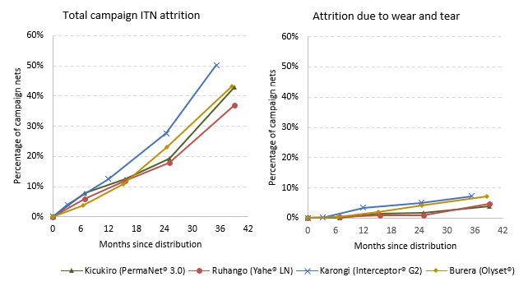
Table 16 reports the physical integrity results of nets that were in the household from baseline to the 36-month survey round (nets that were in the household but were temporarily unavailable due to being washed or were locked away were not included in the assessment).
By the 36-month survey round, the proportion of nets with any holes varied significantly among study sites, with Burera (93%) having the highest proportion followed by progressively lower proportions in Ruhango (92%), Karongi (88%), and Kicukiro (82%) (p=0.005). Similarly, the classification of cohort nets into “good,” “too torn,” and “serviceable” conditions differed between sites. The highest proportion of nets labeled as “too torn” was in Burera (59% in Burera, 36% in Karongi, 31% in Kicukiro, 26% in Ruhango; p<0.001). The highest proportion of nets classified as “serviceable” was in Ruhango (74% in Ruhango, 64% in Karongi, 69% in Kicukiro, 41% in Burera; p<0.001).
From baseline to 36 months, the percentage of cohort ITNs with any holes increased in all districts: Kicukiro (26% to 82%), Ruhango (33% to 92%), Karongi (6% to 88%), and Burera (50% to 93%). Conversely, the proportion of ITNs classified as “Serviceable” declined: Kicukiro (98% to 69%), Ruhango (97% to 74%), Karongi (100% to 64%), and Burera (91% to 41%).

Table 16: Physical Integrity of Observed Campaign Cohort ITNs
 | Baseline | 12-Month | 24-Month | 36-Month
Kicukiro | N=488 | N=424 | N=383 | N=270
Cohort ITN with any holes | 26.4% | 52.1% | 72.6% | 81.9%
ITNs classified as “Good” | 90.2% | 71.2% | 56.9% | 43.0%
ITNs classified as “Too torn” | 2.3% | 8.7% | 16.4% | 31.1%
ITNs classified as “Serviceable” | 97.7% | 91.3% | 83.6% | 68.9%
Among ITNs with any holes: | N=129 | N=221 | N=278 | N=221
Median pHI for ITNs with any holes | 46.0 | 75.0 | 107.0 | 227.0
Ruhango | N=504 | N=451 | N=407 | N=313
Cohort ITN with any holes | 32.5% | 64.1% | 77.9% | 91.7%
ITNs classified as “Good” | 90.5% | 72.9% | 58.7% | 36.7%
ITNs classified as “Too torn” | 2.6% | 6.0% | 12.0% | 26.2%
ITNs classified as “Serviceable” | 97.4% | 94.0% | 88.0% | 73.8%
Among ITNs with any holes: | N=164 | N=289 | N=317 | N=287
Median pHI for ITNs with any holes | 28.5 | 47.0 | 76.0 | 202.0
Karongi | N=534 | N=448 | N=355 | N=233
Cohort ITN with any holes | 6.4% | 53.6% | 69.0% | 87.6%
ITNs classified as “Good” | 98.5% | 73.7% | 55.5% | 40.3%
ITNs classified as “Too torn” | 0.4% | 9.2% | 18.9% | 36.1%
ITNs classified as “Serviceable” | 99.6% | 90.8% | 81.1% | 63.9%
Among ITNs with any holes: | N=34 | N=240 | N=245 | N=204
Median pHI for ITNs with any holes | 14.5 | 61.0 | 188.0 | 314.5
Burera | N=488 | N=421 | N=368 | N=271
Cohort ITN with any holes | 49.6% | 72.2% | 82.6% | 92.6%
ITNs classified as “Good” | 73.4% | 45.1% | 30.7% | 16.6%
ITNs classified as “Too torn” | 8.8% | 27.3% | 40.8% | 59.0%
ITNs classified as “Serviceable” | 91.2% | 72.7% | 59.2% | 41.0%
Among ITNs with any holes: | N=242 | N=304 | N=304 | N=251
Median pHI for ITNs with any holes | 84.0 | 333.5 | 636.5 | 1752.0
To understand the ways in which nets were damaged in real-life conditions, prior to the hole assessment respondents were asked what causes the holes in their nets. The responses are captured in Figure 6. At the 36-month survey round, the most commonly reported damage mechanisms in all districts were damage from rodents and from tears (72% and 51% across all districts, respectively). The proportion of cohort nets damaged from rodents differed between sites and was highest in Burera (92% in Burera, 70% in Karongi, 65% in Ruhango, 56% in Kicukiro; p<0.001). Damage from tears also differed between study sites and was highest in Kicukiro (67% in Kicukiro, 66% in Karongi, 54% in Burera, 25% in Ruhango; p<0.001).
Figure 6: Types of Damage Mechanisms Reported for Damaged Campaign ITNs
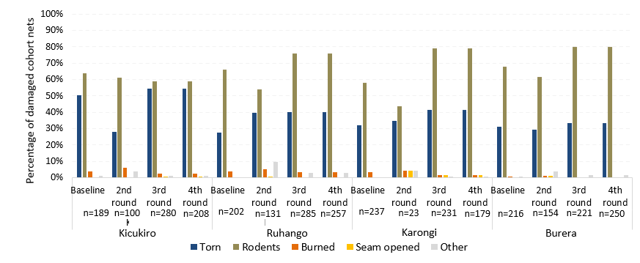
ITN survivorship combines the two aspects of durability (attrition and physical integrity) and is defined as the proportion of campaign ITNs originally received that are still in the possession of the household and in serviceable condition. As with attrition and physical integrity, cohort nets that were said to be used by family elsewhere (e.g., taken to school) were not included in these calculations. Additionally, nets ever given away or lost for other or unknown reasons are not included.
Table 17 reports the proportion of cohort ITNs surviving and in serviceable condition from baseline to the 36-month survey round. At the 36-month survey round, the proportion of all cohort net survival was significantly different between sites and was lowest in Burera (33% in Burera, 53% in Karongi, 61% in Kicukiro, 66% in Ruhango; p<0.001). Among ever used nets, survival followed a similar trend (42% in Burera, 62% in Karongi, 67% in Kicukiro, 72% in Ruhango; p<0.001). These differences reflect the previous findings that physical integrity of nets was poorer in Burera compared to nets in other districts.
Across study rounds and districts, the survival estimates for cohort nets followed a notable trend. In Kicukiro, the survival estimates for all cohort nets decreased from 98% at baseline to 61% at 36 months, with a similar trend for ever used and present cohort nets (97% to 67%) (Table 17). Ruhango showed a decline from 97% to 66% for all cohort nets, and from 97% to 72% for ever used and present nets. Similarly, in Karongi, survival estimates decreased from 99% to 53% for all cohort nets and from 100% to 62% for ever used and present nets. In Burera survival estimates dropped from 91% to 33% for all cohort nets and from 89% to 42% for ever used and present nets.
Table 17: Campaign Cohort ITNs Surviving in Serviceable Condition
 | Baseline | 12-Month | 24-Month | 36-Month
Kicukiro
All cohort nets* | N=489 | N=431 | N=391 | N=289
Survival estimate | 97.5% | 89.3% | 78.8% | 60.9%
95% CI | 96.0%-98.5% | 86.8%-91.4% | 74.4%-82.6% | 55.1%-66.4%
Cohort nets ever used and present | N=376 | N=369 | N=370 | N=247
Survival estimate | 97.3% | 90.0% | 79.7% | 67.2%
95% CI | 95.2%-98.5% | 87.1%-92.2% | 75.1%-83.7% | 62.5%-71.6%
Ruhango
All cohort nets* | N=506 | N=455 | N=412 | N=337
Survival estimate | 97.0% | 91.9% | 83.7% | 66.2%
95% CI | 94.3%-98.5% | 86.7%-95.1% | 77.6%-88.4% | 61.0%-71.0%
Cohort nets ever used and present | N=449 | N=432 | N=378 | N=312
Survival estimate | 97.3% | 92.6% | 86.0% | 71.5%
95% CI | 94.7%-98.7% | 87.5%-95.7% | 80.4%-90.1% | 67.6%-75.1%
Karongi
All cohort nets* | N=535 | N=466 | N=380 | N=268
Survival estimate | 99.4% | 87.3% | 72.9% | 53.0%
95% CI | 97.6%-99.9% | 83.4%-90.4% | 67.7%-77.5% | 42.5%-63.2%
Cohort nets ever used and present | N=481 | N=431 | N=345 | N=231
Survival estimate | 99.6% | 90.0% | 79.1% | 61.5%
95% CI | 98.3%-99.9% | 86.3%-92.8% | 74.5%-83.1% | 50.1%-71.7%
Burera
All cohort nets* | N=490 | N=431 | N=388 | N=305
Survival estimate | 90.8% | 69.8% | 54.1% | 33.4%
95% CI | 88.0%-93.0% | 63.4%-75.6% | 48.6%-59.6% | 25.9%-41.9%
Cohort nets ever used and present | N=370 | N=381 | N=352 | N=234
Survival estimate | 89.2% | 68.8% | 55.7% | 41.5%
95% CI | 86.2%-91.6% | 62.4%-74.5% | 48.9%-62.3% | 31.8%-51.8%
* Among ITNs that are still in the possession of the household or discarded due to wear and tear in a previous survey round.
Figure 7 plots the proportion of nets surviving in serviceable condition against hypothetical survival curves for nets lasting one to four years using the survival data from the baseline, 12-month round, 24-month round and 36-month round surveys. The median survival can be estimated as the relative position of the data point on a horizontal line between the two adjacent median survival curves. Using this method, the estimated median useful life for nets in Ruhango (Yahe® LN) is 4.3 (95% CI: 4.0-4.7) years, nets in Kicukiro (PermaNet® 3.0) is 4.0 (95% CI: 3.6-4.4) years, nets in Karongi (Interceptor® G2) is 3.1 (95% CI: 2.7-3.8) years, and for nets in Burera (Olyset® nets) is 2.3 (95% CI: 2.0-2.7) years.
Figure 7: Estimated ITN Survival
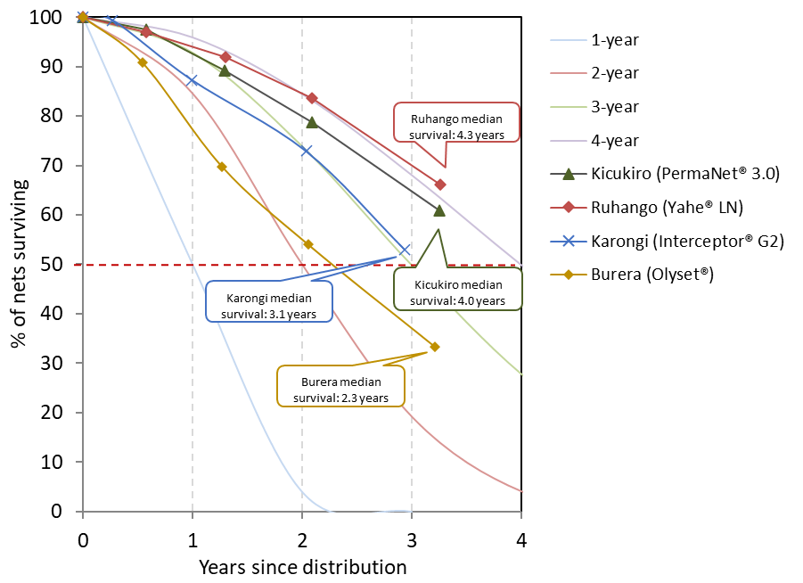

Table 19: Estimated Median Survival of ITNs in Years Using Different Methods
 | 12-month | 24-month | 36-month
Kicukiro (PermaNet® 3.0) | N=489 | N=431 | N=391
Estimated from figure 9 | 3.2 | 3.5 | 4.0
Calculated from last two data points (95% CI) | - | - | 4.0 (3.6-4.4)
Ruhango (Yahe® LN) | N=506 | N=455 | N=412
Estimated from figure 9 | 4.0 | 4.0 | 4.1
Calculated from last two data points (95% CI) | - | - | 4.3 (4.0-4.7)
Karongi (Interceptor® G2) | N=535 | N=466 | N=380
Estimated from figure 9 | 2.2 | 3.0 | 3.1
Calculated from last two data points (95% CI) | - | - | 3.1 (2.7-3.8)
Burera (Olyset®) | N=490 | N=431 | N=388
Estimated from figure 9 | 1.8 | 2.2 | 2.2
Calculated from last two data points (95% CI) | - | - | 2.3 (2.0-2.7)

When data were analyzed as survival analysis in a Kaplan-Meier plot (Figure 8), Olyset® nets in Burera, showed a notably lower survival trend in comparison to Interceptor® G2 nets in Karongi, Yahe® LN in Ruhango and PermaNet® 3.0 nets in Kicukiro.

Figure 8: Kaplan-Meier Curves of Physical Survival with 95% Confidence Intervals
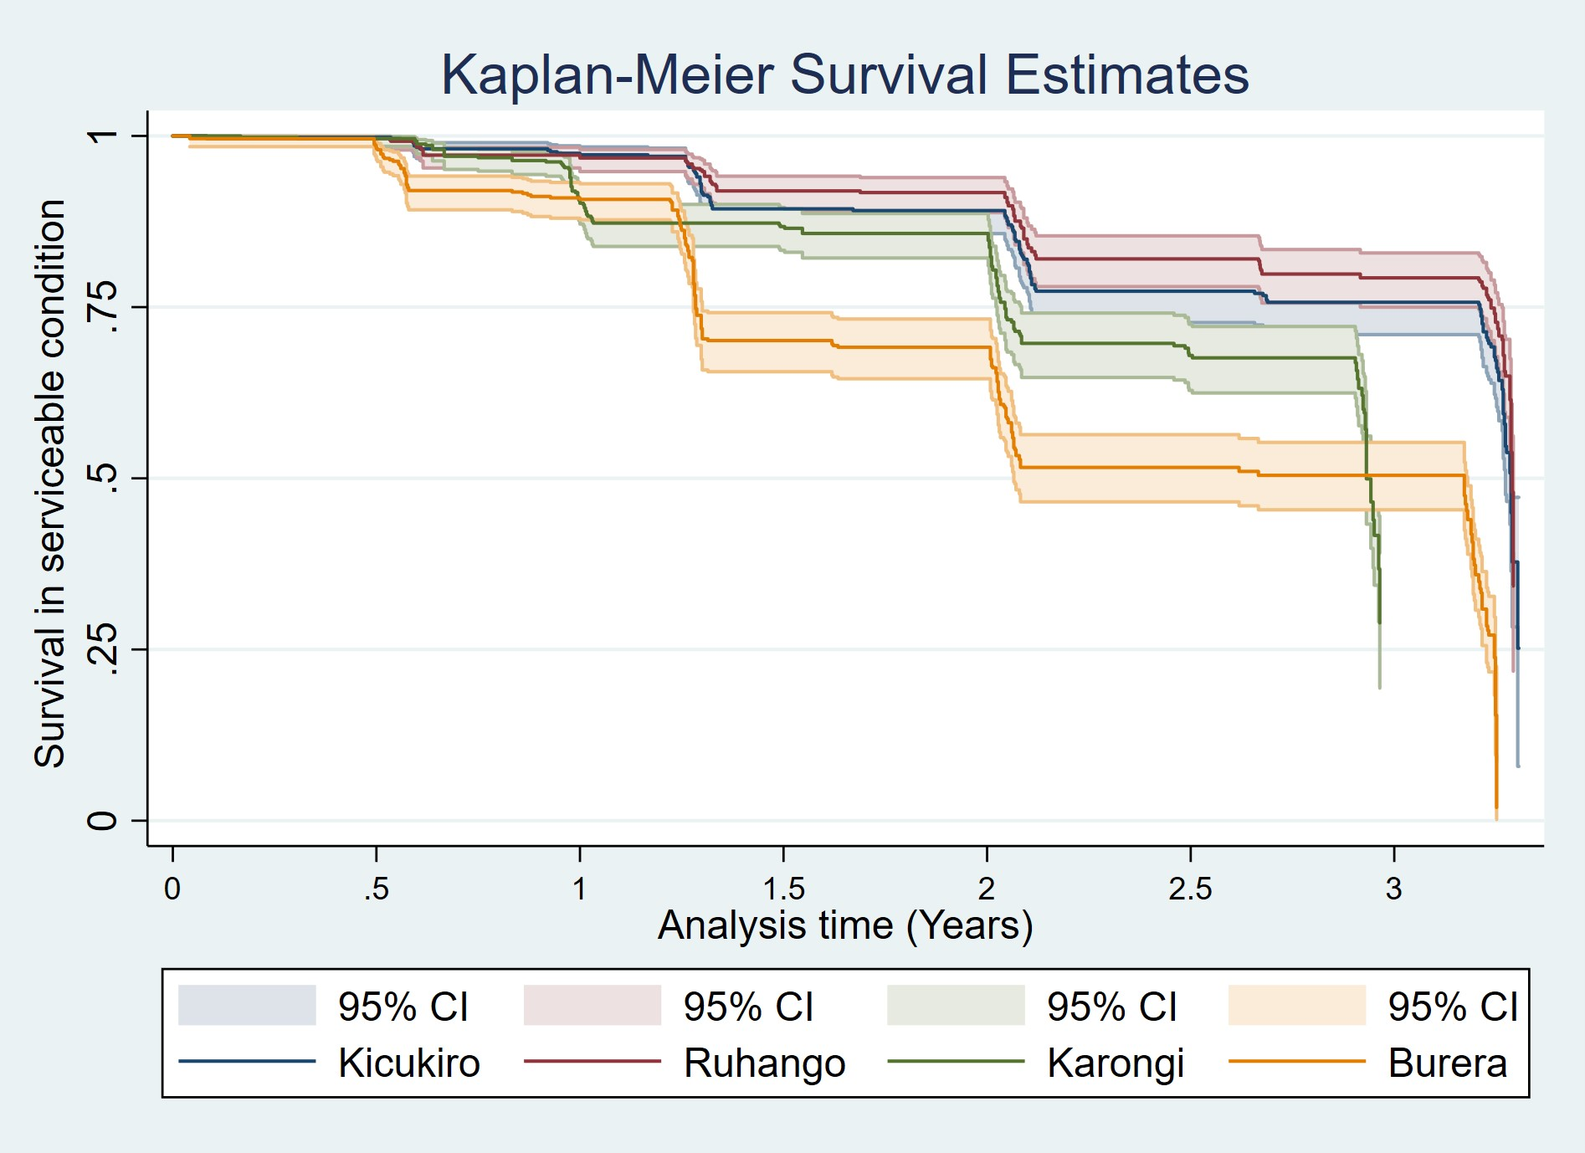

Insecticidal Effectiveness and Content of Campaign Nets
Thirty campaign nets were collected from within sample households at each study site to undergo bioassays and chemical content analysis. Cone bioassays were performed by RBC – MOPDD using an insectary-reared fully pyrethroid susceptible strain of An. gambiae s.s.) and wild collected pyrethroid-resistant strain (An. gambiae s.l.) raised from larvae. The mosquito larvae that exhibited resistance were gathered from Rukara and Mwogo and subsequently raised into adult mosquitoes. The selection of these two locations (Rukara and Mwogo) was based on prior identification of resistance to pyrethroids.
Both mosquito strains were characterized prior to testing for the 36-month survey round. Characterization was done using WHO susceptibility tests with deltamethrin 0.05% (the pyrethroid in Yahe® and PermaNet® 3.0 ITNs), permethrin 0.75% (the pyrethroid in Olyset® ITNs) and alpha-cypermethrin 0.05% (the pyrethroid in Interceptor® G2 ITNs). Tests were also carried out with deltamethrin 0.05% after pre-exposure to PBO 4% (deltamethrin + PBO combination in PermaNet® 3.0 ITNs). The An. gambiae s.l. strain was confirmed as being resistant to pyrethroid insecticides and there was an adequate (>30%) increase in mortality with pre-exposure to PBO synergist. Mortality of An. gambiae s.l. strain to 100ug chlorfenapyr in bottle bioassays was 100% (Table 18). Fifteen samples of the same nets undergoing bioassays from each site were sent to CDC for chemical content analysis.

Table 18: Characterization of An. gambiae s.s. (Kisumu) and An. gambiae s.l. Used for Bioassays
 | 12-months | 24-months | 36-months
Pyrethroid susceptible mosquito strain (An. gambiae s.s. Kisumu)  Used to test Olyset®, Yahe®, PermaNet® 3.0, and Interceptor® G2 nets. | N=100 | N=100 | N=100
% Mortality (24h) in deltamethrin (0.05%) susceptibility tests | 100% | 100% | 100%
% Mortality (24h) in alpha-cypermethrin (0.05%) susceptibility tests | 100% | 100% | 100%
% Mortality (24h) in permethrin (0.75%) susceptibility tests | 100% | 100% | 100%
Species composition of strain (Polymerase chain reaction) | 100% An. gambiae s.s. | 100% An. gambiae s.s. | 100% An. gambiae s.s.
Pyrethroid resistant mosquito strain (Wild collected An. gambiae s.l.)  Used to test PermaNet® 3.0 and Interceptor® G2 nets. | 12-months | 24-months | 36-months
Rukara | N=100 | N=100 | N=100
% Mortality (24h) in Deltamethrin (0.05%) | 46% | 60% | 63%
% Mortality (24h) in Deltamethrin (0.05%) + PBO (4%) | 99% | 100% | 100%
% Mortality (24h) in Permethrin 0.75% | 49% | n/a | n/a
% Mortality (24h) in Permethrin 0.75% + PBO (4%) | 98% | n/a | n/a
% Mortality (24h) in alpha-cypermethrin (0.05%) | 44% | 68% | 60%
% Mortality (24h) in alpha-cypermethrin (0.05%) + PBO (4%) | 97% | 100% | 100%
Mwogo | N=100 | N=100 | N=100
% Mortality (24h) in Deltamethrin (0.05%) | 50% | 41% | 37%
% Mortality (24h) in Deltamethrin (0.05%) + PBO (4%) | 98% | 100% | 99%
% Mortality (24h) in Permethrin 0.75% | 50% | n/a | n/a
% Mortality (24h) in Permethrin 0.75% + PBO (4%) | 100% | n/a | n/a
% Mortality (24h) in alpha-cypermethrin (0.05%) | 75% | 20% | 45%
% Mortality (24h) in alpha-cypermethrin (0.05%) + PBO (4%) | 100% | 100% | 100%
Baseline characterization data not available.

Ruhango / Yahe® (Deltamethrin)
The Yahe® brand is a pyrethroid-only ITN with the active ingredient deltamethrin. Yahe® samples withdrawn during this survey round had been deployed in the field for a duration of 39 months. Insecticidal effectiveness outcomes for Yahe® were assessed through standard WHO cone tests, measuring both the KD60 and the 24-hour mortality rates. These variables were subsequently used to calculate optimal and minimal effectiveness.
Between baseline and endline survey rounds against the susceptible strain, mean KD60 decreased from 99% to 54% and 24-hour mortality dropped from 100% to 53% (Table 19). Both median KD60 and mortality rates in the samples fell below the WHO's recommended thresholds of ≥95% and ≥80%, respectively (Figure 8). Optimal effectiveness was 0% at study endline. Although minimal effectiveness had remained at 100% across baseline, 12- and 24-month survey rounds, it decreased to less than 1% by study endline.

Table 19: Yahe® Cone Bioassay Results for Residual Efficacy of Pyrethroid
Ruhango / Yahe® | Baseline | 12-months | 24-months | 36-months
Susceptible mosquito strain  (An. gambiae s.s.) | Mean (95% CI)  N=30 | Mean (95% CI)  N=30 | Mean (95% CI)  N=30 | Mean (95% CI)  N=30
Knock down 60 minutes | 98.7 (98.2-99.1) | 83.1 (79.2-87.1) | 85.9 (82.5-89.4) | 54.2 (47.2-61.2)
Mortality 24 hours | 100 (--) | 85.1 (81.6-88.6) | 81.3 (77.0-85.6) | 53.3 (46.6-60.1)
Optimal effectiveness | 100 (--) | 80.0 (63.4-90.2) | 53.3 (33.6-72.1) | 0.0 (--)
Minimal effectiveness | 100 (--) | 100 (--) | 100.0 (--) | 0.6 (0.4-0.8)
Figure 8: Box Plot of Yahe® Cone Bioassay Results for Residual Efficacy of Pyrethroid

Results from WHO cone bioassays: the box plot shows the median (horizontal line), interquartile range (box), adjacent values (whiskers) and outliers (circles), lines represent WHO optimal effectiveness thresholds for knock-down (blue, 95%) and mortality (orange, 80%).
Net samples from the 36-month survey round underwent chemical content testing. Yahe® brand ITNs are manufactured with 1.4 g/kg of deltamethrin. Mean concentration of deltamethrin of sampled nets decreased progressively over the study period, declining from 0.9 g/kg at baseline to 0.2 g/kg at 36 months. This represents an 86% reduction in deltamethrin concentration when compared to the manufacturer’s target dose by study endline (Table 20 and Figure 9).

Table 20: Chemical Content Results for Yahe® ITN Brand
Ruhango / Yahe® | Baseline | 12-months | 24-months | 36-months
Deltamethrin 1.4 g/kg | N=15 | N=15 | N=15 | N=15
Mean (95% CI) | 0.9 (0.7-1.2) | 0.5 (0.3-0.8) | 0.4 (0.3-0.6) | 0.2 (0.2-0.3)
Median [IQR] | 0.9 [0.7-1.3] | 0.4 [0.2-0.9] | 0.4 [0.2-0.7] | 0.2 [0.1-0.3]

Figure 9: Box Plot of ITN Chemical Content Results for Yahe® ITN brand
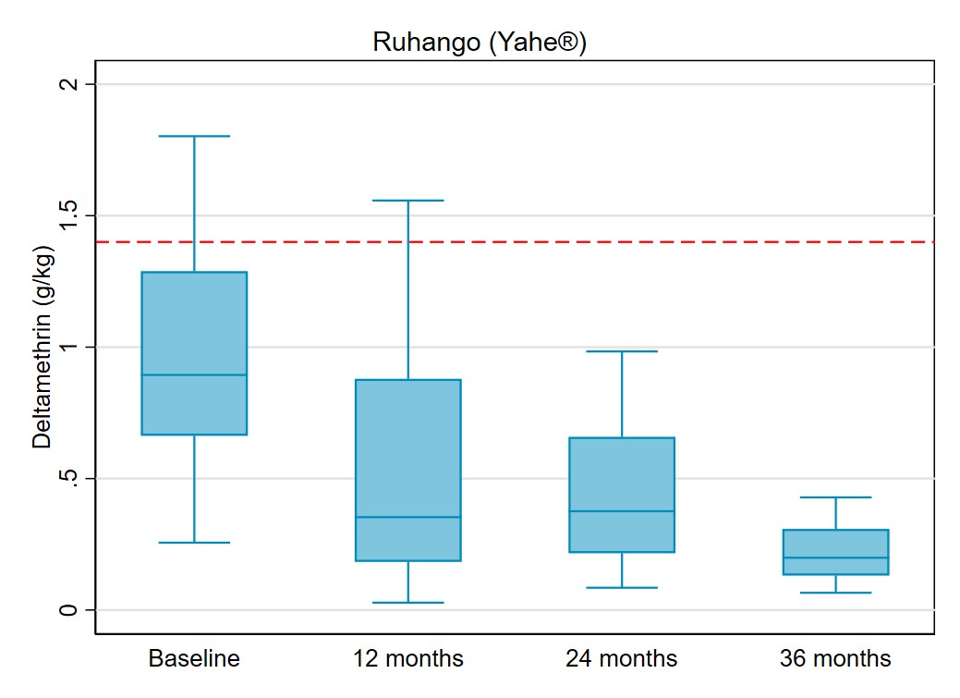
Results from chemical testing: the box plot shows the median (line), interquartile range (box), adjacent values (whiskers) and outliers (circles). The dotted line represents manufacturer target dose for deltamethrin (1.4 g/kg).

Burera / Olyset® (Permethrin)
The Olyset® brand is a pyrethroid-only ITN with permethrin as its active ingredient. Olyset® samples selected for bioassay analysis in this survey round had been in the field for a duration of 38.5 months. The assessment of insecticidal effectiveness for Olyset® was based on standard WHO cone test results, as previously described.
Across all survey rounds, mean KD60 and 24-hour mortality consistently fell below the WHO thresholds (KD60≥95% and 24-hour mortality ≥80%) (Table 21 and Figure 10). Optimal effectiveness was 0% at study endline. Minimal effectiveness, which was 93% after 24 months, dropped to <1% by study endline.

Table 21: Olyset® Cone Bioassay Results for Residual Efficacy of Pyrethroid
Burera / Olyset® | Baseline | 12-months | 24-months | 36-months
Susceptible mosquito strain  (An. gambiae s.s.) | Mean (95% CI) N=30 | Mean (95% CI) N=30 | Mean (95% CI) N=30 | Mean (95% CI) N=30
Knock down 60 minutes | 69.7 (62.6-76.8) | 85.0 (79.9-90.1) | 67.5 (63.9-71.2) | 51.7 (47.3-56.1)
Mortality 24 hours | 75.8 (68.4-83.1) | 66.2 (58.7-73.8) | 62.6 (59.9-65.3) | 52.2 (48.5-56.0)
Optimal effectiveness | 43.3 (23.0-66.2) | 53.3 (37.1-68.9) | 0.0 (--) | 0.0 (--)
Minimal effectiveness | 93.3 (74.5-98.5) | 83.3 (65.4-93.0) | 93.3 (74.4-98.5) | 0.6 (0.4-0.7)

Figure 10: Box Plot of Olyset® Cone Bioassay Results for Residual Efficacy of Pyrethroid
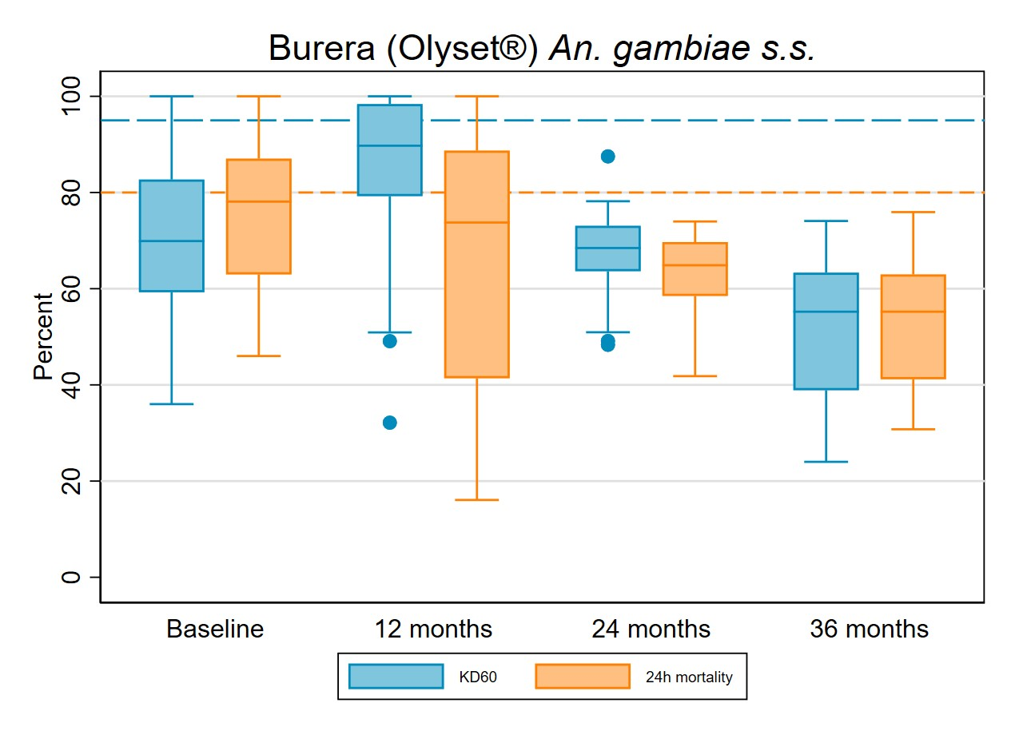
Results from WHO cone bioassays: the box plot shows the median (horizontal line), interquartile range (box), adjacent values (whiskers) and outliers (circles), lines represent WHO optimal effectiveness thresholds for knock-down (blue, 95%) and mortality (orange, 80%).
Olyset® brand ITNs are manufactured with 20g/kg of permethrin. Mean permethrin concentration decreased from 22.0 g/kg at baseline to 19.0 g/kg at 36 months. This corresponds to a 5% loss compared to the manufacturer’s target dose at 36 months (Table 22 and Figure 11).
Table 22: Chemical Content Results for Olyset® ITN brand
Burera / Olyset® | Baseline | 12-months | 24-months | 36-months
Permethrin 20 g/kg | N=15 | N=15 | N=15 | N=15
Mean (95% CI) | 22.0 (21.5-22.4) | 20.0 (19.6-20.5) | 17.7 (17.0-18.4) | 19.0 (18.1-19.9)
Median [IQR] | 21.9 [21.5-22.8] | 20.3 [19.3-20.5] | 17.5 [16.7-19.0] | 19.5 [18.9-20.1]

Figure 11: Box Plot of ITN Chemical Content Results for Olyset® ITN Brand
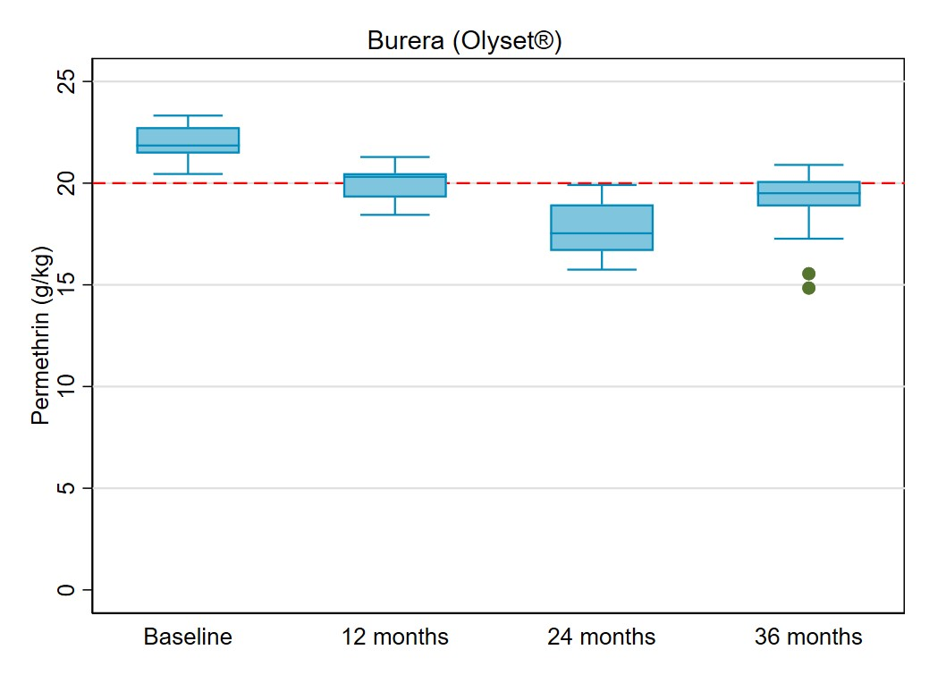
Results from chemical testing: the box plot shows the median (line), interquartile range (box), adjacent values (whiskers) and outliers (circles). The dotted line represents manufacturer target dose for permethrin (20 g/kg).

Kicukiro/ PermaNet® 3.0 (Deltamethrin and PBO)
The PermaNet® 3.0 ITNs combine pyrethroid and PBO synergist, with deltamethrin present on the net sides and deltamethrin + PBO on the roof. Nets examined during this survey round had been deployed in the field for 39.0 months. Cone bioassays were conducted using both an insectary-reared pyrethroid-susceptible strain (An. gambiae s.s.) and a pyrethroid-resistant strain (An. gambiae s.l.). Field ITNs were evaluated alongside new PermaNet® 3.0 and new PermaNet® 2.0 net samples as positive controls, and against untreated netting as a negative control. KD60 and 24-hour mortality results are presented separately for susceptible and resistant mosquito strains, as well as for PermaNet® 3.0 sides and roof pieces in Table 23, Figures 12a and 12b.
PermaNet® 3.0 field samples, tested against pyrethroid-susceptible mosquitoes, exhibited a lower mean 24-hour mortality at 36 months compared to baseline (57% versus 100% on the sides and 70% versus 100% on the roof). A similar trend was observed for KD60 (77% versus 94% on the sides and 76% versus 99% on the roof). Roof samples, incorporating PBO, displayed higher mean mortality outcomes than pyrethroid-only side samples at the 36-month survey round (70% versus 57%) (Table 23).
When tested against the pyrethroid-resistant mosquito strain, KD60 and 24-hour mortality for field roof samples was lower than those for new PermaNet® 3.0 positive control nets (KD60: 81% versus 98%; mortality: 51% versus 98%). Samples withdrawn from the community at the 36-month survey round showed lower KD60 and mortality compared to baseline (KD60: 76% versus 98%; mortality: 48% versus 99%). Field roof samples, when tested against susceptible mosquito strains, exhibited higher mean mortality compared to resistant mosquitoes (70% versus 48%). (Table 23 and Figure 12a). Mortality and KD60 in negative control samples remained low against both resistant and susceptible mosquitoes (< 5%) at the 36-month survey round (Figure 12a, 12b).

Table 23: PermaNet® 3.0 Cone Bioassay Results for Residual Efficacy of Pyrethroid and PBO
Kicukiro / PermaNet® 3.0 | Baseline | 12-months | 24-months | 36-months
Susceptible mosquito strain  (An. gambiae s.s.) | Mean  (95% CI or SD) | Mean  (95% CI or SD) | Mean  (95% CI or SD) | Mean  (95% CI or SD)
Field ITN Sides (pyrethroid-only) | N=30 | N=30 | N=30 | N=30
Knock down 60 minutes | 94.4 (93.3-95.5) | 96.1 (94.2-97.9) | 79.8 (77.0-82.7) | 77.4 (66.1-88.7)
Mortality 24 hours | 99.8 (99.6-100) | 96.9 (94.4-99.4) | 81.7 (80.1-83.3) | 56.7 (50.2-63.2)
Field ITN Roof (pyrethroid + PBO) | N=30 | N=30 | N=30 | N=30
Knock down 60 minutes | 99.0 (97.9-100) | 98.6 (96.8-100) | 93.3 (90.3-96.3) | 75.5 (71.0-79.9)
Mortality 24 hours | 100 (--) | 99.7 (99.0-100) | 92.4 (89.2-95.6) | 70.3 (67.3-73.3)
Untreated control | N=6 | N=6 | N=6 | N=6
Knock down 60 minutes | 0.0 (--) | 0.6 (sd 1.5) | 1.3 (sd 2.1) | 0.0 (--)
Mortality 24 hours | 2.0 (sd 3.3) | 6.9 (sd 1.3) | 2.8 (sd 2.2) | 0.7 (sd 1.6)
Resistant mosquito strain  (An. gambiae s.l.) | Mean  (95% CI or SD) | Mean  (95% CI or SD) | Mean  (95% CI or SD) | Mean  (95% CI or SD)
Field ITN Roof (pyrethroid + PBO) | N=30 | N=30 | N=30 | N=30
Knock down 60 minutes | 97.8 (97.2-98.5) | 87.2 (82.9-91.4) | 81.3 (78.1-84.5) | 76.3 (71.2-81.4)
Mortality 24 hours | 98.9 (98.4-99.4) | 52.2 (46.9-57.6) | 51.2 (47.7-54.7) | 48.0 (45.5-50.6)
New ITN (pyrethroid-only) | N=1 | N=1 | N=1 | N=1
Knock down 60 minutes | 98.0 (--) | 65.9 (--) | 69.4 (--) | 73.5 (-- )
Mortality 24 hours | 98.0 (--) | 31.8 (--) | 71.4 (--) | 69.4 (-- )
New ITN Roof (pyrethroid + PBO) | N=1 | N=1 | N=1 | N=1
Knock down 60 minutes | 93.8 (--) | 93.8 (--) | 100.0 (--) | 98.0 (--)
Mortality 24 hours | 100 (--) | 100 (--) | 100.0 (--) | 98.0 (--)
Untreated control | N=15 | N=25 | N=15 | N=15
Knock down 60 minutes | 5.0 (5.3) | 0.0(--) | 1.8 (sd 4.0) | 1.3 (sd 2.7)
Mortality 24 hours | 3.7 (5.4) | 2.6 (3.3) | 1.8 (sd 3.1) | 0.4 (sd 1.7)

Figure 12a: Box Plot of PermaNet® 3.0 Cone Bioassay Results for Residual Efficacy Against Susceptible Anopheles gambiae s.s.
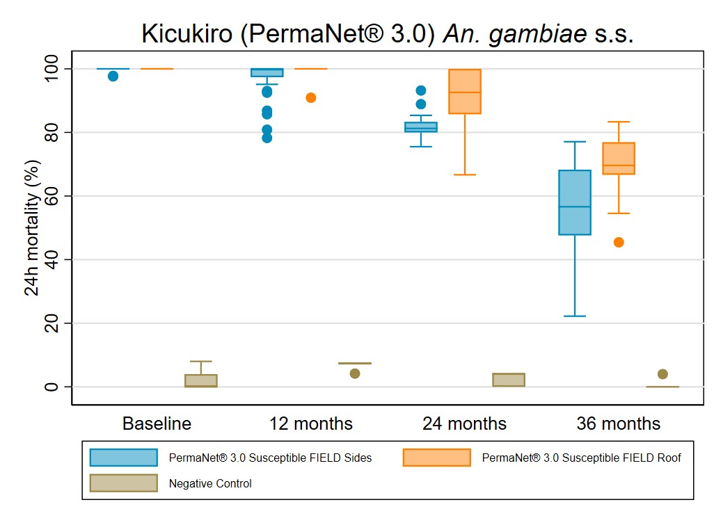
Results from WHO cone bioassays: the box plot shows the median (line), interquartile range (box), adjacent values (whiskers) and outliers (circles).

Figure 12b: Box Plot of PermaNet® 3.0 Cone Bioassay Results for Residual Efficacy Against Pyrethroid Resistant Wild Anopheles gambiae s.l.
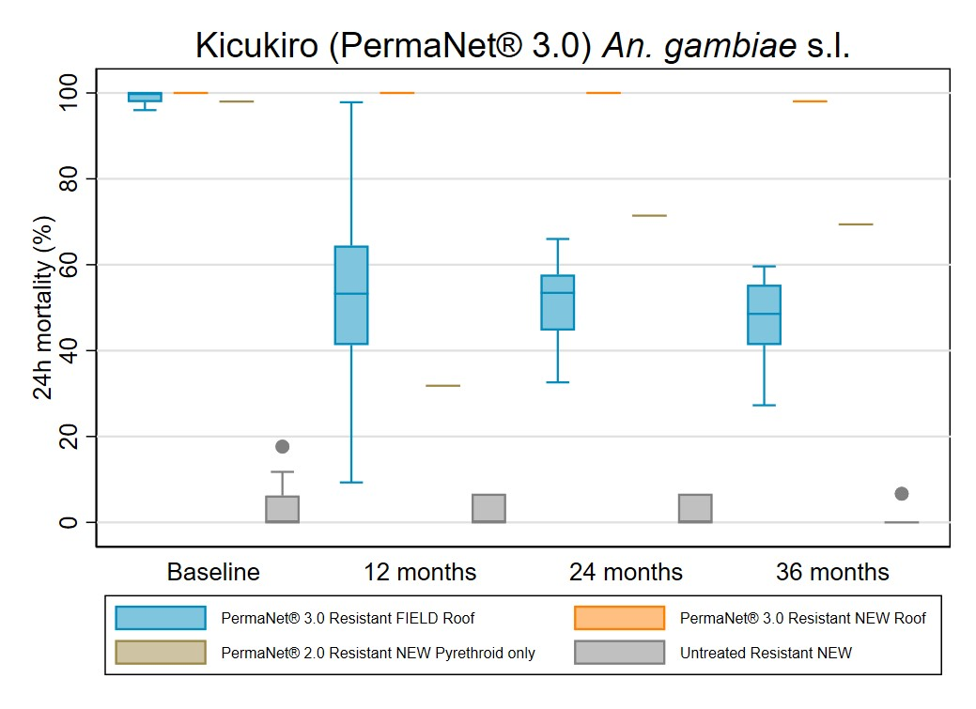
Results from WHO cone bioassays: the box plot shows the median (line), interquartile range (box), adjacent values (whiskers) and outliers (circles).
PermaNet® 3.0 brand ITNs are manufactured with 2.1g/kg of deltamethrin on side panels (for 100 denier nets), 4g/kg deltamethrin on the roof panels and 25g/kg of PBO on the roof panel. After 36 months of use in the field, the mean chemical content of the deltamethrin side panels decreased to 0.4 g/kg, corresponding to an 81% loss compared to the manufacturer’s target dose. The mean roof panel concentrations were 3.7 g/kg for deltamethrin and 4.8 g/kg for PBO, corresponding to an 8% and 81% loss of chemical content compared to the manufacturer’s target dose, respectively (Table 24 and Figure 13).

Table 24: Chemical Content Results for PermaNet® 3.0 ITN Brand
Kicukiro / PermaNet® 3.0 | Baseline | 12-months | 24-months | 36-months
Deltamethrin – side panels (deltamethrin 2.1 g/kg) | N=14 | N=15 | N=15 | N=15
Mean (95% CI) | 1.5 (1.0-2.1) | 1.0 (0.6-1.4) | 0.7 (0.3-1.0) | 0.4 (0.1-0.7)
Median [IQR] | 2.1 [0.5-2.3] | 0.7 [0.3-1.6] | 0.4 [0.3-1.2] | 0.2 [0.1-0.3]
Deltamethrin – roof panels (deltamethrin 4 g/kg) | N=15 | N=15 | N=15 | N=15
Mean (95% CI) | 3.3 (3.1-3.5) | 3.5 (3.3-3.6) | 3.1 (3.0-3.3) | 3.7 (3.2-4.2)
Median [IQR] | 3.4 [3.1-3.5] | 3.5 [3.2-3.7] | 3.2 [3.0-3.2] | 3.7 [3.1-4.5]
PBO – roof (PBO 25 g/kg) | N=15 | N=15 | N=15 | N=15
Mean (95% CI) | 14.9 (13.2-16.6) | 13.5 (11.9-15.1) | 11.4 (9.2-13.6) | 4.8 (3.2-6.4)
Median [IQR] | 15.3 [11.6-17.7] | 13.6 [11.0-17.1] | 12.5 [8.7-14.0] | 3.7 [2.9-6.9]

Figure 13: Box Plot of ITN Chemical Content Results for PermaNet® 3.0 ITN Brand
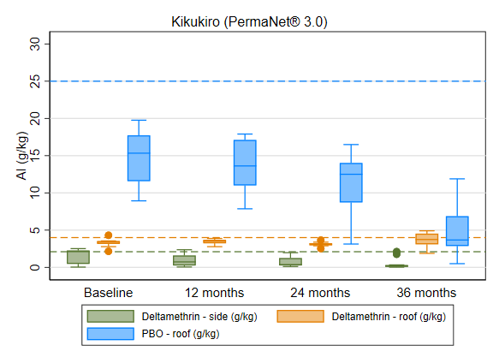
Results from chemical testing: the box plot shows the median (line), interquartile range (box), adjacent values (whiskers) and outliers (circles), dotted lines represent manufacturer target doses for the corresponding insecticide or synergist, with colors aligned to the legend.

Karongi / Interceptor® G2 (Alpha-Cypermethrin and Chlorfenapyr)
The Interceptor® G2 brand is a dual-active ingredient ITN containing alpha-cypermethrin and chlorfenapyr. The Interceptor® G2 samples collected during this survey round had been in the field for 35.2 months.
At the 36-month survey round, Interceptor® G2 field samples, when tested against pyrethroid-susceptible mosquitoes, displayed lower KD60 and 24-hour mortality compared to baseline (KD60: 56% versus 95%; 24-hour mortality: 57% versus 100%). Untreated control nets exhibited low 24-hour mortality (1%) (Table 25 and Figure 14a).
BFI and 72-hour mortality rates against resistant mosquitoes measured at 45% and 57%, respectively, at study endline against resistant mosquitoes (Table 26). Tests using new Interceptor® G2 nets as positive controls revealed a higher 72-hour mortality rate compared to the field nets (98% versus 57%). Pyrethroid-only Interceptor® nets showed no 72-hour mortality; however, BFI was relatively high at 89%. Mortality and BFI in negative control samples remained low against both resistant and susceptible mosquitoes (< 3%) at the 36-month survey round (Table 26 and Figure 14b).
Table 25: Interceptor® G2 Cone Test Bioassay Results for ITN Residual Efficacy Against Susceptible Strain
Karongi / Interceptor® G2 | Baseline | 12-months | 24-months | 36-months
Susceptible mosquito strain  (An. gambiae s.s.) | Mean (95% CI or SD) | Mean (95% CI or SD) | Mean (95% CI or SD) | Mean (95% CI or SD)
Field-sampled ITN  (Pyrethroid + Chlorfenapyr) | N=30 | N=30 | N=30 | N=30
Knock down 60 minutes | 95.3 (93.9-96.8) | 96.3 (95.1-97.5) | 80.1 (77.7-82.5) | 55.9 (49.8-62.1)
Mortality 24 hours | 99.5 (99.2-99.8) | 93.3 (91.0-95.7) | 80.0 (79.4-80.5) | 56.5 (50.9-62.0)
Untreated control | N=6 | N=6 | N=6 | N=6
Knock down 60 minutes | 1.9 (sd 4.5) | 0.0 (sd 0.0) | 0.0 (sd 0.0) | 0.0 (sd 0.0)
Mortality 24 hours | 1.2 (sd 3.0) | 4.5 (sd 3.0) | 2.6 (sd 2.0) | 0.6 (sd 1.5)

Table 26: Interceptor® G2 Tunnel Test Bioassay Results for ITN Residual Efficacy Against Resistant Strain (Baseline, 24- and 36-month Round)
Karongi / Interceptor® G2 | Baseline | 24-months | 36-months
Resistant mosquito strain  (An. gambiae s.l) | Mean (95% CI or SD) | Mean (95% CI or SD) | Mean (95% CI or SD)
Field-sampled ITN  (Pyrethroid + Chlorfenapyr) | N=30 | N=30 | N=30
Mortality 24 hours | 72.5 (68.2-76.8) | 44.7 (41.0-48.5) | 42.4 (38.1-46.8)
Mortality 72 hours | 81.8 (78.4-85.2) | 53.0 (49.8-56.1) | 56.5 (52.3-60.6)
Blood fed | 13.2 (9.4-16.9) | 1.8 (0.2-3.5) | 44.8 (40.7-49.0)
Blood-feeding inhibition | 41.1 (18.7-63.6) | 74.3 (50.7-97.9) | 44.7 (39.5-49.9)
New ITN  (Pyrethroid + Chlorfenapyr) | N=5 | N=5 | N=5
Mortality 24 hours | 87.1 (sd 8.4) | 76.5 (sd 11.8) | 80.1 (sd 14.6)
Mortality 72 hours | 93.3 (sd 4.0) | 97.3 (sd 2.6) | 98.0 (sd 3.0)
Blood fed | 0.0 (sd--) | 1.6 (sd 3.5) | 4.4 (sd 4.0)
Blood-feeding inhibition | 100.0 (sd--) | 72.5 (sd 58.5) | 94.6 (sd 5.0)
New ITN  (Alpha cypermethrin) | N=5 | N=5 | N=5
Mortality 24 hours | 78.2 (sd 5.5) | 49.6 (sd 10.5) | 53.9 (sd 8.4 )
Mortality 72 hours | 78.8 (sd 5.0) | 0.0 (sd --) | 0.0 (sd )
Blood fed | 2.0 (sd 4.5) | 2.0 (sd 2.1) | 9.0 (sd 5.9 )
Blood-feeding inhibition | 91.5 (sd 19.0) | 79.0 (sd 21.6) | 88.8 (sd 7.7)
Untreated control | N=5 | N=5 | N=5
Mortality 24 hours | 2.4 (sd 1.4) | 2.5 (sd 1.8) | 2.6 (sd 1.0)
Mortality 72 hours | 2.6 (sd 1.0) | 2.5 (sd 1.8) | 2.8 (sd 1.1 )
Blood fed | 24.2 (sd 7.7) | 8.5 (sd 3.8) | 81.6 (sd 5.3)
Tunnel test was not done for at 12 months due to budget contains.

Figure 14a: Box Plot of Interceptor® G2 Cone Test Bioassay Results for Residual Efficacy Against Susceptible Strain An. gambiae s.s.
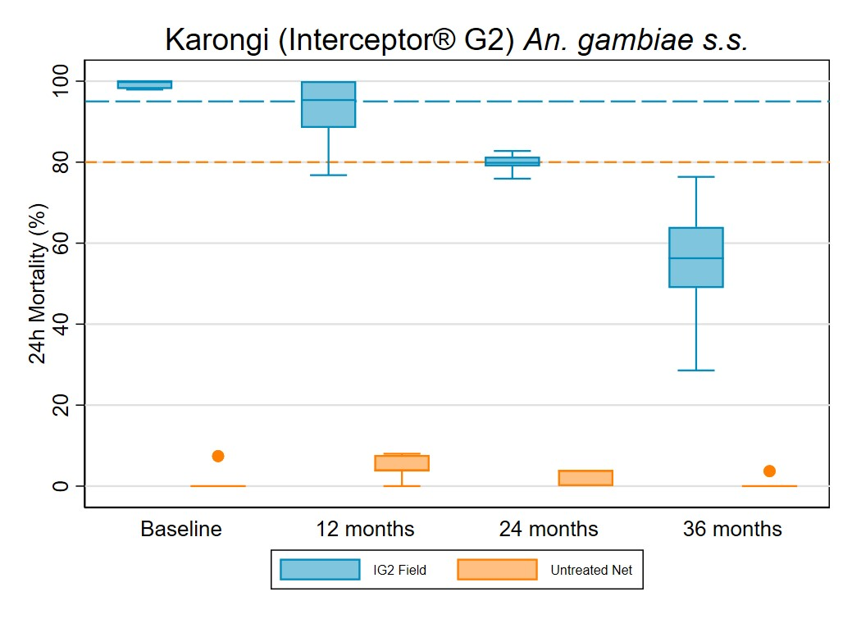
Results from WHO cone bioassays: the box plot shows the median (horizontal line), interquartile range (box), adjacent values (whiskers) and outliers (circles), lines represent WHO optimal effectiveness thresholds for knock-down (blue, 95%) and mortality (orange, 80%).

Figure 14b: Box Plot of Interceptor® G2 Cone Test Bioassay Results for Residual Efficacy Against Resistant Strain An. gambiae s.l.
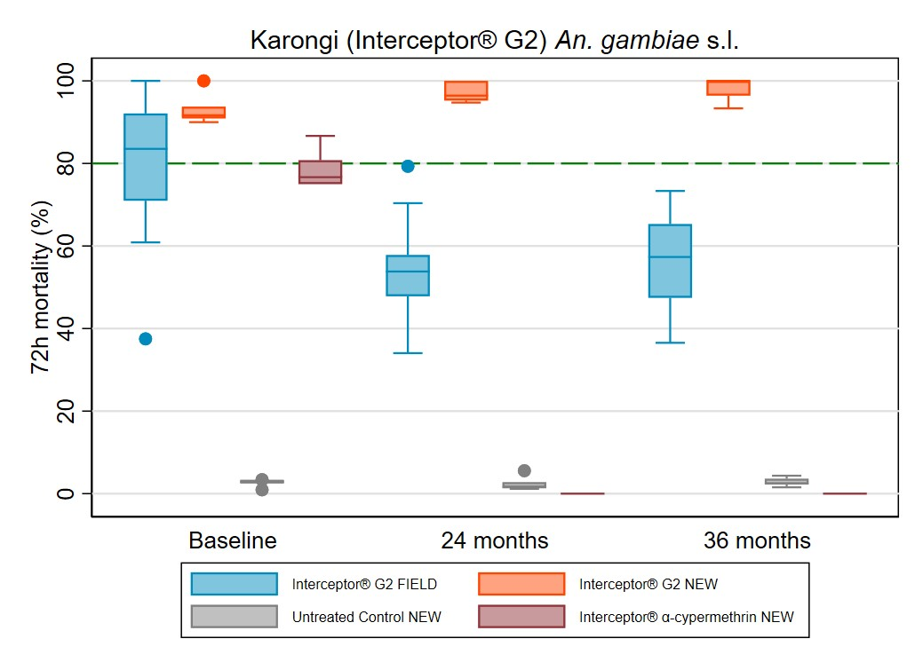
Results from WHO cone bioassays: the box plot shows the median (horizontal line), interquartile range (box), adjacent values (whiskers) and outliers (circles), lines represent WHO thresholds for 72-mortality (green, 80%).
Interceptor® G2 ITNs are manufactured with 2.4g/kg of alpha-cypermethrin and 4.8 g/kg of chlorfenapyr. At study endline, mean alpha-cypermethrin content was 1.3g/kg, corresponding to a loss of 46% compared to the manufacturer’s target dose and mean chlorfenapyr content was 1.9 g/kg, corresponding to a decrease of 60% compared to the target dose (Table 27 and Figure 15).

Table 27: Chemical Content Results for Interceptor® G2 ITN Brand
Karongi / Interceptor® G2 | 12-months | 24-months | 36-months
Alphacypermethrin 2.4 g/kg | N=15 | N=15 | N=15
Mean (95% CI) | 2.1 (1.9-2.3) | 1.7 (1.5-1.9) | 1.3 (1.1-1.6)
Median [IQR] | 2.1 [1.7-2.5] | 1.7 [1.5-2.0] | 1.3 [0.9-1.7]
Chlorfenapyr 4.8 g/kg | N=15 | N=15 | N=15
Mean (95% CI) | 3.0 (2.4-3.7) | 2.2 (1.6-2.7) | 1.9 (1.3-2.4)
Median [IQR] | 3.1 [2.0-4.4] | 2.2 [1.1-3.1] | 1.8 [1.0-2.8]

Figure 15: Box Plot of ITN Chemical Content Results for Interceptor® G2 ITN Brand
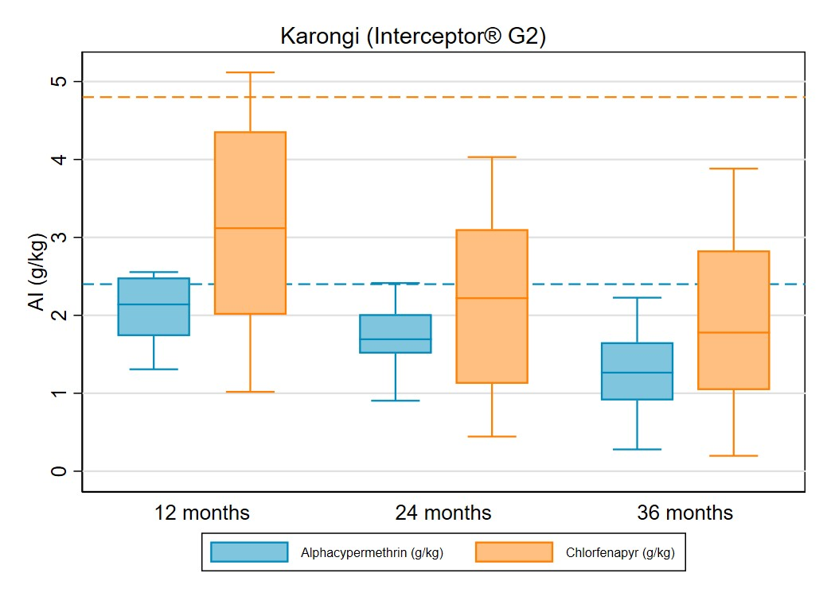
Results from chemical testing: the box plot shows the median (line), interquartile range (box), adjacent values (whiskers) and outliers (circles), dotted lines represent manufacturer target doses for the corresponding insecticide or synergist, with colors aligned to the legend.

Conclusions

Summary of Findings
The 36-month survey round of the 2020 Rwanda durability monitoring study visited 773 households across four districts, each having received different ITNs during the 2020 mass distribution campaign: PermaNet® 3.0 in Kicukiro, Yahe® LN in Ruhango, Interceptor® G2 in Karongi, and Olyset® in Burera. At baseline, a total of 2,130 ITNs were recorded as having been distributed to cohort households. At the 36-month survey round, 1,095 ITNs from the 2020 campaign were still present in the households (270 in Kicukiro, 313 in Ruhango, 241 in Karongi, 271 in Burera).
The prevalence of rodents remained consistently high across all study sites, even as food storage practices improved. Variations in net usage patterns were evident across districts. Notably, Kicukiro exhibited the highest net usage rates, with 82% of nets used on the previous night and 78% used consistently over the past week. In contrast, Burera reported lower rates, with 51% of nets used on the previous night and 45% used consistently throughout the week. The lower rates of net usage in Burera could be attributed to the physical condition of the nets. Burera had the highest percentage of nets with "any holes," reaching 93%, and a substantial 59% of nets classified as "too torn."
District-specific trends in non-cohort net ownership shed light on different acquisition sources. Ruhango and Kicukiro stood out with the highest ownership of non-cohort nets, at 20% and 16%, respectively. Non-cohort nets were largely sourced from antenatal care visits. In Karongi, non-cohort net ownership was comparatively lower at 5%, with contributions from previous mass campaigns and private sector sources. Burera reported a similar ownership rate of 5%, primarily stemming from antenatal care visits.
Attitudinal trends in different districts highlighted varying levels of favorability towards nets and net care. Kicukiro emerged with the highest proportion of respondents exhibiting favorable attitudes (81% for nets, 93% for net care/repair). In contrast, Burera saw less favorable attitudes (37% for nets, 66% for net care/repair), emphasizing the importance of social and behavior change strategies tailored to district-specific needs.
Attrition rates ranged from 37% in Ruhango to 50% in Karongi. Across study districts, attrition was primarily due to nets being given away to others.
Variation in ITN survivorship across districts revealed valuable insights into net longevity. Kicukiro and Ruhango demonstrated relatively higher survivorship rates, with 61% and 66% of all cohort nets still in serviceable condition at study endline. In contrast, Karongi experienced lower survivorship rate of 53%, which was lower in Burera where only 33% of cohort nets were remaining in serviceable condition by the end of the study.
Median useful life estimates for cohort nets varied across districts: Kicukiro (PermaNet® 3.0) - 4.0 (95% CI: 3.6-4.4) years, Ruhango (Yahe® LN) - 4.3 (95% CI: 4.0-4.7) years, Karongi (Interceptor® G2) - 3.1 (95% CI: 2.7-3.8) years, Burera (Olyset® nets) - 2.3 (95% CI: 2.0-2.7) years.
At study endline, Yahe® ITNs in Ruhango showed a steep decline in insecticidal effectiveness, with optimal effectiveness at 0% and minimal effectiveness at <1%. The decline in bio efficacy was mirrored in the chemical content analysis, with a total mean deltamethrin content loss of 86% compared to the manufacturer’s target dose. Despite a consistent decline in the bio efficacy of Olyset® nets in Burera (optimal efficacy 0% and minimal efficacy <1%), permethrin content only decreased by 5% compared to the manufacturer’s target dose. The mean PBO content of PermaNet® 3.0 ITNs in Kicukiro decreased by 86% compared to the manufacturer’s target dose, while 24-hour mortality dropped to 48%. BFI and 72-hour mortality of Interceptor® G2 ITNs from Karongi was measured at 45% and 57%, as mean alpha-cypermethrin and chlorfenapyr content reduced by 46% and 60%, respectively, compared to the manufacturer’s target dose.

Recommendations
The extensive assessment of ITN durability following the 2020 mass distribution campaign furnishes indispensable insights for NMCPs. The collaborative efforts of RBC-MOPDD and PMI Evolve Rwanda have produced valuable data. The variations in ownership, utilization, and durability underscore the need for tailored interventions, which are listed below.
Overarching recommendations
- Adhere to WHO recommendations around the prioritization of PBO and CFP ITNs over pyrethroid-only ITNs in settings with pyrethroid-resistant mosquitoes when making future procurement decisions. PBO and CFP ITNs demonstrated an estimated median survival above three years and offered protection against both pyrethroid-susceptible and resistant mosquitoes.
- Entomological monitoring should continue to take place to measure pyrethroid, PBO and CFP resistance.
- This study detected low ITN access in Kicukiro, Karongi and Burera at study endline. To increase access, ITNs should be distributed through the upcoming mass campaign and through routine channels.
- Engage SBC partners to positively reinforce common protective practices like cooking away from sleeping rooms, avoiding bleach and detergents when washing nets, favorable attitudes towards net and net care/repair, and consistent net usage.
- Engage SBC partners to target messaging around presence of rodents in areas used for sleeping, as well as net use, care and repair.
District-specific recommendations
Kicukiro
- Implement focused rodent control interventions and SBC messaging to reduce the primary mechanism of net damage.
- Promote the tying of loose nets (45%) while not in use to reduce damage.
Ruhango
- Implement focused rodent control interventions and SBC messaging to reduce the primary mechanism of net damage.
- Discourage food storage in sleeping areas, particularly given its higher prevalence (35%) in the district.
- Discourage practice of using nets over mats or the ground (26%) and encourage use over mattresses and bedframes, if possible.
Karongi
- Implement focused rodent control interventions and SBC messaging to reduce the primary mechanism of net damage.
- Discourage the practice of drying nets on bushes or fences (38%).
Burera
- Implement focused rodent control interventions and SBC messaging to reduce the primary mechanism of net damage.
- Promote the tying of loose nets (24%) while not in use to reduce damage.
- Promote hole repair practices among household with damaged nets (15%) as part of SBC net care and repair messaging.
- Increase SBC communication, tailoring messaging on net care and repair to emphasize the role of a well-maintained net to prevent malaria.

Key Challenges and Lessons Learned
Baseline data collection was slightly delayed due to COVID-19. Endline data collection was originally planned to commence in March 2023 for three sites, followed by one site in May 2023. However, due to the transition from PMI VectorLink to PMI Evolve, data collection for all sites was rescheduled to begin in May 2023. For both baseline and endline survey rounds, the commitment of stakeholders to commence data collection resulted in only minor delays.
During the study, several minor challenges were encountered. These included intermittent mobile network coverage and unreliable data connectivity, as well as challenging road conditions. However, the unwavering determination of the field staff ensured the successful completion of data collection across all study sites. The use of WhatsApp for daily feedback facilitated swift issue resolution and effective communication. To navigate transportation difficulties arising from inadequate road networks, the team arranged for the rental of dependable all-terrain vehicles.
A noteworthy aspect of the study was the substantial capacity-strengthening progress achieved by the in-country team throughout the 36-month study period. The demonstrated growth in expertise is poised to play a pivotal role in the future endeavors of the RBC-MOPDD.

Acknowledgements
The successful execution of the survey can be attributed to the collaborative efforts of various individuals and organizations. The RBC-MOPDD played a pivotal role by providing crucial guidance and expertise in malaria and parasitic diseases, laying a solid foundation for the survey. The commitment of PMI Evolve Rwanda, a key partner in the endeavor, significantly enhanced the implementation and overall value of the survey. The fieldwork team, comprising supervisors, notetakers, and interviewers, demonstrated dedication and professionalism, ensuring the accurate and thorough collection of data. The leadership of field coordinators in each district was instrumental in organizing and executing survey activities seamlessly. Local authorities and chiefs in each village provided essential approval, facilitating the survey's progress. The invaluable assistance of local community guides greatly contributed to navigating study households. Lastly, the survey's ultimate success rested on the participation of households that graciously welcomed and contributed to the initiative, playing a significant role in advancing research. Appreciation is extended to all for their collaborative efforts, dedication, and substantial contributions to the accomplishment of the survey's objectives.

Annex 1: Sensitive analysis
Figure 5_sa: Trends in Total Attrition And Attrition Due to Wear and Tear (Discarded Nets)
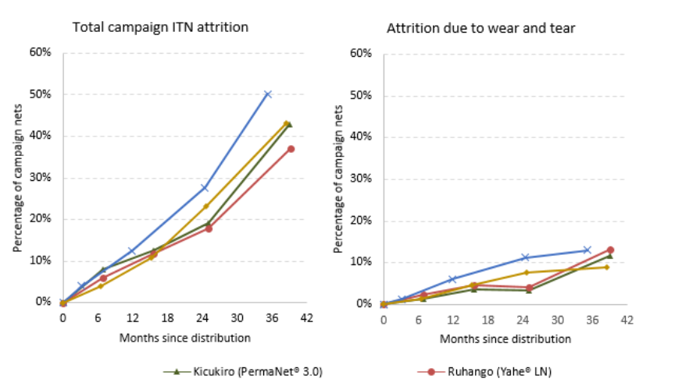

Table 17_sa: Campaign Cohort ITNs Surviving in Serviceable Condition
 | Baseline | 2nd Round | 3rd Round | 4th Round
Kicukiro
All cohort nets* | N=495 | N=449 | N=424 | N=366
Survival estimate | 96.4% | 85.7% | 72.6% | 48.1%
95% CI | 93.6%-98.0% | 80.9%-89.5% | 65.7%-78.7% | 41.7%-54.5%
Cohort nets ever-used and present | N=376 | N=369 | N=370 | N=247
Survival estimate | 97.3% | 90.0% | 79.7% | 67.2%
95% CI | 95.3%-98.5% | 87.2%-92.2% | 75.3%-83.6% | 62.5%-71.6%
Ruhango
All cohort nets* | N=516 | N=487 | N=464 | N=435
Survival estimate | 95.2% | 85.8% | 74.4% | 51.3%
95% CI | 91.8%-97.2% | 78.4%-91.0% | 65.4%-81.7% | 43.3%-59.2%
Cohort nets ever-used and present | N=449 | N=432 | N=378 | N=312
Survival estimate | 97.3% | 92.6% | 86.0% | 71.5%
95% CI | 95.0%-98.6% | 88.5%-95.3% | 80.3%-90.2% | 67.6%-75.1%
Karongi
All cohort nets* | N=541 | N=486 | N=448 | N=389
Survival estimate | 98.3% | 83.7% | 61.8% | 36.5%
95% CI | 96.2%-99.3% | 76.8%-88.9% | 50.6%-71.9% | 26.5%-47.9%
Cohort nets ever-used and present | N=481 | N=431 | N=345 | N=231
Survival estimate | 99.6% | 90.0% | 79.1% | 61.5%
95% CI | 98.3%-99.9% | 86.1%-92.9% | 74.3%-83.2% | 50.1%-71.7%
Burera
All cohort nets* | N=494 | N=449 | N=433 | N=378
Survival estimate | 90.1% | 67.0% | 48.5% | 27.0%
95% CI | 86.0%-93.1% | 60.3%-73.2% | 41.5%-55.5% | 20.2%-35.0%
Cohort nets ever-used and present | N=370 | N=381 | N=352 | N=234
Survival estimate | 89.2% | 68.8% | 55.7% | 41.5%
95% CI | 85.1%-92.3% | 62.4%-74.5% | 49.0%-62.1% | 31.8%-51.8%

Figure 7_sa: Estimated ITN Survival
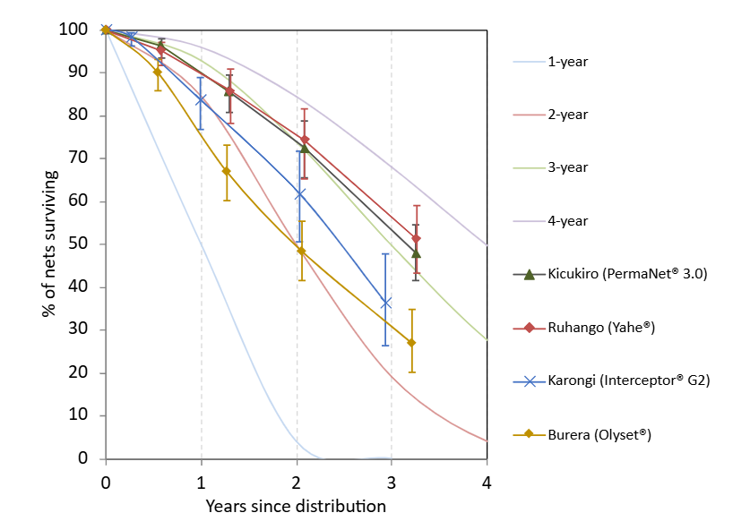

Figure 8_sa: Kaplan-Meier Curves of Physical Survival with 95% Confidence Intervals
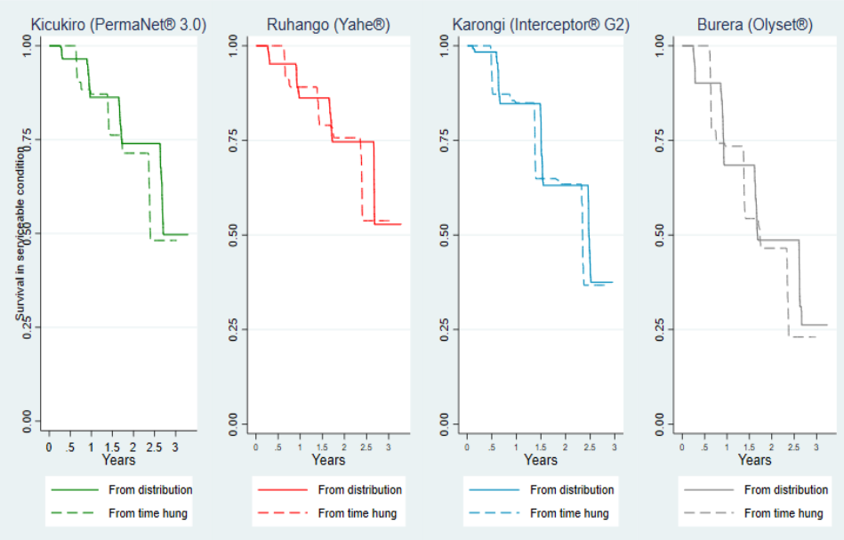

Hakizimana E, Cyubahiro B, Rukundo A, Kabayiza A, Mutabazi A, Beach R, et al. Monitoring long-lasting insecticidal net (LLIN) durability to validate net serviceable life assumptions, in Rwanda. Malar J. 2014 Dec;13(1):344. doi:10.1186/1475-2875-13-344
www.durabilitymonitoring.org
Breakthrough Action. ITN use and access report. [Online] Available at: https://breakthroughactionandresearch.org/resources/itn-use-and-access-report/rwanda/.
https://www.who.int/news/item/14-03-2023-who-publishes-recommendations-on-two-new-types-of-insecticide-treated-nets
Rwanda Biomedical Centre. Rwanda: Distributing Insecticide-treated nets during the COVID-19 Pandemic. [Online] Available at: CS_Campaign_Rwanda_Covid_082021_EN.pdf (allianceformalariaprevention.com)
Breakthrough Action. ITN use and access report. [Online] Available at: https://breakthroughactionandresearch.org/resources/itn-use-and-access-report/rwanda/
www.durabilitymonitoring.org
World Health Organization: WHO Guidelines for Laboratory and Field Testing of Long‐Lasting Insecticidal Nets. Geneva 2013, WHO/HTM/NTD/WHO Pesticide Evaluation Scheme/2013.3
Bioassays to determine residual efficacy of PBO and pyrethroids on PBO synergist ITNs
World Health Organization: WHO Guidance Note for Estimating the Longevity of Long-Lasting Insecticidal Nets in Malaria Control. Geneva: 2013

