Nigeria
Streamlined Durability Monitoring Snapshot: 36 Months
November 25, 2025 – December 5, 2025



Assessment Overview
Net product:
- Interceptor® G2 (IG2) (alpha-cypermethrin + chlorfenapyr [CFP])
Design: Streamlined durability monitoring (SDM) - One brand in one zone
Campaign date:
- November 2022 in Argungu Local Government Area, Kebbi State
Last data collection round: 36 months (November 25, 2025 – December 5, 2025)

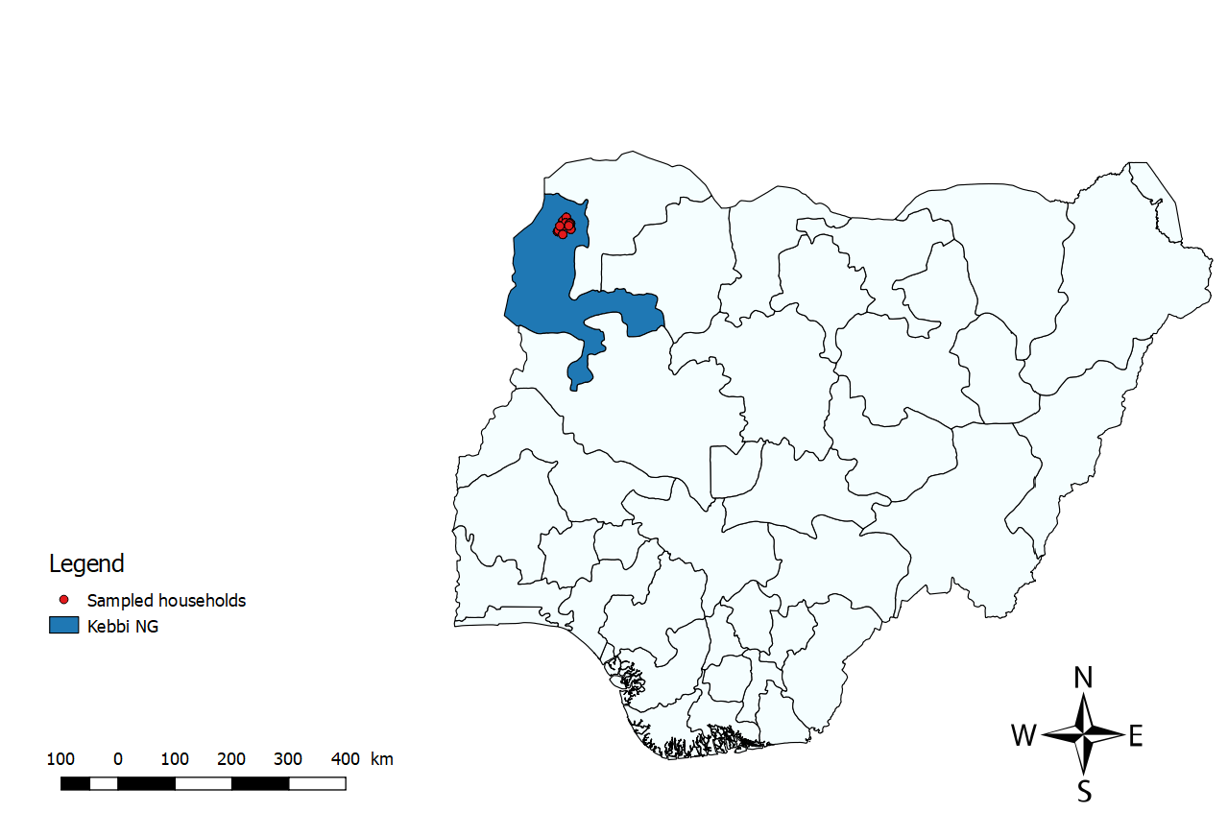
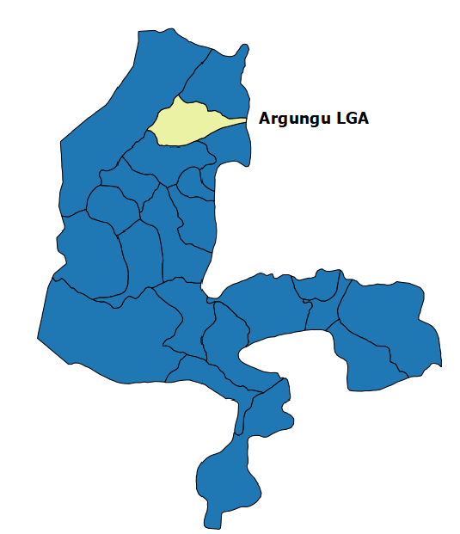
Assessment Site: Kebbi State, Nigeria

Key Results
The Nigeria SDM assessment was initiated by the U.S. President’s Malaria Initiative (PMI) under the PMI Evolve project in 2022. PMI’s January 2025 reorientation resulted in the halting of this work prior to its final survey round. In September 2025, GiveWell stepped in to support the endline round of data collection, multi-round bioassay/chemical residue analysis, and manuscript production.
The endline SDM survey round was conducted 36.7 months after the distribution of IG2 nets in Kebbi State. All-cause attrition was low (19%) at endline. Endline attrition due to wear and tear was also low (9%). Both attrition and attrition due to wear and tear measures were notably lower than those in a recently conducted SDM study of IG2 insecticide treated nets (ITNs) in Lagdo District, Cameroon (46% and 32%, respectively). However, due to the small ITN sample size generated through the SDM methodology, direct comparisons of approximated attrition values across studies should be interpreted with caution. At assessment endline, approximately three quarters (73%) of sampled ITNs remained in serviceable condition. A high proportion (93%) of ITNs were reported to be hanging over sleeping spaces, either tied or untied.
IG2 ITNs remained highly effective against pyrethroid-susceptible mosquitoes after 36 months of field use, achieving over 92% 72-hour mortality. Against the pyrethroid-resistant Nigeria An. arabiensis Kingani strain, 72-hour mortality declined from 68% at pre-distribution to 44% at endline. Blood feeding inhibition (BFI) remained consistently high across rounds (>95%). Losses in CFP content increased from 17% at pre-distribution to 93% at endline compared to the manufacturer’s target dose. After 12 months, CFP content loss was 75%, a level only reached by the endline round in Cameroon. However, endline alpha-cypermethrin content loss was similar in both Nigerian and Cameroonian assessments (70% and 63%, respectively).

Table 1: Summary of key outcomes for IG2 ITNs by survey round in Kebbi, Nigeria
Site | Survey round and time since distribution (months) | Attrition wear and tear | Remaining nets in serviceable condition | Remaining campaign nets hanging over sleeping space | 72 – hour mortality^{α} against resistant mosquito strain | BFI | Mean alpha-cypermethrin chemical content | Reduction in alpha-cypermethrin compared to manufacturer target dose | Mean CFP chemical content | Reduction in CFP compared to manufacturer target dose
 |  | (%) | N (%) | N (%) | (%) | (%) | (g/kg) | (%) | (g/kg) | (%)
Kebbi IG2 | Pre - distribution | N/A | N/A | N/A | 67.7 | 95.5 | 2.20 | 8.3 | 4.02 | 16.7
Kebbi IG2 | First (14.9) | (0.9%) | 23 (76.7%) | 30 (100.0%) | 48.8 | 97.4 | 1.25 | 47.9 | 1.19 | 75.2
Kebbi IG2 | Second (24.8) | (8.0%) | 22 (73.3%) | 25 (83.4%) | 62.3 | 98.3 | 0.67 | 72.1 | 0.36 | 92.5
Kebbi IG2 | Third (36.7) | (8.5%) | 22 (73.3%) | 28 (93.3%) | 43.8 | 98.1 | 0.71 | 70.4 | 0.35 | 92.7
N/A: Not Applicable
^{α}: 72-hour morality was determined by tunnel tests using the pyrethroid-resistant Nigeria An. arabiensis Kingani strain

Key Risk Factors for Sampled ITN Physical Durability at Endline
- ITNs that are hanging should be folded or tied when not in use to enhance their longevity., Of surveyed nets at endline, a very high proportion of ITNs 90% (27/30) were found to be unfolded or untied.
- Nets that were slept under by children or by both children and adults are exposed to greater risks of physical damage.² At endline, 23% (7/30) of nets were reported to be slept under by children only, and 70% (21/30) by a mix of children and adults.
- Using detergent or bleach during washing may also damage the physical and chemical durability of an ITN. At endline, all sampled nets under assessment had been washed at least once. Use of detergent or bleach was reported for 50% (15/30) of washed nets, a proportion that remained stable across rounds.
- Drying ITNs in the sun after washing may diminish their physical and chemical durability. Among nets ever washed, 60% (18/30) were dried in the sun, while the remaining 40% (12/30) were dried in the shade.
- Drying nets on bushes or fences after washing can physically damage ITNs. This practice was uncommon in Kebbi state and was only reported for 10% (3/30) of ever-washed nets.
- Generally, nets used when sleeping on mats or the ground are more prone to wear and tear than those used over mattresses and bed frame., This practice was uncommon across rounds, ranging from 13% to 17%.

Bioassay and Chemical Results: IG2
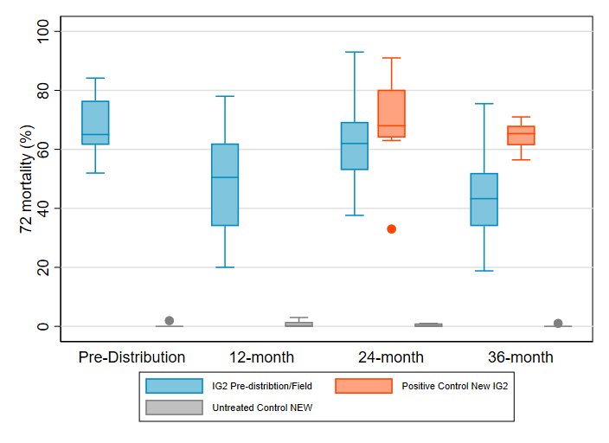
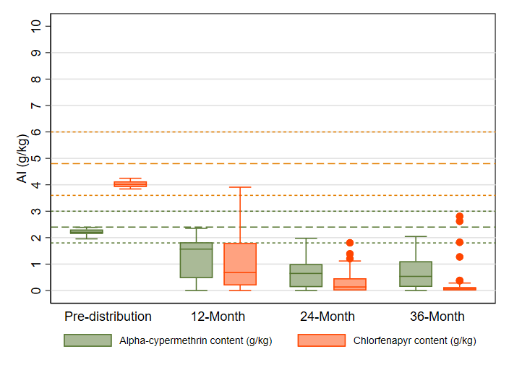
Colonies were characterized using the World Health Organization (WHO) tube tests prior to bioassay testing. Two colonies were used: An. gambiae s.s. (pyrethroid - susceptible, Ifakara strain) and An. arabiensis (pyrethroid - resistant, Kingani strain). An. gambiae s.s. was 100% susceptible to the diagnostic dose of alpha-cypermethrin (0.05%) and 100% susceptible to chlorfenapyr (100 µg/bottle) after 24-hours of exposure. Characterization of the An. arabiensis Kingani strain using WHO tube tests showed that, at 24- and 36-months, the colony was resistant to alpha-cypermethrin, with 57% 24-hour mortality. Exposure to alpha-cypermethrin only during tunnel testing resulted in 59% 72-hour mortality. The An. arabiensis Kingani strain colony were susceptible to chlorfenapyr (100 µg/bottle), with mortality at 100% after 72-hours of exposure. Across all rounds, 72-hour mortality against the susceptible strain remained consistently high (>92%). Against the resistant strain, the 72-hour mortality decreased from 68% at pre-distribution to 44% at endline round. BFI remained consistently high across all rounds (>95%). Mean alpha-cypermethrin content declined from 2.2 g/kg at pre-distribution to 0.71 g/kg at endline, corresponding to an increase in chemical content loss from 8% to 70% compared to the manufacturer’s target dose of 2.4 g/kg. Similarly, mean CFP content declined from 4.0 g/kg at pre-distribution to 0.4 g/kg at endline, corresponding to increases in chemical content loss from 17% to 93% relative to the target dose of 4.8 g/kg. At endline, nearly all (26/30) field ITN samples fell below the lower limit of the manufacturer target alpha-cypermethrin content of 1.8 g/kg (2.4 g/kg +/- 25%). All the 30 samples had CFP content below the manufacturer target lower limit of 3.6 g/kg (4.8 g/kg +/- 25%) at endline.
72-hour mortality for field/new Interceptor® G2 ITN brand samples taken from Kebbi District, Nigeria against resistant An. gambiae Kingani mosquitos
Alpha-cypermethrin and chlorfenapyr content of Interceptor® G2 brand ITNs from Kebbi District, Nigeria

Box plot shows the median (horizontal line), interquartile range (box), adjacent values (whiskers), outliers (circles), and for each legend, bold line dashes specify manufacturer threshold (with fine line dashes indicating acceptable range).
Box plot shows the median (horizontal line), interquartile range (box), adjacent values (whiskers) and outlier (circle).

Durability Monitoring Indicator Definitions
All-cause attrition:
At 12 months, attrition is calculated as the ITNs reportedly received during the mass campaign that are no longer physically present divided by the total number of ITNs reportedly received during the mass campaign.
At 24 and 36 months, total attrition is calculated as the number of nets with known status lost by 12-month plus an estimate* of the number of nets with known status lost between 12 months and the 24- or 36-month survey round divided by the total number of ITNs reportedly received during the mass campaign.
*Assuming all nets in the sampling frame for that round undergo attrition/attrition due to wear and tear at the same level as the point estimate calculated for the survey round.
Attrition due to wear and tear:
At 12 months, attrition due to wear and tear is calculated as the ITNs reportedly received during the mass campaign that were destroyed, discarded or used for other purposes divided by the total number of ITNs reportedly received during the mass campaign.
At 24 and 36 months, total attrition due to wear and tear is calculated as the number of nets with known status that were destroyed /discarded /used for other purposes by 12-month plus an estimate* of the number of nets with known status that were destroyed /discarded /used for other purposes between 12 months and the 24-or 36-month survey round divided by the total number of ITNs reportedly received during the mass campaign.
*Assuming all nets in the sampling frame for that round undergo attrition/attrition due to wear and tear at the same level as the point estimate calculated for the survey round.
Remaining nets in serviceable condition: The percentage of sampled nets surviving to date that are still in serviceable physical condition (good or damaged), specifically, with a proportionate hole index of 642 or less.
à Provides an estimate of the physical quality of remaining campaign nets.
Remaining nets hanging over sleeping space: The percentage of sampled nets and, separately, non-sampled nets present in the household that are hanging up, whether tied up or not.
à Provides an estimate of the use of different nets in the household. Households adopt nets newly received from campaigns at different rates. A present net hanging up in the home is an indicator of net use generally, beyond the formal indicator of net use the night before the survey.

Population Services International. Cameroon Streamlined Durability Monitoring Snapshot: 36 Months.
Obi E, Okoh F, Blaufuss S, Olapeju B, Akilah J, Okoko OO, Okechukwu A, Maire M, Popoola K, Yahaya MA, Uneke CJ. Monitoring the physical and insecticidal durability of the long-lasting insecticidal net DawaPlus® 2.0 in three States in Nigeria. Malaria journal. 2020 Dec; 19:1-9.
Sudoi, R.K., Esch, K., Yamba, F. et al. Physical and insecticidal durability of PermaNet® 3.0 and Olyset® plus piperonyl butoxide-synergist insecticide-treated nets in Sierra Leone: results of durability monitoring from 2020 to 2023. Malar J 24, 230 (2025). https://doi.org/10.1186/s12936-025-05421-7.
Castellanos ME, Rodas S, Juárez JG, Lol JC, Chanquin S, Morales Z, Vizcaino L, Smith SC, Vanden Eng J, Woldu HG, Lenhart A. Evaluation of the durability of long‐lasting insecticidal nets in Guatemala. Malaria Journal. 2021 May 14;20(1):219.
Atieli, F.K., Munga, S.O., Ofulla, A.V. et al. Wash durability and optimal drying regimen of four brands of long-lasting insecticide-treated nets after repeated washing under tropical conditions. Malar J 9, 248 (2010). https://doi.org/10.1186/1475-2875-9-248
Jacky Raharinjatovo et al., “Physical and Insecticidal Durability of Interceptor®, Interceptor® G2, and PermaNet® 3.0 Insecticide-Treated Nets in Burkina Faso: Results of Durability Monitoring in Three Sites from 2019 to 2022,” Malaria Journal 23, no. 1 (June 4, 2024): 173, https://doi.org/10.1186/s12936-024-04989-w.
Haji KA, Khatib BO, Obi E, Dimoso K, Koenker H, Babalola S, et al. Monitoring the durability of the long lasting insecticidal nets Olyset® and PermaNet® 2.0 in similar use environments in Zanzibar. Malar J. 2020 May 24;19(1):187.

